SMTP Gmail Settings

Login to your Work Gmail account – NOT the main box

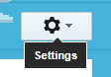

Click the Option Settings

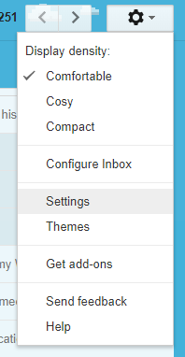

Click Accounts and Import

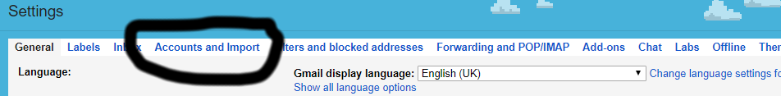

In the Send Mail as Section:

On the first NON gmail account click Edit Info

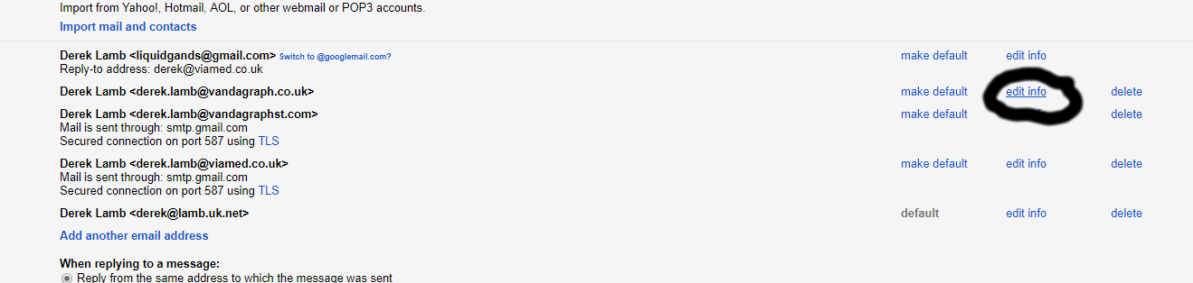

Leave the Next Page settings as is :

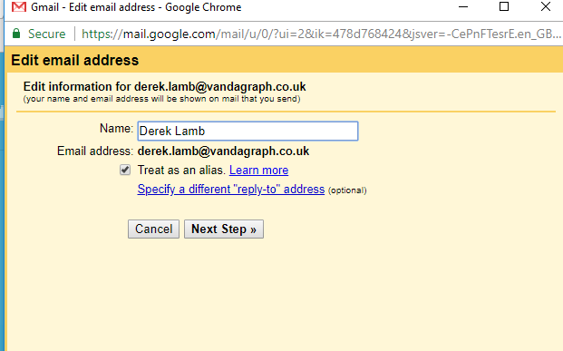

Click the Specify a different “Reply-to” Address

In the Box that opens up cut and paste the Email address setting into it, this should stop customer replys dropping in to the main box and go directly to your gmail account.

Click Next Step >>
Update SMTP Server smtp.gmail.com
Update Username viamedinbox@gmail.com
Update Password : xsjymtwyucdxybnv

Leave other settings alone

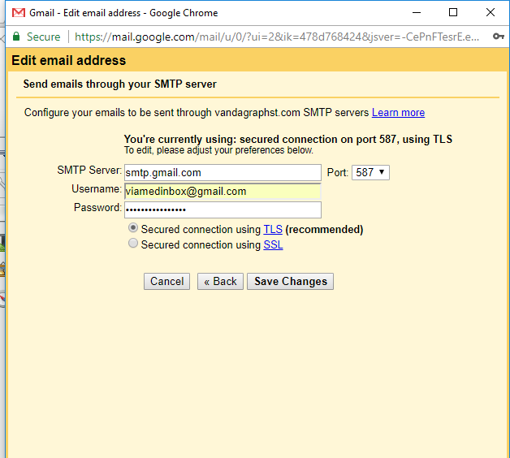

Click Save Changes.

Send a Test email from your gmail account, but select the send as email the one you just updated the settings for,
Send the mail to your @viamed.co.uk address.

- You should receive the email into your account.
- You should also see a copy of your sent email in the MAIN inbox sent mail folder.

Now do any other ‘send as’ addresses in your gmail settings accounts list. Use the same smtp settings for all email accounts.

