SMTP Gmail Settings

Login to your Work Gmail account – NOT the main box

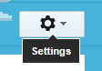

Click the Option Settings

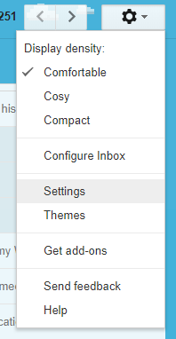

Click Accounts and Import

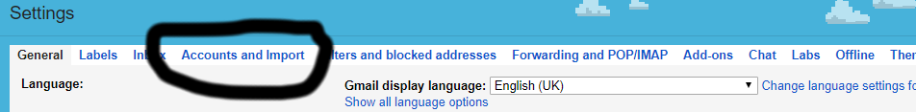

In the Send Mail as Section:

On the first NON gmail account click Edit Info

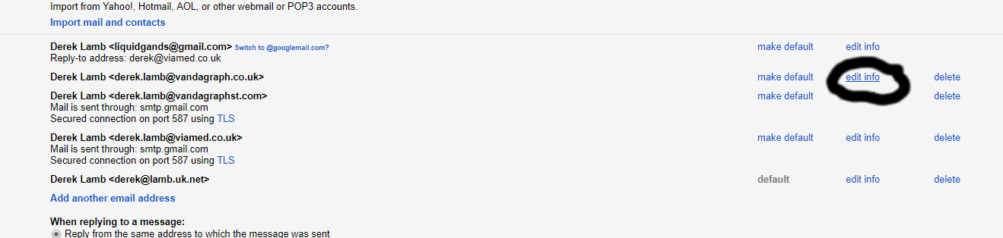

Leave the Next Page settings as is :

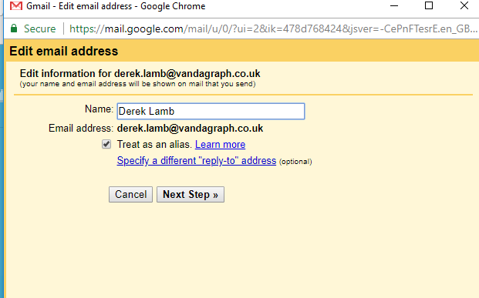

Click Next Step >>
Update SMTP Server smtp.gmail.com
Update Username viamedinbox@gmail.com
Update Password : xsjymtwyucdxybnv

Leave other settings alone

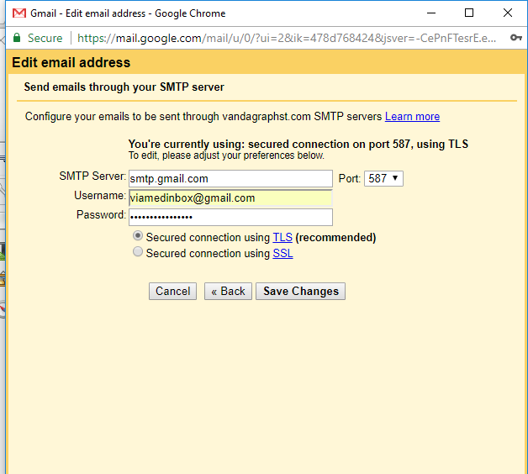

Click Save Changes.

Send a Test email from your gmail account, but select the send as email the one you just updated the settings for,
Send the mail to your @viamed.co.uk address.

- You should receive the email into your account.
- You should also see a copy of your sent email in the MAIN inbox sent mail folder.

Now do any other ‘send as’ addresses in your gmail settings accounts list.

