SMTP Gmail Settings

Login to your Work Gmail account – NOT the main box

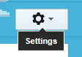

Click the Option Settings

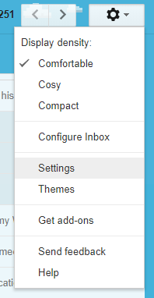

Click Accounts and Import

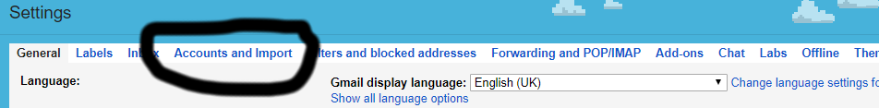

In the Send Mail as Section:

On the first NON gmail account click Edit Info

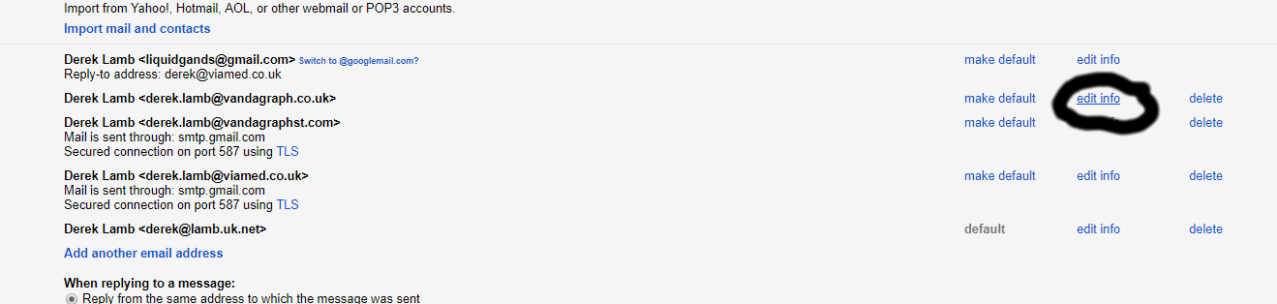

Leave the Next Page settings as is :

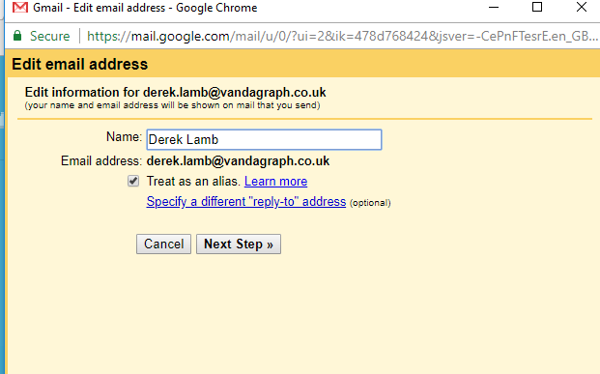

Click Next Step >>
Update SMTP Server smtp.gmail.com
Update Username viamedinbox@gmail.com
Update Password : xsjymtwyucdxybnv

Leave other settings alone

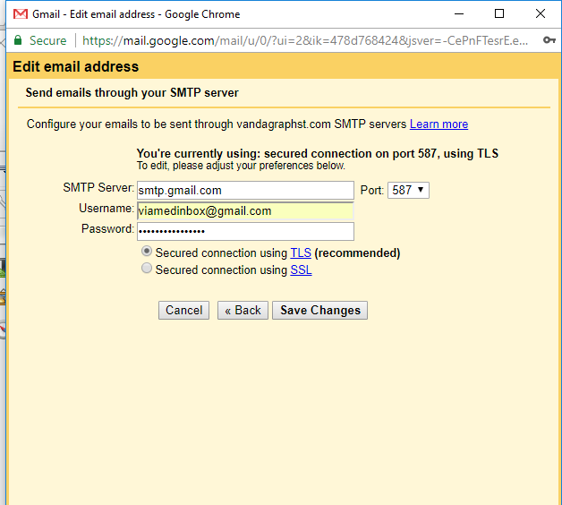

Click Save Changes.

Now do any other send as addresses in your list.

