VM3COP40.72 Production procedure for 0110238 Oxygen sensor (R-22AT)
Parts list:
Qty | Description | Part No.
1 | Oxygen sensor - Automotive R-22AV | 0110132
1 | 2 pin Molex connector
2 | Molex pin
1 | Sensor adapter
1 | Sensor label

Tool list:
Soldering iron
Wire cutters
Stanley knife
Sensor cap removal tool
Super glue (Loctite 435)

- Remove the sensor from the sealed protective bag. | 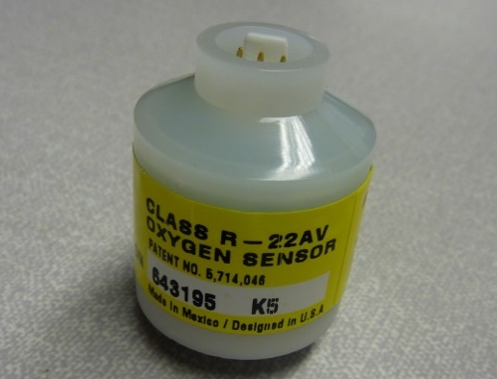
- Remove the top cap from the sensor. | 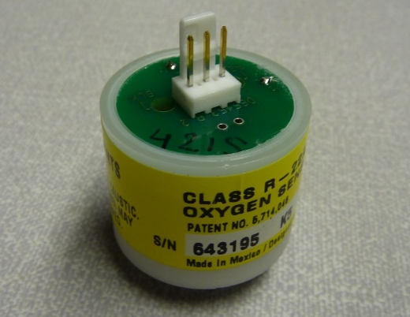
- Remove the white plastic surround from the Molex connector. | 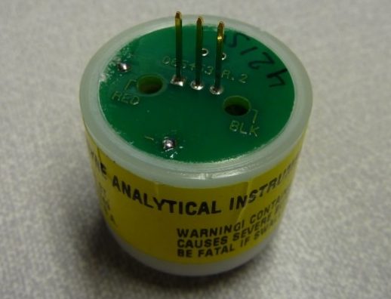
- Using a soldering iron and pliers, remove the pins. | 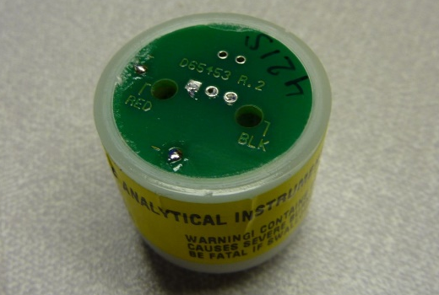
- Cut lengths of black and red wire to 75mm.  - Strip 3mm from each end of each wire.  - Tin one end of each wire.  - Apply a Molex crimp pin to the non-tinned wire. | 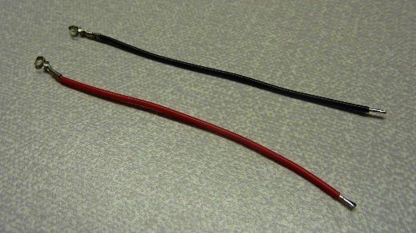
- Insert the wires, as shown, into the Molex connector. | 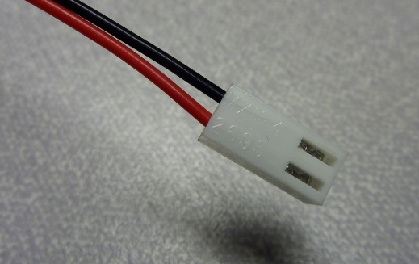
- Solder the wires to the solder points as shown. | 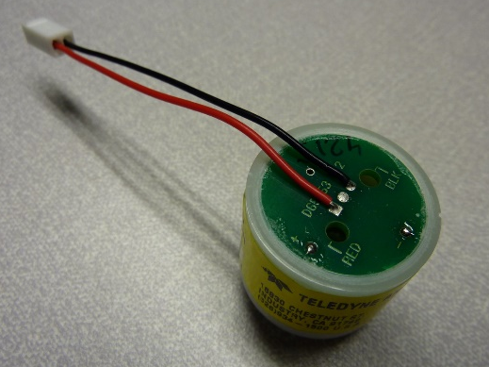
- Prepare the foam cap by placing double sided sticky tape to one side.  - Peel away the backing from the double sided sticky tape. | 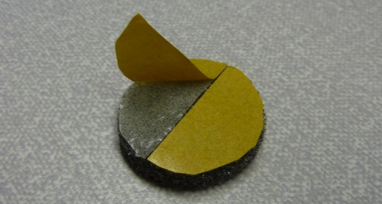
- Place the foam cap, sticky side down, onto the top of the sensor and gently press into place. | 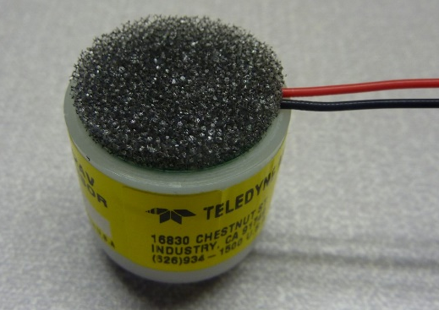
- Noting the serial number, remove the sensor label. | 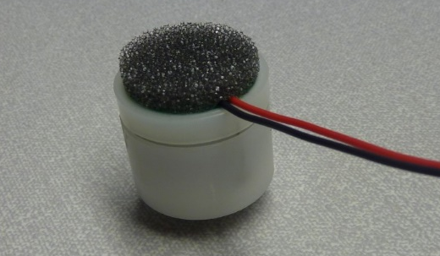
- Apply the new label, ensuring that the serial number matches the one previously removed. | 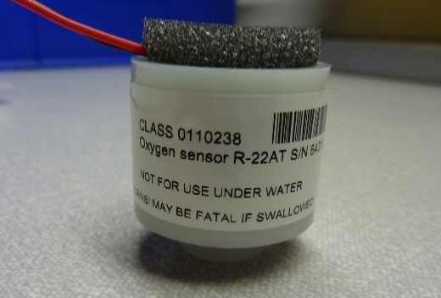
- Remove the black O ring. | 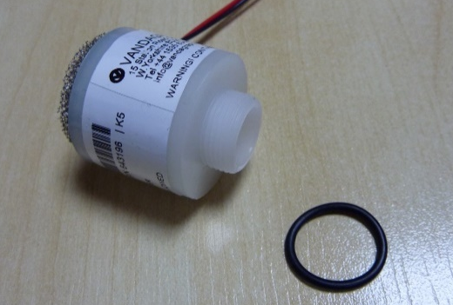
- Place a drop of super glue onto the thread. | 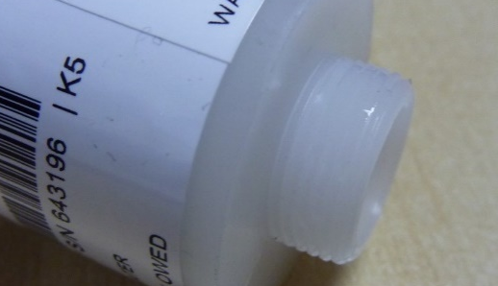
- Attach the sensor adapter to the sensor thread. | 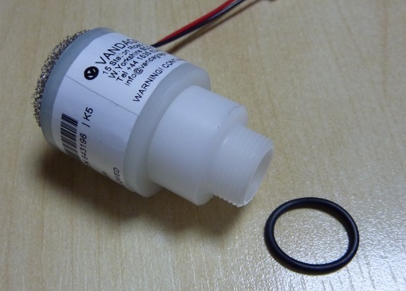
- Place the O ring over the sensor adapter thread.  - The sensor is now ready for testing. | 

