VM3COP44.01 - Envitec OxiQuant S QA Procedure
Testing:
- Unbox the OxiQuant analyser (PN:0111275) and the Oxygen sensor (PN:0110660). | 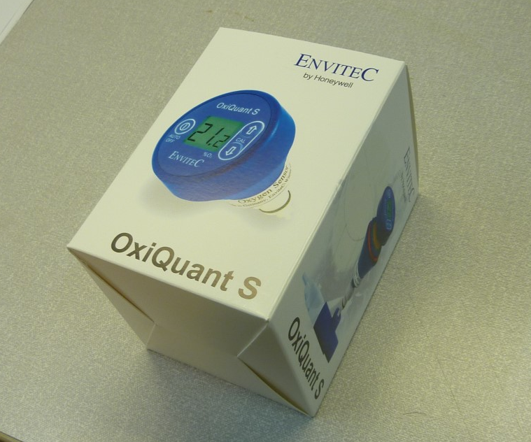
- Check the box contains all the items listed:  1 x OxiQuant analyser (PN:0111275)  1 x Oxygen sensor (PN:0110660)  1 x T piece adaptor  1 x Flow diverter  1 x Hose adaptor  1 x Operating instructions | 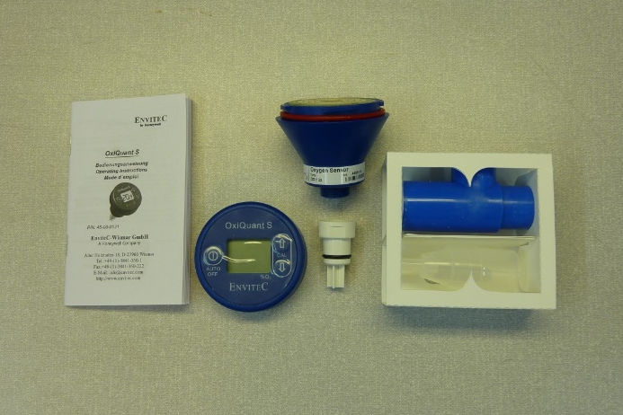
- Attach the Oxygen sensor to analyser. Place the analyser over the sensor contacts and rotate the analyser clockwise, until locked in place. | 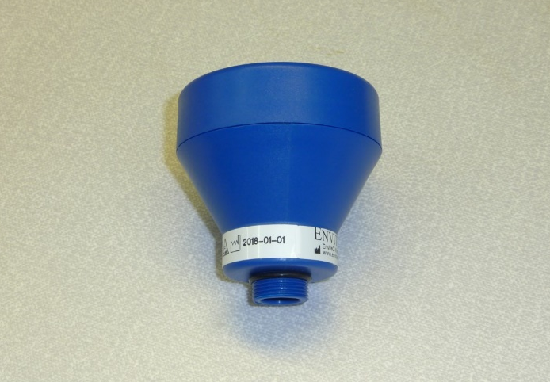
- Activate the analyser by pressing and holding the power button for 3 seconds.  - The display will briefly activate all the LCD segments. Check these are all working.  - The unit will then briefly display the version number, before showing an Oxygen reading. | 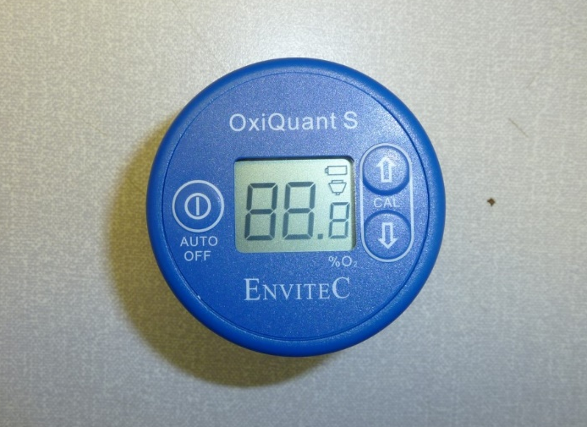
- The initial reading will start at 20.9%. This might fluctuate slightly (±1%) in air. | 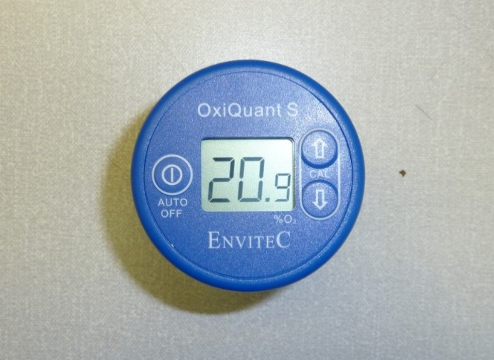
- In turn, press the ▲ and ▼buttons. Observe that these raise and lower the displayed Oxygen value.

- Return the displayed value to 20.9%.
- The unit can be switched off by pressing the power button for 3 seconds.  - Observe that the analyser automatically powers off after 3 minutes. Nothing is shown on the display when the analyser is switched off. | 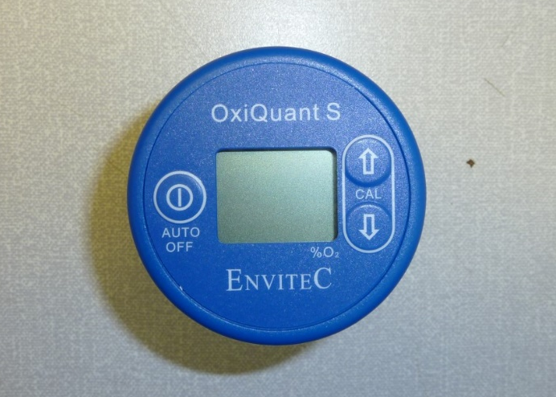
Packing and labelling:
- Disconnect the Oxygen sensor from the analyser by turning the analyser counter clockwise to the sensor. | 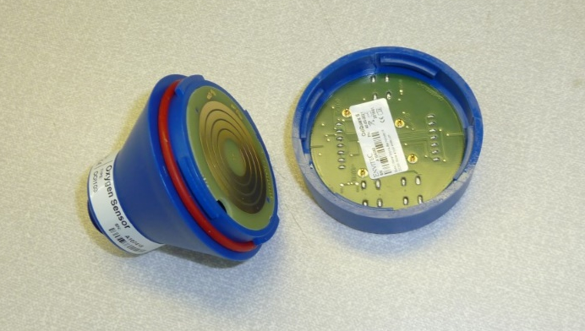
- Check the serial number of the analyser, which is located on the underside of the unit. | 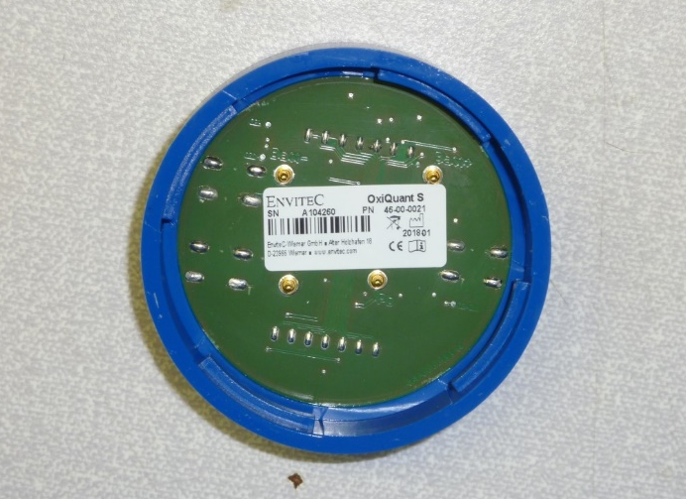
- Confirm that the serial number of the unit matches that of the one found on the label on the outer packaging. | 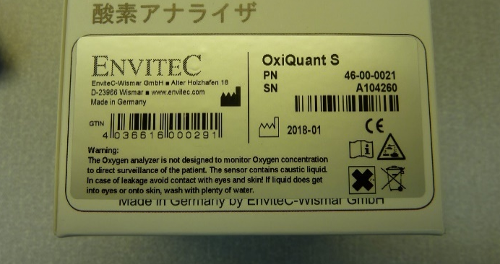
- Check the serial number of the Oxygen sensor, which can be found on the white label near the sensor base. | 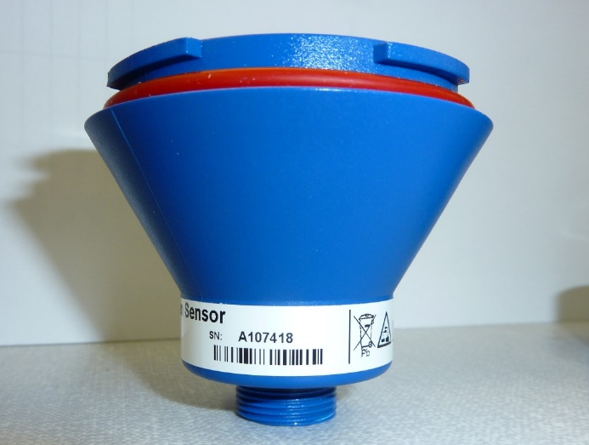
- Affix the corresponding serial number labels, for both the analyser and sensor, to the front face of the outer packaging. | 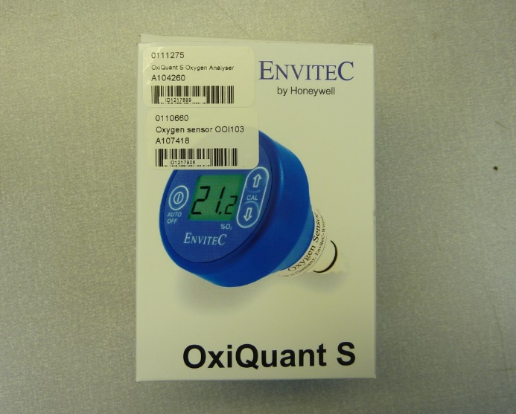
- Record the QA results, for both the analyser and the sensor individually, in the Intrastats system.

