VM3COP40.39 R-33VAN-4 Production Procedure
Parts list:
Description | Part Number | Supplier | Supplier part number | Quantity
R-33S Sensor | 0110226 | Teledyne | R-33S | 1
Black housing – R-33VAN | 9720200 | Vandagraph |  | 1
TDK ferrite - 2035-0930 | 9730502 | Farnell | 1301656 | 1
Cable | 9730500 | VDC | 211-311-000 | 1.3m
CONNECTOR 3.5mm jack | 0131356 | Farnell | 1243261 | 1
Viton ‘O’ ring (Large) | 9730501 | Spen Bearings | BS0140-15 | 1
Viton ‘O’ ring (Small) | 9730201 | Spen Bearings | VIT-0130:10-274
Sensor top cap |  | Vandagraph |  | 1
Grommet | 9730015 | RS | 543-197 | 1
Cable grip | 0030500 | Viamed | 0030500 | 1

Tool list:
Soldering iron
Wire cutters
Wire stripper
Stanley knife
Heat gun
Crimp tool
Scissors

- Remove the R-33S Oxygen sensor from the packaging. | 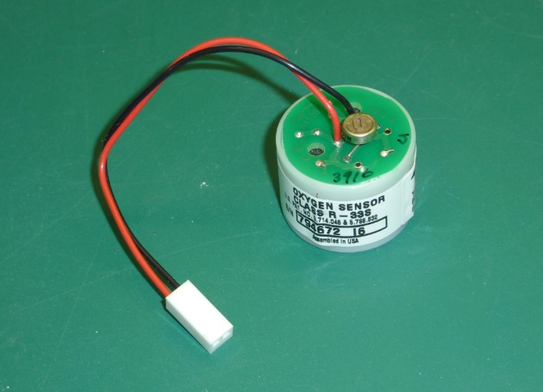
- De-solder the red and black wires.  - Remove the label from the sensor. Note the serial number. When the sensor is relabelled, the same serial number will need to be applied. | 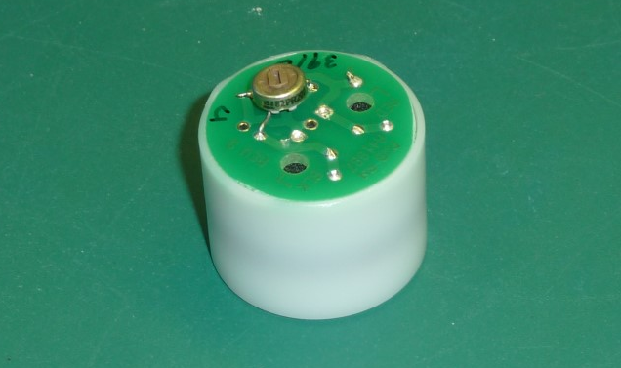
- Insert a grommet into the hole in top cap. | 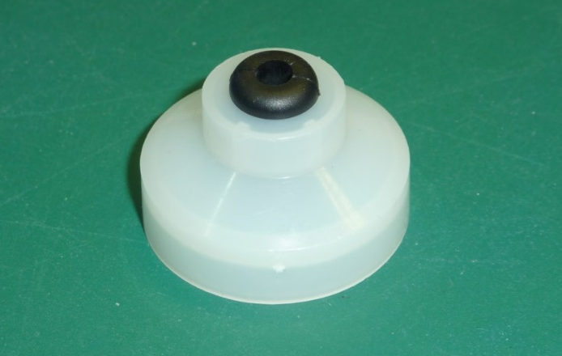
- Feed the cable through the grommet. | 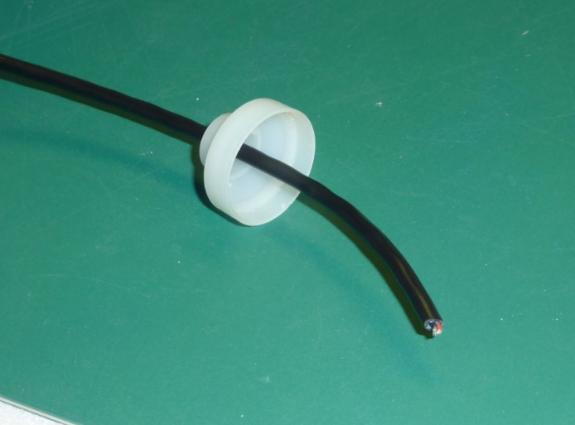
- Strip 12mm from the outer cable sheath.  - Cut the shield away.  - Affix a cable grip 2mm from the cable end. | 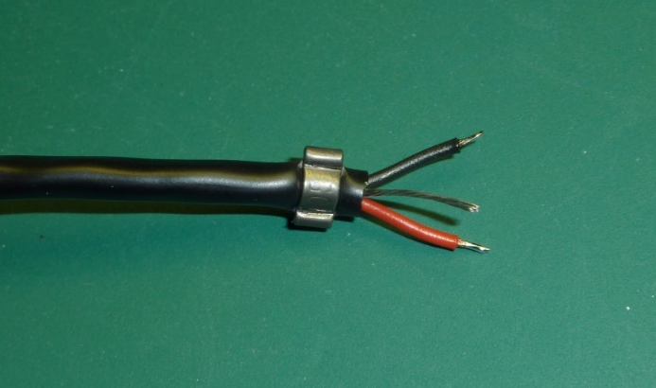
- Place 10mm of 6mm heat shrink over the cable grip. Using a heat gun, shrink into place. | 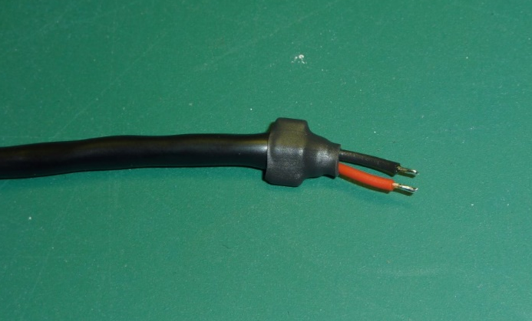
- Trim the sensor housing to leave 18mm on the wider part. | 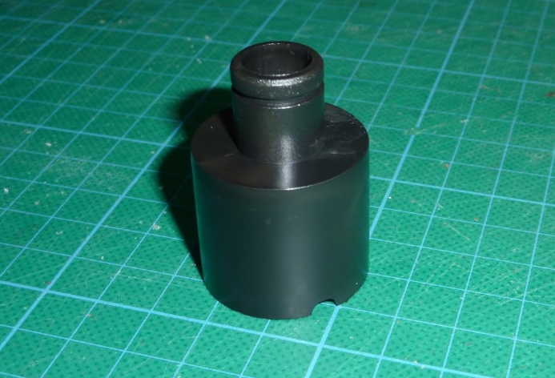
 | 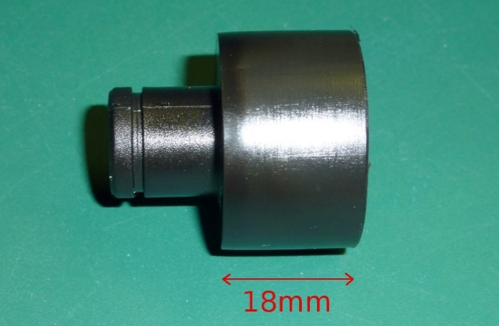
- Apply clear adhesive silicone to the inside face of the sensor housing. | 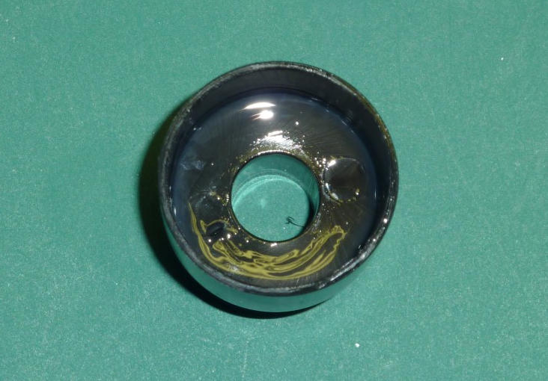
- Place the sensor inside the sensor housing and firmly press down. | 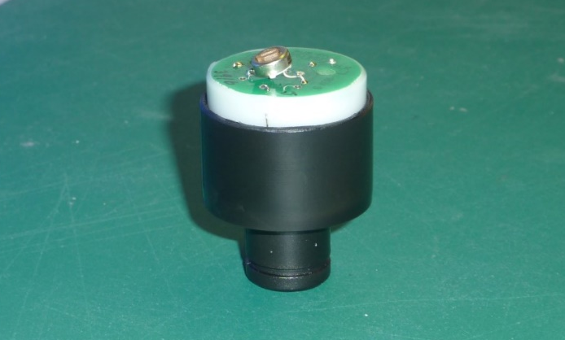
- Solder the red and black wires to the corresponding contacts on the PCB. | 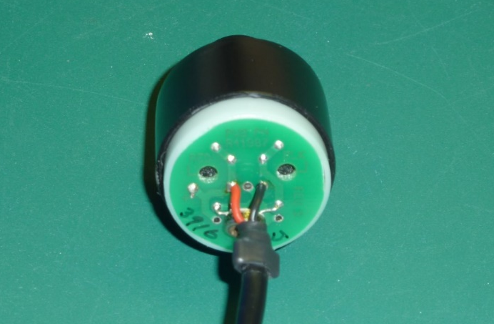
- Apply a modest amount of super glue to the inside of the sensor cap. Firmly press and hold the sensor cap in place. Wipe away any excess. | 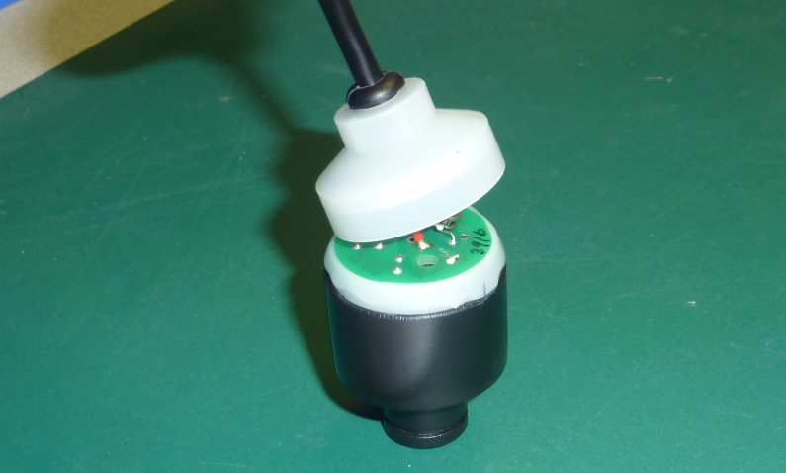
- Affix the serial number label. | 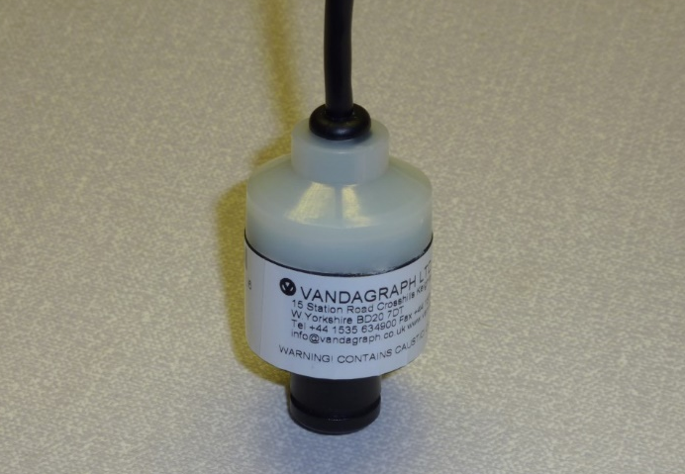
- Place the large ‘O’ ring over gas inlet port.  - Place the small ‘O’ ring in the recess on the length of the gas inlet port. | 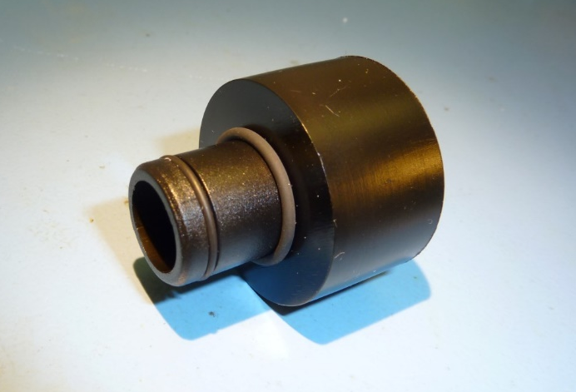
- Strip 7mm from the outer sheath of the cable and peel away the foil shield, leaving the wire shield in place.  - Strip and tin 2mm from the black wire. | 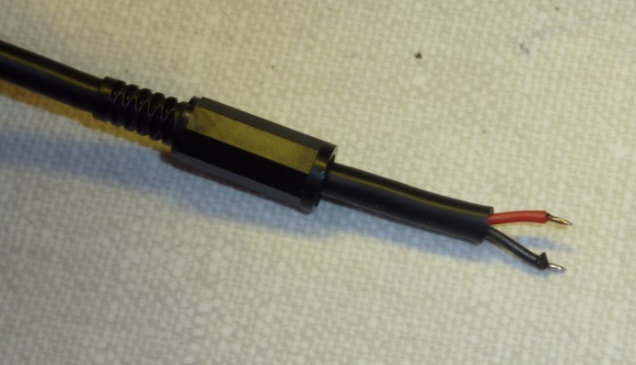
- Strip 7mm from the red wire and twist together with the shield wire.  - Tin both the black and red/shield wires | 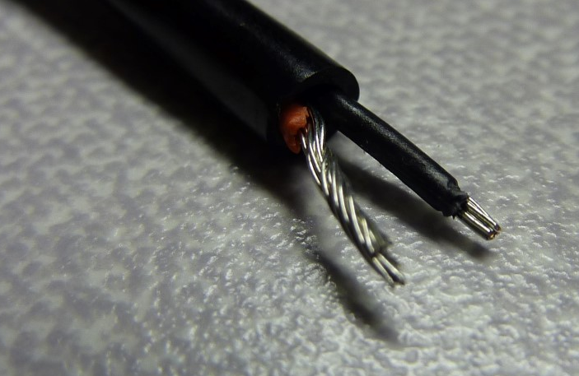
- Solder the black wire the centre pin of the 3.5mm jack plug.  - Solder the red/shield wire to the outer ring of the 3.5mm jack plug. | 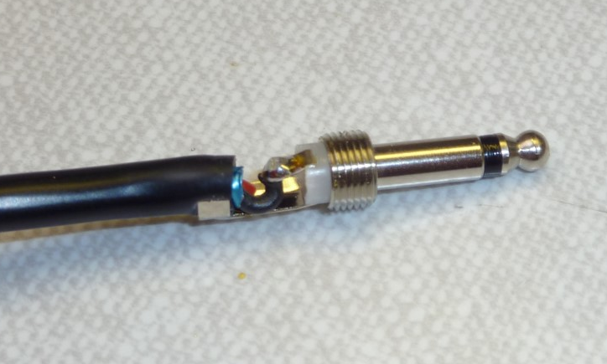
- Affix the connector hood to the 3.5mm jack connector. | 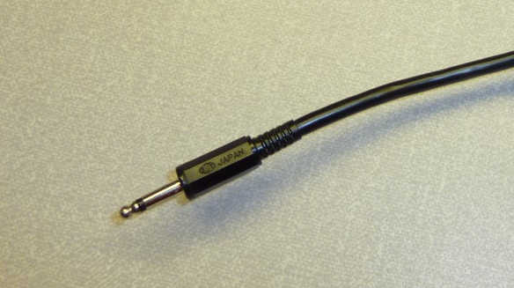
- Affix a ferrite by looping once thought. Leave 60mm of sheathed cable protruding from the ferrite. | 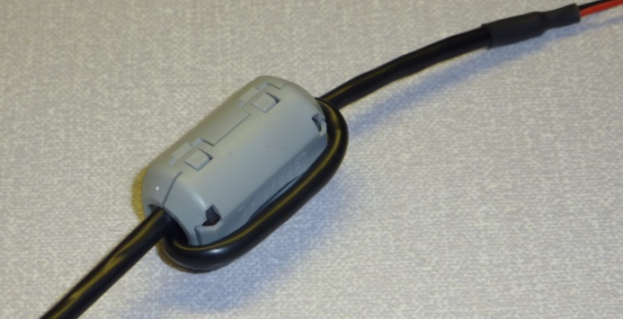
Q.A.
- Using a digital volt meter, test the output of the sensor. The output must be 25mV ±2mV.  - Note the output and record the results on the Intrastats system. | 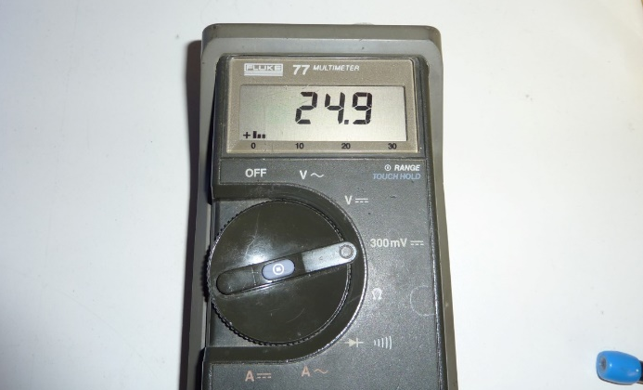
Packing
- Place the sensor in a gas barrier bag.  - Using a strip heat sealer, seal the sensor within the bag.  - Affix the corresponding serial number label to the outside of the bag. | 

