Maxtec and Life Spark Oxygen Monitoring - Technical Training

Why do we measure oxygen?

Oxygen is essential to human life. The atmosphere consists of 20.95% oxygen, often approximated to 21%.

Too little oxygen results in hypoxia, which is fatal if prolonged.

In high concentrations (i.e. when inhaled under pressure) it can be fatal.

Oxygen in medical applications in the UK is classed as a controlled drug* and needs to be monitored when administered to ensure that the patient is breathing a safe gas mixture.

How do we measure oxygen?

To measure the percentage of oxygen in a breathing gas, we use an oxygen analyser or an oxygen monitor, which are electronic devices that use an oxygen sensor to measure oxygen levels, displayed as a percentage between 0% and 100% O₂.

- Oxygen analyser - no user adjustable alarms.

Should only be used for checking oxygen concentration and not for continuous monitoring.

- Oxygen monitor - has user adjustable high and low alarms.

Can be used for continuous monitoring.

Allows the user to set a ‘window’ of desired oxygen percentage and be alerted should the reading drift from this zone.

*British National Formulary (BNF), a joint publication of British Medical Journal and the Royal Pharmaceutical Society - https://bnf.nice.org.uk/treatment-summaries/oxygen/
Maxtec MaxO2+A Oxygen Analyser

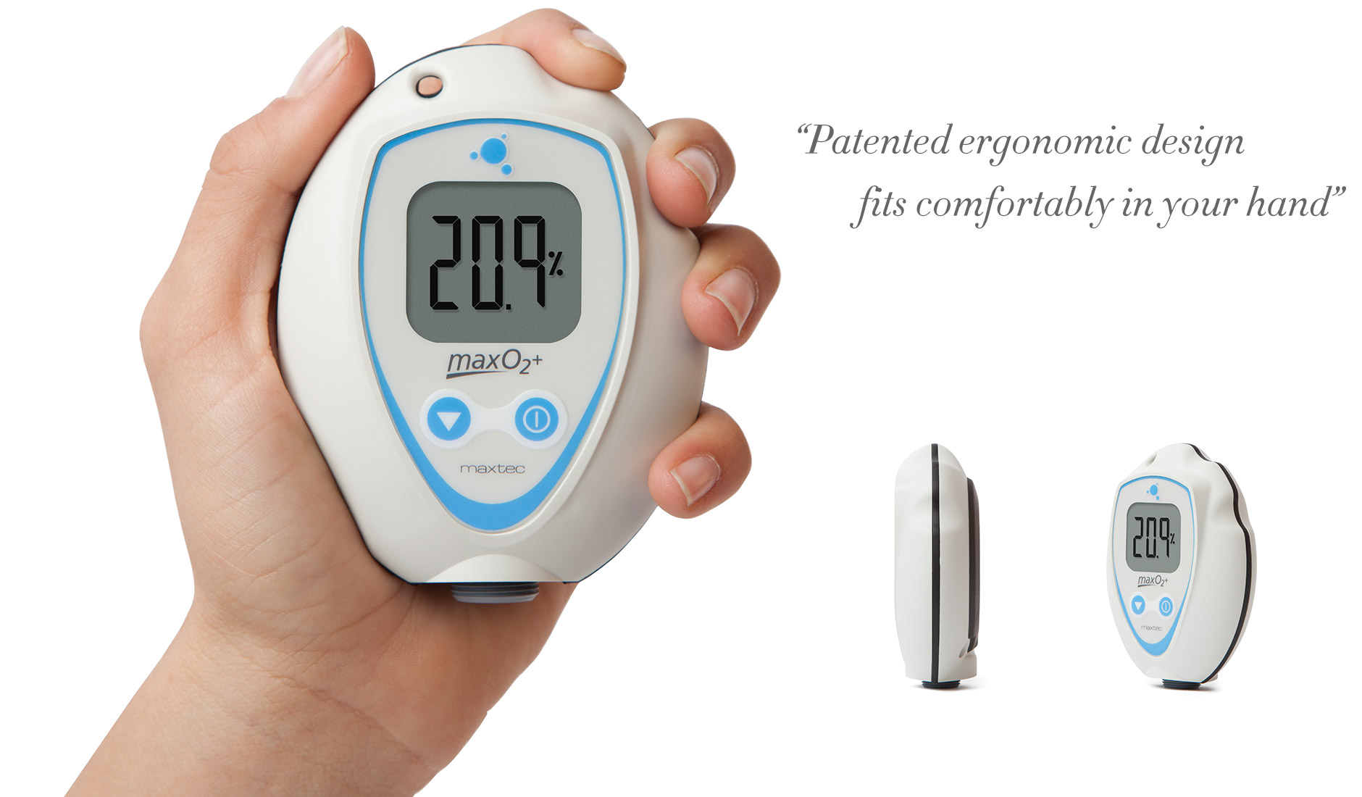

Supplied with an internal sensor (fig.1), the gas is delivered to the device via T-adapter using a flow divertor (fig.2 & 3) connected to the bottom of the device, or alternatively, using a barbed adapter connected to oxygen tubing (fig.4).
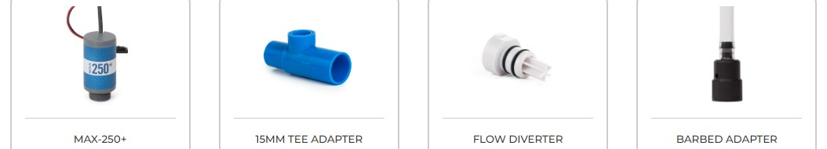

Accessories included with device
Features:

- No alarms: best suited to spot-checking, not suited to continuous monitoring.

- Automatic calibration to room air on power up.

- Can be calibrated in 100% in oxygen - will automatically detect air or oxygen when the CAL button is pressed.

- Long battery life: approximately 5,000 hours with continuous use.

- Accuracy: 1% constant temperature, relative humidity and pressure when calibrated at full scale.

- Response time: <15 seconds to show a 90% change in value.

- Expected sensor life: greater than 1,500,000 oxygen percent hours minimum (2-year in typical medical applications).

- Internal sensor can be replaced. Part no 0110427 - Max-250+.

The device can be hand held or mounted using an optional V mount assembly (p/n 0121302 - below left), which allows it to connect into a pole mount (p/n 0121181 or 0121182 - below right), also optional.
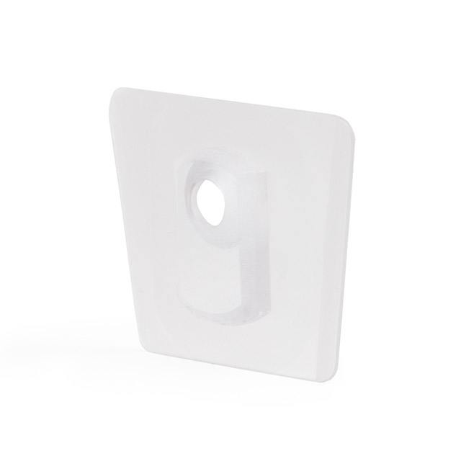
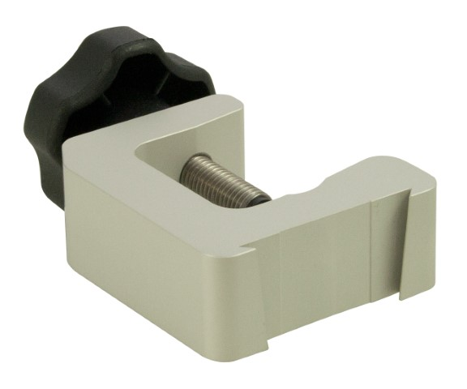
Optional V-Mount Bracket and Pole Mount
Maxtec MaxO2+AE Oxygen Analyser
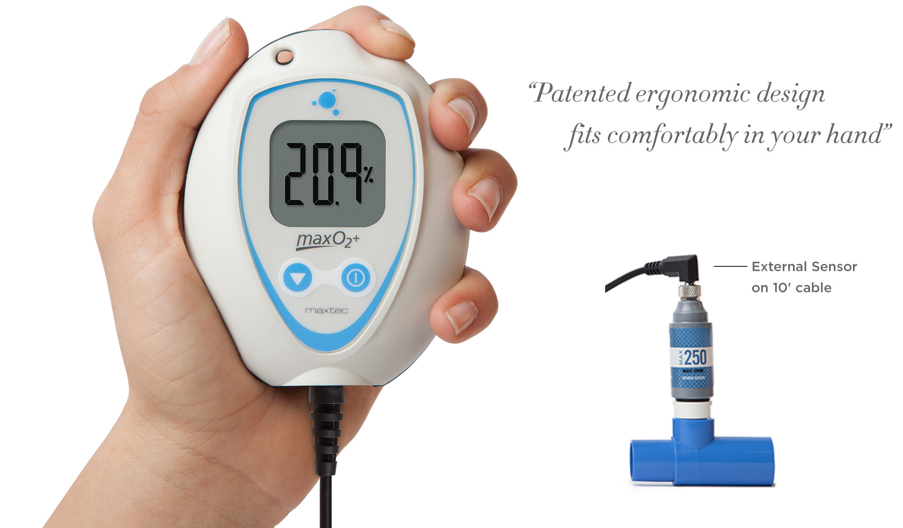
Supplied with an external sensor (fig.1) with a coiled cable, which allows the sensor to connect into T-adapter using a flow divertor (fig.3 and 4).

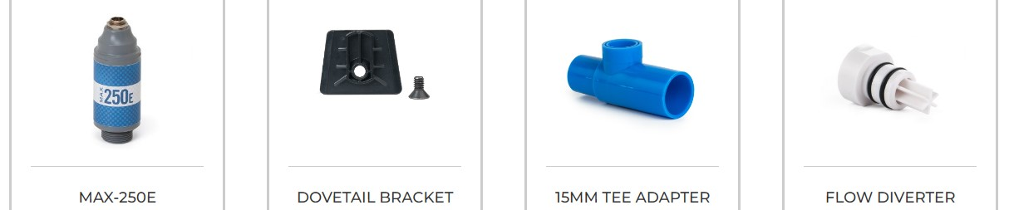
Also supplied with a V-mount bracket (fig.2).

Accessories included with device
Features:

- No alarms: best suited to spot-checking, not suited to continuous monitoring.

- Automatic calibration to room air on power up.

- Can be calibrated in 100% in oxygen - will automatically detect air or oxygen when the CAL button is pressed.

- Long battery life: approximately 5,000 hours with continuous use.

- Accuracy: 1% constant temperature, relative humidity and pressure when calibrated at full scale.

- Response time: <15 seconds to show a 90% change in value.

- Expected Sensor Life: greater than 1,500,000 O2 percent hours minimum (2-year in typical medical applications).

- External sensor can be replaced. Part no 0110429 - Max-250E.

The device can be hand held or mounted using the included V mount assembly (p/n 0121302 - below left), which allows it to connect into an optional pole mount (p/n 0121181 or 0121182 - below right).
V-Mount Bracket (included) and Pole Mount (optional)
Maxtec Handi+ Oxygen Analyser
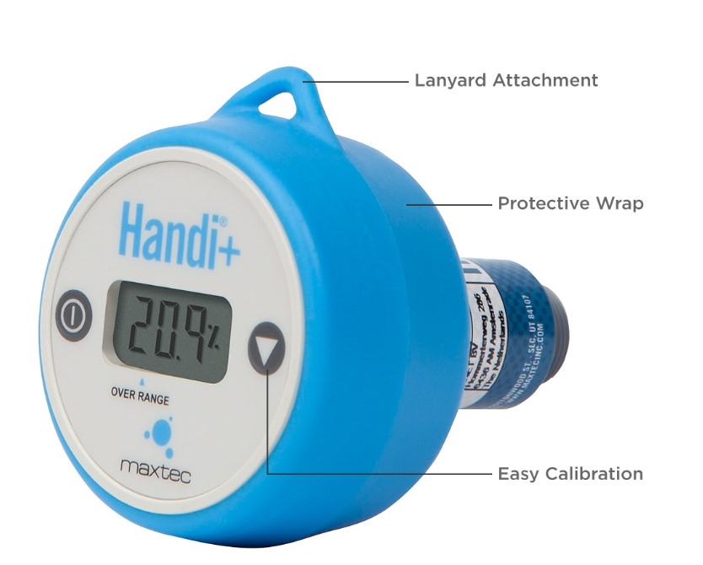
Supplied with an internal sensor, the gas is delivered to the device via T-adapter using a flow divertor (fig.1 & 2) connected to the bottom of the device, or alternatively, using a barbed adapter connected to oxygen tubing (fig.3).

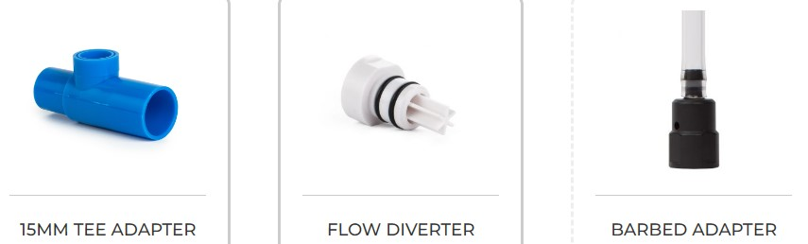
Accessories included with device
Features:

- No alarms: best suited to spot-checking, not suited to continuous monitoring.

- Can be calibrated in 100% in oxygen - will automatically detect air or oxygen when the CAL button is pressed.

- Auto-power off after approximately 80 seconds.

- Long battery life: approximately 1,850 hours, equates to approximately 74,000 operational cycles.

- Accuracy: 1% constant temperature, relative humidity and pressure when calibrated at full scale.

- Response time: <15 seconds to show a 90% change in value.

- Expected Sensor Life: greater than 1,500,000 O2 percent hours minimum (2-year in typical medical applications).

- CE Certified as a medical device and can be used to measure gases being delivered to a patient.

Limitations and points to note:

- The sensor contains the battery for powering the device, integrated with the oxygen sensor that cannot be replaced.

- Once the sensor or battery is depleted the whole unit should be disposed of.

Maxtec MaxO2 ME Oxygen Monitor
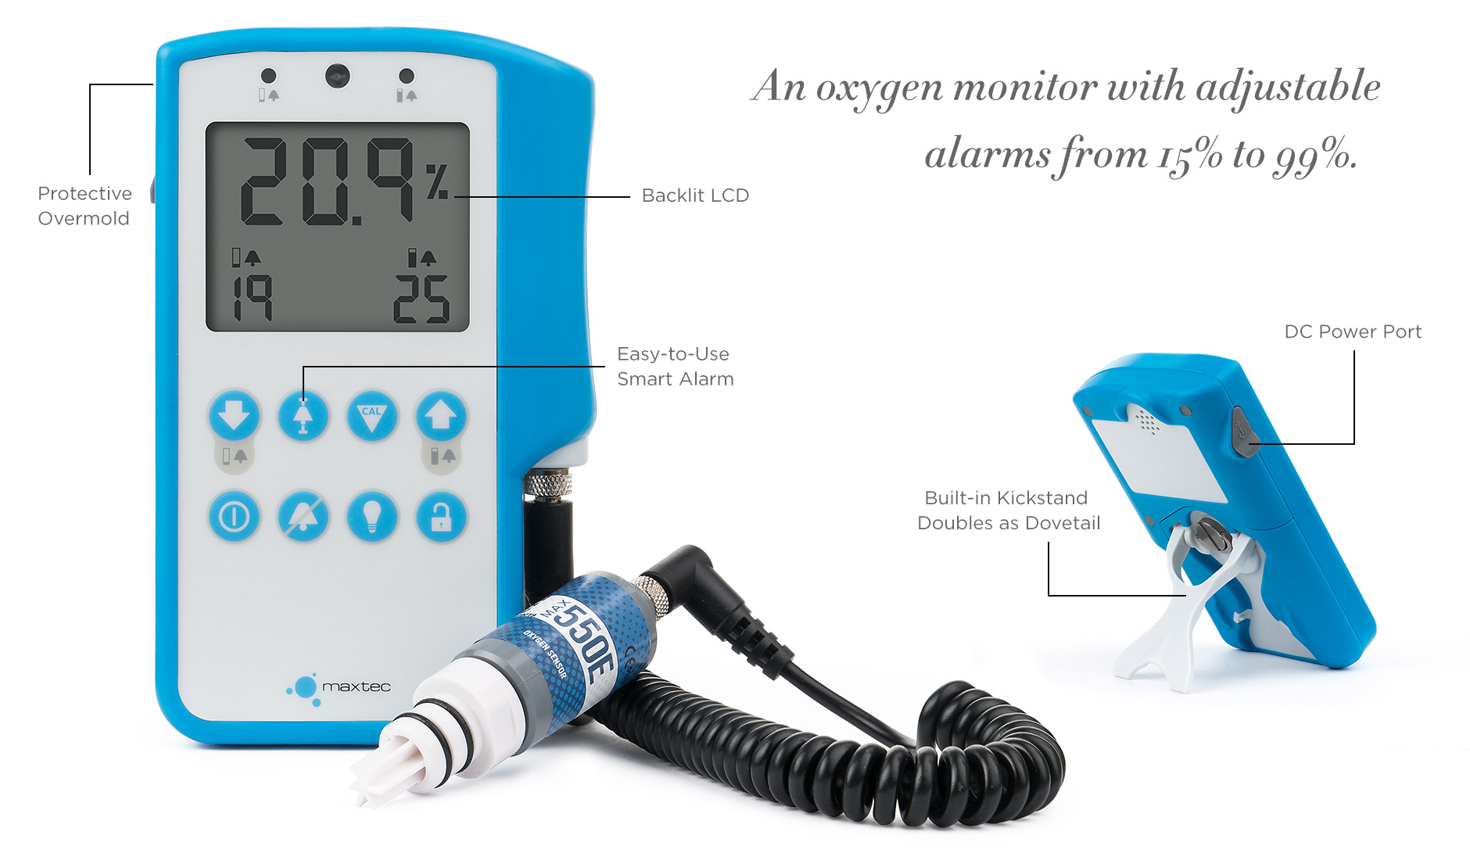
Supplied with an external sensor (fig.1) that connects to the device using a coiled cable, the sensor connects into T-adapter using a flow divertor (fig.2 and 3).
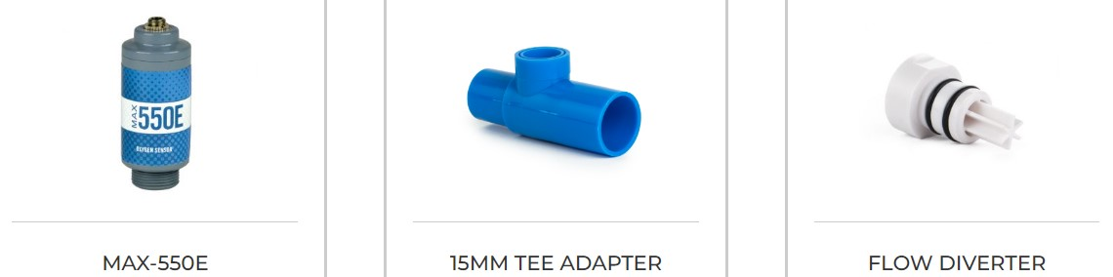
Accessories included with device
Features:

- User adjustable high and low alarms (15 - 99% O2): ideally suited to continuous monitoring.

- Smart Alarm Key: automatically sets the high-low alarm window to ±3% above and below the current oxygen level.

- Can be calibrated in 100% in oxygen - will automatically detect air or oxygen when the CAL button is pressed.

- Long battery life: approximately 5,000 hours with continuous use.

- Accuracy: 1% constant temperature, relative humidity and pressure when calibrated at full scale.

- Response time: <15 seconds to show a 90% change in value.

- Expected sensor life: greater than 1,500,000 O2 percent hours minimum (2-year in typical medical applications).

- External sensor can be replaced. Part no 0110452 - Max-550E.

The device can be used hand held, stood up using its integral kickstand or mounted into an optional pole mount (p/n 0121181 or 0121182 - below). Note: the kickstand in the tucked away position acts as a dovetail V-mount.

Optional Pole Mount
Ultrasonic Oxygen Analysers

Maxtec UltraMaxO2 Ultrasonic Oxygen Analyser
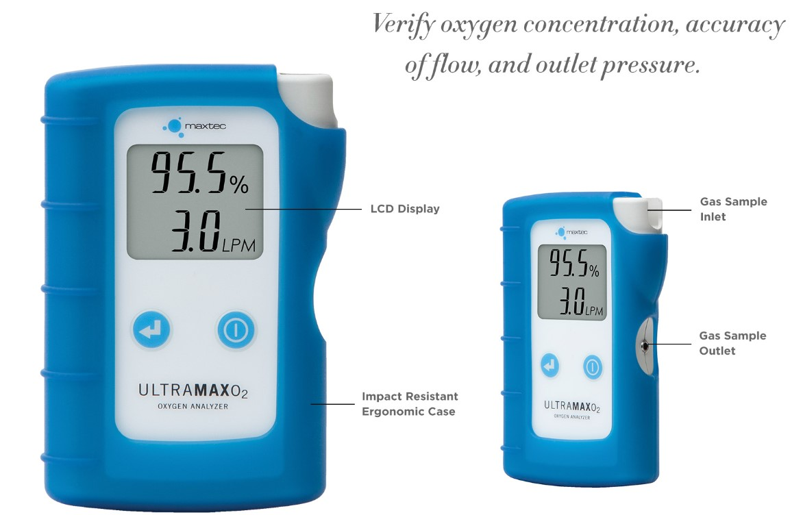

Designed for use with oxygen concentrators, the UltraMaxO2 uses ultrasonic technology to measure the level of oxygen.

The analyser uses ultrasonic measurement technology and does not contain a replaceable electrochemical oxygen sensor.
The gas is delivered into the device via oxygen tubing connected to the gas sample inlet.
Features:

- Specifically designed for use with oxygen concentrators, it is not intended for continuous monitoring.

- Low cost of ownership.

- Measures flow rate and oxygen concentration simultaneously.

- Switches to measuring pressure by occluding the gas outlet port.

- Oxygen measurement range: 20.9 - 96%.

- Flow measurement range: 0 - 10 L/min.

- Pressure measurement range: 0.5 - 50 PSI / 3.4 - 344 kPa.

- Fast warm up time: < 1 second.

- Long battery life: ≥ 1,100 hours (16,500 read cycles).

Points to note:

- The ultrasound technology is calibrated to measure the oxygen-enriched gas mixture from an oxygen concentrator, it is not suitable for use with medical grade oxygen as this may lead to errors in the readings.

- Not intended to be used to measure oxygen being delivered to a patient.

- For spot-checking; not designed for continuous monitoring.

- Intended to be used in an environment where oxygen concentrators are being serviced or repaired.
Life Spark Smart Check Ultrasonic Oxygen Analyser
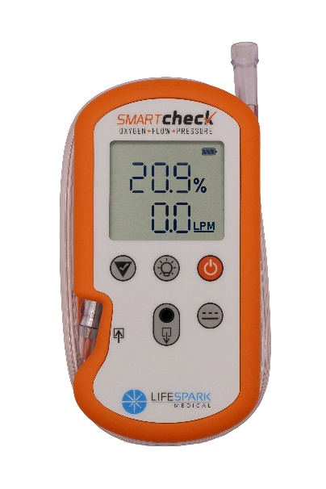
Designed for testing oxygen concentrators, the Smart Check uses ultrasonic technology to measure oxygen concentration, flow and pressure.

The analyser uses ultrasonic measurement technology and does not contain a replaceable electrochemical oxygen sensor.

Gas is delivered to the analyser through oxygen tubing connected to the sample inlet.

Features:

- Suitable for continuous-flow and pulse-dose oxygen concentrators
- Measures flow rate and oxygen concentration simultaneously in continuous mode
- Measures oxygen concentration and delivered pulse volume in pulse mode.
- Pulse-volume measurement range: 3 - 200 ml
- Measures pressure by occluding the gas outlet.
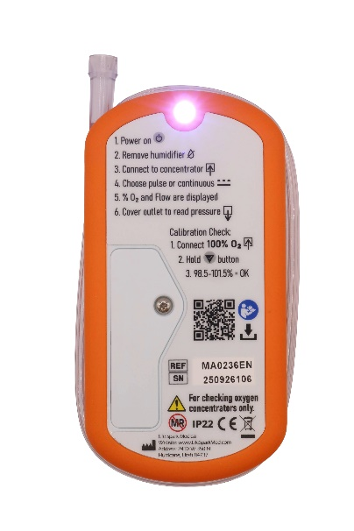
- High-pressure measurement range: 0 - 40 PSI / 0 - 275 kPa.
- Low-pressure measurement range: 3 - 70 cmH₂O.
- Low-pressure mode can be used when testing CPAP, BiPAP and nebuliser equipment.
- Oxygen measurement range: 20.9 - 96% for oxygen concentrators.
- Continuous-flow measurement range: 0 - 10 LPM.
- Continuous-flow accuracy: ±0.2 LPM.
- Oxygen measurement accuracy: ±1.5% full scale.
- Oxygen measurement resolution: 0.1%.
- Pressure can be displayed in PSI, kPa or cmH₂O.
- The calibration check passes when the reading is between 98.5% and 101.5%.
- Backlit display, built-in torch and integrated tube management.
- Start-up time: approximately 2.5 seconds.
- Response time in continuous mode: approximately 10 seconds.
- Uses two replaceable AA batteries.
- Automatic shut-off after two minutes.
- CE marked as an industrial Class I device; not CE marked as a medical device.
- Warranty: 36 months.

Points to note:
- The Smart Check is intended for testing oxygen concentrators during service and repair.
- It must not be used to monitor or confirm oxygen being delivered to a patient.
- Remove any humidifier before connecting the analyser.
- Select the correct continuous or pulse mode before testing.
- When testing in continuous mode, allow readings to stabilise for approximately 10 seconds.
- In pulse mode, allow 12 pulse cycles for the readings to stabilise.
- Pressure is displayed by covering the sample outlet with a finger.
- The analyser does not require field calibration. Its performance can be verified using the calibration-check function and a pure oxygen source at 2 - 4 LPM.
- Do not use an oxygen concentrator as the reference source for the calibration check.
- The Smart Check is CE marked as an industrial Class I device; it is not CE marked as a medical device. This distinction must be considered where a customer or tender specification requires a medical-device-certified analyser.
Automotive Versions

Maxtec also manufactures variants for measuring nitrogen in automotive applications, where nitrogen is sometimes used as a filling gas for tyres to offer superior performance.
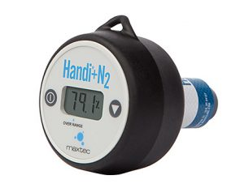
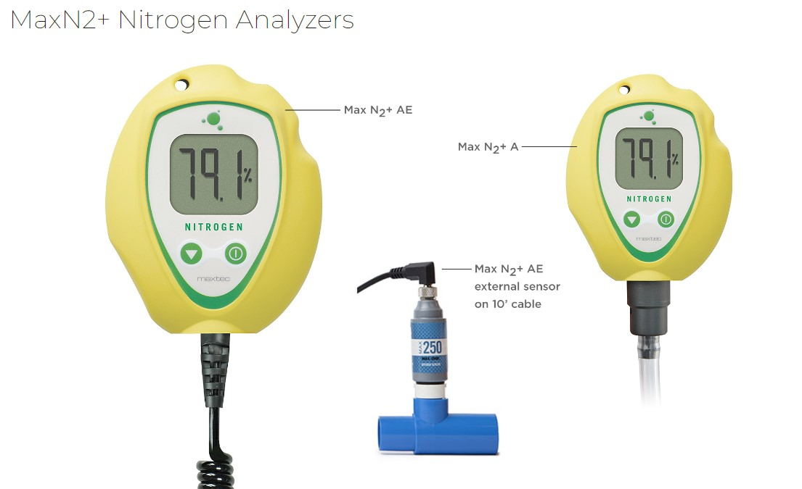

These devices don’t actually measure nitrogen, which is a difficult gas to measure, technically they measure ‘non-oxygen gases’ by subtracting the percentage oxygen reading from 100%. For this application, this method is sufficient.

Note: currently, we have no means of connecting these analysers to tyres as the tyre chuck that Maxtec previously supplied has been discontinued. We can only supply these if the customer already has the means to connect them i.e. when replacing a similar device.

Enquiries for these items should be referred to the Technical Support Manager, Sales Manager or Commercial & Technical Director.

Scuba Versions

Maxtec also manufactures variants for scuba diving applications.

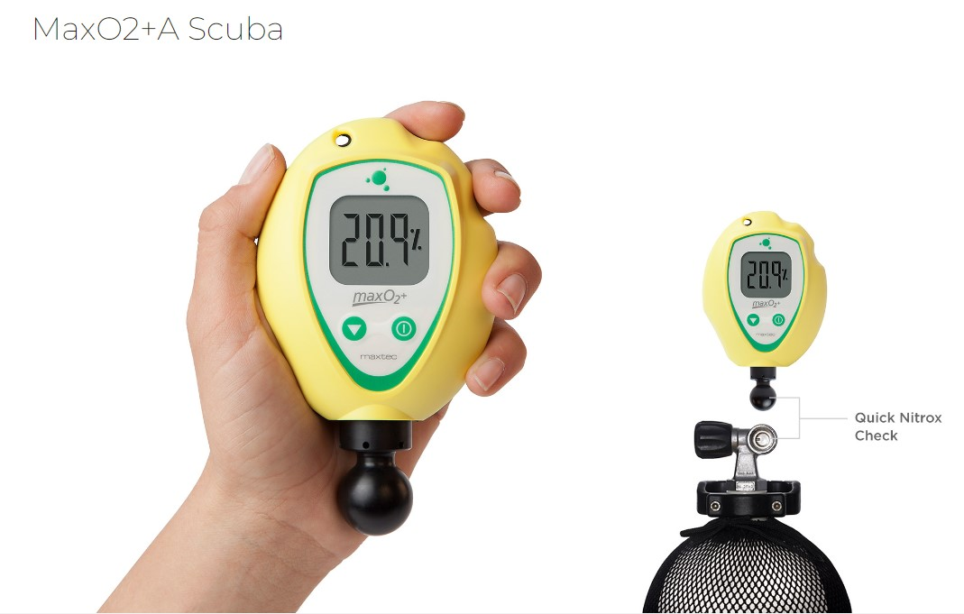
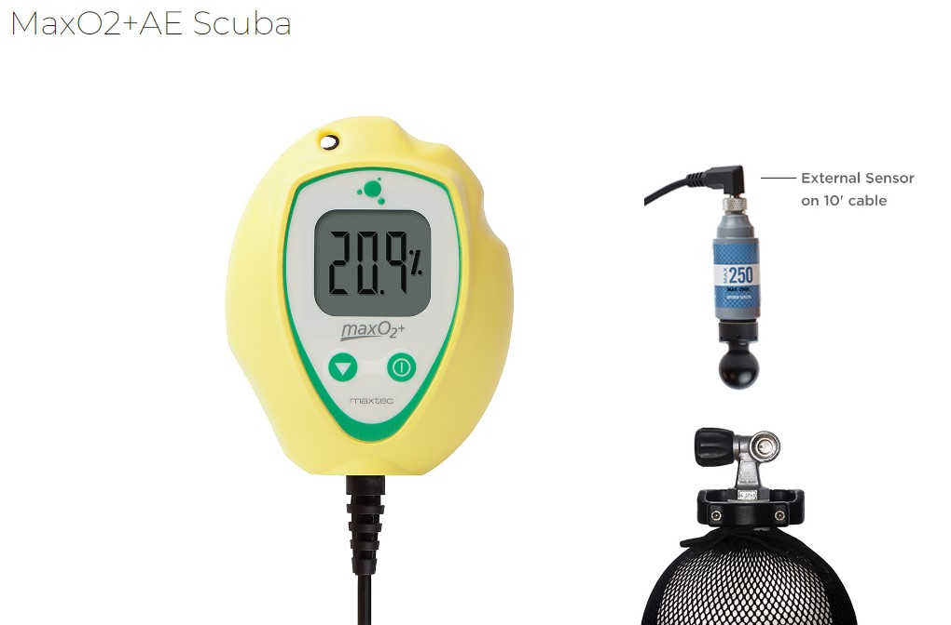
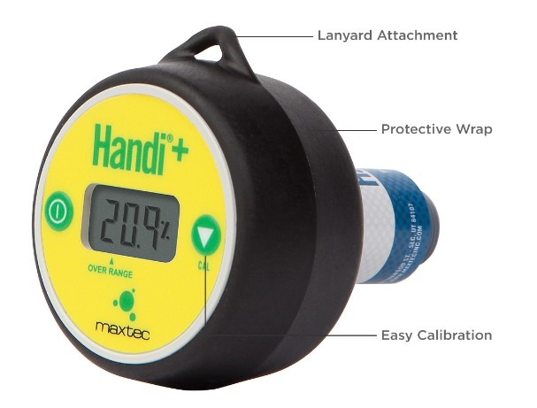

Enquiries for these devices should be handled as Vandagraph enquiries.
Connecting oxygen monitors into gas circuits

Maxtec analysers and monitors (with the exception of the UltraMaxO2 and Smart Check) are supplied with a blue T-adapter and a flow diverter. The flow diverter screws onto the end of the sensor and allows connection into the T-port of the T-adapter, which is 15 mm I.D.

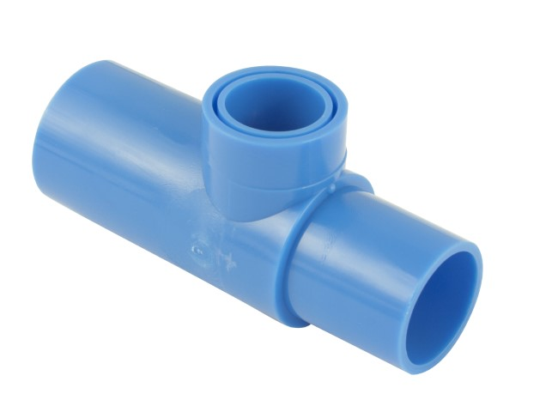
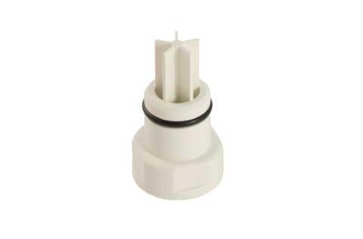

The T-adapter has a 22 mm I.D. port and a 22 mm O.D. port, allowing it to connect into standard 22 mm ventilator tubing.

Users may want to connect into narrow bore oxygen tubing, for this we can offer a Perfusion Adapter Kit (p/n 0120112 below left).

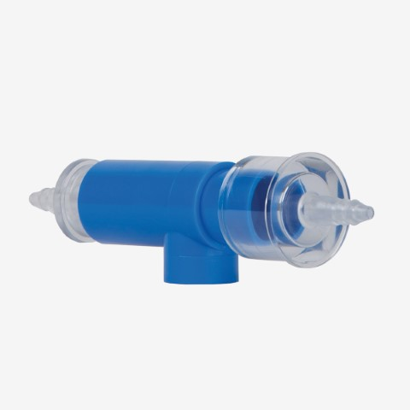
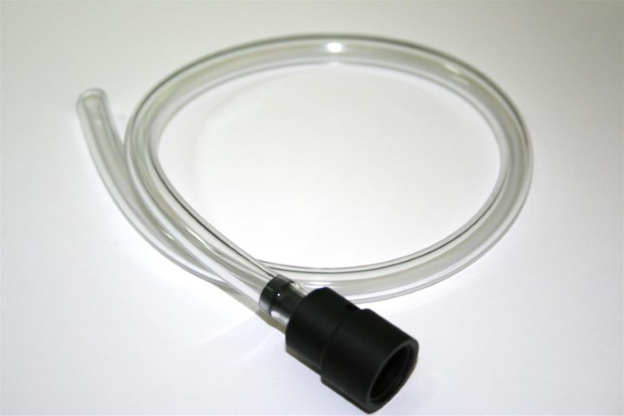
To connect to the output from an oxygen concentrator, we can offer the Oxygen Barbed Adapter (p/n 0120120 below right).

Some points to note regarding calibration and electrochemical sensor life

The following information applies to analysers and monitors that use electrochemical oxygen sensors. It does not apply to the UltraMaxO2 or Smart Check, which use ultrasonic measurement technology and do not require routine in-field calibration.

Oxygen sensors measure the partial pressure of oxygen and are pressure sensitive.

An increase in atmospheric pressure will cause an increase in the displayed oxygen reading and a decrease in atmospheric pressure will result in a lower reading.

Atmospheric pressure varies with changing weather conditions, so oxygen analysers and monitors should be calibrated on a regular basis. Maxtec does not specify a calibration interval but Teledyne has always recommended every 8 hours, which is a good rule of thumb based on legacy knowledge.

Calibration is most accurate when performed in 100% oxygen.

Oxygen sensors are similar to batteries; their output increases with the amount of oxygen that they are exposed to, so using sensors in high oxygen levels results in a shorter operating life.

In varied use at lower oxygen concentrations, this may mean typically 2 - 3 years.

In very high oxygen concentrations, it can mean around 1 year but that kind of usage is extremely uncommon.

Warranty

The customer warranty is 24 months from the date of invoice for all Maxtec oxygen monitors, analysers and the sensors supplied with them, with the exception of the UltraMaxO2 and Life Spark Smart Check, which both have a 36-month warranty.

Maintenance/Service

These devices do not contain user serviceable components. Viamed offers an annual service by return to Viamed, which can be found by searching using the information below:

- 01800xx Functional Check Service - (device name)

Latex

All devices and all accessories are latex-free.

Where to find additional information

- Viamed website
- Maxtec website
- Product leaflets - linked to stock pages
- FAQs on the stock page
- Memos on the stock page
- Instructions for use

