Introduction to Maxtec and Life Spark Oxygen Monitoring

What is oxygen monitoring?
Oxygen monitoring is used for the physical measurement of gases for fractional oxygen (FiO2) outside of the body before it enters the patient i.e.
- Piped or Bottled Gases
- Oxygen Concentrators
- Ventilators
- Air/Oxygen Blenders
- Oxygen Hoods (product dependent)
Measurements are typically between 21 and 100%.

Medical Maxtec Analysers and Monitors

MaxO2+A Oxygen Analyser
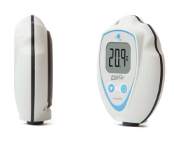
This analyser, with internal sensor, quickly adapts for use in tubing applications and is ideal for checking oxygen percent accuracy in line or on concentrators. The MaxO2+A and AE will calibrate to room air (20.9%) or 100% oxygen. For applications needing an external sensor, see the MaxO2+AE below.
The MaxO2+A includes the following accessories:
- 1 x 0110427 MAX-250+ oxygen sensor
- 1 x 0120100 T adapter*
- 1 x 0120095 Flow divertor
- 1 x 0120120 Oxygen concentrator adaptor cap
Benefits
- Long battery life (approximately 5,000 hours on 2 x AA batteries)
- Ergonomically designed hand-held unit
- Impact resistant and drip proof
- Large LCD with 3.5 digit display
- Warranty: 24 months
Part Number: 0111260
Other variants available, SCUBA.

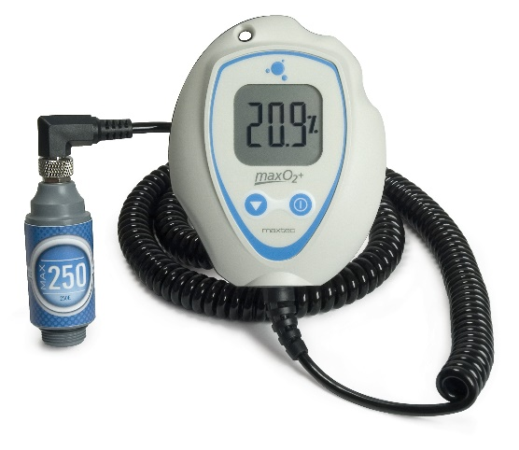
MaxO2+AE Oxygen Analysers
The MaxO2+AE is best used wherever an inline analyser is required—especially useful with older ventilators or oscillators.
The MaxO2+AE includes the following accessories:
- 1 x 0110429 MAX-250E oxygen sensor
- 1 x 0120100 T adapter*
- 1 x 0120095 Flow divertor
- 1 x 0121302 V mount assembly
Benefits
- Long battery life (approximately 5,000 hours on 2 x AA batteries)
- Ergonomically designed hand-held unit
- Impact resistant and drip proof
- Large LCD with 3.5 digit display
- Warranty: 24 months
Part Number (Standard): 0111261
Part Number (Short Cable): 0111262
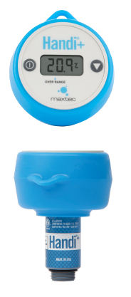
Other variants available, SCUBA.
Handi+
The Handi+ oxygen analyser is great for spot-checking oxygen percentages in hospitals, clinics, and home care environments.
Benefits
- One-touch calibration
- Over mould for extra protection
- Small, convenient and portable
- Auto-off
- Disposable at end of sensor life
- 3 digit LCD display
- Warranty: 24 months
Other variants available including, for use in Industrial, Automotive (Nitrogen) and SCUBA applications.
Please be aware, this has an integrated sensor and therefore, once depleted, has to be disposed of. The sensor has a long life of 1,500,000 oxygen percent hours and the battery will last for 1,850 hours.
The Handi+ includes the following accessories:
- 1 x 0120100 T adapter*
- 1 x 0120095 Flow Divertor
- 1 x 0120120 Oxygen Concentrator Adaptor Cap
Unlike the Envitec OxiQuant S, this unit is CE certified for medical use.
Part Number: 0111250
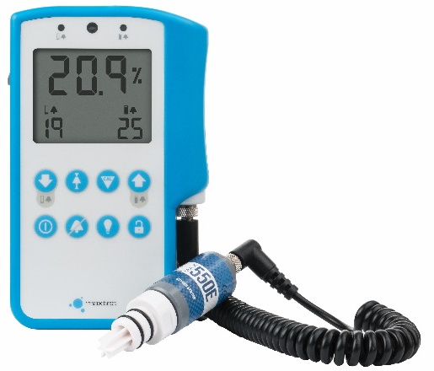
MaxO2 ME Oxygen Monitor
The MaxO2 ME low-maintenance oxygen monitor with smart alarms auto-set at 3% ± current reading. Oxygen monitor with adjustable alarms from 15 – 99%.
The MaxO2 ME includes the following accessories:
- 1 x 0110452 MAX-550E oxygen sensor**
- 1 x 0131700 Sensor cable
- 1 x 0120100 T adapter*
- 1 x 0120095 Flow divertor
Benefits
- Long battery life (approximately 5,000 hours on 2 x AA batteries)
- Adjustable alarms from 15 - 99%
- Smart alarms - Sets alarms 3% ± current reading
- Backlit LCD display
- DC power port (power supply sold separately)
- Protective overmould
- Built-in kickstand and dove tail
- Warranty: 24 months
Part Number: 0111263

Ultrasonic Oxygen Analysers
Both of the following analysers are intended for equipment testing during oxygen concentrator service and repair. They must not be used to monitor or confirm oxygen delivery to a patient.
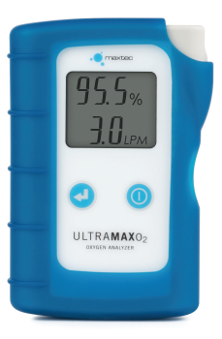
Maxtec UltraMaxO2
The UltraMaxO2 offers a fast and easy verification of oxygen concentration, flow and outlet pressure of oxygen concentrators.
The UltraMaxO2 helps oxygen concentrator service technicians looking to save on costs and time when checking patient oxygen concentrators. With integrated oxygen, flow, and outlet pressure monitoring in a single device, this handheld device is easy to operate, store, and transport and does not require a traditional electrochemical sensor, which reduces the overall maintenance and minimizes the cost of ownership.
The UltraMaxO2 is calibrated to measure oxygen, nitrogen and argon in the oxygen-enriched gas produced by an oxygen concentrator, and pure oxygen during calibration-verification mode.
Benefits
- Accurately measure oxygen, flow & pressure
- No oxygen sensor required
- No in-field calibration
- Self-diagnostics
- Shielded, reinforced sample gas inlet port
- Measurement range: 20.9 - 96%
- Warranty: 36 months
No annual calibration or service required but is available upon request.
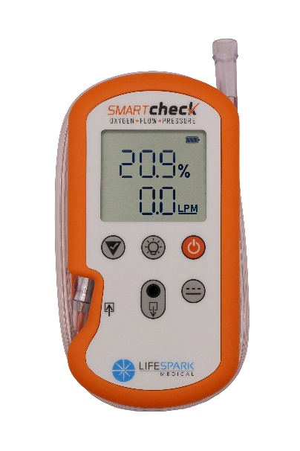
Part Number: 0111265
Life Spark Smart Check
The Smart Check offers fast and easy verification of oxygen concentration, flow and outlet pressure from oxygen concentrators.
Designed for oxygen concentrator service and repair, the Smart Check combines oxygen, flow and pressure measurement within one handheld unit. It can test both continuous-flow and pulse-dose oxygen concentrators, measuring flow rate in continuous mode and delivered pulse volume in pulse mode.
A dedicated low-pressure range also allows pressure testing of equipment such as CPAP, BiPAP and nebulisers. The backlit display, built-in torch and integrated tube management make the Smart Check particularly convenient for service engineers working in different environments.
The Smart Check uses ultrasonic measurement technology and does not require a replaceable electrochemical oxygen sensor or routine in-field calibration. A calibration check can be performed using pure oxygen to verify the analyser’s performance.
Benefits
- Accurately measures oxygen concentration, flow and pressure
- Tests continuous-flow and pulse-dose oxygen concentrators
- Measures delivered pulse volume from 3–200 ml
- Low-pressure mode for CPAP machines, BiPAP ventilators and nebuliser testing
- No replaceable oxygen sensor required
- No in-field calibration required
- Easy calibration check using pure oxygen
- Backlit display and built-in torch
- Integrated tube management
- Measurement range: 20.9–96% for oxygen concentrators
- Warranty: 36 months
No annual calibration or service required but is available upon request.
Part Number: 0111266

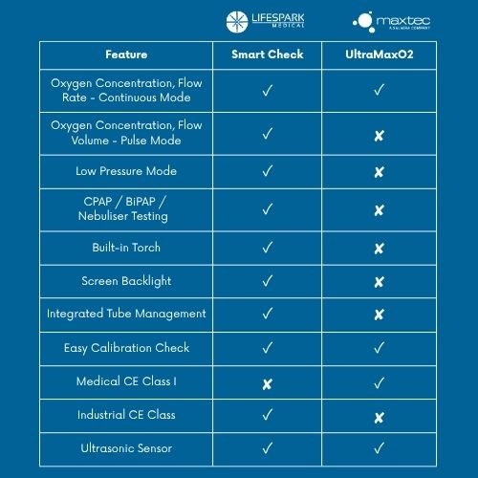
Product selection: UltraMaxO2 is the straightforward choice for continuous-flow oxygen concentrator testing. Smart Check is better suited to customers who also service pulse-dose concentrators or require low-pressure testing.

Maxtec Nitrogen Analysers
Nitrogen tire inflation will allow tires to perform better, last longer and provide superior fuel economy all while maintaining a more constant pressure than regular air-filled tyres.
The oxygen diffuses through the membrane and an electrical current is generated that is proportional to the partial pressure of oxygen in the gas sample. The oxygen percentage is subtracted from 100, with the remainder being displayed as percent nitrogen. The sensor has a minimal response to gases other than oxygen.
Handi+N2
Similar to the Medical version, the Handi+N2 is maintenance and disposable at the end of the sensor life. The Handi+N2 is great for spot-checking Nitrogen percentage in industrial and automotive applications.
Part Number: 0111248
MaxN2+A Nitrogen Analyser
Similar to the Medical version, the MaxN2+A has an internal sensor.
Part Number: 0111273
MaxN2+AE Nitrogen Analyser
Similar to the Medical version, the MaxN2+AE has an external sensor.
Part Number: 0111274

Cross Reference
When searching for replacement oxygen sensors for applicable monitors and analysers, go to the cross reference which can be found in Intrastats, drop down menu, cross references, select group “oxygen sensors”.
Website: www.viamed.co.uk/xref
There are currently no lead-free alternatives for the Maxtec range of Oxygen Sensors.
Pricing
Pricing can be found on Intrastats, under the “£” symbol. There are also downloadable PDFs against the “£” or in the “i” section.
Marketing Materials
Up to date copies of marketing materials such as leaflets, manuals and price lists (or in the £ screen) can be found on the stock pages under the “i” icon.
Certifications
Should you require to find information on what certifications a product has please see the stock screen, “i” icon and find the “Certificates” option. Click this and it will open the document index and all related certificates for that line.

