The Microstim does not need waterproofing. It has been used for 30 years and we have no complaints, or records of damage by fluids. This is not surprising as the instrument is always used in a dry environment. In OR it will always be used outside of the sterile areain a dry clean area.

The Microstim should;d have an IP00 label affixed to it. To designate it is not dust or waterproof.

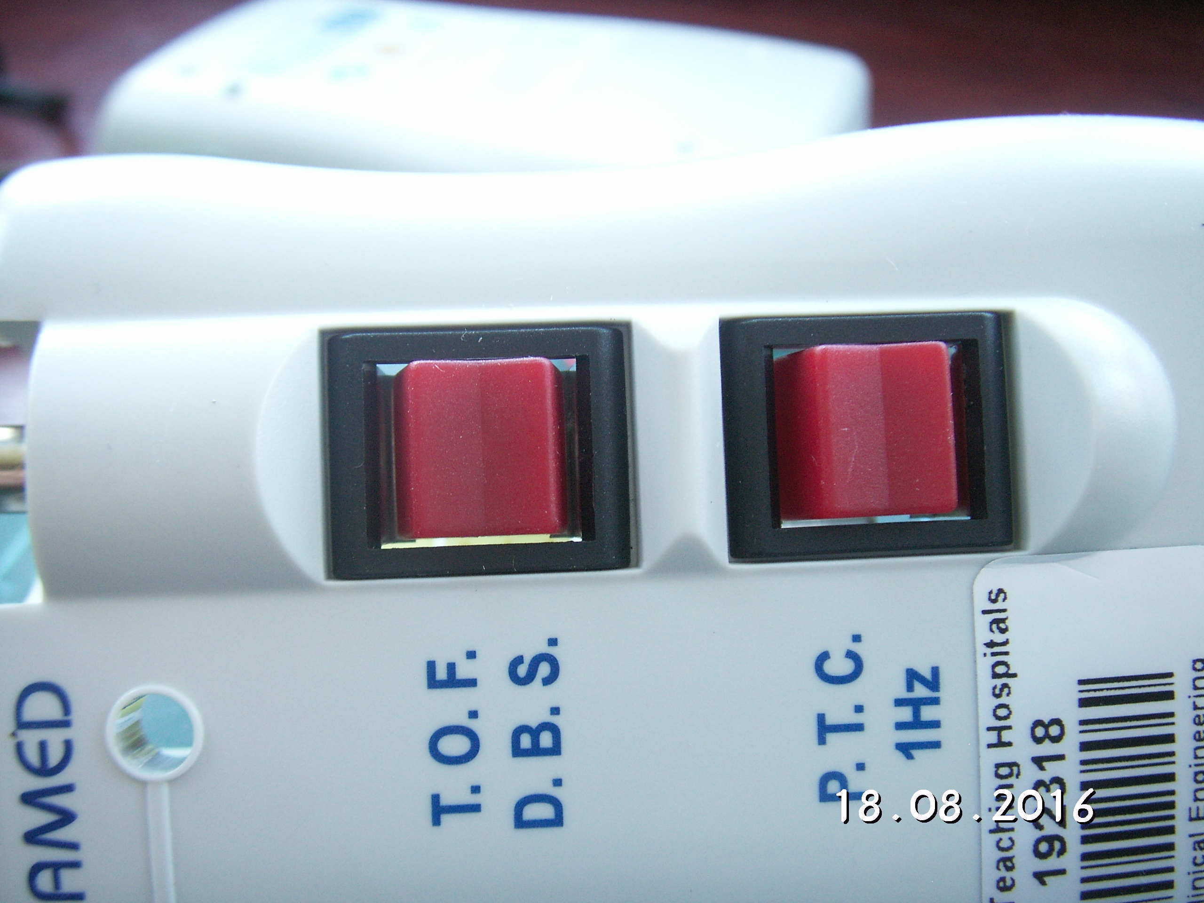
If third party testing is envisaged then mandatory waterproofing may be required useless though this may be.main ingress of fluid will be through the gaps shown as white in the photo
The rest of the enclosure appears waterproof. It should be possible to mould a cover that sits over the switchesand can be gled to the switch and enclose. This drawing is not very good but shows the priciple

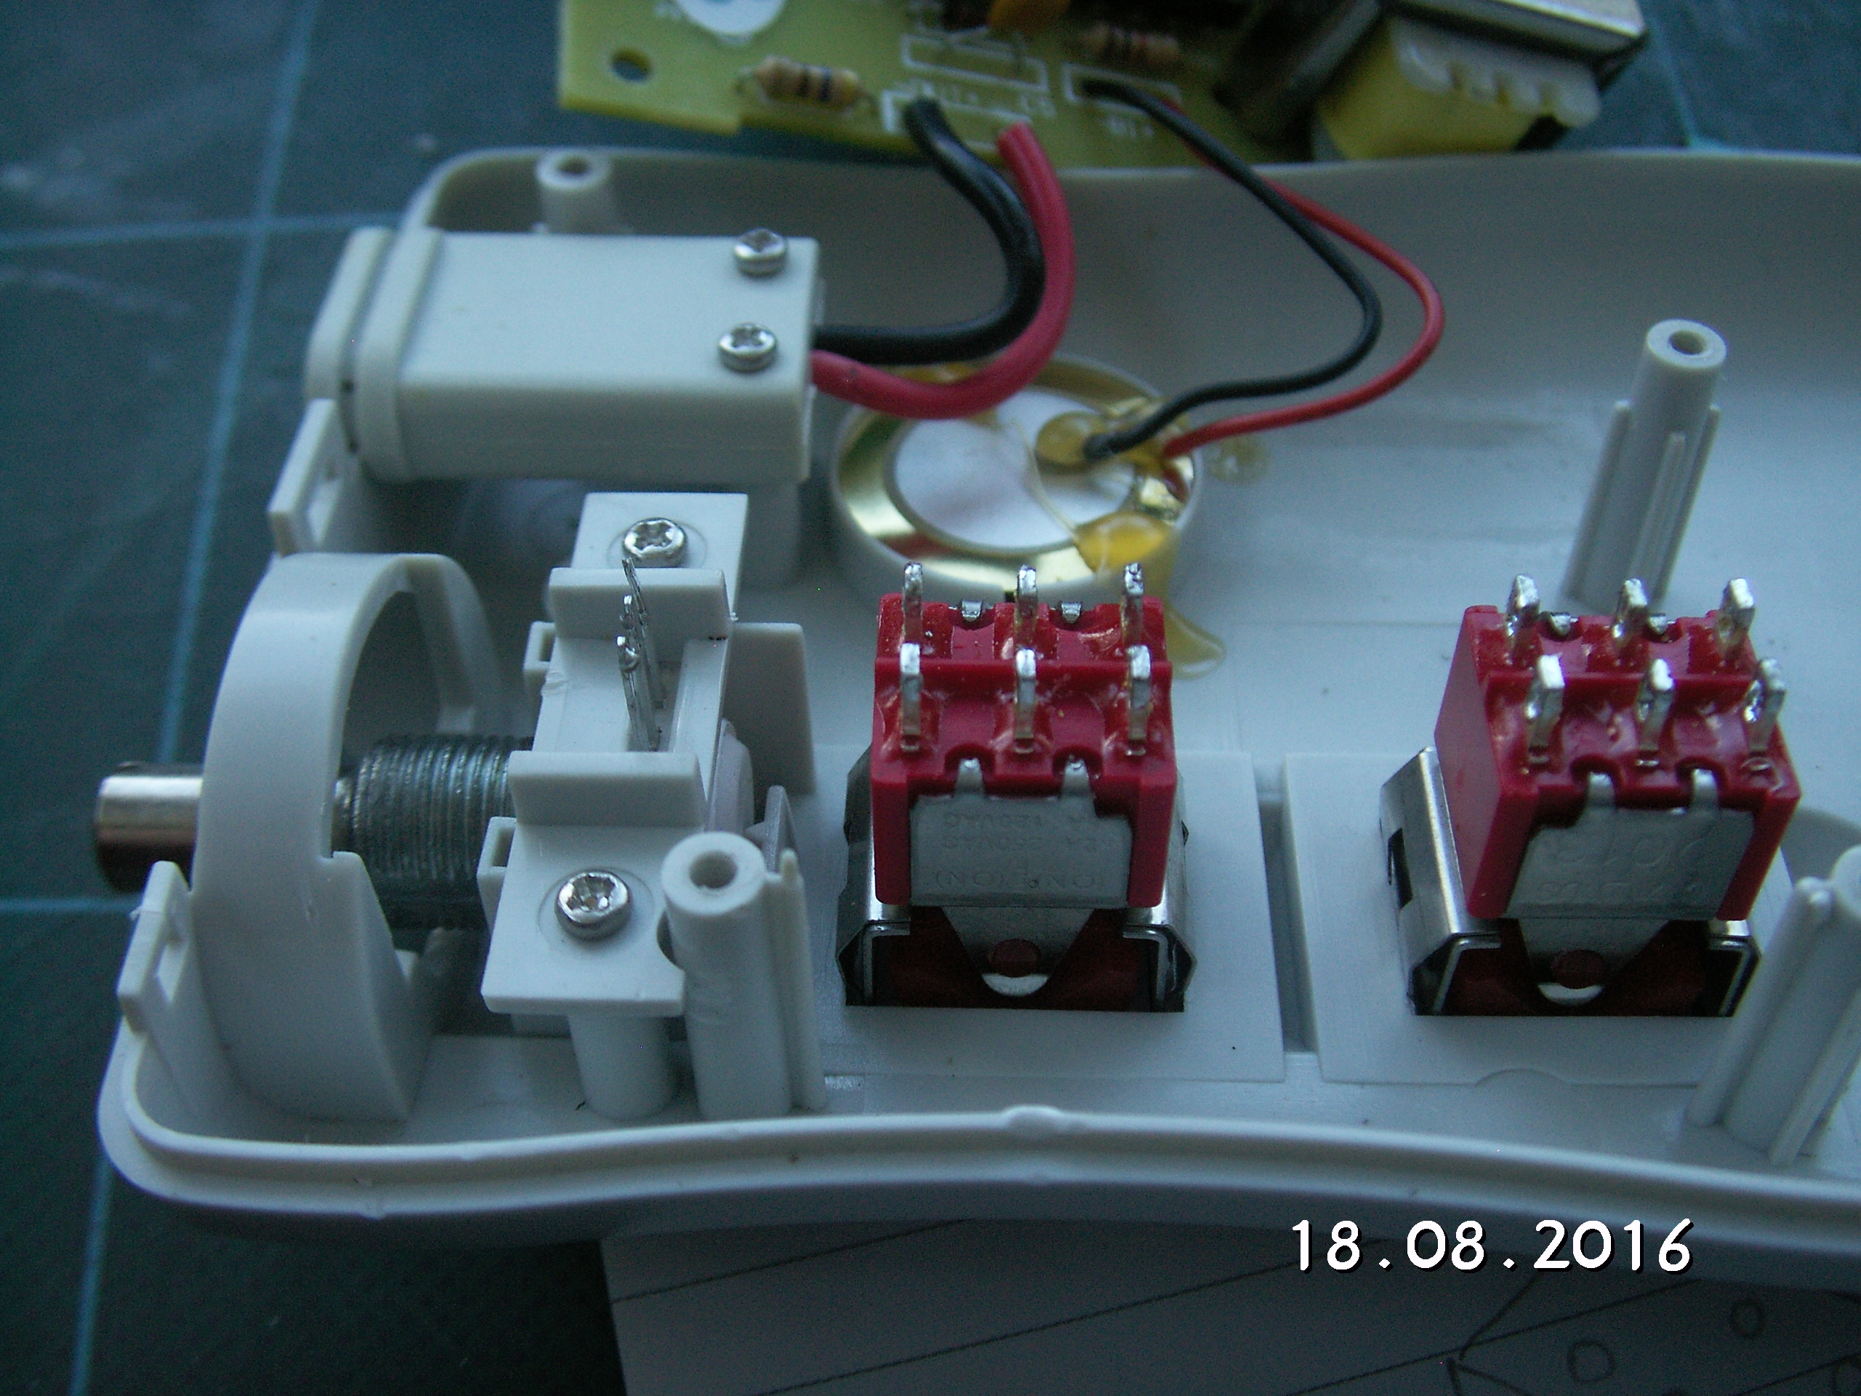

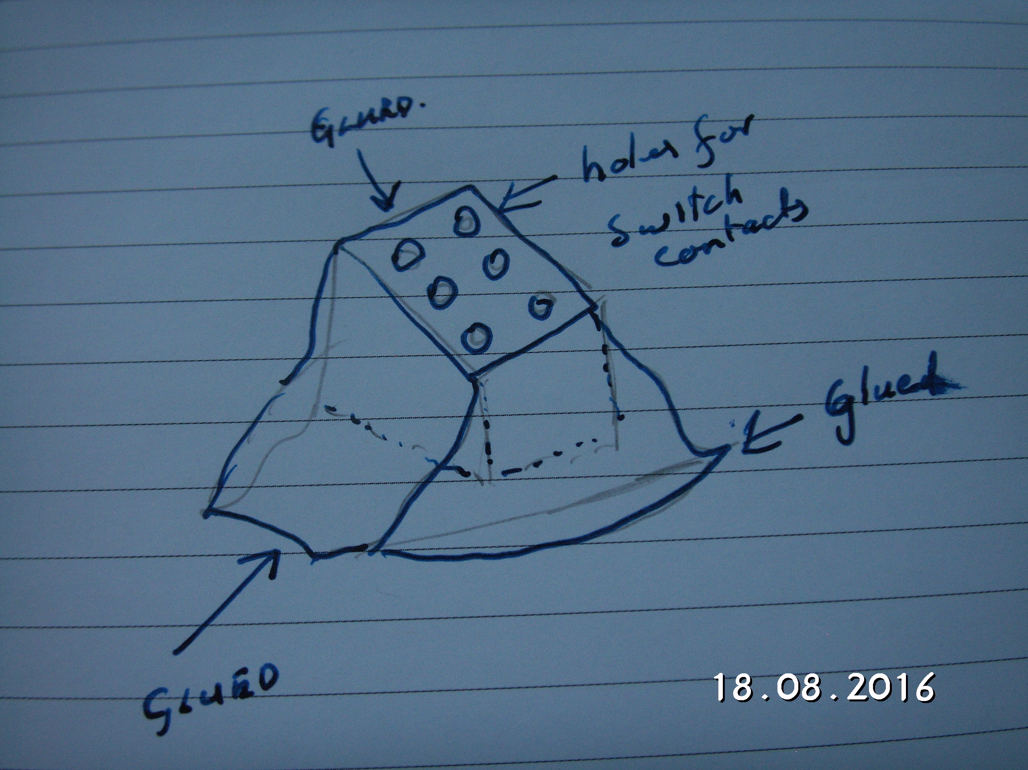

The main reason for keeping the switches instead of a membrane is the Microstim is off when not producing pulses. This increases the battery life and prevents the instrument being left on after use.

J.S.Lamb 18 Aug 2017

