VM3COP51.40 Resus Cabinet QA
- Check Viamed logo label is located on the front of the cabinet and above the door. The label must be central and straight.  - Check the ‘Support door’ label is located on the front of the cabinet door. This must be central, straight and at the top of the door. | 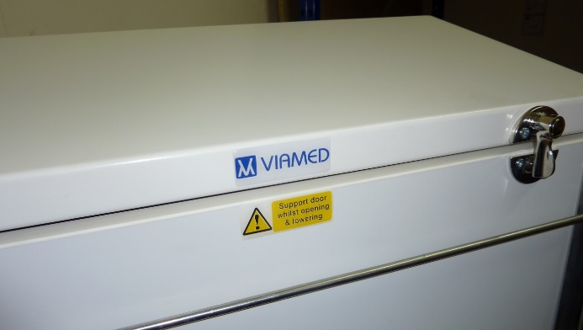
- Check the serial number label is located to the lower right-hand side of the cabinet as shown. This must be central and straight. | 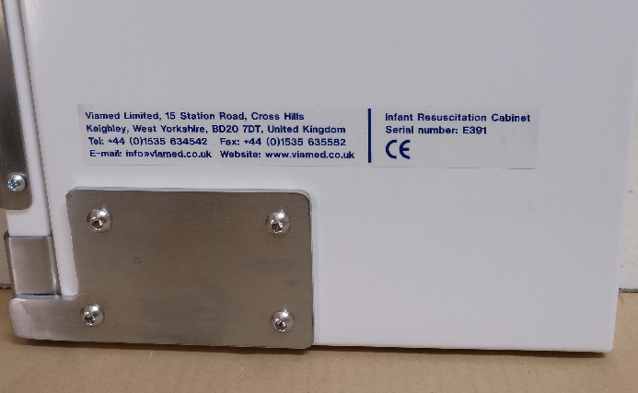
- Check the Caution label is on the inside of the door. The must be straight and on the right-side corner. | 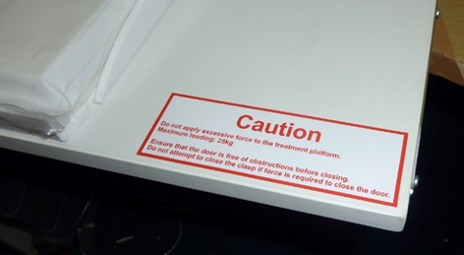
- Check the rubber door stoppers to either side of the door opening are present. | 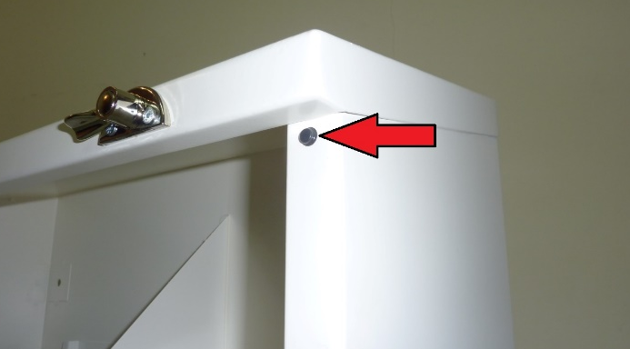
- Check the rails are in place.  The rails can be fitted in several positions to suit customer requirements. The standard positions are:  Top – short rail  One below middle – Long rail  Bottom – Long rail | 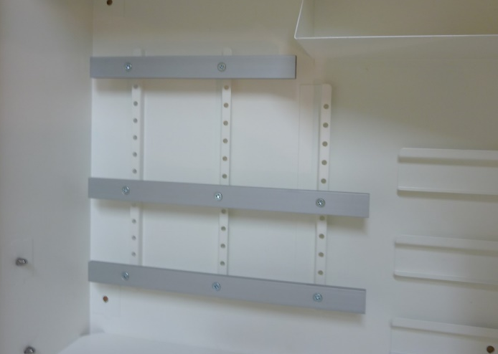
- Check the mattress is present and stored on top of the bed. | 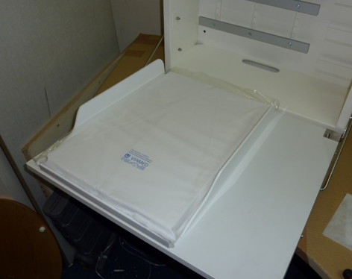
- Check the three plastic storage bins are stored in the top right corner. | 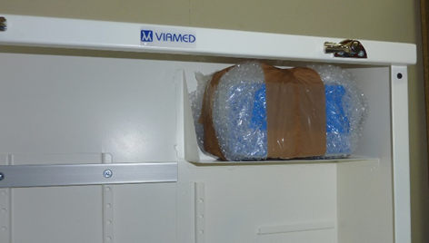
- Ensure that the door closes with the bed in place.  - Check both catches latch and sufficiently prevent the door from opening. | 

