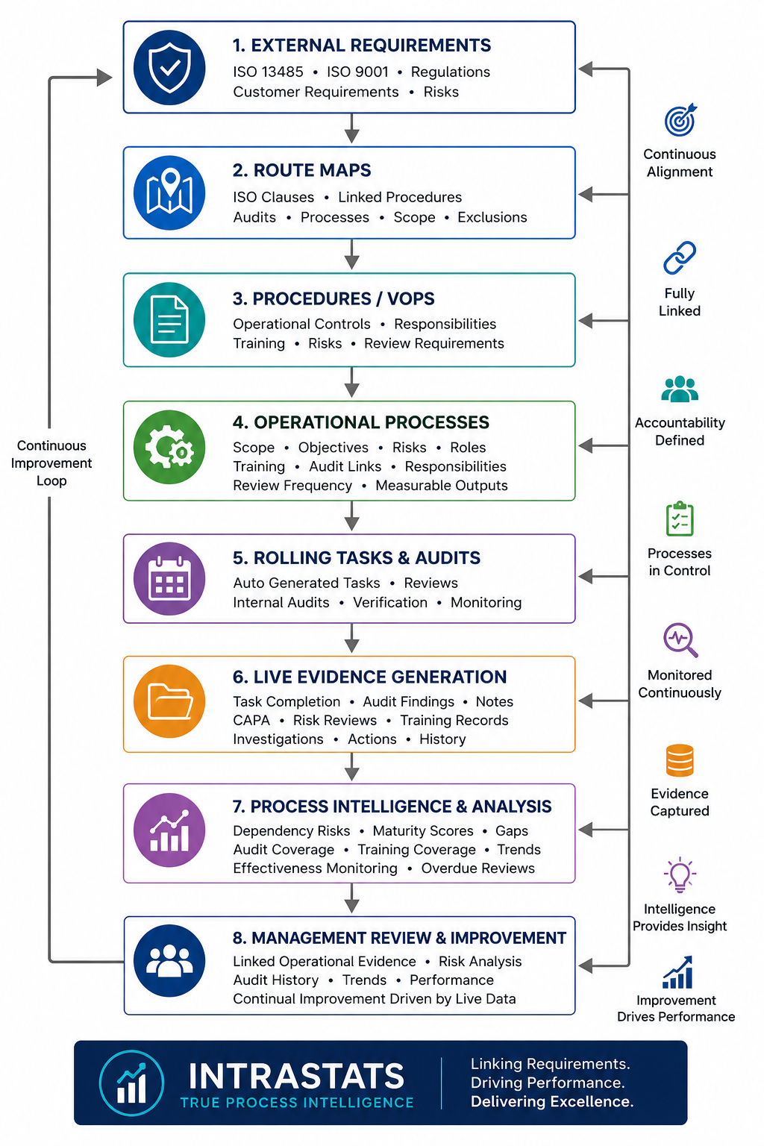

Intrastats — True Process Intelligence

Executive Overview

Intrastats — True Process Intelligence
Intrastats is an integrated operational governance and quality management system designed to transform static ISO procedures into continuously monitored, evidence-linked operational processes.
Rather than operating as a traditional document-only QMS, Intrastats connects:
- ISO route maps
- Procedures and VOPs
- Risks and controls
- Staff responsibilities
- Training records
- Rolling reviews
- Internal audits
- Process verification
- Corrective actions
- Management review evidence
into a live operational framework.
The system continuously generates traceable operational evidence through normal business activity, allowing procedures, risks, responsibilities, and compliance activities to be monitored in real time rather than reviewed only during periodic audits.
Intrastats has been developed internally over many years to support:
- ISO 13485 Medical Device Quality Management
- ISO 9001 Quality Management
- Risk-based operational governance
- Continuous improvement
- Process ownership and accountability
- Regulatory compliance monitoring
- Organisational resilience and process intelligence
The system is designed to provide not only compliance evidence, but also operational insight into process effectiveness, dependency risks, training coverage, audit status, and continual improvement activities.
Intrastats is therefore not simply a document repository or audit tracker.
It is a live process intelligence and operational governance platform.

System Philosophy
Traditional quality systems are often heavily document-based, relying on static procedures, manual evidence gathering, and periodic audits to demonstrate compliance.
Intrastats was developed to move beyond this traditional model.
The core philosophy of the system is that compliance should not exist only within documents, but should instead be continuously operated, monitored, reviewed, and evidenced through daily business activity.
The system therefore focuses on:
- operational process ownership, recurring review, evidence generation, risk visibility, accountability, and continual improvement.

Within Intrastats, procedures are not isolated documents.
Each procedure becomes part of a wider operational structure linking:
- responsibilities, risks, processes, recurring tasks, audits, training, and management review activities.

This approach allows the organisation to demonstrate not only that procedures exist, but also that they are:
- active, reviewed, operationally monitored, and continuously verified for effectiveness.

The system has evolved organically over many years through practical operational use within multiple business areas, including:
- medical device quality management, supplier control, process monitoring, post market surveillance, training and competency, maintenance, documentation control, and regulatory compliance.

The objective of Intrastats is therefore to create a “living” management system where operational governance and compliance activities are embedded into normal business processes rather than existing as separate administrative activities.

System Architecture
Intrastats operates using a layered and interconnected governance structure.
At the highest level, ISO standards and regulatory requirements are mapped using company-specific route maps.
Each route map links:
- ISO clauses, procedures (VOPs), supporting documents, audits, operational processes and recurring verification activities.

The structure allows the organisation to navigate directly from:
ISO Requirement
→ Procedure
→ Operational Process
→ Rolling Task / Audit
→ Completion Evidence
→ Management Review
This creates full traceability between regulatory requirements and operational evidence.
The system supports multiple company structures and standards simultaneously, including:
- ISO 13485 medical device systems,
- ISO 9001 quality systems,
- shared operational infrastructure,
- and company-specific scopes and exclusions.
Operational processes are individually managed within the system and may contain:
- defined scope and objectives, risk assessments, measurable objectives, training requirements, linked staff, audit assignments, recurring review frequencies and evidence history.

Recurring tasks and audits are automatically generated and assigned to relevant personnel to ensure ongoing operational review.
All actions, reviews, updates, and investigations are historically logged to create a continuous operational evidence trail.
This architecture allows the organisation to demonstrate:
- process ownership, operational monitoring, verification of effectiveness, continual review,
and management oversight
through a single integrated governance structure.

Operational Evidence Model
Intrastats is designed so that operational evidence is generated continuously through normal system usage and recurring governance activities.
Rather than requiring evidence to be manually assembled during audits, the system creates evidence dynamically through:
- rolling task completion, recurring audits, process reviews, training updates, issue management, risk reviews, management reviews, and linked operational activities.

Each operational process may contain:
- review dates, responsible personnel, risk evaluations, verification methods, measurable objectives, training records, linked audits and completion histories.

This allows the organisation to demonstrate not only procedural compliance, but also operational effectiveness and ongoing governance.
The system records historical activity including:
- review comments, investigation notes, audit findings, task completion dates, linked corrective actions, and process updates.

This creates a traceable and auditable evidence chain showing that processes are:
- active, monitored, reviewed and continuously maintained.

Operational evidence therefore becomes part of normal business activity rather than a separate compliance exercise.
This approach supports:
- continual improvement, management review, internal auditing, regulatory inspections and process verification activities.

The result is a management system where evidence is continuously generated through operation of the business itself.

Continual Improvement and Process Intelligence
Intrastats extends beyond traditional document management by incorporating operational intelligence and governance analysis into the quality management system.
The system monitors not only whether processes exist, but also:
- how effectively they are maintained, whether reviews are overdue, whether audit coverage exists, whether backup personnel are available, and where organisational dependency risks may exist.
This allows the organisation to identify:
- single points of failure, training gaps, audit gaps, process maturity weaknesses, overdue governance activities, and operational risks.

Processes may be measured using maturity indicators including:
- risk assessment status, audit assignment, measurable objectives, backup staff availability, review frequency and recent completion evidence.

This provides management with visibility into both compliance status and operational resilience.
The system also supports continual improvement through:
- recurring process review, linked audit activities, trend analysis, issue escalation and historical evidence tracking.

By linking operational processes directly to audits, reviews, risks, and management oversight, Intrastats creates a dynamic governance model focused on continuous operational verification rather than static procedural control.
The objective is not simply to maintain compliance documentation, but to provide:
- ongoing operational visibility, measurable governance, evidence-based review and true process intelligence.

Intrastats therefore acts as both a quality management platform and an operational governance intelligence system.

