Apgar Timer Packing Procedure VM3COP47.07
- Take an Apgar timer box (PN:0350110). | 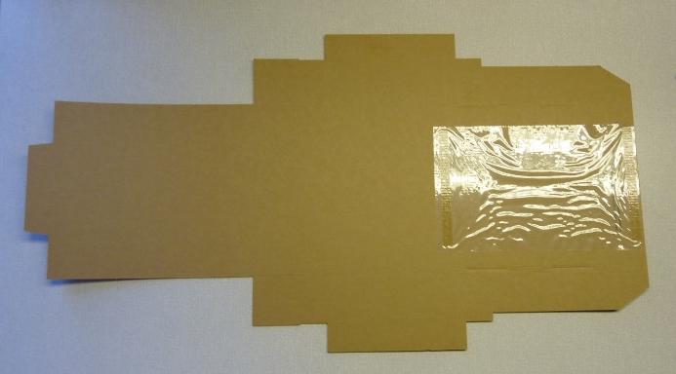
- Form the box by folding along the pre-creased lines. | 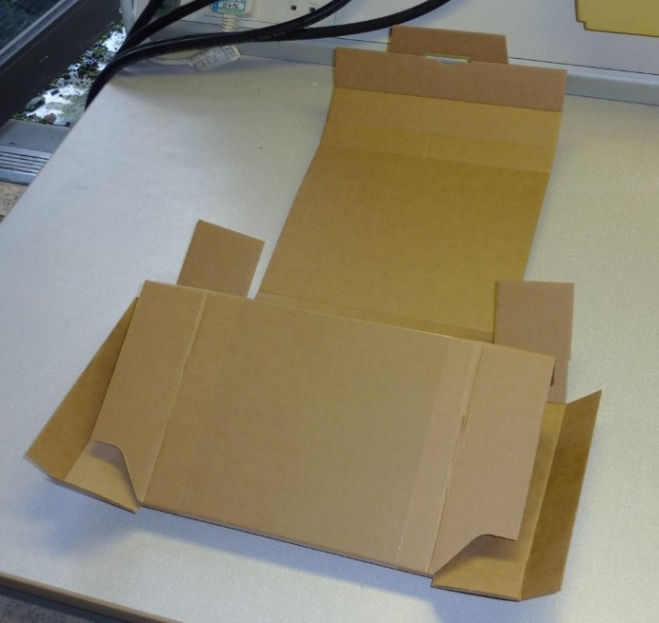
- Tape the four AA batteries (PN:9950054) to the left hand, inside wall. | 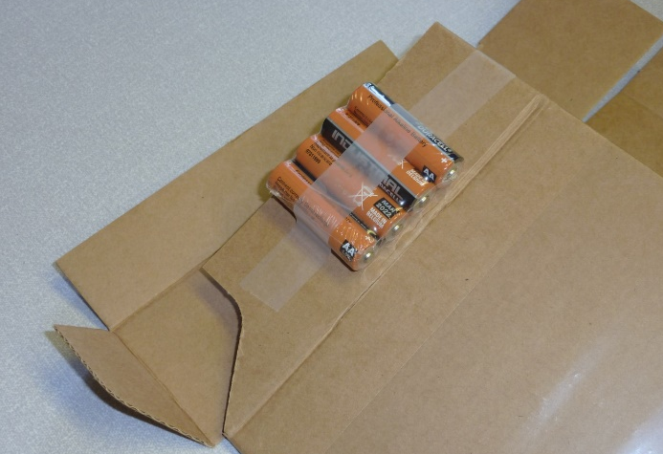
- Place the appropriate operator manual under the plastic film.  Operator manual - APGAR Timer - English (PN:0392000).  Operator manual - APGAR Timer - German (PN:0391999). | 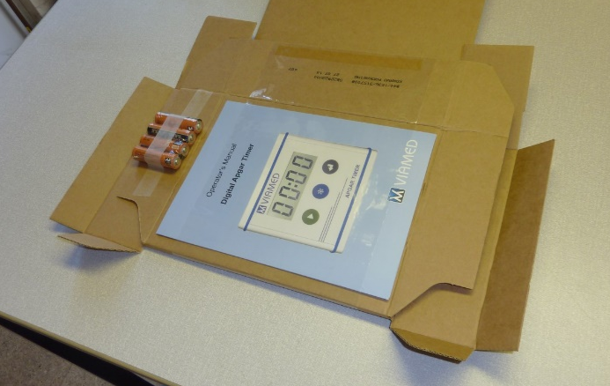
- Place the Apgar timer under the plastic film. Ensure that the Apgar timer is positioned centrally and parallel with the box edges. | 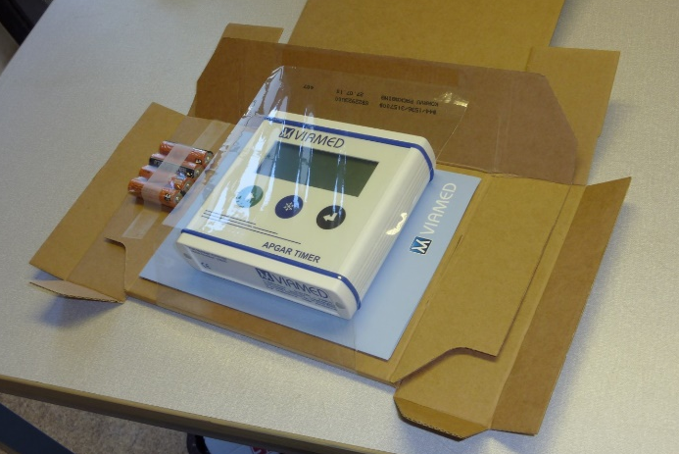
- Form the box by folding the flaps inwards.  - Tuck the retaining tab into the slot on the underside of the box to close. | 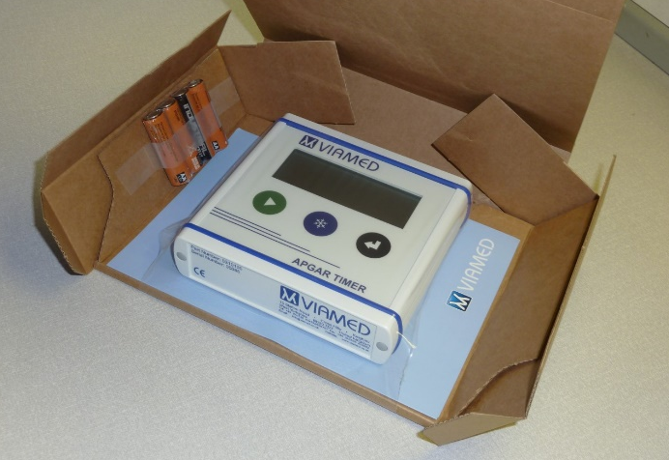
- Check the serial number of the Apgar timer.  - Affix the corresponding serial/part number label to the front of the box.  - Affix the ‘British made’ label (PN: 9992600) to the front of the box. | 

