Apgar Timer Production Procedure
VM3COP47.03

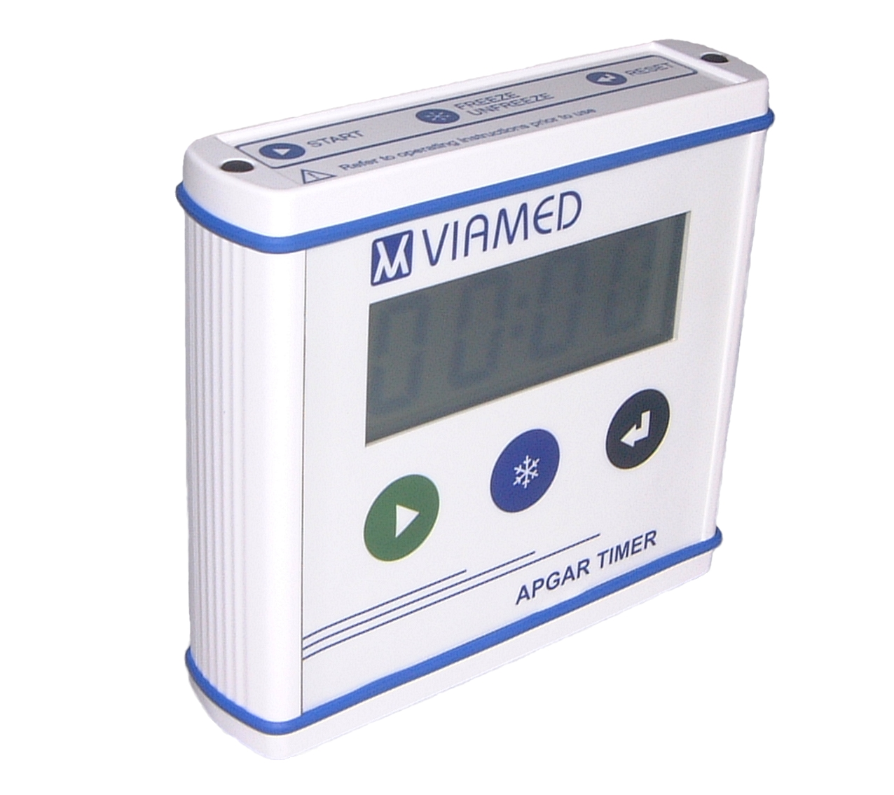

Tool list:
Soldering iron
Side cutters
Long nose pliers
Torx T-10 driver
Spanner 5.5mm

Parts list: | Quantity: | Part number:
Label top panel | 1 | 0330505
Label bottom panel | 1 | 0330506
Apgar case | 1 | 0330548
Apgar case end | 2 | 0330549
Apgar timer PCB v1.0 | 1 | 0330555
Apgar battery holder | 1 | 0330558
PCB spacer – single unit | 2 | 0330566
Apgar keypad membrane | 1 | 0330570
Apgar timer LCD | 1 | 0330575

Production method:
- Apply the, 1.5V AA, battery orientation labels to the battery box and insert the battery contacts. | 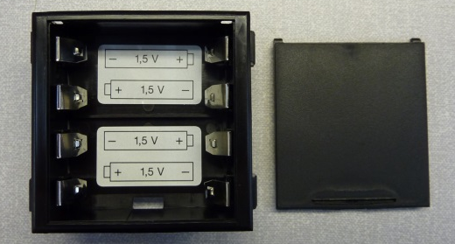
- Insert the battery box into the rear case panel. | 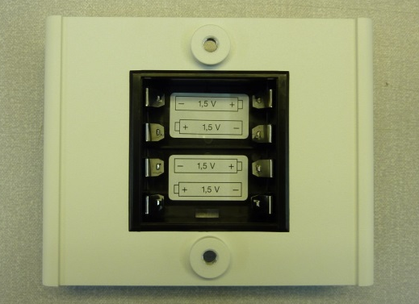
 | 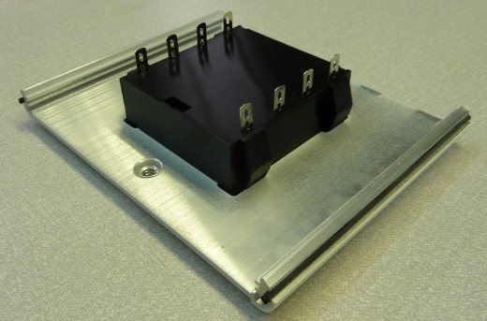
- Peel away the adhesive backing from the keypad. Route the keypad connector through the small hole and stick the keypad down. | 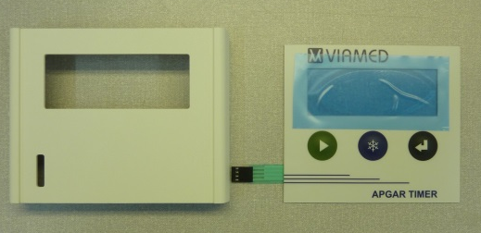
 | 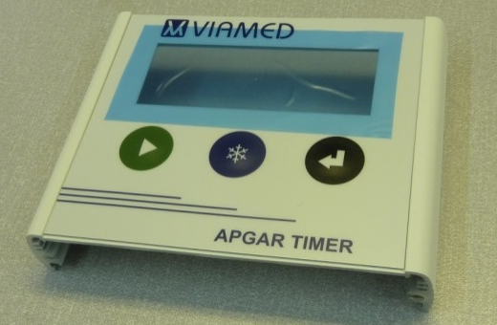
 | 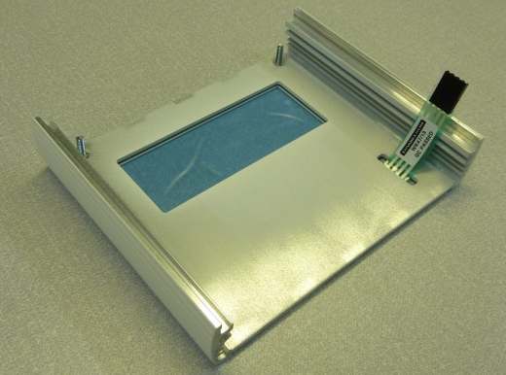
- Note the serial number of the PCB, which can be found on the lower left front side of the PCB. | 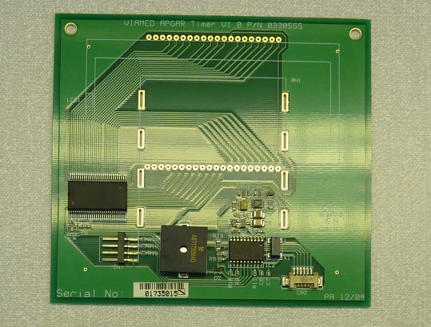
- Place the PCB over the battery contacts. | 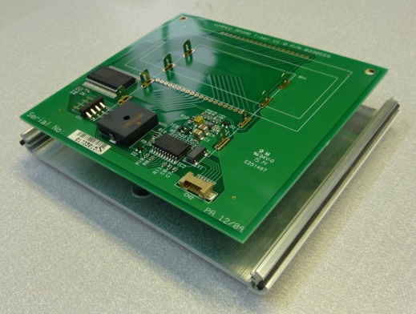
- Ensure that the PCB is flush to the battery box then solder the contacts to the PCB. | 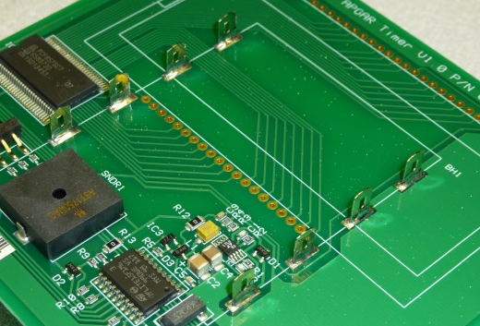
- Trim away the excess battery contact tab. | 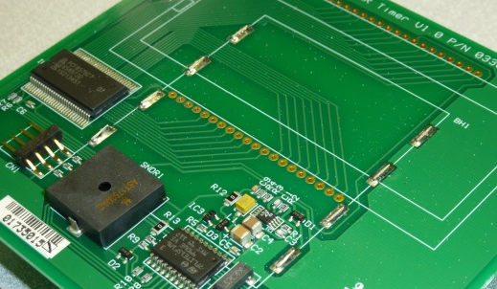
- Locate the display orientation markers on the PCB and LCD. | 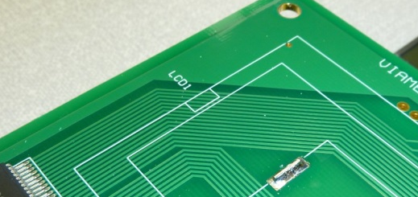
- With the orientation markers aligned, insert the LCD contacts into the PCB. | 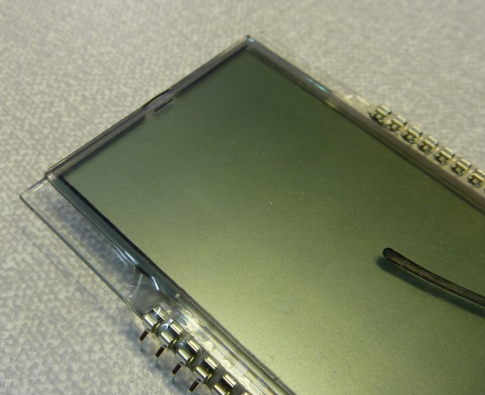
 | 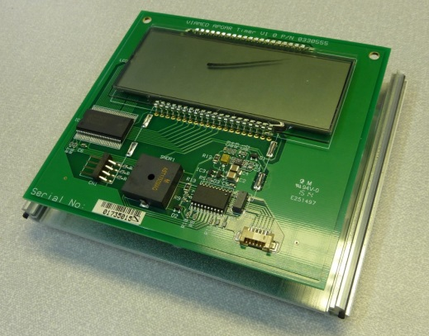
- Support the display at each end. | 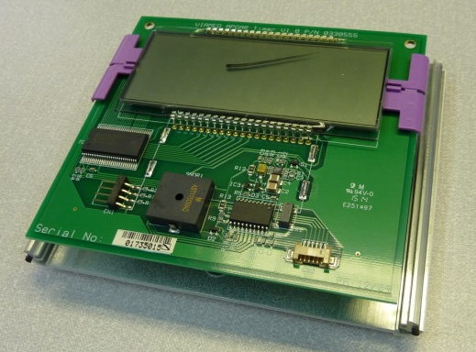
- Solder the LCD to the PCB then remove the supports. | 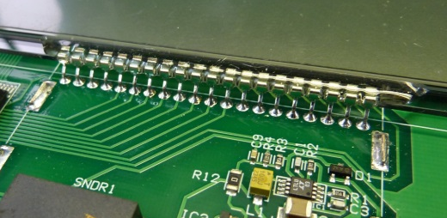
- Connect the keypad connector to the PCB.  At this point, the unit can be tested. Refer to the testing section, on page 6, in this manual. | 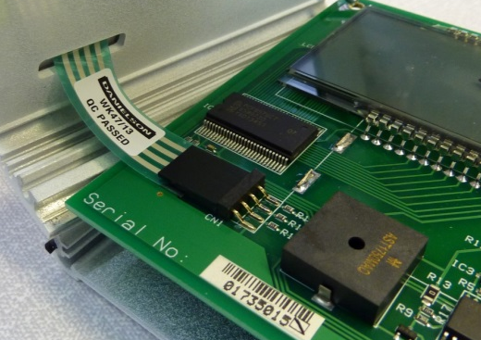
- Place the spacers over the retaining screws on the front case. | 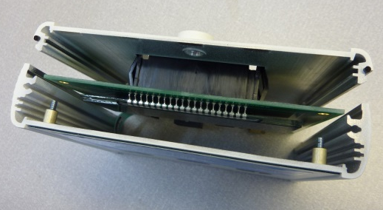
- Remove the protective film from the LCD. | 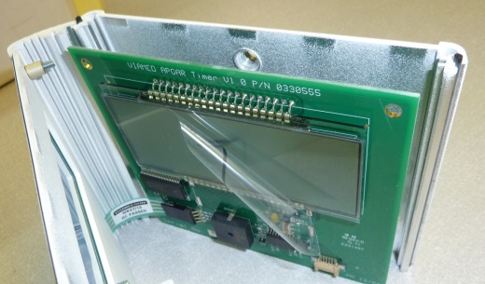
- Guide the screws through the holes in the PCB then snap the two case halves together. | 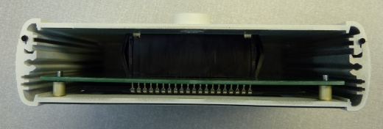
- Using a 5.5mm spanner, affix the retaining nuts to each screw thread. | 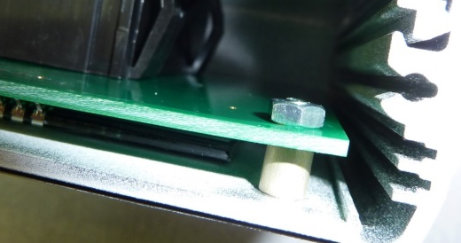
- Position the top cap on the case, ensure that the seal is correctly located. Using a torx T-10 driver, screw the cap down. Repeat the process for the bottom cap. | 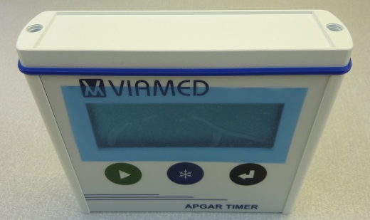
- Insert the screw covers to all four screw holes. | 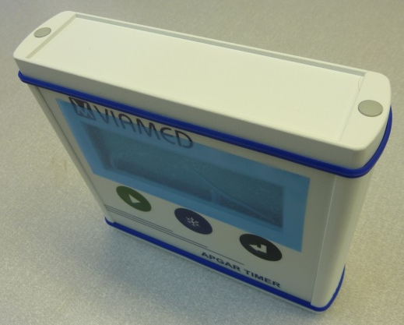
- Affix the top label. | 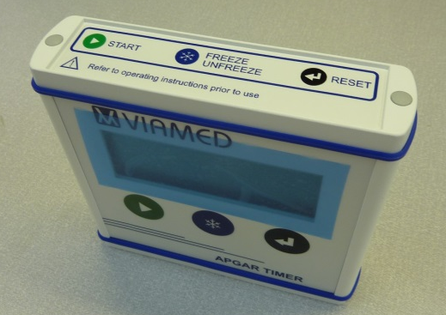
- Affix the bottom label. | 

