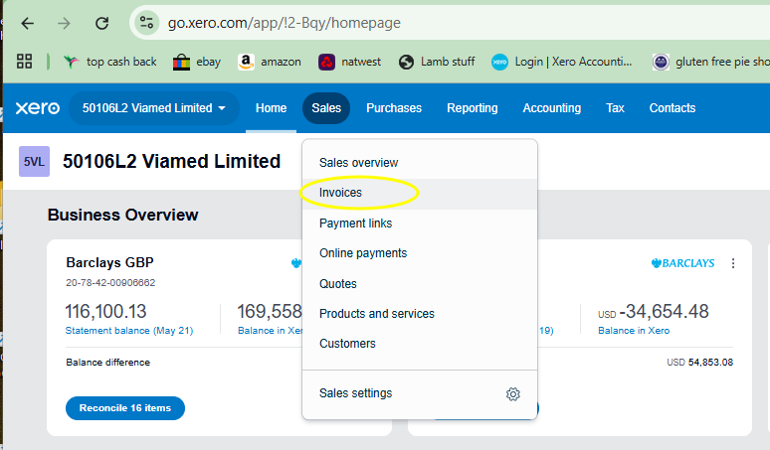

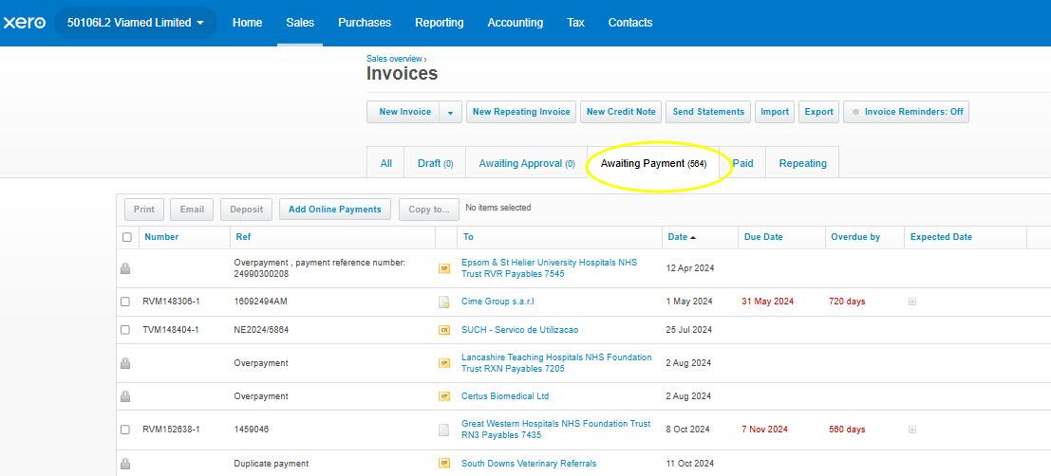

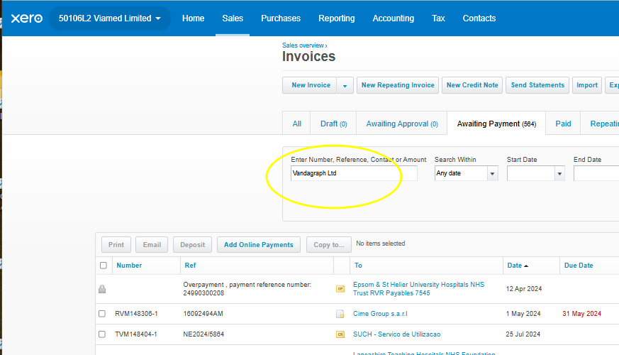

Search both Vandagraph Ltd and Vandagraph Sensor Technologies Ltd. They both need doing but do one at a time.

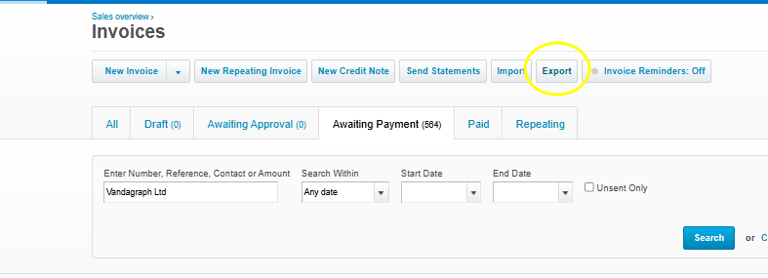
It will download as a csv doc.

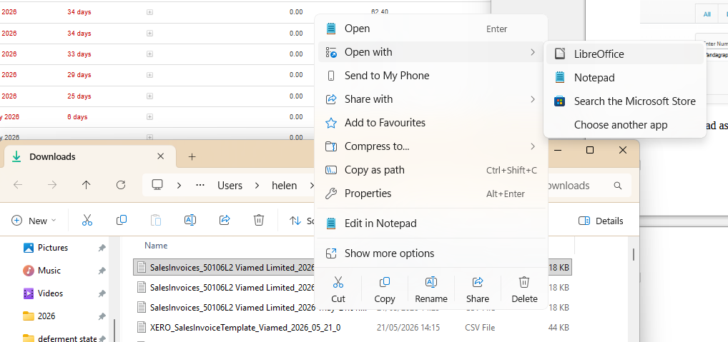

Open the csv file with Libra office but make sure to make the stock column a text type or it will remove the 0 from the beginning of the stock part number. A pop up comes up when you first open it so you can set it in that.

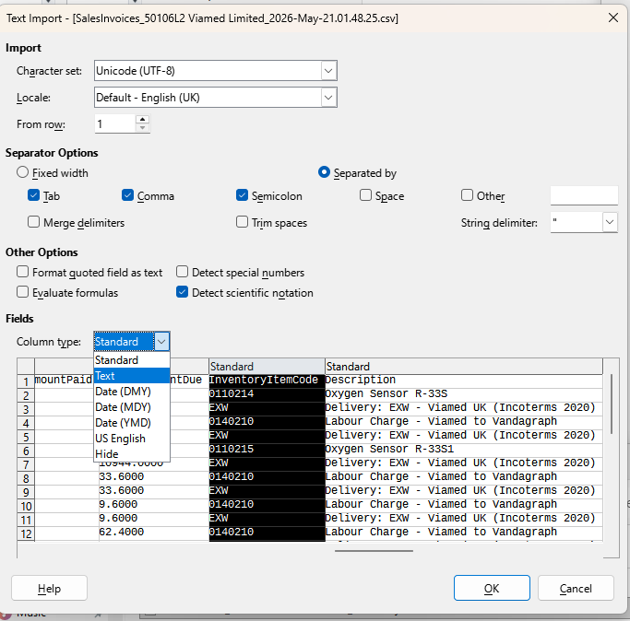

Once open we have to turn the date from sales linked to purchase linked.
In this case we are going from Viamed sales to Vandagraph purchasing. We will import it in to Vandagraph Ltd Xero purchasing.

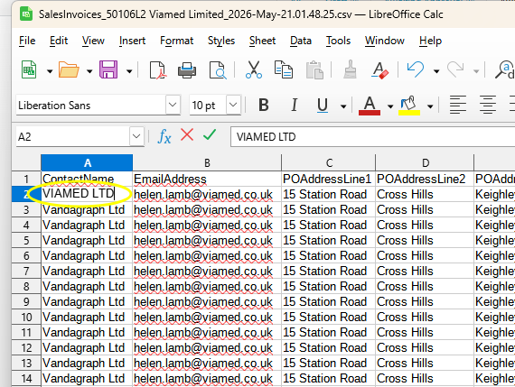

This needs to be the name in the Xero contacts you are putting the import into in this case
In Vandagraph the account we are importing in to is called VIAMED LTD (As I have tried to label all purchasing as capitals and sales as not capitalised.
Once you’ve done one line copy it and past into the rest. These are all going to be VIAMED LTD.

You will need to shrink the columns so you can work on the ones further accross.

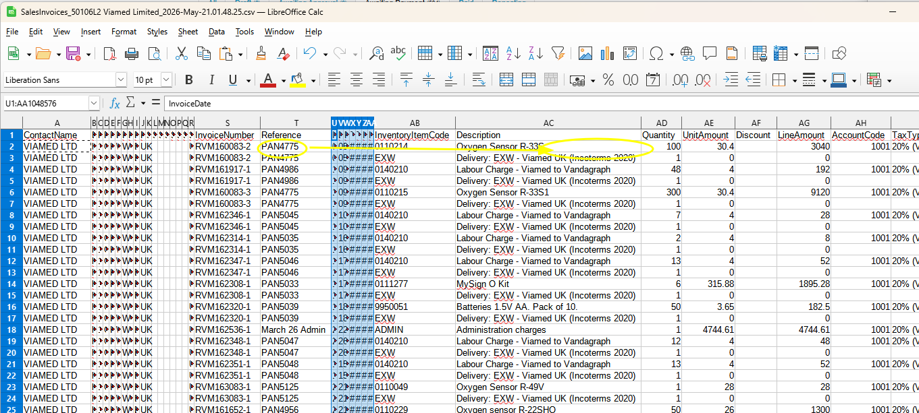
I copy the purchase order number in to the stock description so it goes in to Xero with this info available

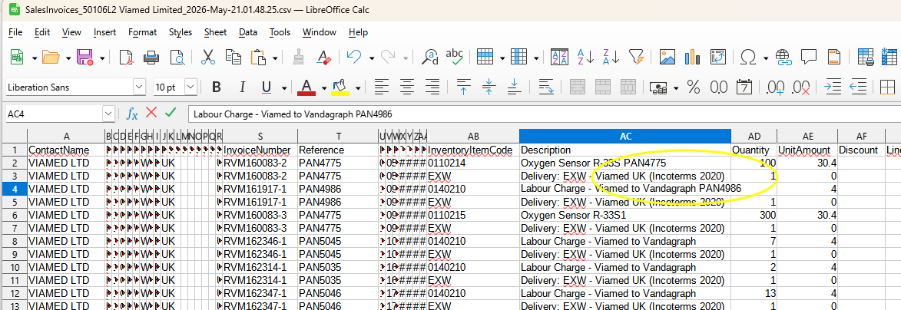

do for all stock lines its a bit faffy but comes in useful. You will need it at some point when someone asks you about it.
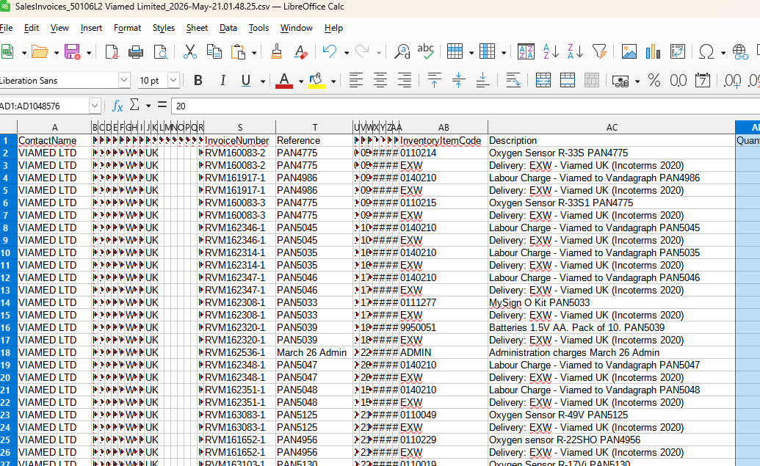

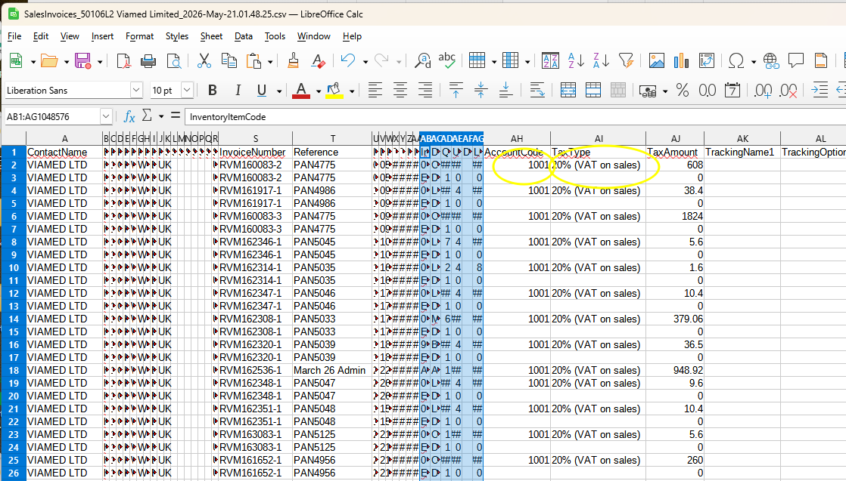

Now we change the AccountCode from a sales one to a purchasing on this has to be 2002. Or it will go to the wrong nominal account.

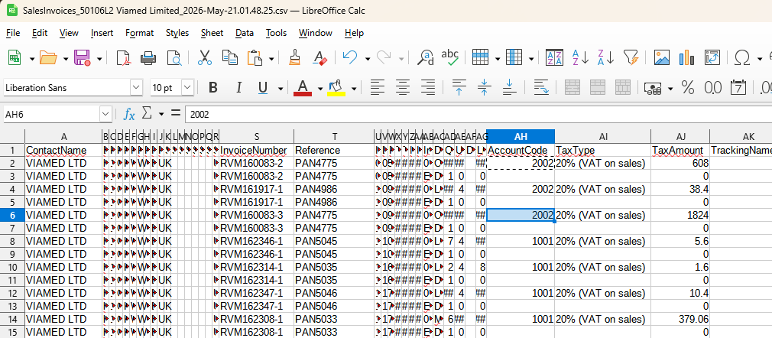

Now we update the TaxType This has to be changed from the sales VAT to the purchasing VAT.
So we go from 20% (VAT on sales) to 20% (VAT on Purchasing). (the capital P matters it goes in wrong if you use lower case).

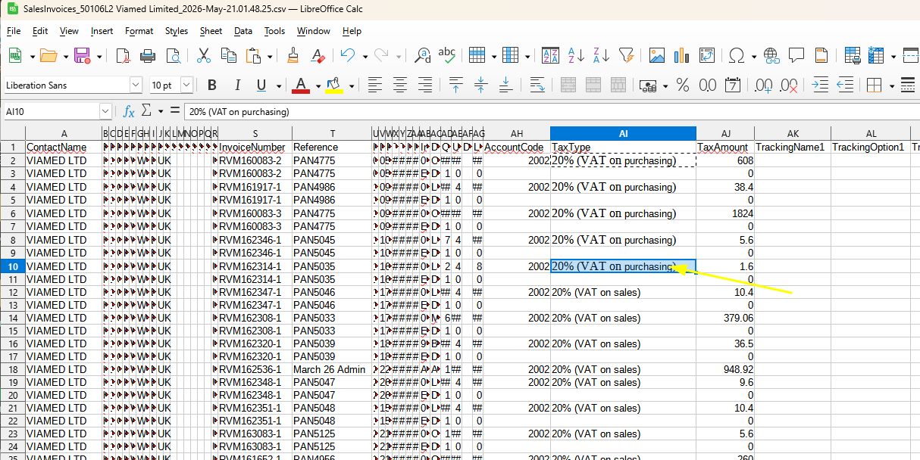

Finally we will tell the spreadsheet its a purchase bill not a sales invoice.
In Type change it from Sales invoice to Bill. So when we import to Xero its knows its a bill / purchasing, with purchase Vat going in to the right nominal and to the correct contact.

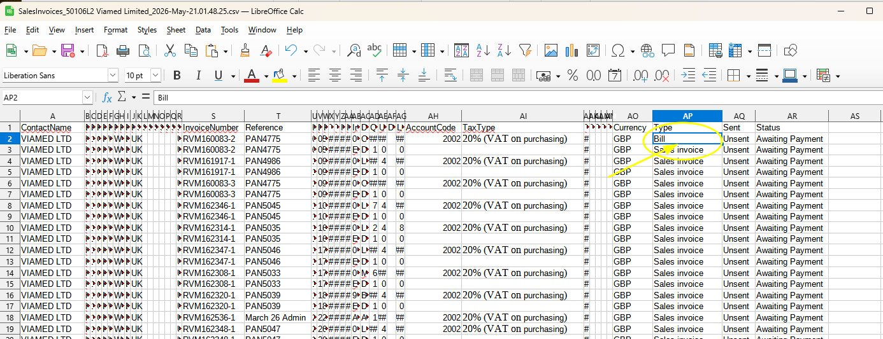

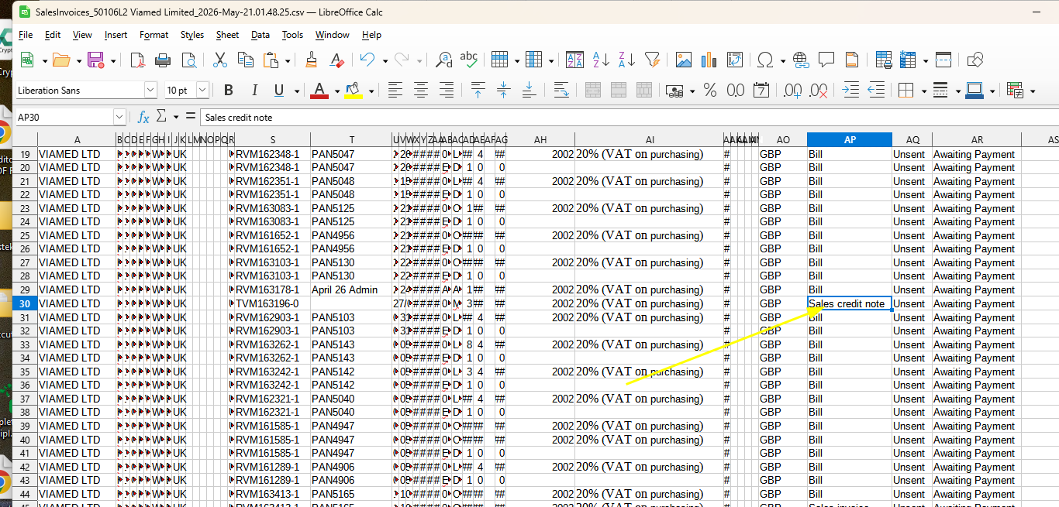

If there is a credit note “Sales credit note” this needs changing to “Credit Note”

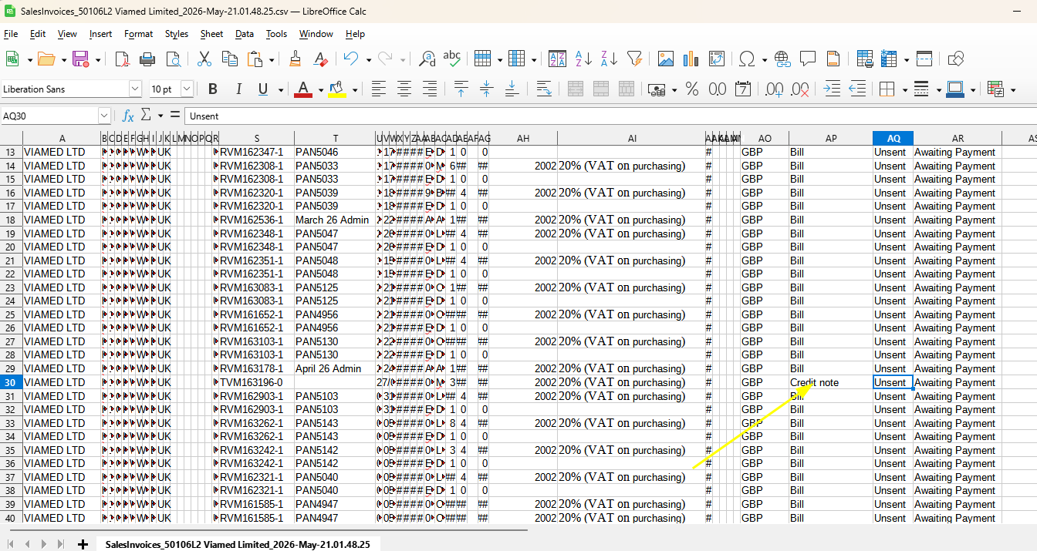
once you have update these 4 things save and then we can Import in to the correct company in this case Vandagraph Ltd. Click Purchasing
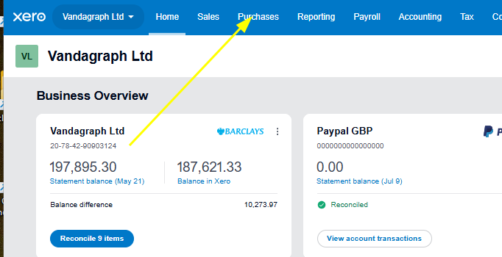

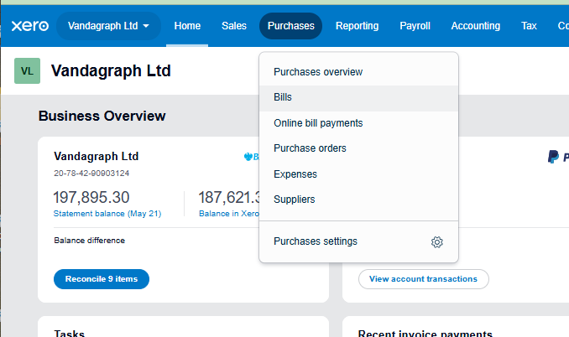

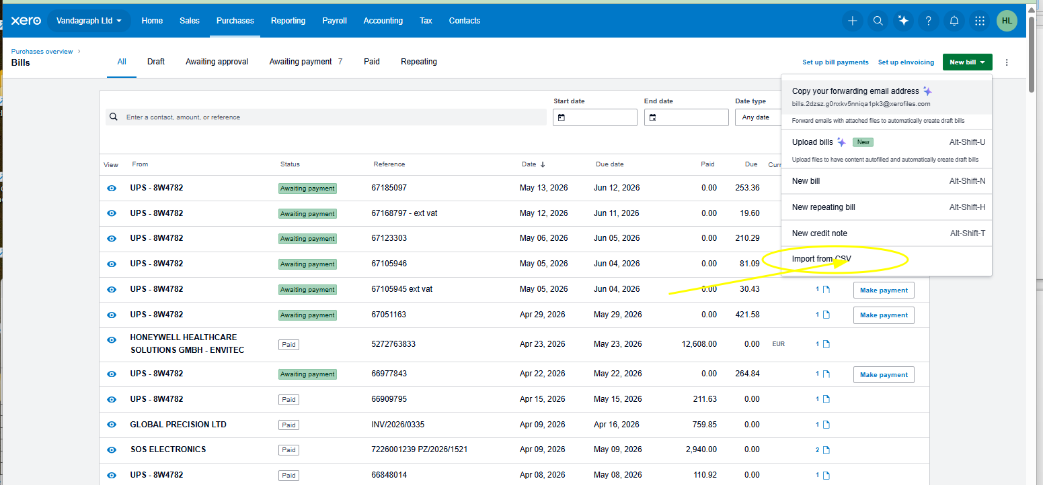

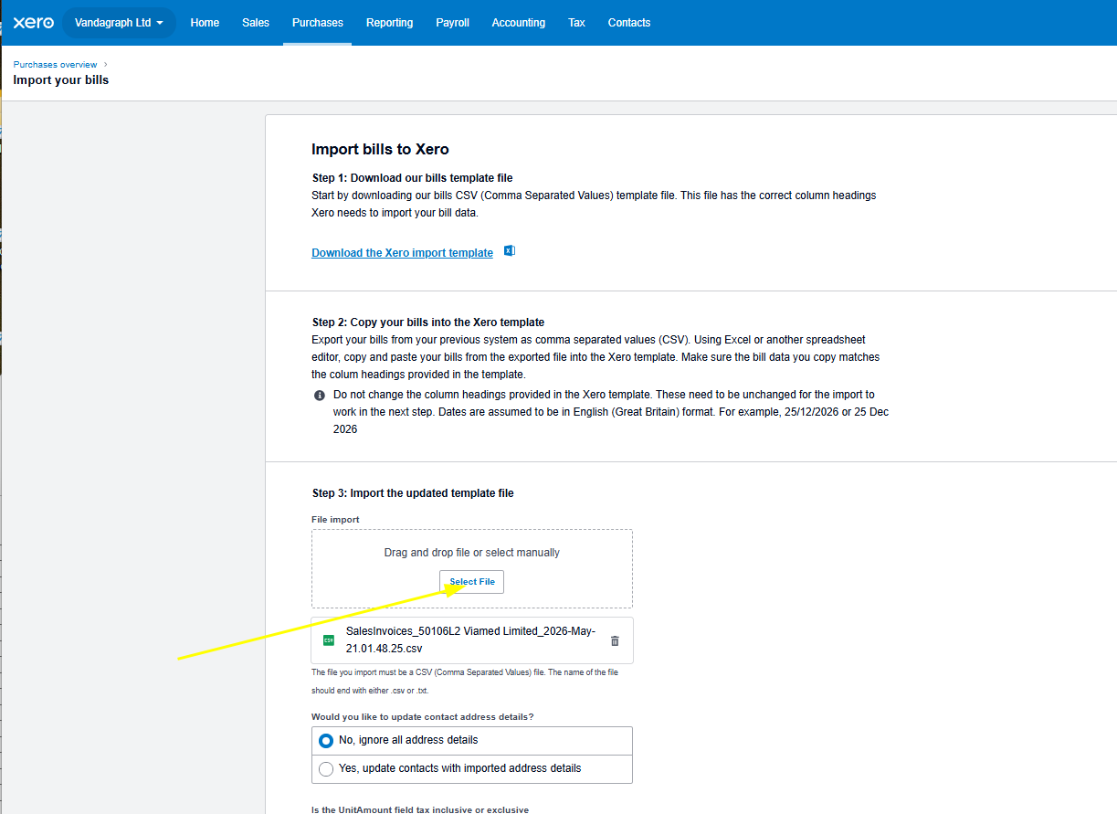

Go in to Vandagraph Xero purchasing import csv. Select the file you have been working on. (make sure you saved it)

Hit confirm, then Complete import.

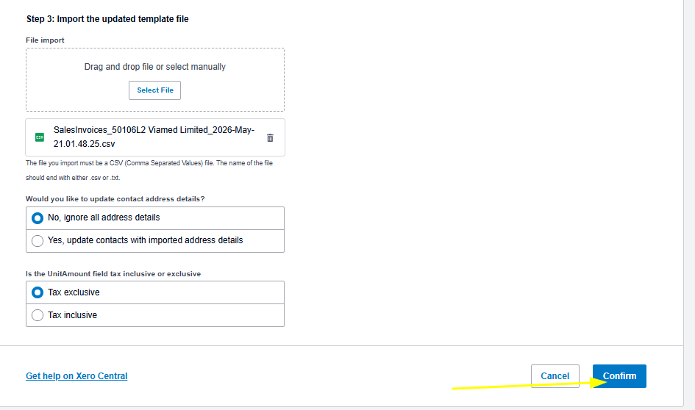

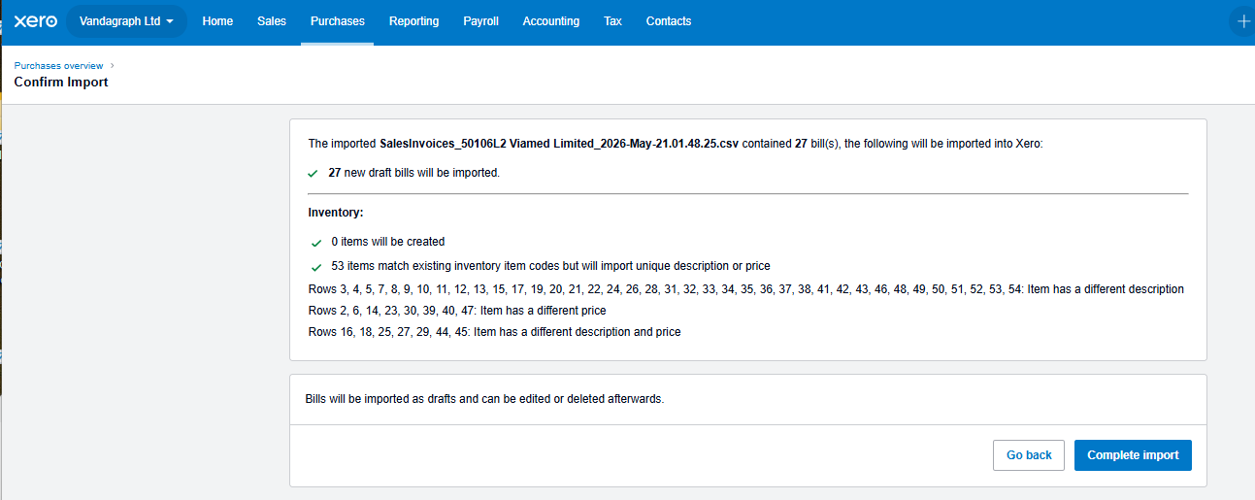

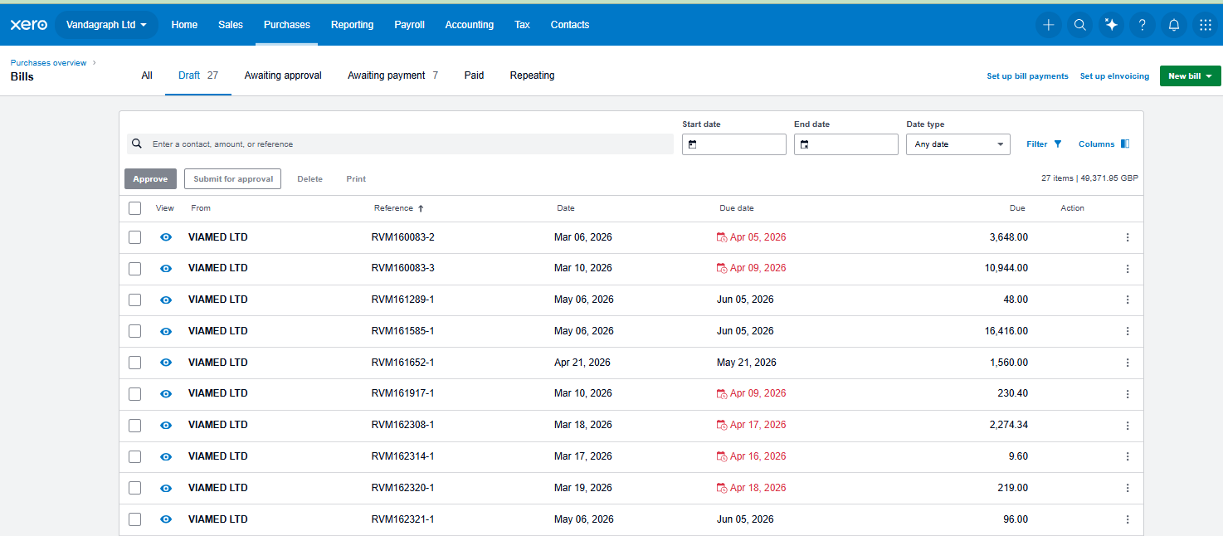

Click in to some and checked they are correct. Make sure company, VAT and type are right

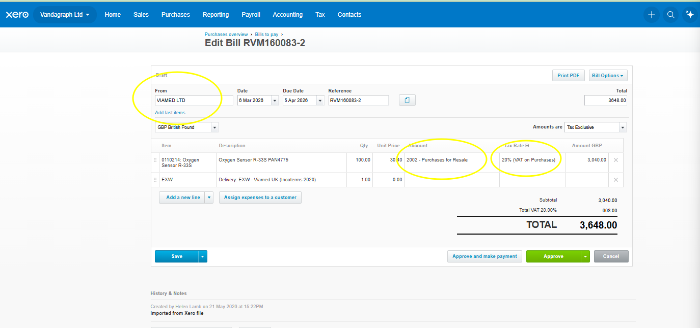

Once you are happy they are right. You can select them all and approve, but only do this once you happy as you CANNOT DELETE IN BULK. If you get it wrong it deleting then one at a time.
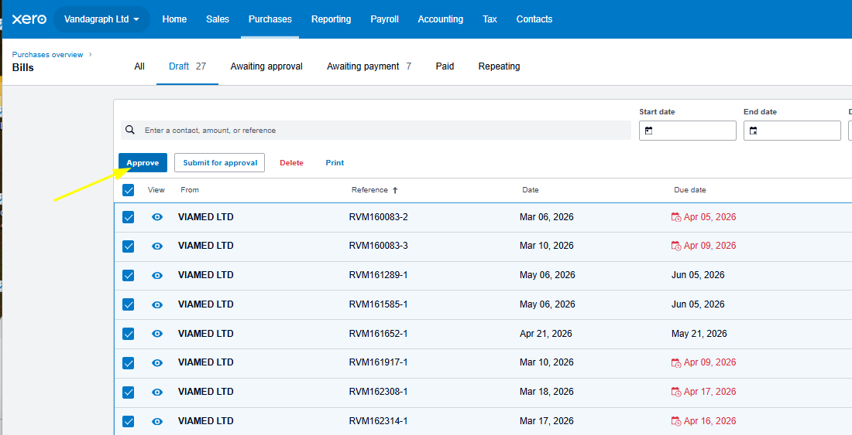

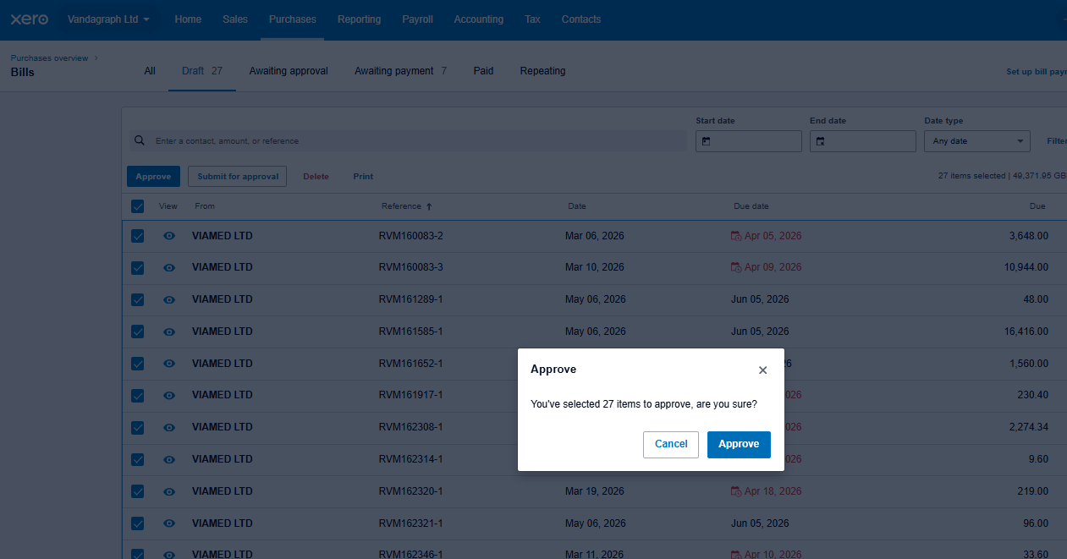

Now you can go to the Awaiting Payment tab and make a payment from Vandagraph to Viamed.

I always check the sales on all three Xeros Viamed, Vandagraph Ltd and VST Ltd. Most of the time its just Vandagraph and VST sales in Viamed that need to be put on as a purchase invoice on Vandagraph and VST.

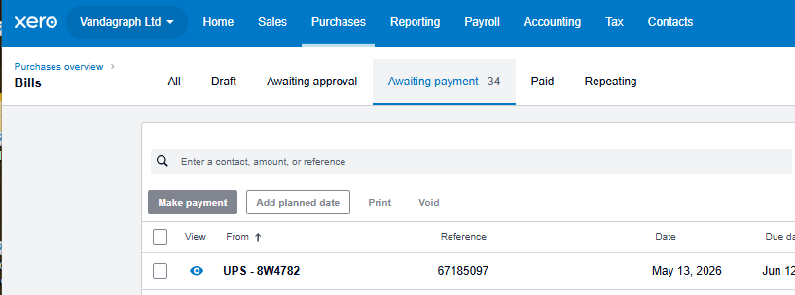

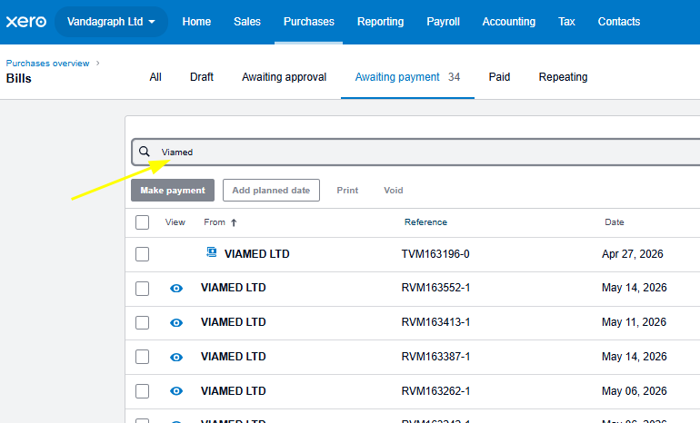

Select all
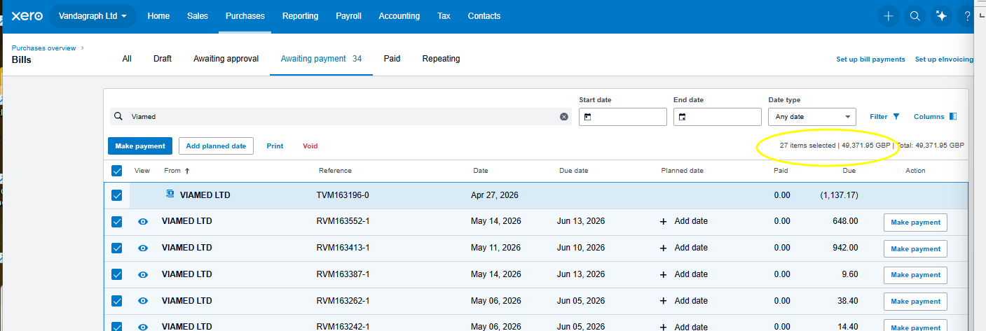
Total to pay from Vandagraph to Viamed is £49,371.95. Should do this monthly, this has been two. Usually its about £20,000. Its less for VST about £8000.

Make a note VAN to VIA £ 49,371.95 so when doing bank you have the figure at hand.

Once done do the same for VST. DO NOT DO BOTH TOGETHER. Always search Vandagraph Ltd.

Final note they import named the same. So if you likely to get confused make sure to add Vandagraph or VST to the csv file.

If you don’t do it bulk you will have to do them individually this way is a lot quicker once you get in to it. These are bills that Vandagraph have to pay so should be treated as such.

VST if it wont approve the drafts go in to each one and approve individually.

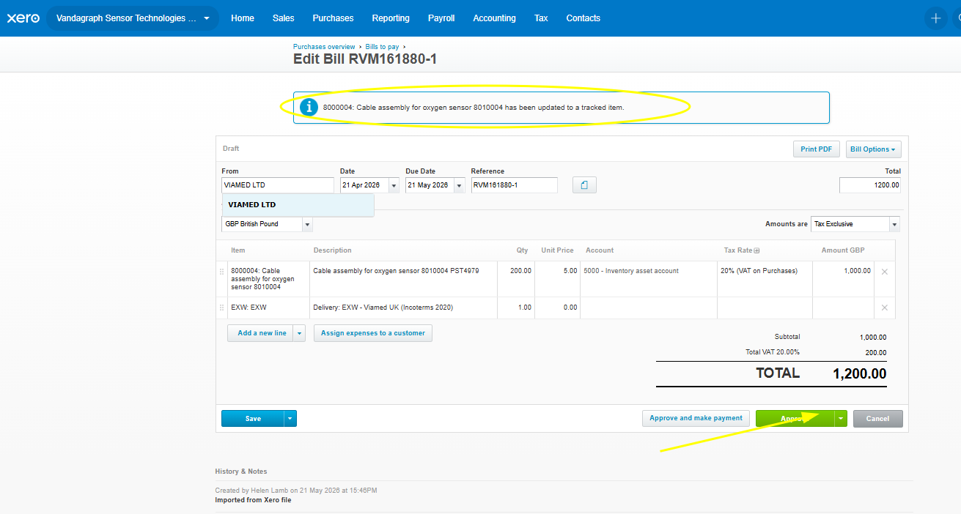

No idea why but it seems to always do it on VST ones.

