VM3COP37.62 0110525 KE-25 Oxygen sensor Packaging Procedure

Tools required:
 |  | Description:
 |  | Heat sealer
Parts list:
 | Part number: | Description:
 | 0150012 | Oxygen sensor box
 | 0150020 | Oxygen sensor barrier bag
 | 9992515 | Label – Medical Oxygen sensor Viamed

Method:
- Take the MAX-250B Oxygen sensor and place it in an Oxygen sensor barrier bag. Use the heat sealer to seal the bag. | 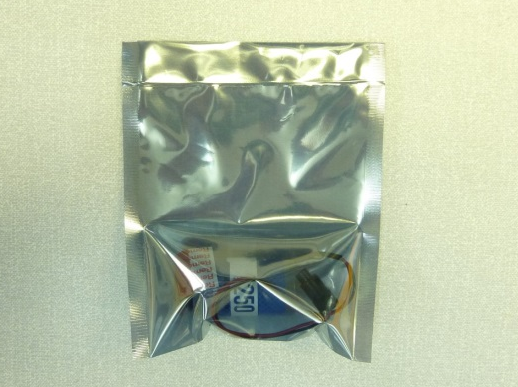
- Take the sealed sensor and package it in a sensor box. | 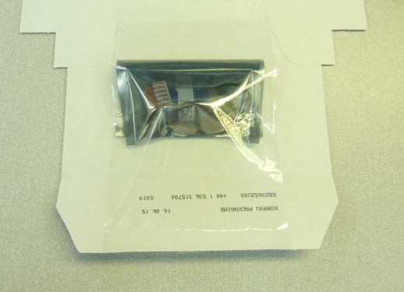
 | 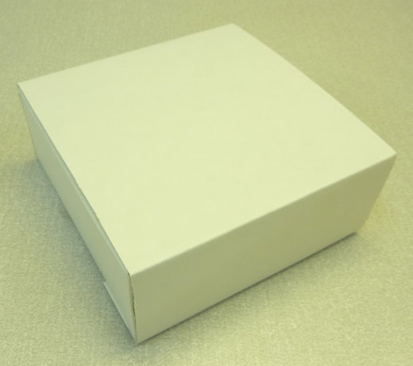
- Affix the box label to the box by wrapping from the top to the bottom, ensuring the label is straight and without air bubbles or creases. | 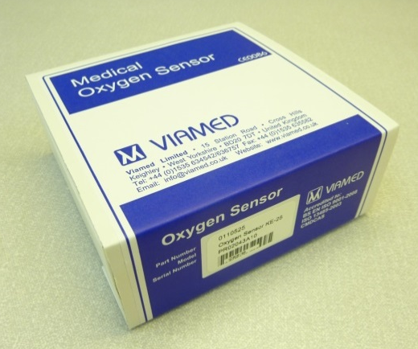
- Affix the serial number label to the front of the box in the space provided. | 

