VM3COP37.58 0110436 MAX-250B Oxygen Sensor QA Procedure

Tools required:
Description:
Multi-meter
MAX-250B multi-meter adapter

- Connect the MAX-250B multi-meter adapter to the multi-meter, ensuring that the polarity is correct (Black to common) | 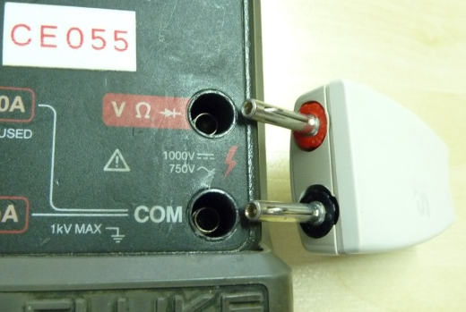
- Set the multi-meter to the millivolt range. | 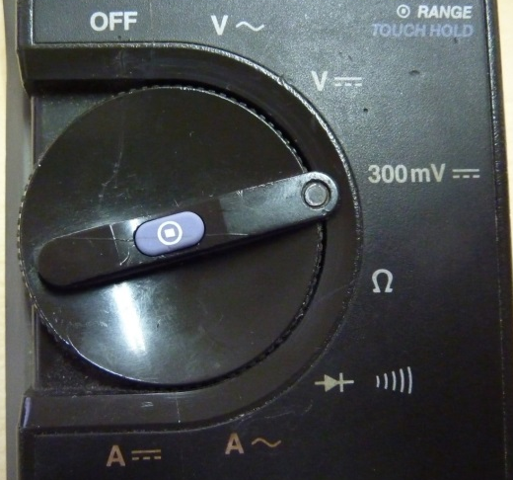
- Connect to MAX-250B sensor to the multi-meter adapter. The output reading, to pass QA, should be between 10.0mV and 15.5mV. | 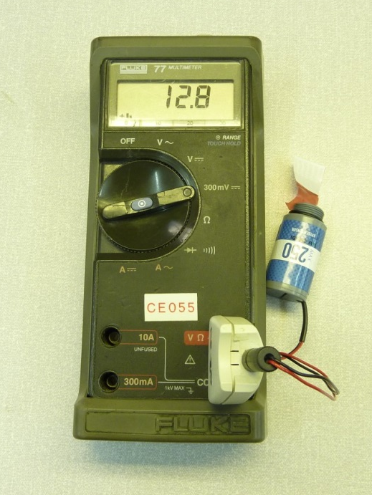
- Fill out the QA sheet that came with the production job. Fill out the QA form on intrastats.  The sensor is now ready for packaging. | 

