VM3COP37.54 0110436 Maxtec Oxygen Sensor Production Procedure

Tools required:
 |  | Description:
Soldering iron
Long nose pliers
Small vice
Wire cutters
Parts list:
 | Part number: | Description:
 | 0110432 | Oxygen sensor MAX-250B
 | 0131525 | Connector 2 pole black socket 1mm
 | 0131526 | Connector hood black
 | 0032310 | Heat shrink tubing – black 1.6mm
 |  | 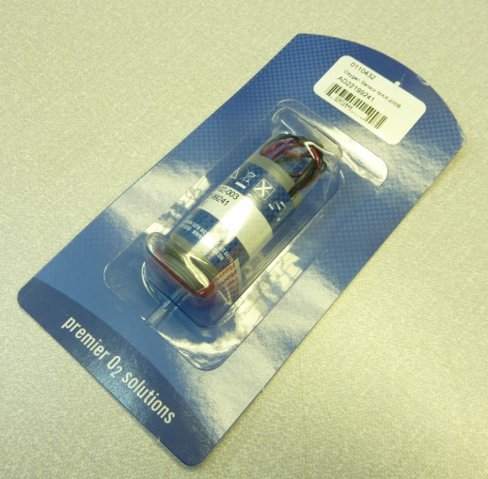

- Remove the sensor from the outer packaging. | 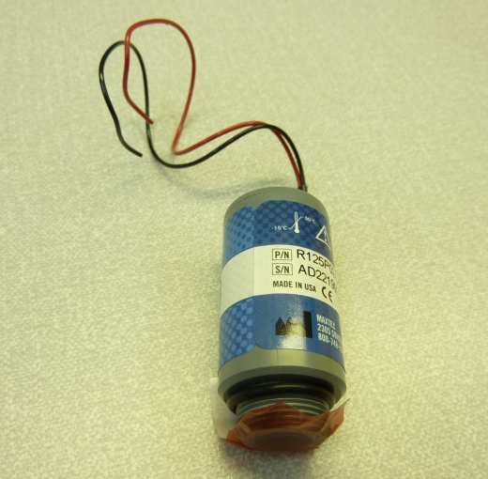
- Place the connector hood over both sensor wires. | 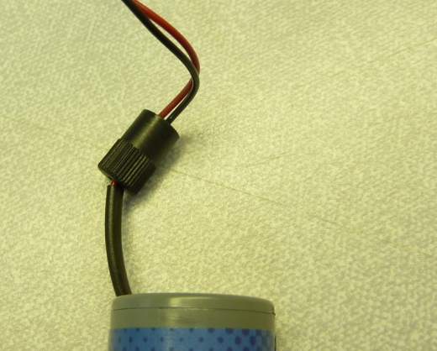
- Strip and tin 2mm of each wire. Place 5mm of 1.6mm heat shrink over each wire. | 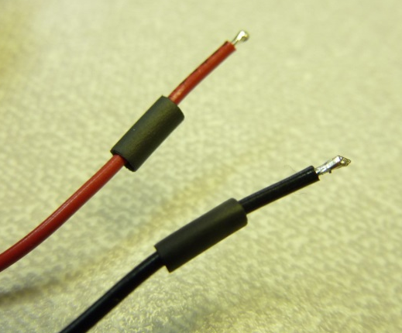
- Apply solder to the connector pins. | 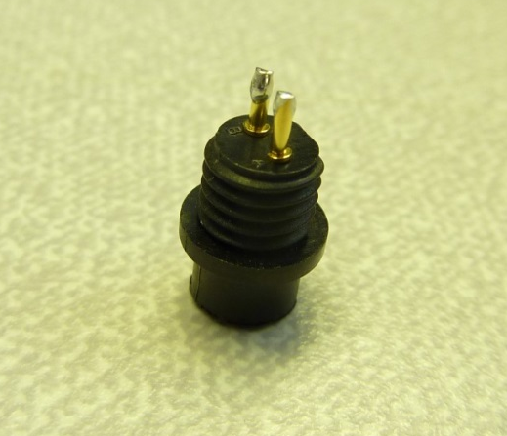
- Solder the wires to the connector pins. | 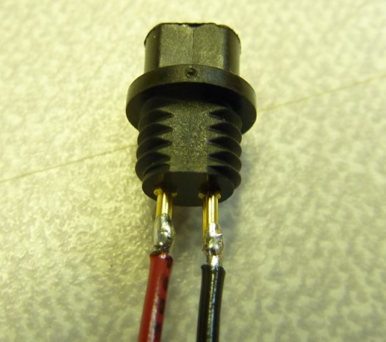
- Cover the pins with the heat shrink. Shrink the tubing leaving none of the pin exposed. | 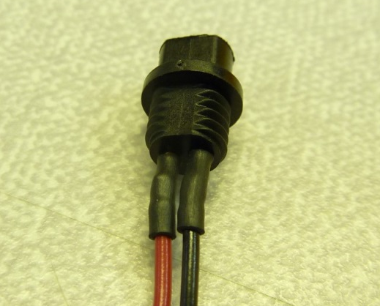
- Screw the connector hood to the connector. If the wires are not compact enough then there may be resistance when tightening the hood, this can cause the pins to bend. | 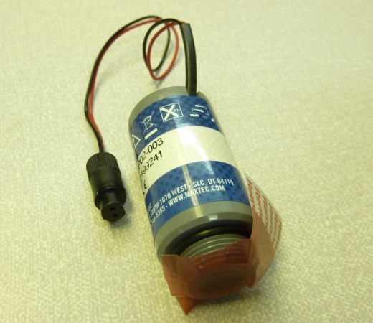
- Affix a serial number label to the sensor.  The sensor is now ready for QA. | 

