Company Operating Procedure VM3COP37.11

0110525 KE-25 Oxygen sensor
Tools required:
 |  | Description:
Soldering iron
Long nose pliers
Small vice
Wire cutters
Parts list:
 | Part number: | Description:
 | 0110524 | Oxygen sensor KE-25
 | 0131525 | Connector 2 pole black socket 1mm
 | 0131526 | Connector hood black
 | 1430112 | 10kΩ resistor
 |  | 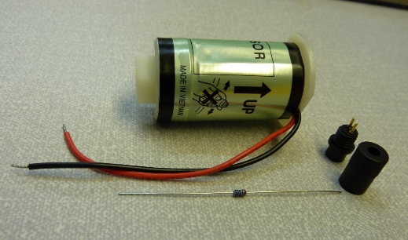

- Take the 10kΩ resistor and shape the legs to fit into the connector pins. | 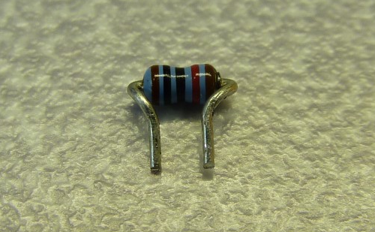
- With the flat spot on the front of the connector to the top, insert the resistor so that it leans towards the flat spot. The connector pins are marked A and B. A should be on the right and B on the left. | 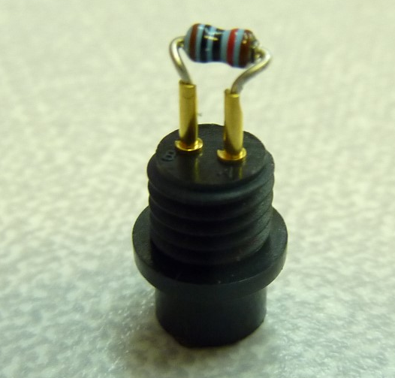  B  A
- Solder the resistor in place. The resistor should lean slightly forward to allow the sensor wires to pass freely out of the connector hood. | 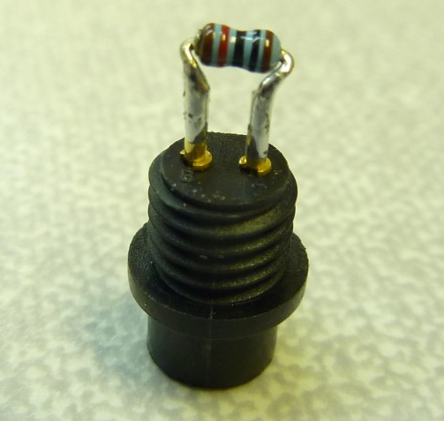
- Place the connector hood over both sensor wires. | 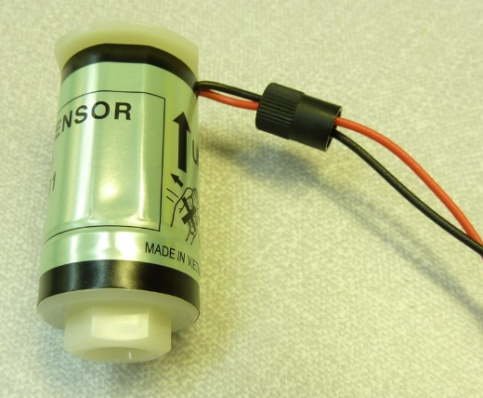
- Solder the sensor wires to the connector. Pin A is Black and pin B is Red | 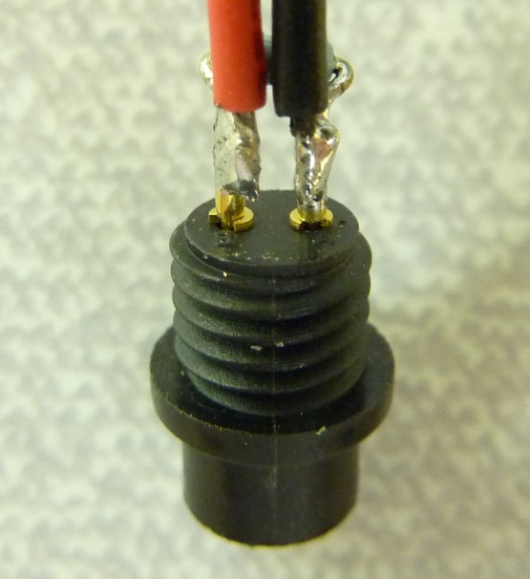
 | 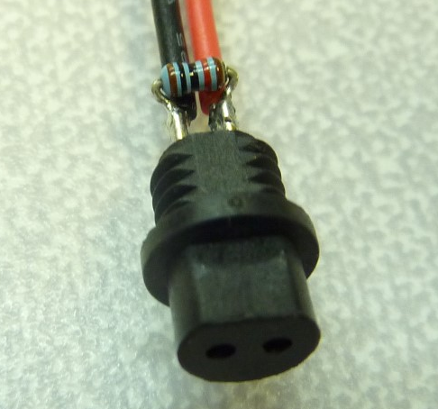
- Screw the connector hood to the connector. If the resistor and wires are not compact enough then there may be resistance when tightening the hood, this can cause the pins to bend. | 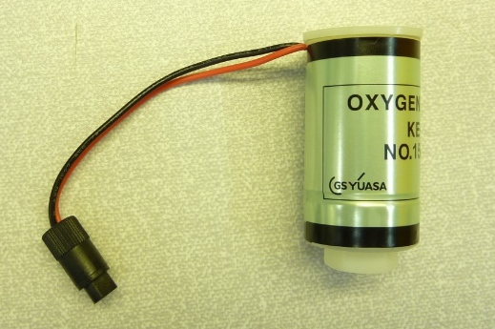
- Affix a serial number label to the sensor. | 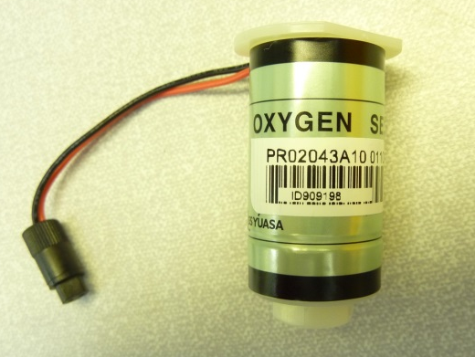
- The sensor is now ready for QA.

