Viamed Manufacturing Flow Chart

Viamed are a Virtual Manufacturer of Envitec Products

Therefore our Manufacturing Flowchart is as Below:

Envitec - > Viamed.

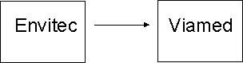

Envitec Manufacturing Flow charts See Section BSI 9 Manufacturing process flow chart

Derek Lamb
01/08/2017

