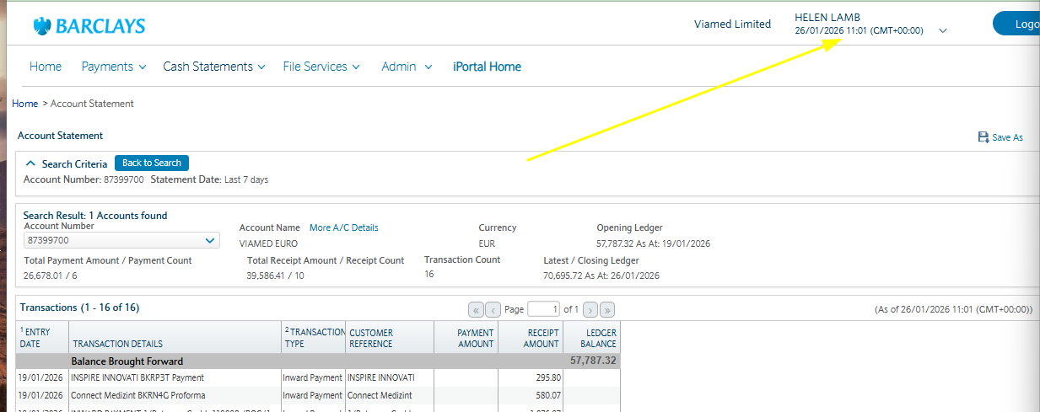
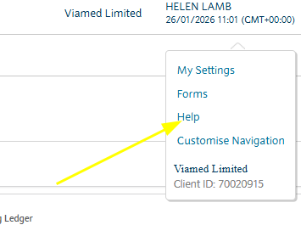
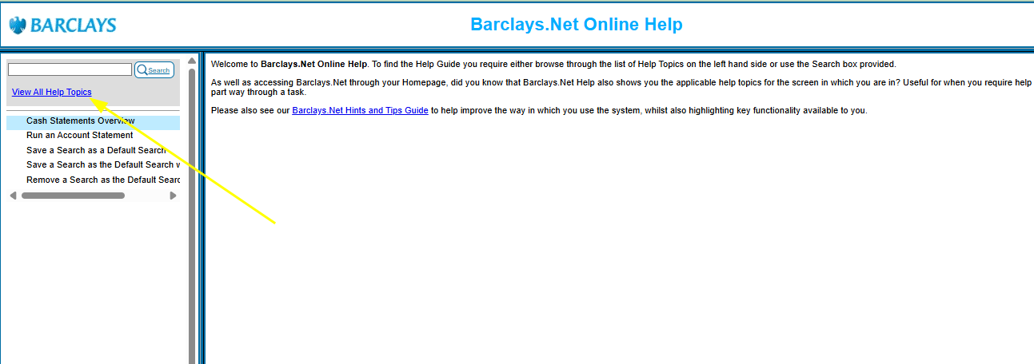
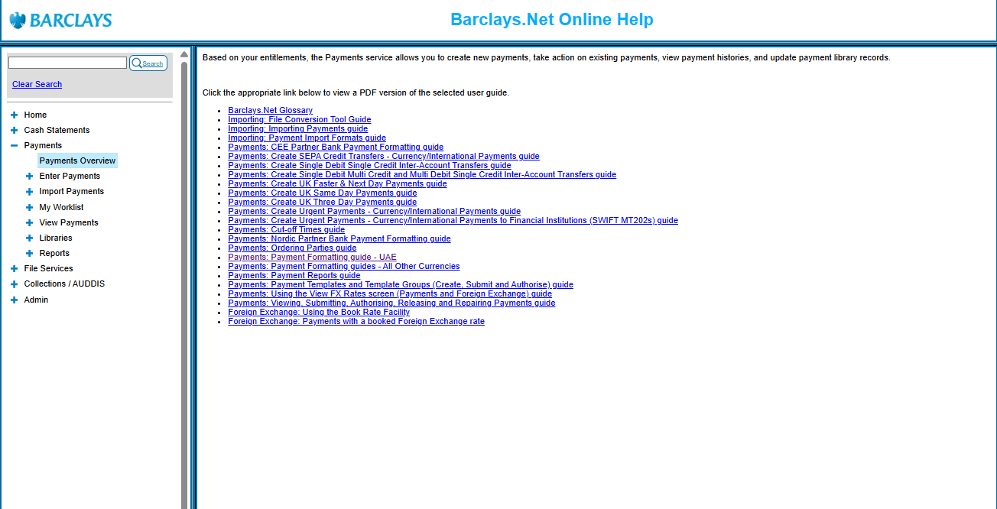
You can ring Barclays and ask
they are very good. Helen lamb
is currently named on the account
to do this stuff but Derek and Jean
are also down as admins. So they can also ring and talk to them.

If we need someone else to be able to do this ask Derek or Helen to add as a new admin. Theres a form to fill in

If Barclays are on the phone they use the Barclays
app (private banking app) to clear you and them through
security.

