VM3COP43.07 Maxtec Ultramax Analyser Testing
- Unbox the Ultramax analyser. | 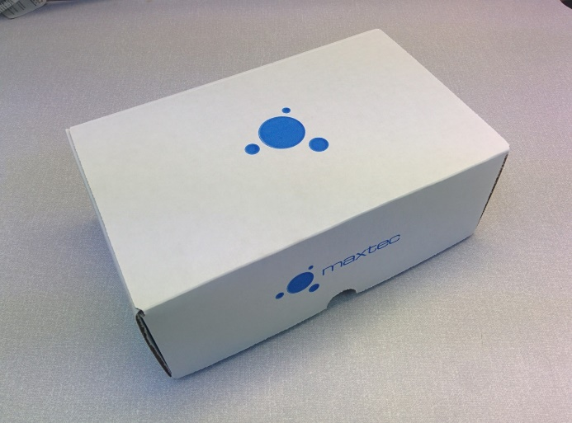
- Check the box contains all the items listed:  Ultramax analyser  Operating manual  Clear tubing  Soft cover  Batteries | 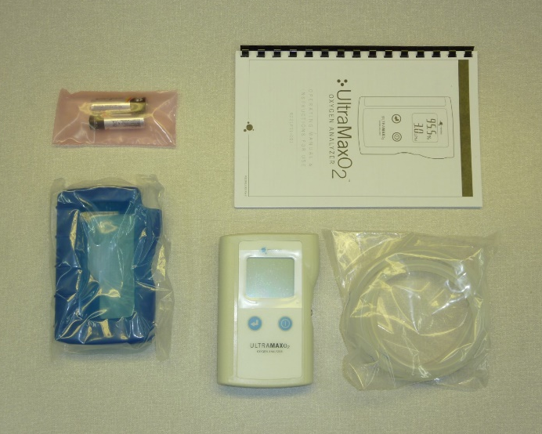
- Using a #1 Phillips screw driver, remove the battery door and insert two AA batteries. Battery orientation markings can be found on the inside of the battery compartment. | 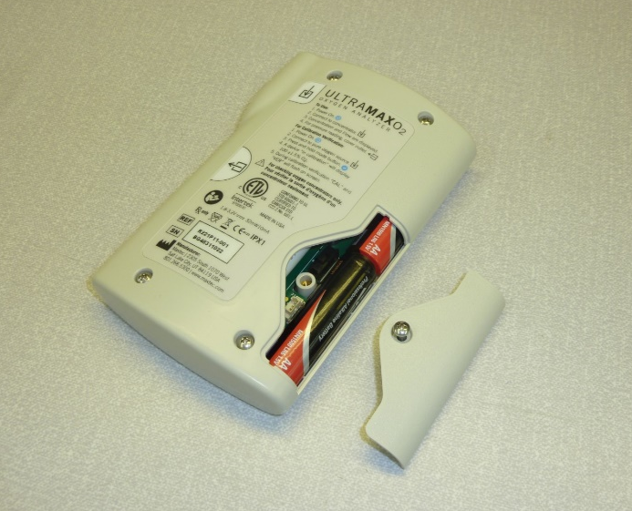
- Activate the analyser by pressing the power button on the front panel. | 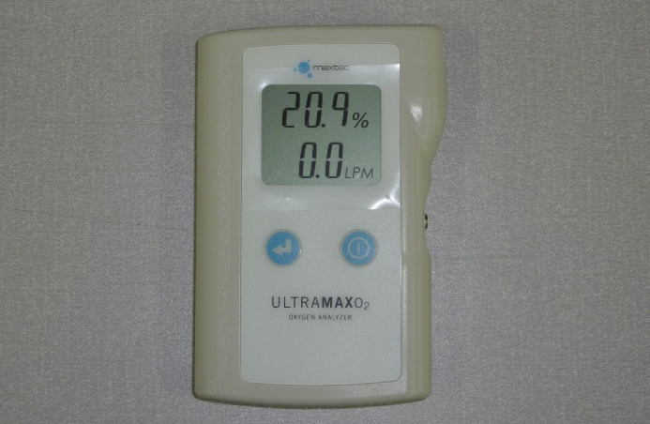
- Connect one end the tubing to gas inlet port. | 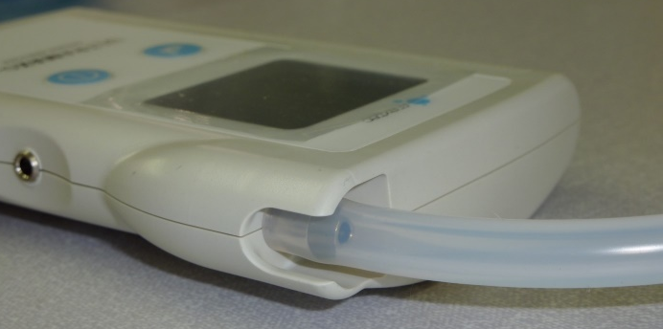
- Connect the remaining end of the tubing to gas source with an inline flow meter. | 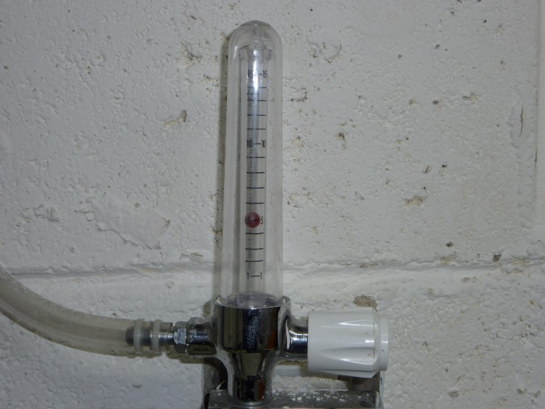
- Test the flow meter by allowing gas to flow at the rate of 2 litres per minute (lpm). Compare the reading on the Ultramax monitor to the reading on the inline flow meter. A reading of ±0.2lpm is acceptable.  - Repeat the process at 5 and 8 lpm. | 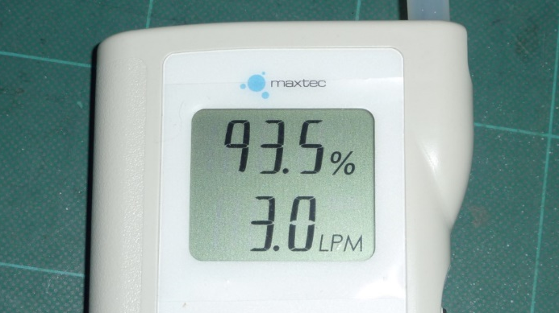
- Test the PSI gas pressure function. Allow gas to flow at 2lpm.  - Cover the gas sample outlet port, located on the right-hand side, with a finger or thumb.  - Allow 5 seconds before observing a pressure reading. | 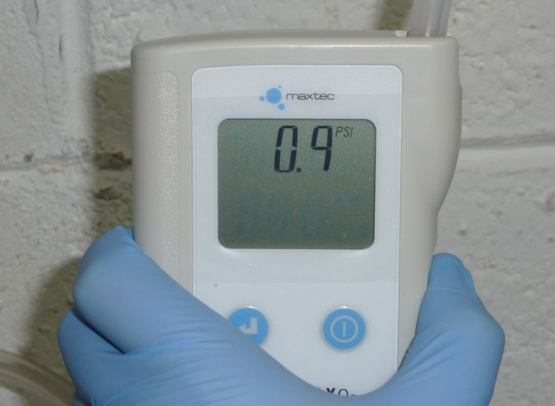
- Set the pressure mode switch kPa. This can be found inside the battery compartment. | 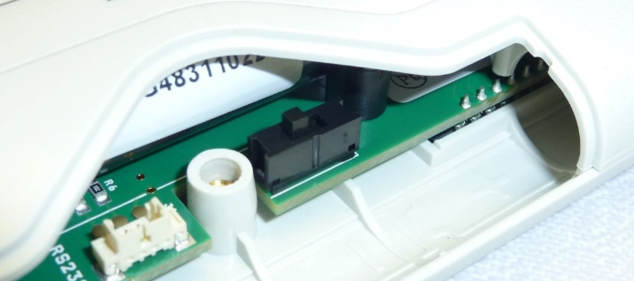
- Test the kPa gas pressure function. Allow gas to flow at 2lpm  - Cover the gas sample outlet port, located on the right-hand side, with a finger or thumb.  - Allow 5 seconds before observing a pressure reading.  - Return the mode switch to the PSI setting. | 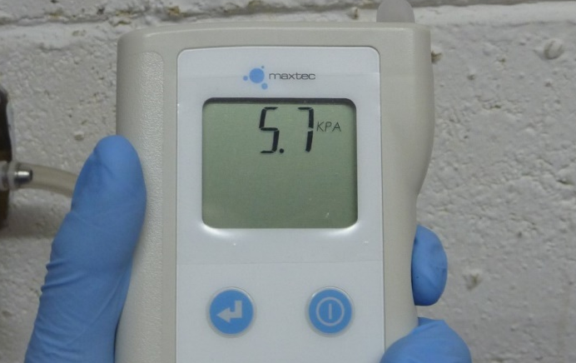
- Verify the Oxygen calibration. Connect the inlet tubing to a source of pure Oxygen (≥99.95%). Allow gas to flow at 2lpm.  - Press and hold the mode button. While holding the mode button, the gas measurement should read between 98.5 and 101.5%. If the gas measurement is not within this range, then inform the team leader.  - Record the QA results on the intrastats system. | 

