Contract Change Notice
(CCN002 VIAMED LTD Patient Monitoring MED-PA-37500)

CCN Reference | CCN002 VIAMED LTD Patient Monitoring MED-PA-37500
Contract Title | Patient Monitoring
Contract Reference | MED-PA-37500

WHEREAS the Limited Company VIAMED LTD (reg. no. 01291765) whose registered office is at 15 Station Road, Cross Hills, Keighley, West Yorkshire, BD20 7DT (the "Service Provider"), and the Contracting Authority entered a Contract for the above services dated 31/05/2025 – 31/07/2025 (the “Original Agreement”) and now wish to amend the Original Agreement.

It is AGREED as follows:

- With effect from 01/08/2025 the Original Agreement shall be amended as set out as follows;

Agreement MED-PA-37500 - Patient Monitoring will be extended for an additional 4 months expiring 30th November 2025.

- Save the amendments stated above, all other terms and conditions of the Original
Agreement shall remain in full force and effect.

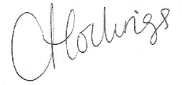
Signed for and on behalf of the Provider by:

Name | Catrin Hollings
Title | Marketing
Date | 29/07/2025

Signed for and on behalf of the Contracting Authority by: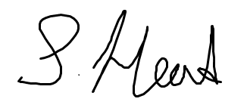

Name | Sian Head
Title | Senior Category Manager
Date | 17/07/25

