VM3COP51.30 Resus Cabinet Assembly
Parts list
Qty | Description | Part No.
1 | Resuscitation Cabinet | 0330105
320mm | Edging Grommet Strip 1.6mm to 2.0mm | 0330012
1 | Resuscitation Bed 14” flat | 0320021
6 | Self-Tapping Screw No. 6 x 0.5 inch | 0330064
1 | Mattress large - infant resuscitation | 0320043
1 | Resuscitation Cabinet Rail - 0.3m length | 0332058
2 | Resuscitation Cabinet Rail - 0.4m length | 0332059
8 | Resuscitation Cabinet Rail - Spacer 20mm | 0332039
8 | Resuscitation Cabinet Rail - Bolt 35mm | 0332041
8 | Resuscitation Cabinet Rail - Lock nut | 0332043
3 | Storage bins: Size 3 (blue) | 0310020
1 | Label: Viamed (domed) | 0390056
1 | Label: Support door (domed) | 0390057
1 | Label: Caution | 0390054
1 | Label: Serial number | 0390053

Tool list
Pozi-drive No.2
Pozi-drive No.3
Drill with 2mm bit
10mm open ended spanner
Ruler
Pencil
Hand held vacuum cleaner

- Unpack and inspect the cabinet for damage. Faults or damage must be reported to the warehouse team leader. | 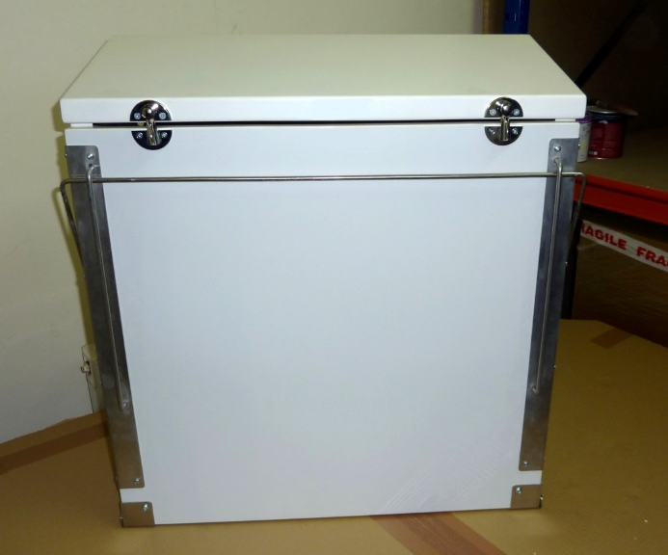
- Affix the front labels as shown. These must be central and straight. | 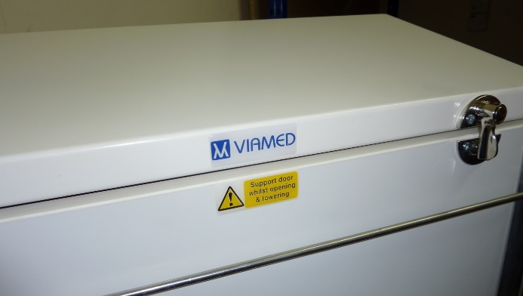
- Affix the serial number label to the right-hand side of the cabinet as shown. This should be central and 90mm from the base of the cabinet. | 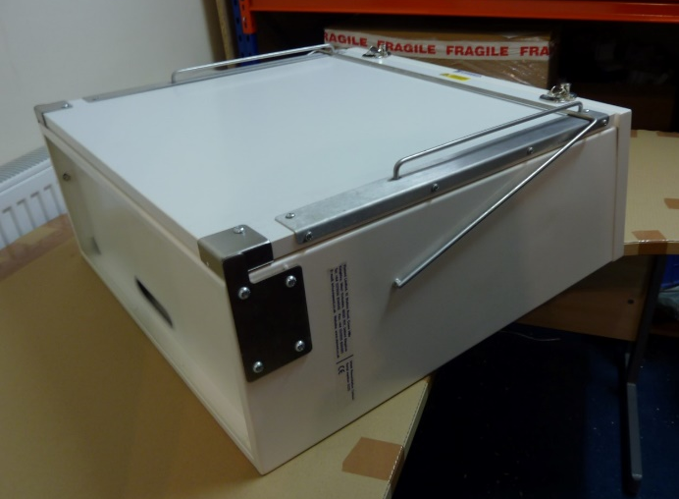
- Affix the rubber door stoppers to either side of the door opening. | 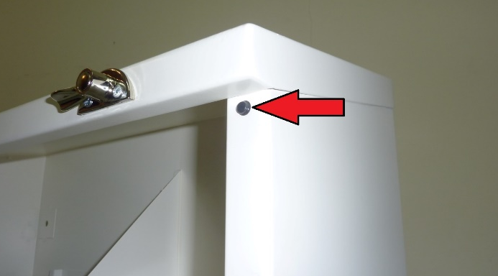
- Cut a length of edging strip to 320mm.  - Insert the protective strip around the edges of the inlet access hole located in the base of the cabinet. | 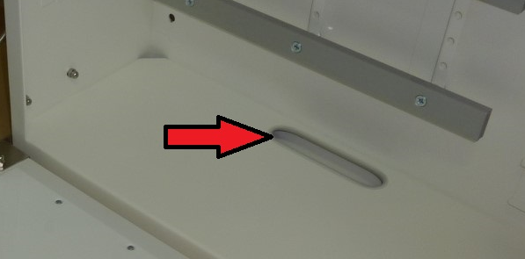
- Inside the cabinet, on the rear panel, are three rail mounts. Place a nut behind the rail mount. | 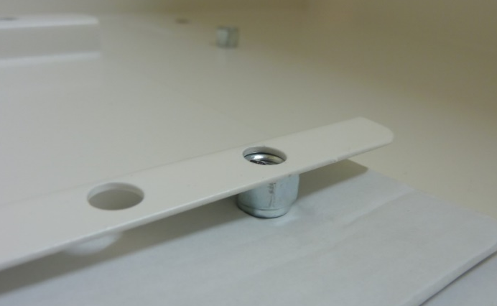
- Place piece of folded card behind the nut to hold it in place.  The standard arrangement for these is: Top, bottom and fifth from bottom.  The rails are of two lengths. The top one is short, the two lower rails are long. | 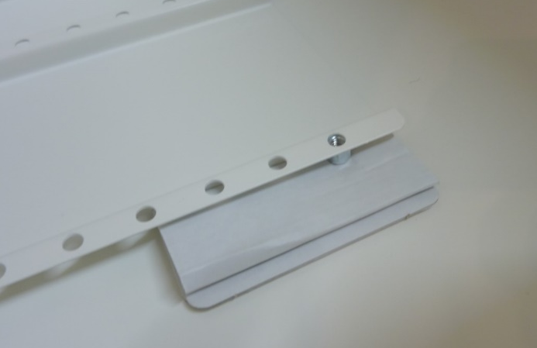
- Place a spacer on the top side of the rail mount. Ensure that the spacer aligns with the nut.  - Repeat this process on each rail. | 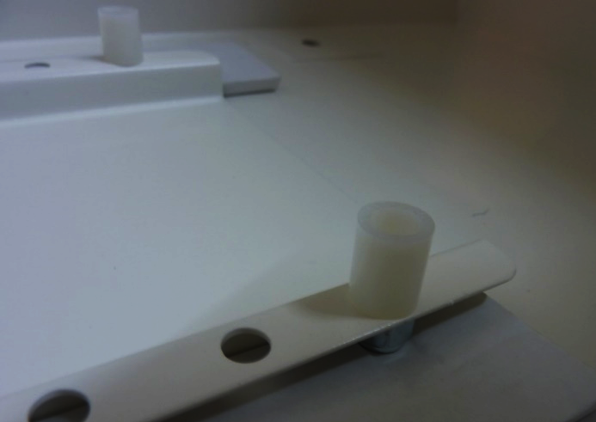
- Place a counter sunk bolt through each hole in the rail.  Note: The rail has channel on the lower side. | 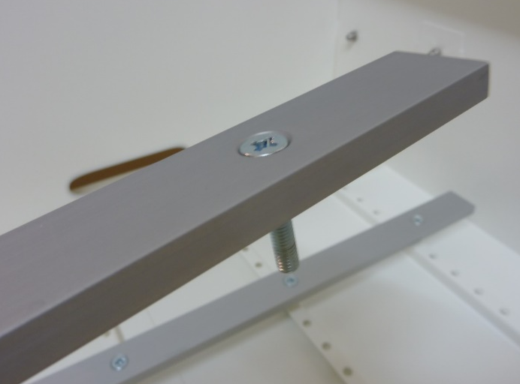
- Affix each rail to the rail mounts.  The rails can be fitted in several positions to suit customer requirements. The standard positions are:  Top – short rail  One below middle – Long rail  Bottom – Long rail | 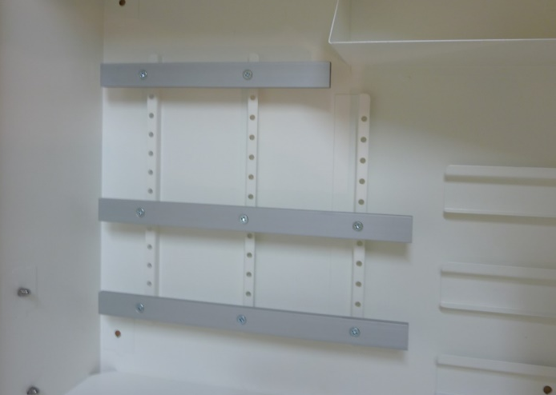
- Using a pencil, mark 50mm from the left side of the cabinet door. This measurement must be taken from the panel and not the rubber edge strip. | 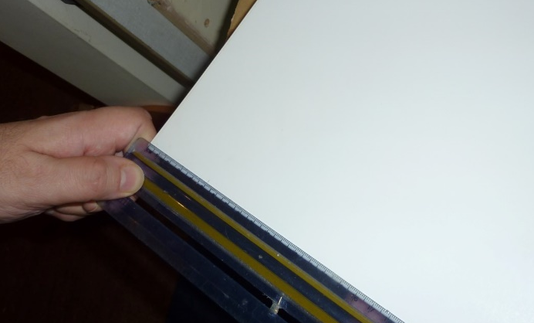
 | 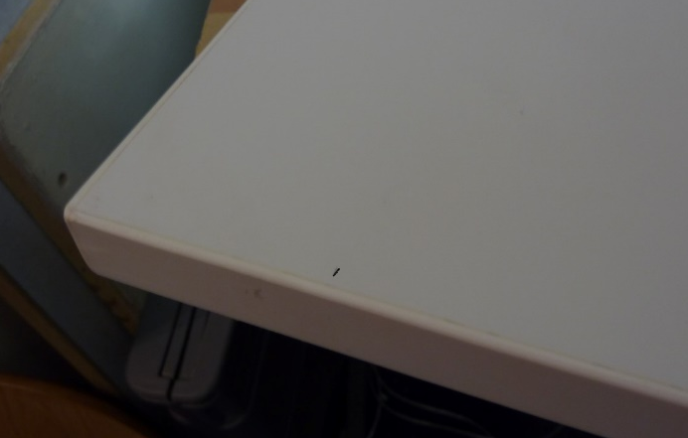
- Place the bed on the cabinet door. And align with the pencil mark. | 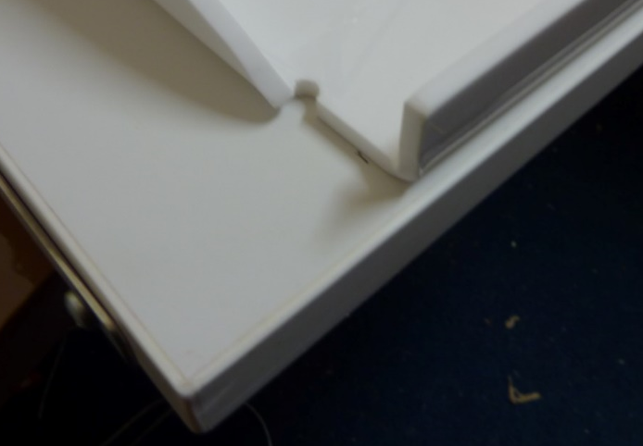
- Align the top of the bed with the top of the door panel. This alignment must be from the panel and not the rubber edge strip. | 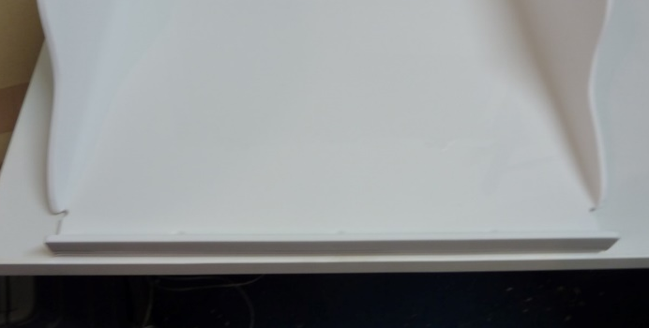
- Using a pencil, mark through each of the six holes in the bottom of the bed. | 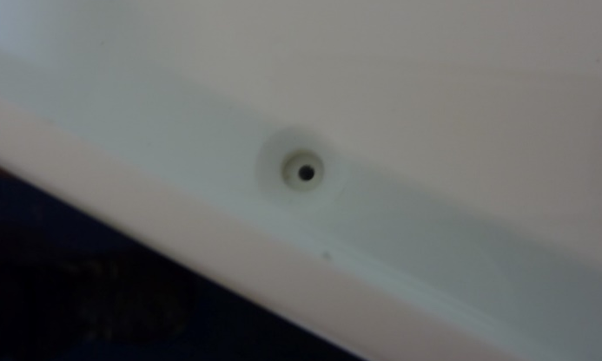
- Using a 2mm drill bit, drill pilot holes to a depth of 10mm at each mark.  - Using a hand-held vacuum cleaner, remove any swarf. | 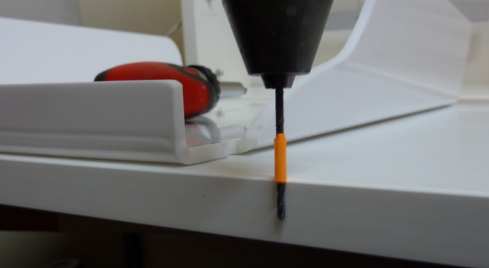
- Using the six fixing screws, affix the bed in place.  - Ensure that the door closes with the bed in place. | 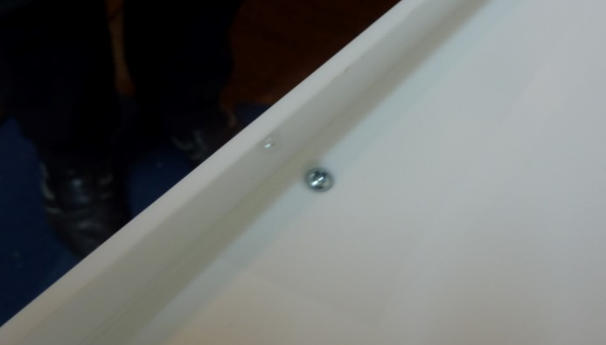
- Leave the mattress in the original packaging and place on top of the bed. | 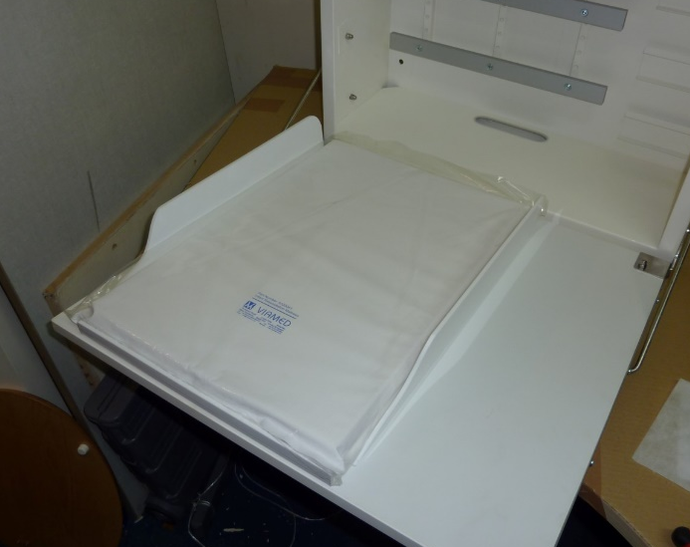
- Wrap the three plastic storage bins in bubble wrap and place them on the shelf in the top right corner. | 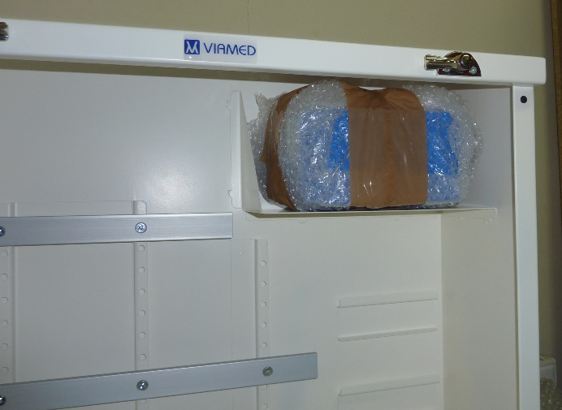
- Affix the ‘Caution’ label on the inside of the door. The label should be 5mm from the edges. | 

