VM3COP40.14 R-22DEM Oxygen Sensor Production Procedure
Parts list
Qty | Description | Part No.
1 | Oxygen sensor – R-22AV | 0110132
1 | Connector Housing, M20 Series, 2 Way | 9081047
2 | M20 Series Female Crimp Contacts | 9071046
1 | Anti-static gas barrier bag | 0150000
1 | R-22DEM PCB | 9015004
2 | Resistor 4k7Ω surface mount | -
5cm | Red wire | -
5cm | Black wire | -

Tool list
Soldering iron
Wire cutters
Stanley knife
Small pliers
Low melt glue gun
Abrasive contact cleaner
M20 crimp tool
Wire stripper
Strip heat sealer

PCB Preparation:
- Using an abrasive contact cleaner, clean the solder contact surfaces of the PCB. | 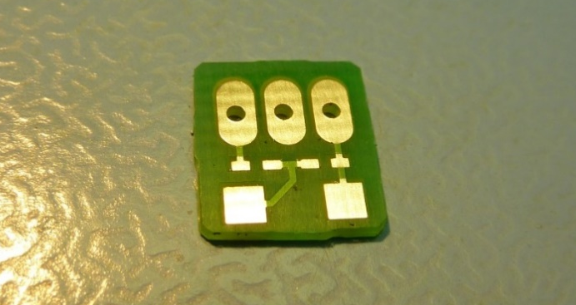
- Solder the two resistors into place as shown.  Note: The resistor are surface mount components, it may be necessary to use magnification when soldering or inspecting the PCB. | 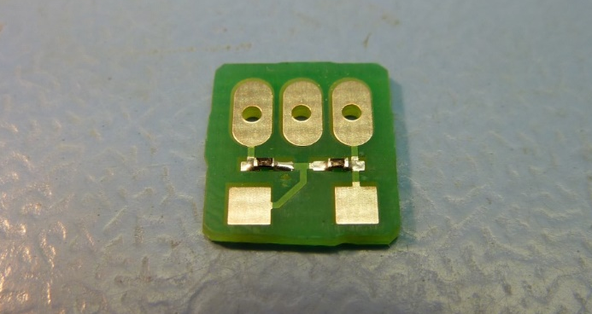

Sensor production:
- Remove the sensor from the sealed protective bag. | 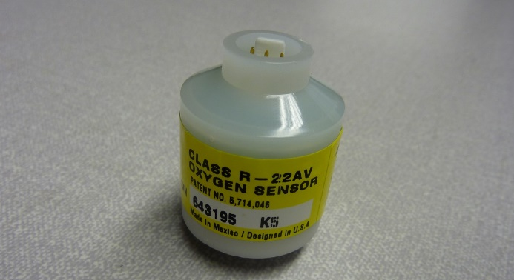
- Remove the top cap from the sensor. Use VM3COP40.11 for the method. | 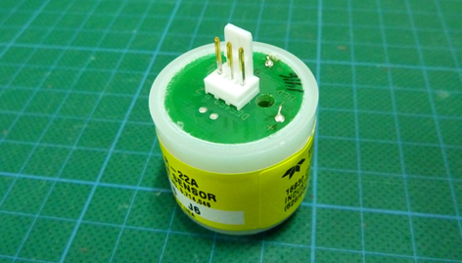
- Remove the white plastic surround from the Molex connector. | 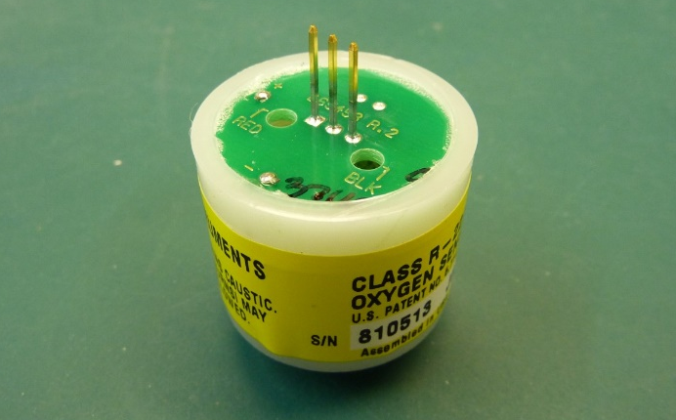
- Noting the Red and Black marking on the sensor surface, place the PCB over the sensor’s pin contacts as shown. | 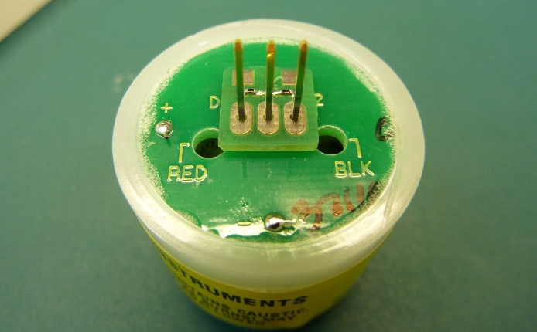
- Solder the pins to PCB contacts.  - Trim the sensor’s pins as shown. | 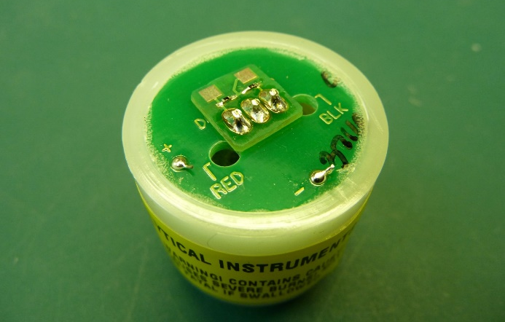
- Strip 3mm of cable outer from each end of the black and red wires.  - Using the M20 crimp tool, affix a pin to one end of red and black wires. Tin the remaining end of each wire.  - Insert the pins into the connector housing as shown. | 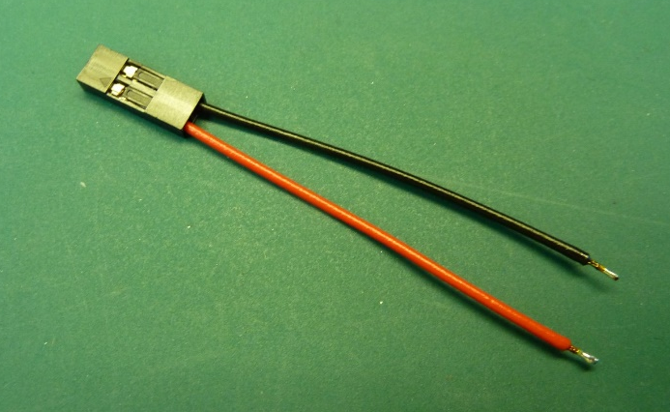
- Noting the Red and Black marking on the sensor surface, solder the connector assembly to the PCB as shown.  - Test the sensor by connecting it to a digital volt meter. The output in air should be between 4.0mV and 6.5mV. | 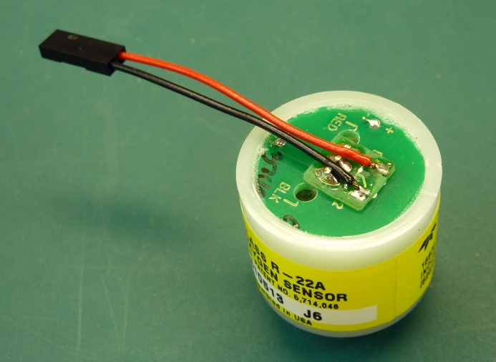
- Using a low melt glue gun, cover the small PCB and its components in adhesive and allow to set. | 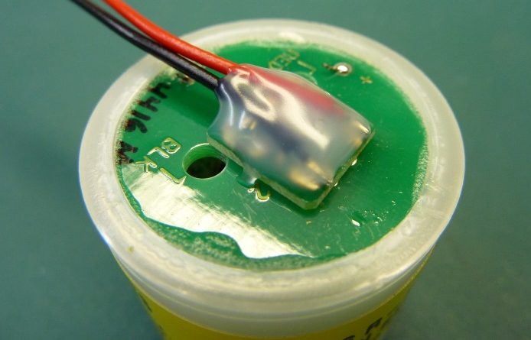
- Noting the serial number of the sensor, remove the sensor label. Replace the label with the Vandagraph label with the corresponding serial number. | 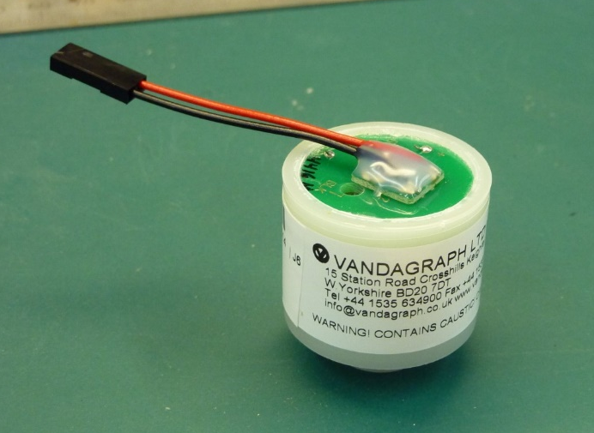
- The sensor is now ready to be QA tested. As before, test the sensor by connecting it to a digital volt meter. The output in air should be between 4.0mV and 6.5mV.

- Record the QA results on the Intrastats system.
- Place the sensor into a gas barrier bag.  - Seal the bag using a strip heat sealer.  - Affix the corresponding serial number to the bag. | 

