V1000 Foetal Heart Simulator – Technical Training

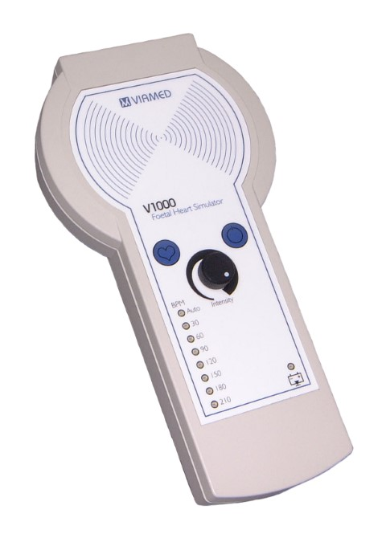

What is a Foetal Heart Simulator used for?

A Foetal Heart Simulator creates a simulation of the movement generated by the beating heart of a foetus in the womb during pregnancy.

It is used to test whether a foetal heart monitor is functioning correctly.

What is foetal heart monitoring?

Foetal heart monitoring uses ultrasound waves to measure the baby’s heart rate, sending them though the mother’s abdomen via a probe / transducer, then analysing the reflected sounds waves to determine the heart rate.

A water-based ultrasound gel is applied to the abdomen to enhance the transmission of ultrasound waves and the probe is applied directly to the abdomen.

The probe measures the Doppler effect* which is the effect that an object’s movement has on the frequency of the sound that is emitted.

*Think about the sound of an approaching vehicle, how the pitch increases when it is moving towards you and suddenly decreases as it passes. This is caused by sound waves compressing on approach and lengthening upon moving away.

Ultrasound bouncing off the baby’s heart tissue is modulated by the movement of the heart, so the foetal heart monitor can tell when the heart is moving towards or away from the probe.

The ultrasound waves are very high frequency, usually 2MHz or 3MHz, so can be used to detect very small movements.

This data translates to an audio signal, but unlike a microphone, the sound is actually generated by the device from the movement of the heart tissue and is not a true sound recording.

Unlike an ultrasound scan, a foetal doppler only produces sound, not an image.

Why is foetal heart monitoring used?

It is commonly used during pregnancy and labour to measure the baby’s heart rate, which is a sign of how well the baby is doing.

It can detect changes in the normal heart rate pattern during labour, which can give the clinician an insight into any potential issues and steps can be taken to address any underlying problems.

Foetal heart rate monitoring also can help to prevent the use of treatments that are not needed.
What type of foetal heart monitors are there?

Handheld Doppler Ultrasound: handheld doppler devices are commonly used during pre-natal visits.

They are available as low-cost devices that are used for spot-monitoring, and can even be purchased for home use.

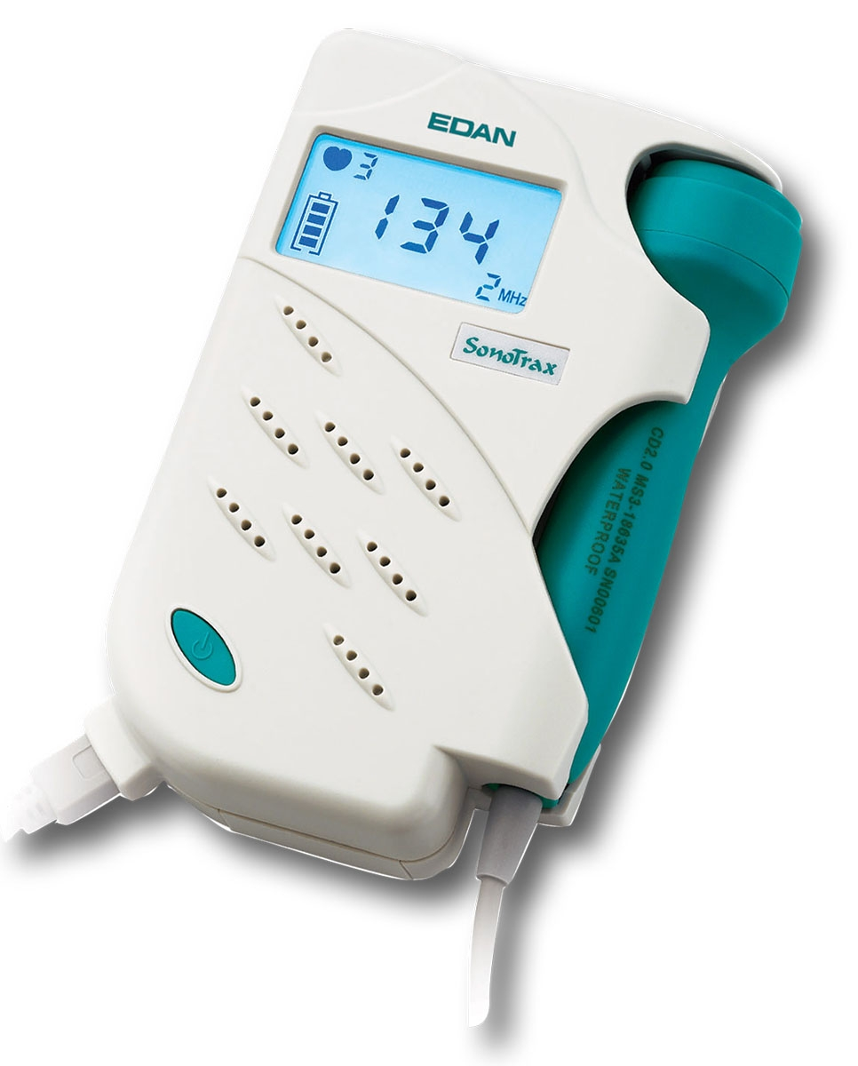
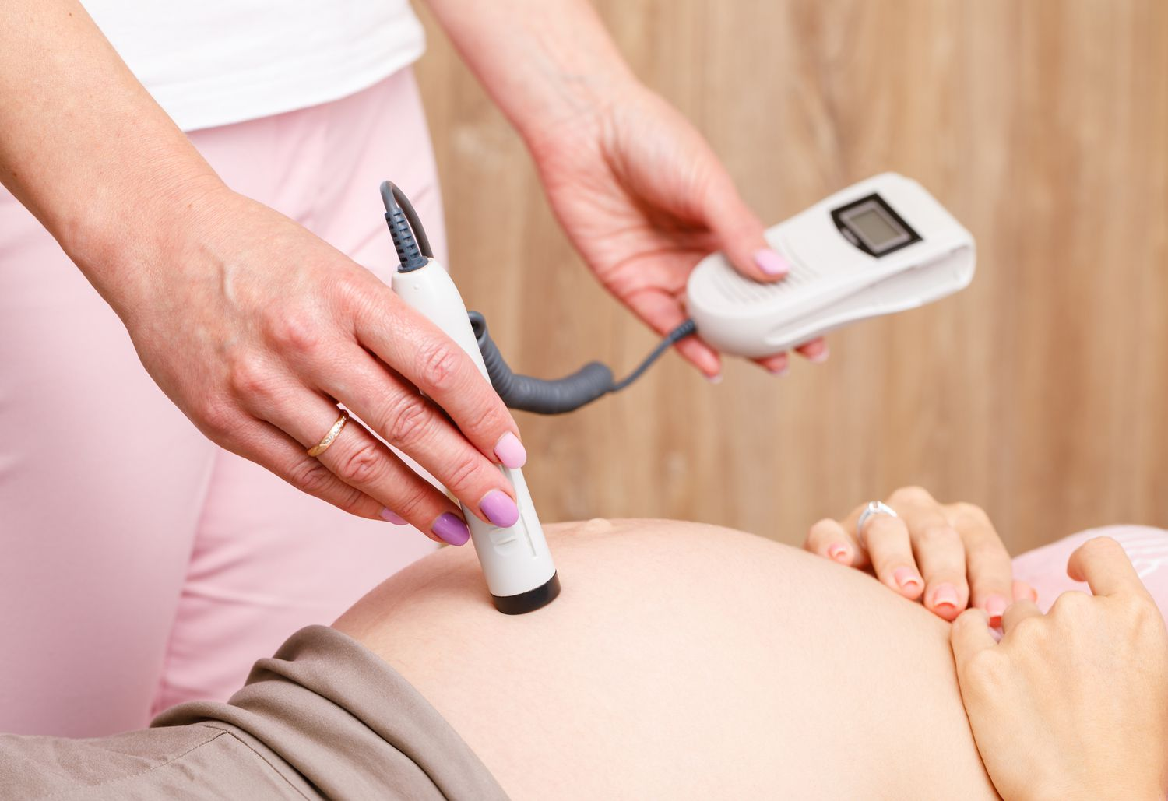

Continuous Doppler Ultrasound: uses an ultrasound transducer held in place on the abdomen with an elastic strap.

Often used for ongoing monitoring in the later stages of labour.

The transducer attaches to a monitor that provides a continuous readout of the baby’s heart rate.

Continuous foetal heart monitors often produce printed output of the heart heart rhythm on chart paper for easy visual analysis.

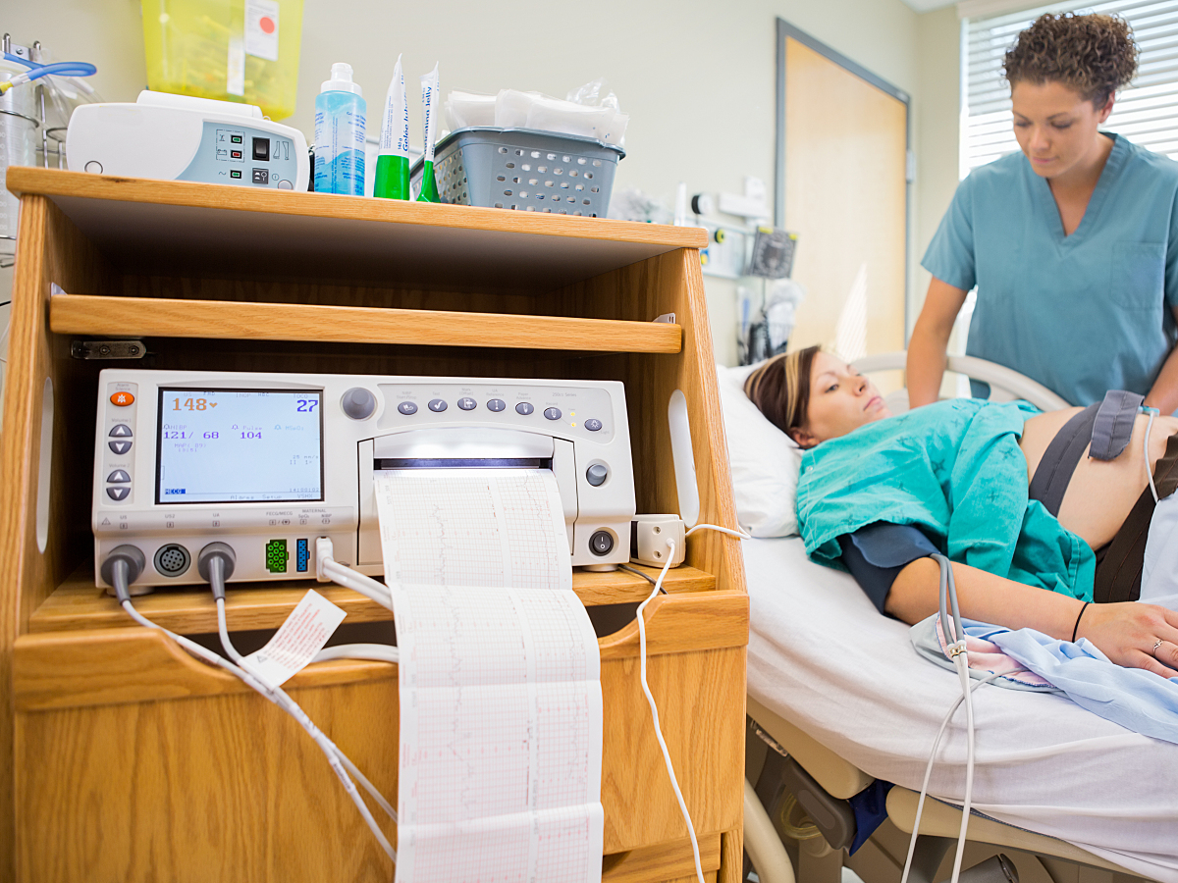
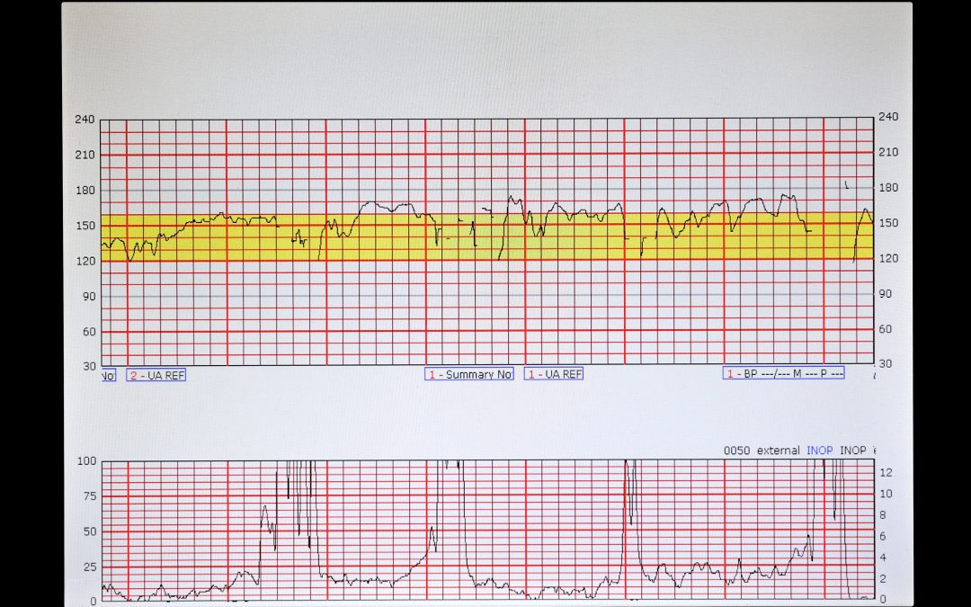

Where is a V1000 used?

By engineers for:

- Fault finding and diagnosis of the monitor and transducer.
- Soak testing of the monitor.
- As part of a Planned Preventative Maintenance* procedure.
- Verification of correct chart paper installed.

By midwives & clinicians for:

- Testing monitors and transducers prior to use.
- Verification of correct chart paper installed.

For teaching purposes:

- Simulation of the foetal heart and training in the use of monitoring equipment.

*Planned preventative maintenance (PPM) is usually in the form of an annual check by the end user, which in an NHS Hospital is done by the Clinical Engineering / EBME / Medical Engineering / Medical Physics Department.

How does the V1000 work?

The V1000 has an internal transducer, which is actually a speaker, that is used to play a sound file that replicates a baby’s heart.

The speaker generates sound by vibrating backwards and forwards, and it is this movement that is picked up by the ultrasound device.

The ultrasound transducer is placed on the target area of the V1000 using a layer of ultrasound gel.

Target heart rate is set by pressing the rate button. Heart rates of 30, 60, 90, 120, 150, 180 and 210 BPM (beats per minute) are available, along with an ‘auto’ cycle of 30s duration at each rate that repeats until deselected or the device is turned off.

The amplitude (volume) can be adjusted using the intensity knob.

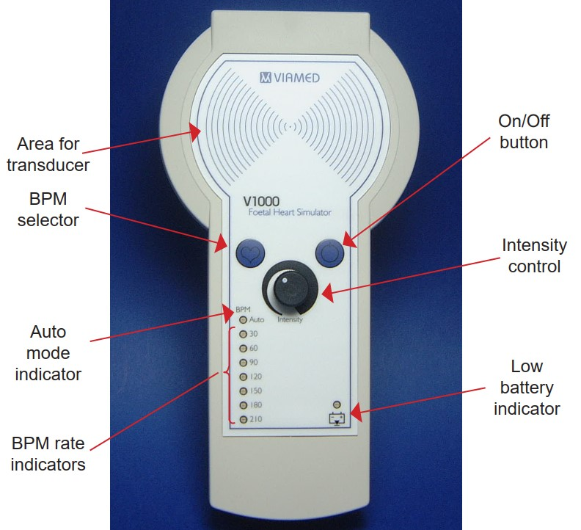

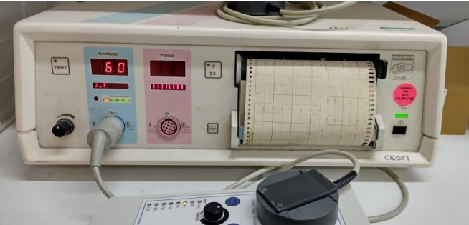
Maintenance

The V1000 features a liquid filled bag, known as a transducer cushion, that sits on top of the transducer under the front casing.

The transducer moves the liquid in the cushion back and forth. The liquid has a similar density to the muscles of the heart, which the ultrasound devices sees in the same way as it would moving heart tissue.

Over time, this liquid can escape through the bag at a molecular level, reducing the volume inside the bag and degrading the performance of the V1000.

We recommend that the V1000 be checked annually, a performance evaluation sheet is included in the user manual.

If returned to Viamed for service, the transducer cushion will be inspected and replaced if required at no additional cost.

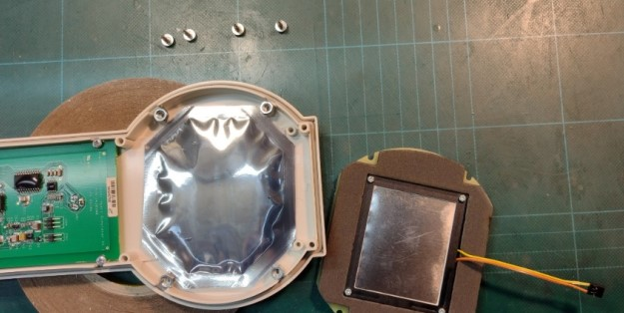

Accessories

The V1000 is supplied in a hard carrying case. An optional soft carrying case is also available whilst stocks last, p/n 0013110.
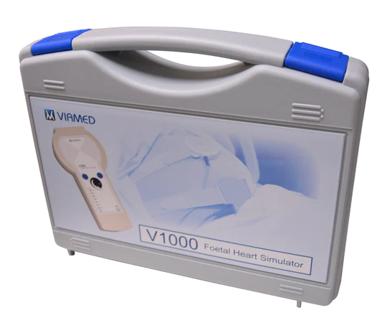
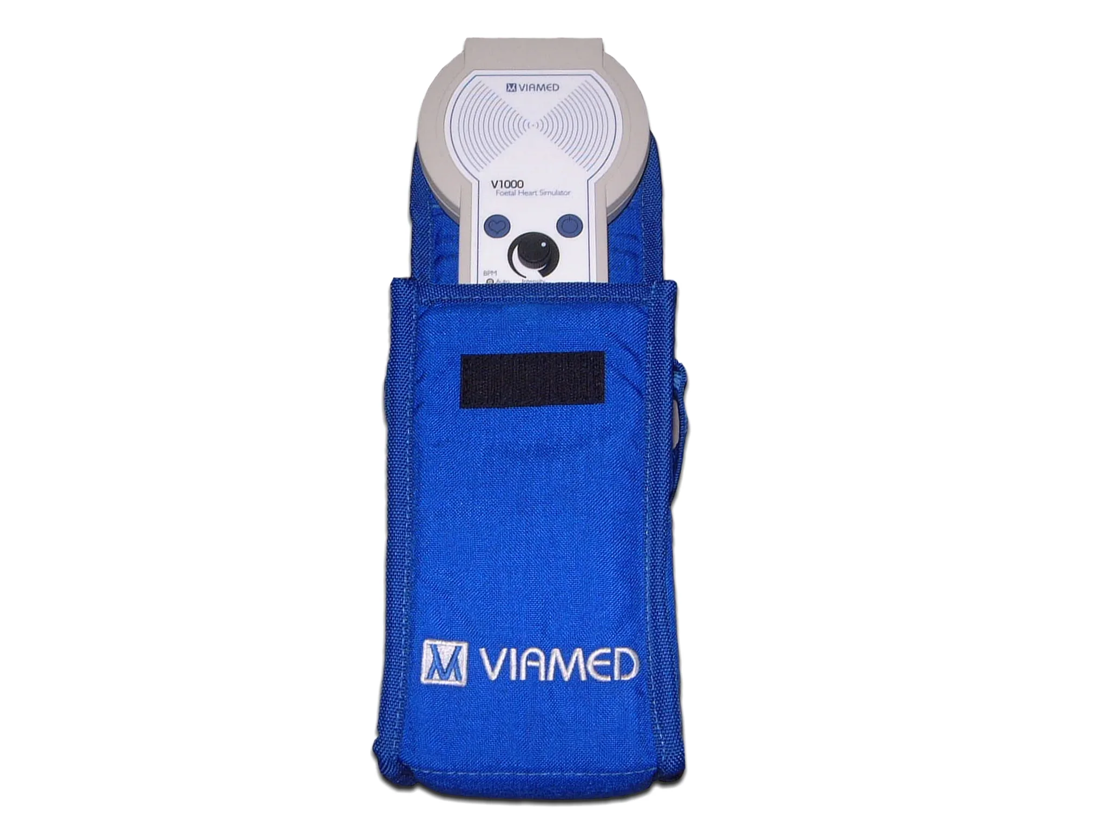
A rubber case protector protector is available, p/n 1420001. Also a wall mount, p/n 1420000.
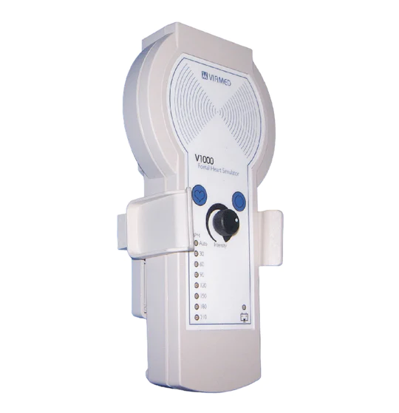
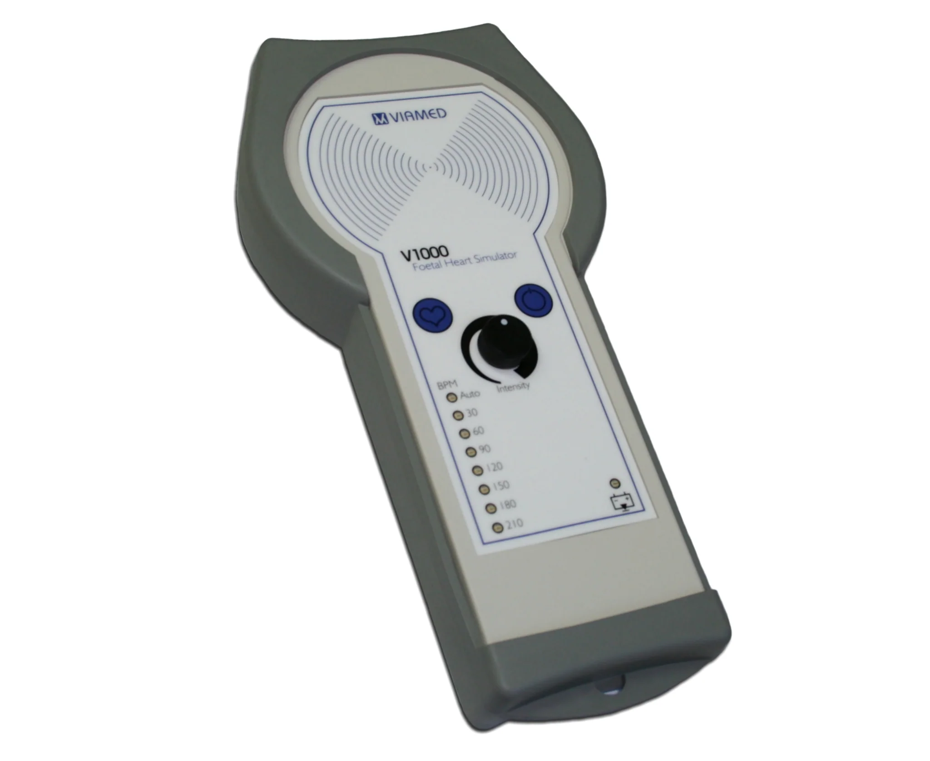
Batteries

When the V1000 detects that the batteries are nearing depletion, the low battery indicator will begin to flash red.

The V1000 takes 4 1.5V AA/MN1500/LR6 alkaline batteries, which can be replaced by the user.

Can the V1000 be calibrated?

No, the output BPM is governed by the firmware and the micro-processor, there is no adjustable calibration control.

If required, the unit can be returned to Viamed for its accuracy to be checked and a Certificate of Calibration can be issued:

- 1480000 – V1000 Foetal Heart Simulator Functional Check Service

A device isn't picking up 30 bpm, does it need a repair?

Most foetal heart monitors don't read as low as 30bpm but the function exists for those that do.

Can the V1000 be used to calibrate a foetal heart monitor?

The V1000 cannot be used as a calibrator; it is intended for indication only. However, it can be used to verify whether a foetal monitor appears to be operating outside of its specification and is in need of calibrating by the manufacturer.

Can we issue a calibration certificate for brand new devices?

Yes, a certificate can be issued from new at additional cost due to additional work involved.

- 1480001 – V1000 Foetal Heart Simulator Calibration Certificate
Warranty

The customer warranty is 12 months from the date of invoice.

Latex

All devices and all accessories are latex-free.

Where to find additional information

- Viamed website
- Product leaflets – linked to stock pages
- FAQs on the stock page
- Memos on the stock page
- Instructions for use

