Flowsensors – Technical Training

What are flowsensors?

Flowsensors are used in both intensive care ventilators and anaesthetic ventilators to accurately measure the flow of gases during ventilation, this allows the ventilator to monitor and regulate the patient’s breathing cycle.

Ventilators apply positive pressure to deliver breathing gas to the patient’s lungs. They are able to automatically adapt to changes in lung function or patient breathing, to do this they need to know the flow rate of gas going to and from the patient.

This allows the ventilator to calculate the inspired and expired volumes, known as the tidal volume, and it uses this information to regulate the breathing cycle.

Flowsensors are placed at the vent’s inspiratory and expiratory ports, and for more accurate readings, may also be placed proximally at the patient’s airway.
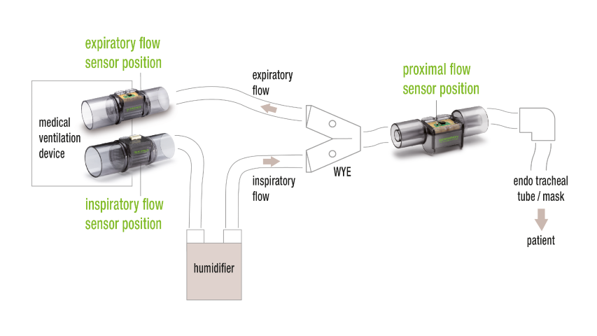
How do they work?

There are 2 methods used to determine gas flow in the flowsensors that Viamed supplies.

Hot wire anenometric* flowsensors work by measuring the change in electrical resistance of thin, heated wires. The resistance changes due to the cooling effect of the gas passing over the wires. The higher the cooling effect, the higher the flow of gas.
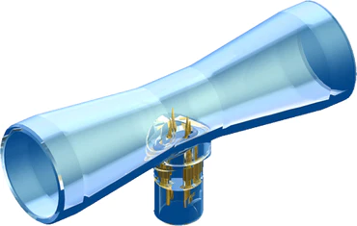
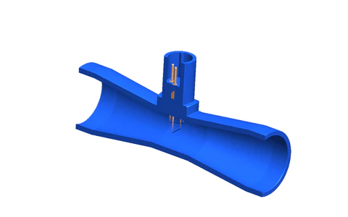
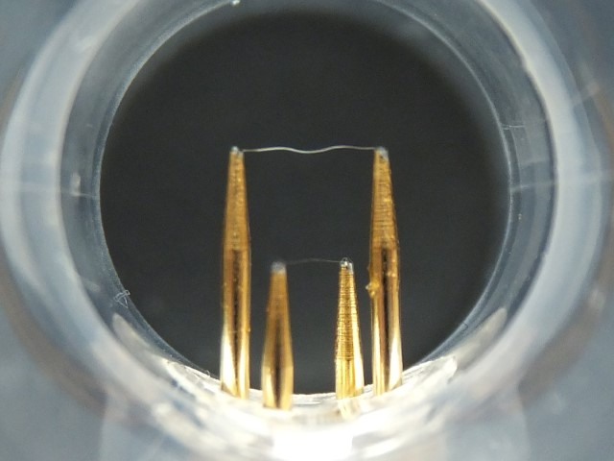
Drager compatible SpiroTrue A Flowsensor Cross section Internal view with sensing wires

Drager Spirolog flowsensors are of this type, Viamed supplies the following Bluepoint flowsensors for Drager devices:

- 4310007 - SpiroTrue A single-use flow sensor. Box of 5.
Can be cleaned as per manufacturer’s instructions, however, it is recommended that be considered single-use.

- 4310008 - SpiroTrue A (PC) - Autoclavable flow sensor. Box of 5.
Can be cleaned by immersion in specific cleaning agents as per manufacturer’s instructions.
Can be autoclaved up to 100 cycles at 134C but cannot be cleaned using automated cleaning or disinfection equipment, as this damages the wires.

Life cycle of both sensors is limited. It can be used as long as calibration in the anaesthesia or ventilation equipment is possible.

*Anenometric - pertaining to the measurement of wind speed and direction
Pressure differential flowsensors introduce a restriction in the airflow that creates a pressure drop across the flowsensor.

Tubes connected to either side of the orifice feed pressure back to the ventilator.

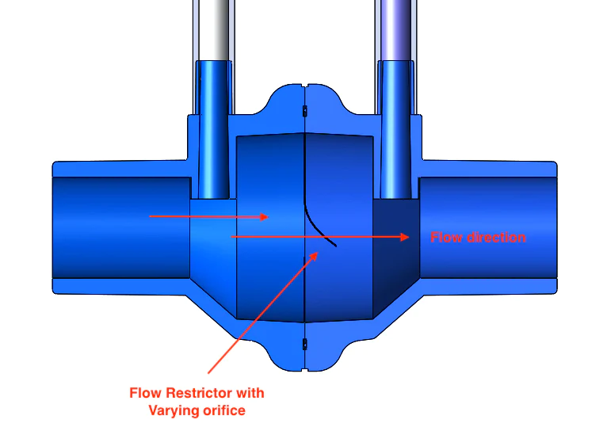
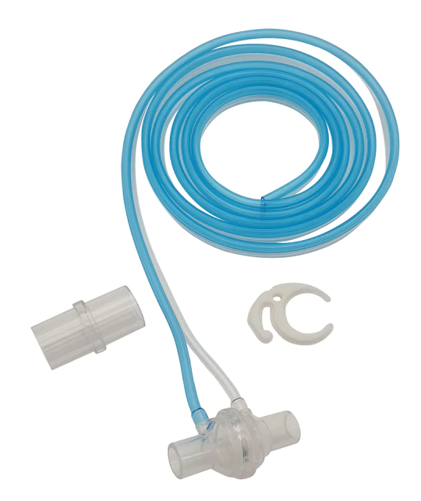
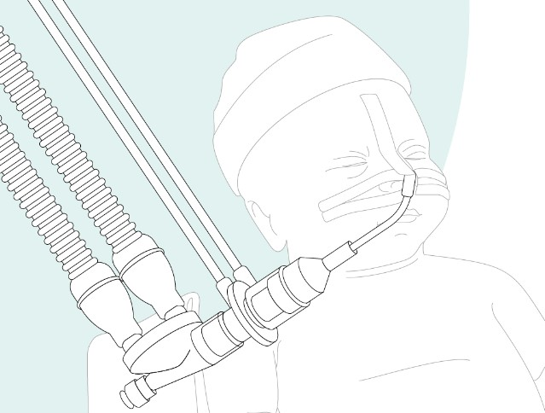
Hamilton compatible Flowsensor H Cross section Typical positioning for Pressure differential flowsensors (proximal)

When the flow increases, more pressure drop is created, which the ventilator can use to calculate the flow rate.

Hamilton flowsensors are of this type, Viamed supplies the following Bluepoint flowsensor for Hamilton devices:

- 4310009 - SpiroTrue H - Single use flow sensor. Box of 6

These are single-use and cannot cleaned or autoclaved.
Future development

Development is under way for a Drager compatible Neonatal Flowsensor, which at this stage is unreleased.

Warranty

The customer warranty is limited to out-of-box failures.

Latex

All devices and all accessories are latex-free.

Where to find additional information

- Viamed website
- Product leaflets – linked to stock pages
- FAQs on the stock page
- Memos on the stock page
- Instructions For Use
- Cross reference page

