Air/Oxygen Blenders – Technical Training

What is an air/oxygen blender and what does it do?

Hospitals use medical grade air and oxygen, which in modern hospitals is piped to the departments though gas pipeline systems installed in the walls.

An air/oxygen blender is a medical device used to mix air and oxygen to deliver gas with a precise concentration of oxygen to patients.

Blenders are connected to the gas source using 4 Bar* air and oxygen hoses, and can be operated from gas cylinders or from gas pipeline systems.

Viamed currently supplies the following manufacturers’ blenders:

- Inspiration Healthcare – UK based supplier that uses Bio-Med Devices blenders under their own labelling

- Maxtec – offers standard blenders (MicroMax series) alongside blenders with built-in oxygen monitoring (MaxBlend series) and blenders that can operate without piped air (MaxVenturi) [note: the latter 2 will be covered on a separate training presentation].
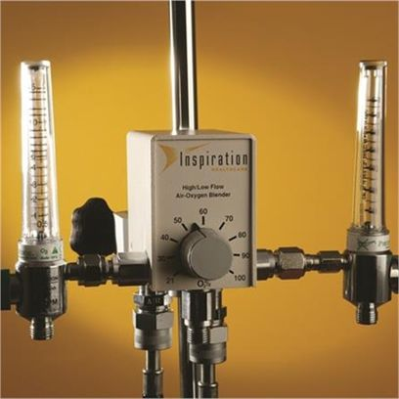
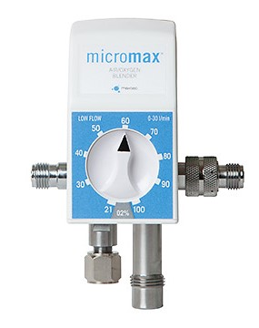
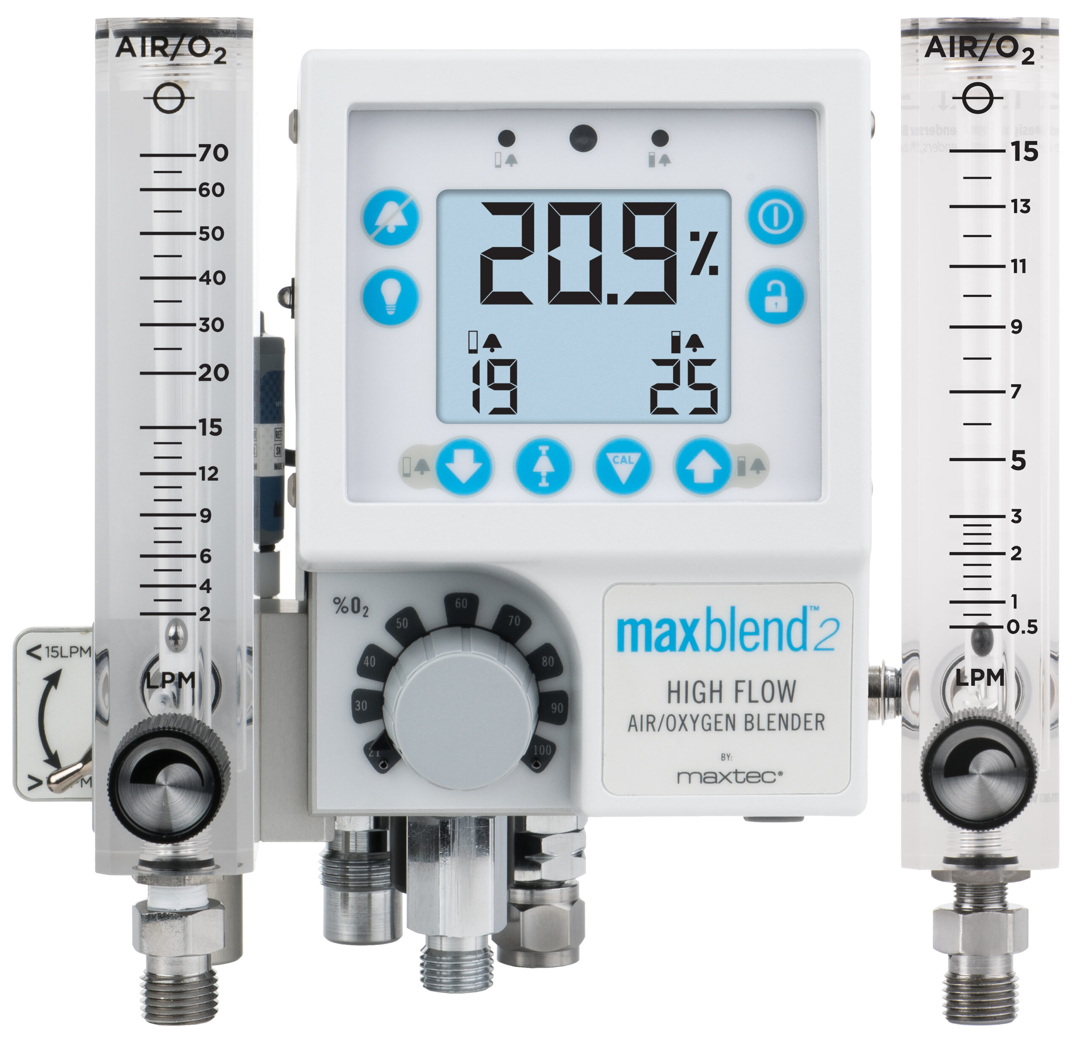
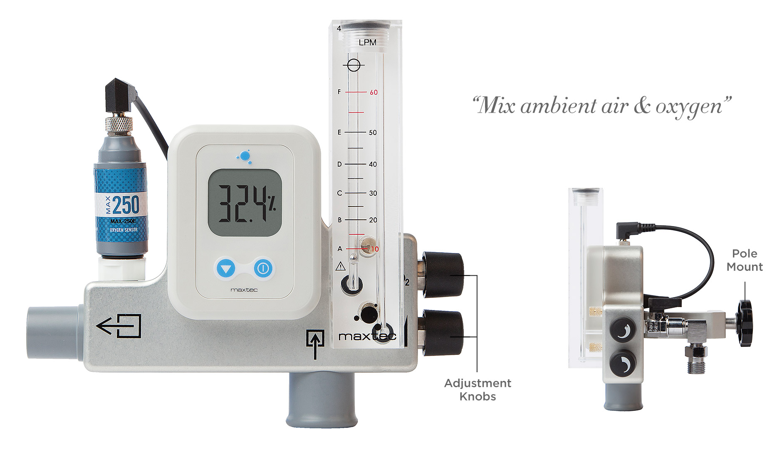
Inspiration Healthcare air/oxygen blender Maxtec MicroMax air/oxygen blender Maxtec MaxBlend2 air/oxygen blender Maxtec MaxVenturi blender

*4 Bar is a measure of pressure, equal to 4x atmospheric pressure or 50 psi

What are blenders used for?

Some patients require additional oxygen, but not necessarily at a concentration of 100% pure oxygen, which can be harmful at this concentration for certain patients, notably neonates.

A blender allows the oxygen concentration to be precisely adjusted according to the specific needs of the patient.

What types of blenders are available?

Generally, they can be broken down into 2 main types:

- High Flow Blenders – These are used for applications requiring higher flow rates, typically ranging from 15 to 120 litres per minute (lpm).

- Low Flow Blenders – These are designed for applications that require precise control at lower flow rates, typically delivering flow rates from 3 to 30 lpm, making them ideal for neonatal and paediatric settings.

Where are they used?

Blenders are used in many departments where precise control of supplemental oxygen is required, such as:

- Neonatal Intensive Care Unit (NICU)
- Adult Intensive Care Unit (ICU / ITU)
- Paediatric Intensive Care Unit (PICU)
- High Dependency Unit (HDU)
- Accident & Emergency
- Theatre Recovery
- Respiratory Wards

Viamed’s blender sales have mostly been low-flow devices for use in Delivery Suites and Neonatal Units to support the Tom Thumb infant resuscitator and the Viamed infant resuscitation cabinet system.

The blender allows the delivery of breathing gas mixtures from 21% oxygen up to 100% oxygen, which is fed into a Tom Thumb infant resuscitator to allow the resuscitation of neonates shortly after birth.

Initial delivered oxygen concentration depends upon gestation*:

- ≥ 32 weeks gestation: 21% oxygen
- 28-32 weeks: 21-30% oxygen
- < 28 weeks: 30% oxygen.

* Source: Newborn resuscitation and support of transition of infants at birth guidelines
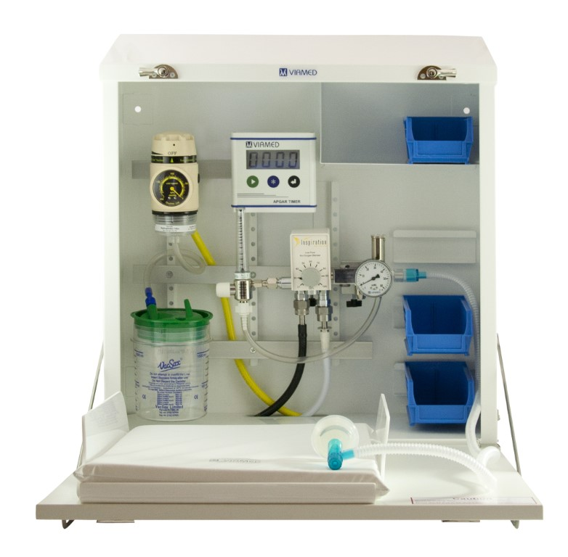
Viamed infant resuscitation cabinet

How do blenders work?

Blenders take medical grade air and oxygen into the device using hoses with keyed gas inlets.

There are a number of different international standards for gas connectors that determine their size and shape; they are designed to allow only the correct gas to be connected to a particular fitting for patient safety.

Each country will standardise on a particular fitting type. In the UK, blenders are supplied with NIST* fittings and require the corresponding NIST hoses. For other countries, we need to determine the connection type; the next most common type is DISS**.
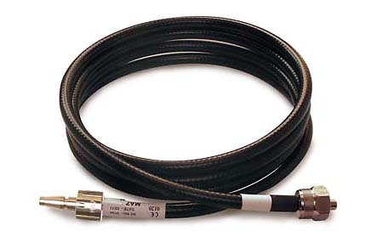
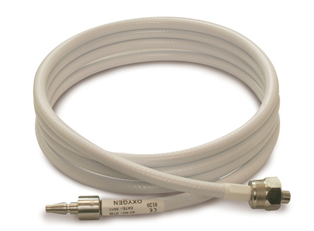
Air hose with NIST connector (right side of image) Oxygen hose with NIST connector (right side of image)

Hoses in the UK are colour coded black for air (or less commonly, black and white stripes) and white for oxygen.

*NIST - National Institute of Standards and Technology
**DISS - Diameter Index Safety System

The blender uses internal diaphragms and a valve that is connected to the adjustable concentration knob on the front of the blender, which regulates the amount of each gas that is put into the mixture, allowing mixes from 21% to 100% oxygen.

When calibrated, the delivered gas concentration can be known to within +/- 3% of Full Scale.

The flow of gas from the blender is regulated using a flowmeter, typically 0-15 lpm on a low-flow blender and 0-60 lpm on a high-flow.

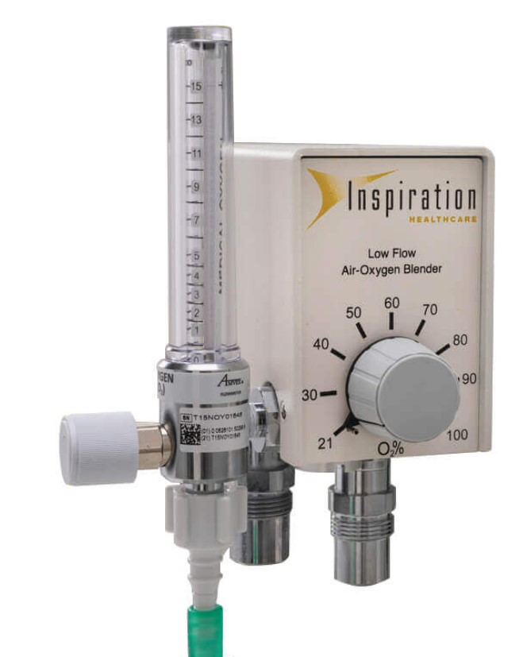
Inspiration Healthcare low-flow blender with 0-15 lpm flowmeter attached.

What accessories are available?

Inspiration Healthcare blenders are available as a kit, complete with hoses, a flowmeter and a choice of rail mounting or pole mounting bracket. The following are the NIST versions for the UK market.

Low-Flow

- 0310200 - Low Flow Air / Oxygen Blender, 0 - 30 lpm with rail mounting bracket
- 0310207 - Low Flow Air / Oxygen Blender, 0 - 30 lpm with pole mounting bracket

High-Flow

- 0310205 - High/Low Flow Air / Oxygen Blender, 2 - 120 lpm with rail mounting bracket
- 0310204 - High/Low Flow Air / Oxygen Blender, 2 - 120 lpm with pole mounting bracket

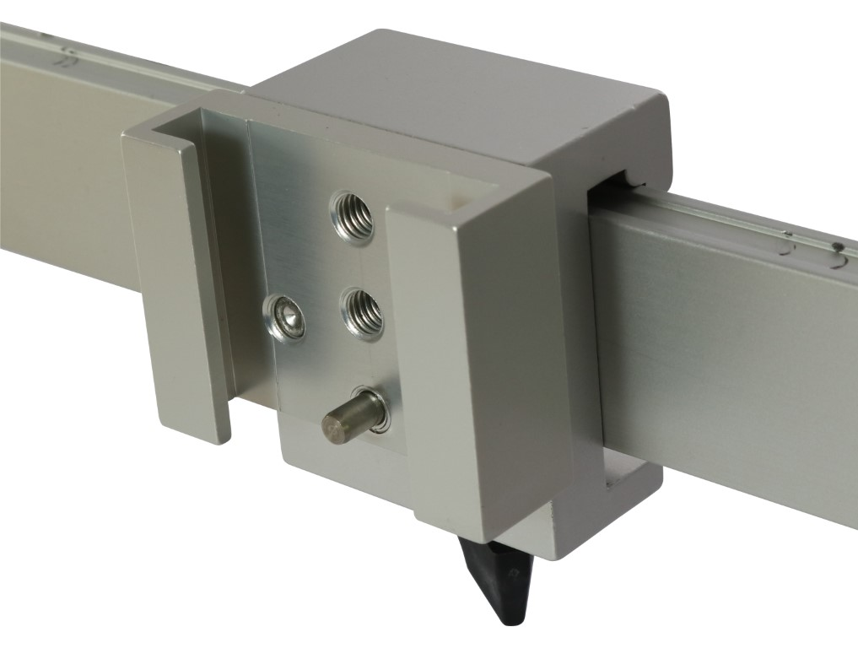
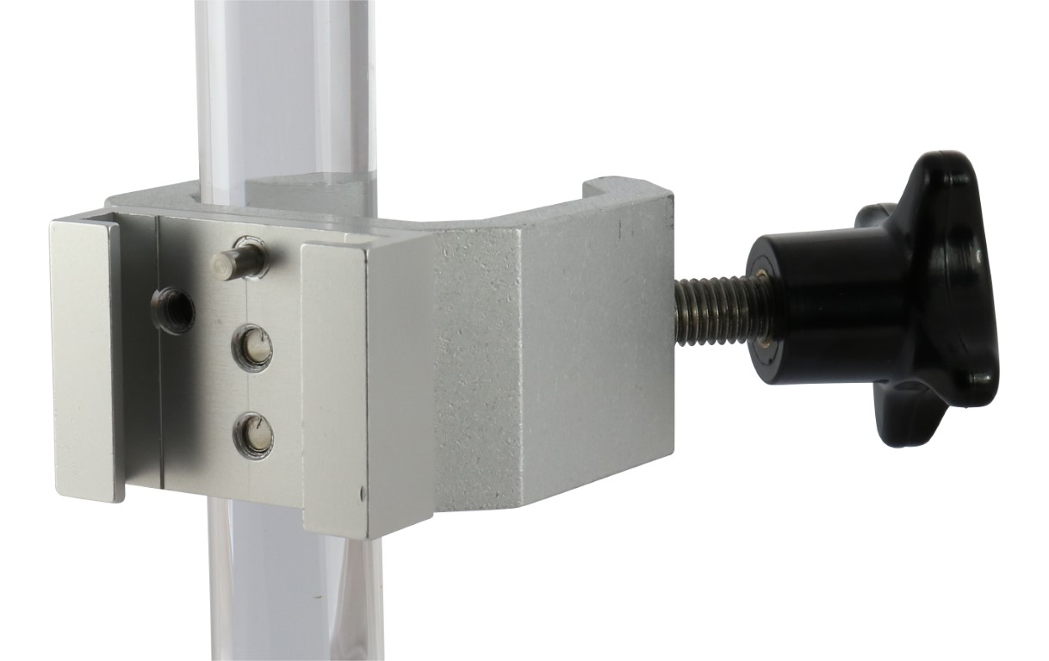
0320214 rail mounting bracket 0320213 pole mounting bracket

For export enquiries, please consult the Export Manager to determine whether a NIST, DISS or another standard is required.

Maxtec MicroMax blenders are supplied without hoses and flowmeter. The following are the NIST versions for the UK market.

Low-Flow

- 5610151 MicroMax Series Low Flow Air/O2 Blender (NIST)

High-Flow

- 5610153 MicroMax Series High Flow Air/O2 Blender (NIST)

For export enquiries, please consult the Export Manager to determine whether a NIST, DISS or another standard is required.

Flowmeters for MicroMax

- 5620220 Flowmeter 0-15 lpm with white knob

Note: we do not currently have the high-flow flowmeters on the system, if enquiries are received for this, please consult the Commerical Director determine availability, price and part number.

Hoses for Inspiration Healthcare and MicroMax Blenders

We currently offer the following 2 types of NIST hose for UK customers. The default length is 3m, but other lengths may be available upon request if required.

- 0320216 NIST Hose with Oxygen Probe 3.0m
- 0320217 NIST Hose with Air Probe 3.0m

For export enquiries, please consult the Export Manager to determine whether a NIST, DISS or another standard is required.

Maintenance/Service

Blenders should be serviced regularly in line with the service manuals.

Inspiration Healthcare recommend that in the UK and countries with high quality standards for their pipeline gas supplies, blenders should undergo an annual service with a full overhaul service every 4 years.

Annual service – requires routine replacement of parts and a calibration check

- 0380020 Blender Service – Return to base.
- Includes the annual service kit, which is also available separately, p/n 0332000

Overhaul service – requires a complete strip-down and ultrasonic cleaning of the device and a calibration check

- 0380019 Blender Overhaul Service – Return to base
- Includes the overhaul service kit, which is also available separately, p/n 0332001

Note: most NHS hospitals have a policy to replace hoses every 4 years, so we always offer to supply replacement hoses with overhaul services, which are charged separately.

Maxtec recommend that MicroMax blenders undergo a full overhaul service every 2 years. They make no stipulation for annual service, but Viamed can perform a calibration check annually if required.

- 0380050 MicroMax Blender 2yr Overhaul Service – Back to Base (excludes overhaul parts kit)
- 0332004 Blender, Low Flow – Overhaul Kit. 2yr service kit
- 0332006 Blender, High Flow – Overhaul Kit. 2yr service kit

Return carriage is chargeable for all devices returned to Viamed for service.

Warranty

The customer warranty is 12 months from the date of invoice for Inspiration Healthcare blenders, and 24 months for Maxtec Micromax blenders.

Latex

All products and packaging are latex-free.

Where to find additional information

- Viamed website
- Manufacturers’ websites
- User manual
- Service manuals
- Product leaflets – linked to stock pages
- Technical datasheets – linked to stock pages
- FAQs on the stock page
- Memos on the stock page

