Disposable EEG Sensors – Technical Training

What are EEG sensors?

EEG sensors are disposable, self-adhesive sensors used with Bispectral Index (BIS) Monitors (as used by Medtronic and partner companies using their technology) and with Entropy Monitors (used by GE and their partners).

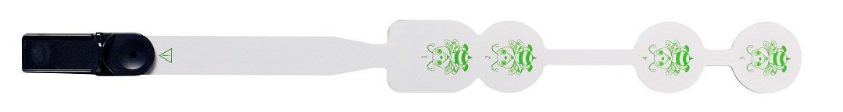
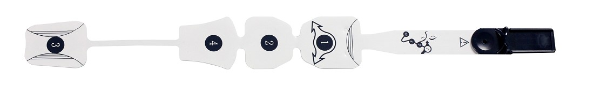
MK-01 (4610010) EEG Sensor for BIS Monitoring (Adult) MK-02 (4610011) EEG Sensor for BIS Monitoring (Paediatric)
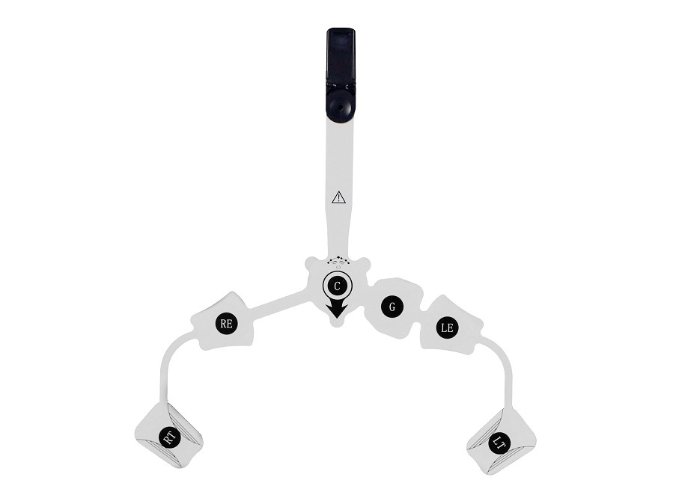
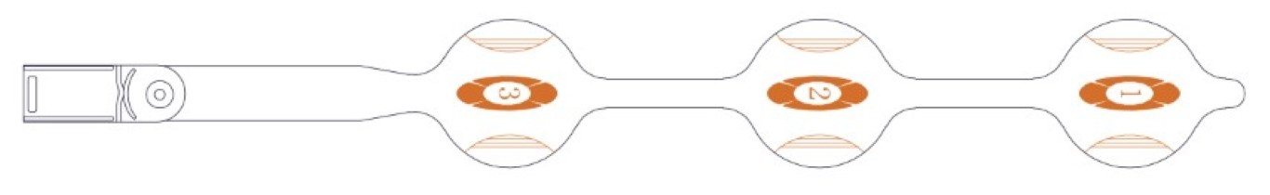
MK-03 (4610013) EEG Sensor for Entropy Monitoring

MK-04 (4610012) Bilateral EEG Sensor for BIS Monitoring

How does EEG monitoring work?

A number of electrodes are placed on the scalp and the electrical activity of the brain is recorded non-invasively.

Electrical activity within the brain changes at different levels of consciousness.
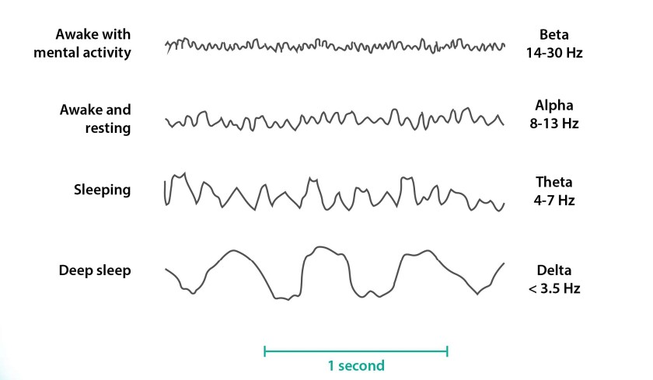
EEG can be used to detect various brain-related disorders such as seizure disorders, sleep-related abnormalities, head injuries, encephalitis and dementia. It can also be used to determine depth of anaesthesia.

BIS monitors and Entropy monitors both use the EEG data to determine the depth of anaesthesia but they use different algorithms and processes to analyse brain activity.

What does ‘depth of anaesthesia’ mean and why is it important?

General anaesthesia can be broken down into three key stages:

- Induction – This is the initial phase where the patient is transitioned from a state of consciousness to unconsciousness.

- Maintenance – During this phase, the patient is kept in a continued unconscious state.

- Emergence – This is the final stage where the patient is brought back to consciousness after the procedure is completed.

These stages are critical for the safe and effective management of anaesthesia during surgical procedures. Anaesthesiologists use EEG monitoring to:

- Optimize drug dosages.

- Prevent anaesthesia awareness (waking up during surgery).

- Avoid excessive anaesthesia depth.

- Tailor anaesthesia to individual patients.

What is Bispectral Index (BIS) monitoring?

Bispectral Index (BIS) monitoring is one technology used to monitor depth of anaesthesia (owned by Medtronic), another type being entropy monitoring (owned be GE Healthcare).

BIS relies on analysing the patient’s EEG (Electroencephalogram), which is a measure of electrical brain activity.

BIS bilateral sensors are designed for symmetrical placement on the patient’s forehead to capture data from both hemispheres of the brain, which offers advanced monitoring applications.

BIS Monitors

Bispectral Index™ and BIS™ are trademarks owned by Medtronic. Many manufacturers use Medtronic technology rather than developing their own.

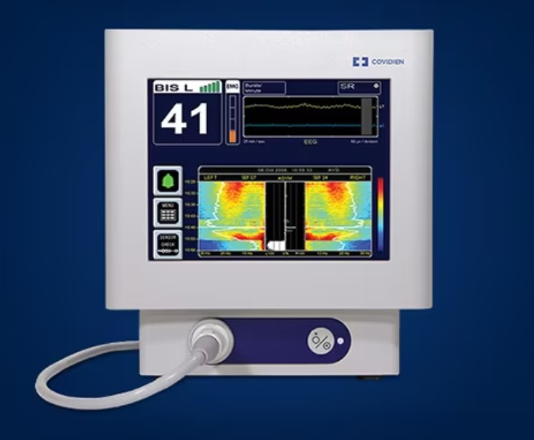
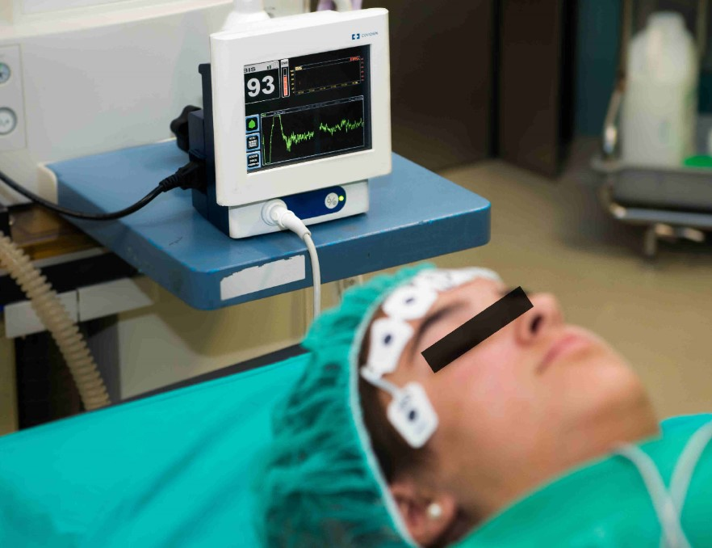
Medtronic BIS Monitor Patient with BIS Sensor Applied

What is Entropy monitoring?

Entropy is a measure of irregularity in any signal. During general anaesthesia, EEG changes from irregular to more regular patterns
when anaesthesia deepens.

- Highly irregular signals may indicate that the patient is awake.

- More ordered signals with less variation in wavelength and amplitude indicates the suppression of brain electrical activity.

Entropy monitoring responds faster to changes than BIS. The choice between BIS and Entropy monitoring may depend on the specific requirements of the clinical setting and the available anaesthesia equipment.

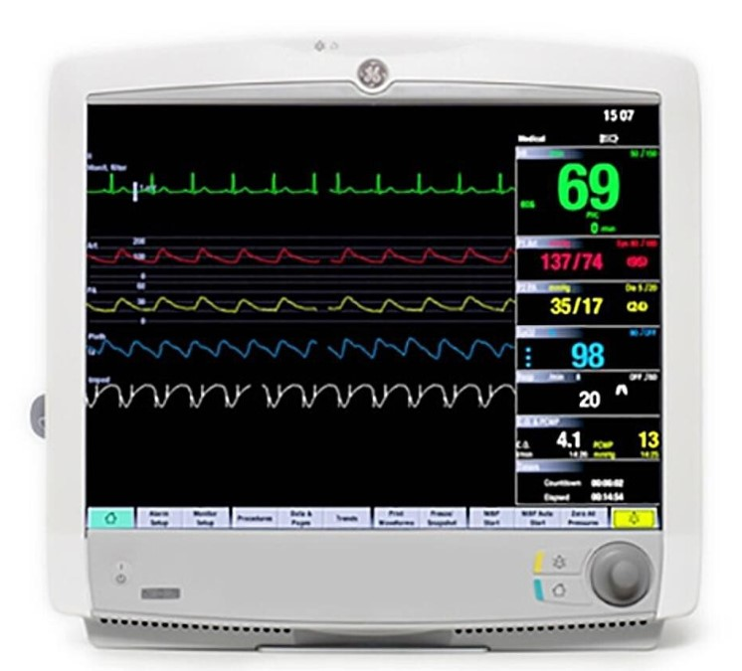
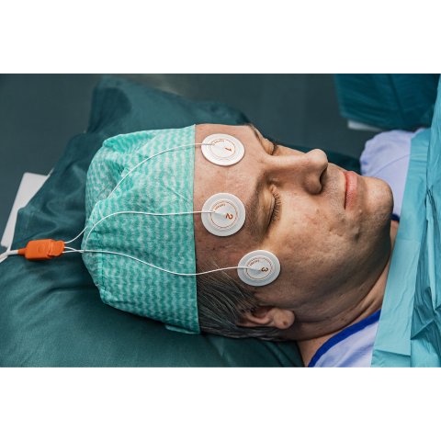
GE Carescape Patient Monitor with Entropy Monitoring Patient with Entropy Sensor Applied

The types of EEG sensors that Viamed offers

Viamed offers sensors manufactured by Medker, supplied by Anandic. There are sensors for both BIS monitoring and entropy monitoring:

BIS sensors

Viamed p/n | Anandic p/n | Description | Type | Units | Medtronic p/n
4610010 | MK-01 | Single use EEG Sensor for Measurement of Bispectral Index – Adult | Adult | Box/25 | 186-0106
4610011 | MK-02 | Single use EEG Sensor for Measurement of Bispectral Index – Paed | Paed | Box/25 | 186-0200
4610012 | MK-04 | Single use EEG Sensor for Measurement of Bispectral Index – Bilateral | Bilateral | Box/25 | 186-0212

Compatible with Medtronic BIS Monitors and partners using their technology.

Entropy sensors

Viamed p/n | Anandic p/n | Description | Type | Units | GE p/n
4610013 | MK-03 | Single Use EEG Entropy Sensor | Adult | Box/25 | M1174413

Compatible with GE Entropy Monitors and partners using their technology.

Which departments in a hospital use these sensors?

Primarily Theatres where general anaesthesia is performed, and Intensive Care and High Dependency Units where patients may undergo long-term sedation.
Warranty

Warranty is limited to out of packet failure / batch failure only.

Latex

All sensors are latex-free.

Where to find additional information

• Viamed website
• Product leaflets – linked to stock pages
• FAQs on the stock page
• Memos on the stock page
• Instructions For Use
• Cross reference page

