Automotive Oxygen Sensors – Technical Training

What are oxygen sensors?

Oxygen sensors (sometimes called fuel cells) are similar to batteries in that they give out a voltage. However, unlike a battery, the voltage from an oxygen sensor is directly proportional to the amount of oxygen that the sensor is being exposed to.

They are used to measure the level of oxygen in various applications, such as medical devices, industrial processes and automotive vehicle emissions testing, which forms part of the MOT test.

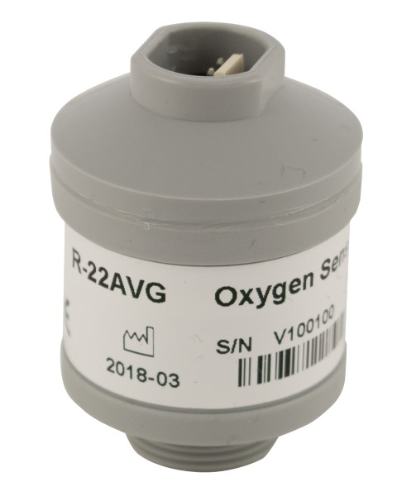
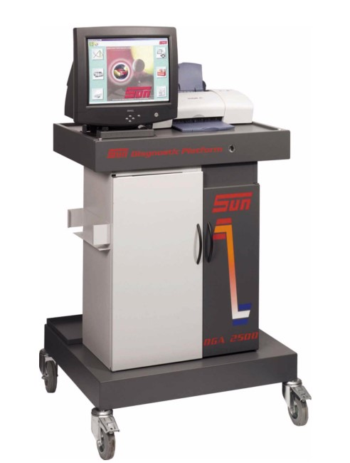
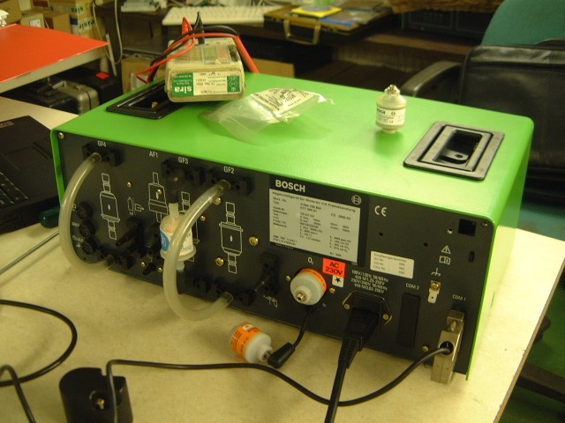
R-22AVG Oxygen sensor Sun Emissions Tester Bosch Emissions Tester

How do they work?

Oxygen sensors contain an anode*, a cathode** and a liquid electrolyte*** solution, housed in a sensor body with a thin membrane that prevents the liquid electrolyte from escaping but allows oxygen to pass into the sensor at a molecular level.

The sensor has electrical connections to allow connection to the emissions tester, typically this will be a 3.5mm jack plug or a 3-pin Molex connector.

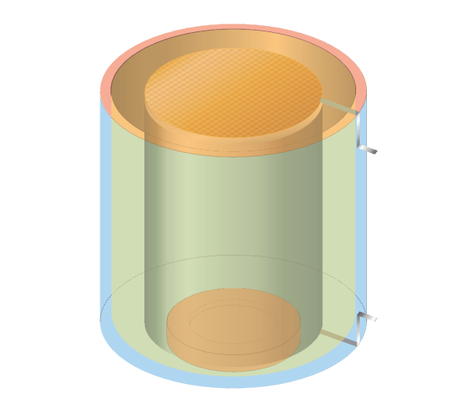
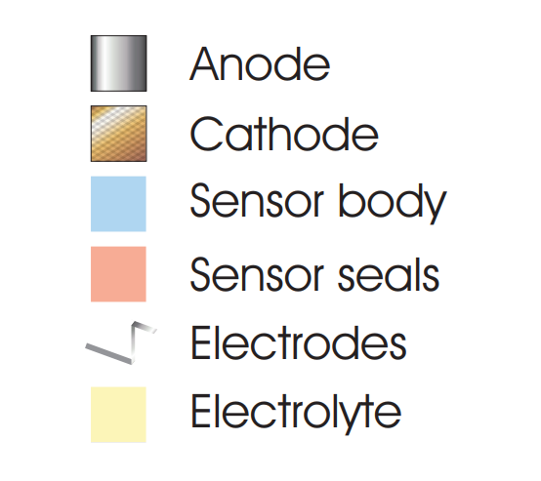
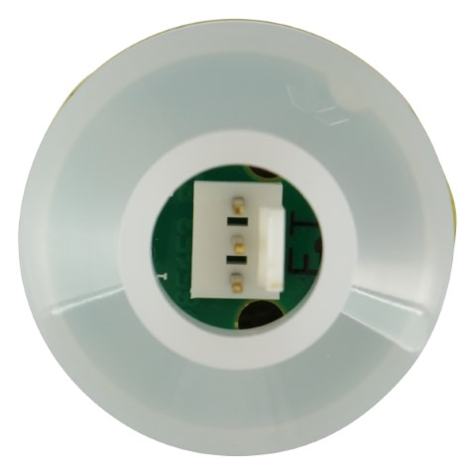
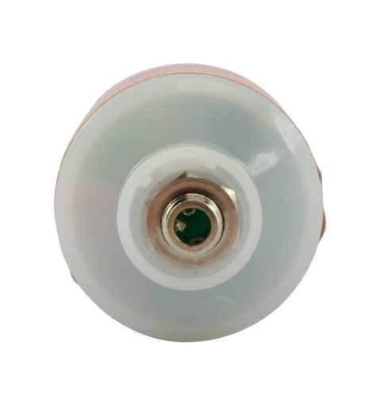
Schematic of a typical oxygen sensor Oxygen sensor with 3-pin Molex Oxygen sensor with 3.5mm jack plug

*anode – the electronically positive component of a battery or fuel cell: currently lead, although lead-free legislation is on the way.
**cathode – the electronically negative component of a battery or fuel cell: made from a noble metal.
***electrolyte – the fluid between the anode and cathode: potassium hydroxide which is strongly alkaline and can cause burns to skin.

Oxygen sensor output is typically in the range of 7.0 mV to 13.0 mV in air. The Teledyne R-17A, R-21A and R-22A operate in this range.
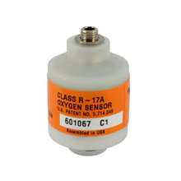
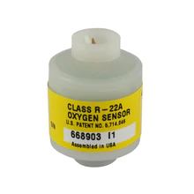
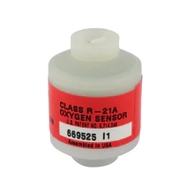
Note: the R-21A uses a 5/8-24 UNEF American Thread, all other sensors use a 16 mm metric thread.

Some emissions testers have been designed to operate with sensors that have a minimum input voltage of 9.0 mV in air. This would mean that some R-17A and R-22A sensors with outputs less than 9.0 mV may fail to calibrate on these devices.

To address this, Teledyne developed higher output versions of these sensors in the R-17AH and R-22AH, with outputs in the range of 10.5 mV – 13.5 mV in air.
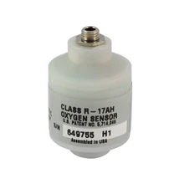
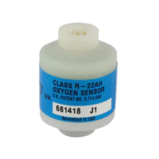

However, the ‘AH’ sensors were not an ideal solution, as some devices would then fail to calibrate with sensors over 13.0 mV. This meant that distributors and service engineers would need to stock both the standard and AH variants.

To address this, Viamed developed a multi-application solution by asking Teledyne for sensors in the range of 9.0 mV – 13.0 mV in air, the result was the R-17AV and R-22AV.

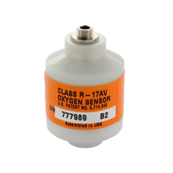
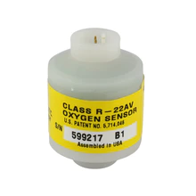
The AV designation denotes Automotive Viamed specification.

The output of the AV series sits within the overlap between the A and AH series, meaning that they act as a one-sensor solution and will work in place of both A and AH sensors:

- The R-17AV sensor can be used wherever the R-17A or R-17AH is used.
- The R-22AV sensor can be used wherever the R-22A or R-22AH is used.

Viamed later added an additional alternative solution by specifying Viamed branded sensors from Envitec / Honeywell with the 9.0 mV – 13.0 mV output, these are the R-17AVG and R-22AVG.

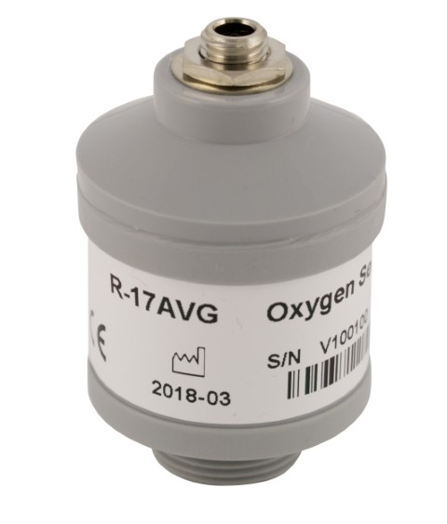
The AVG designation denotes Automotive Viamed Grey and is easily identified by the grey coloured sensor body.

The Viamed AVG series are directly compatible to the Teledyne AV series:

- The R-17AVG sensor can be used wherever the R-17A, R-17AH or R-17AV is used.
- The R-22AVG sensor can be used wherever the R-22A, R-22AH or R-22AV is used.

Some emissions testers are designed to work with sensors at lower outputs, notably Bosch devices.

Bosch sensors have an output specification of 7.0 mV - 11.5 mV in air.

The Teledyne R-17A-LV and Viamed R-17A-LVG are designed specifically for Bosch devices.
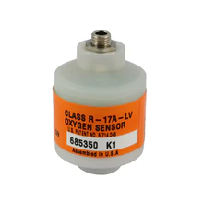
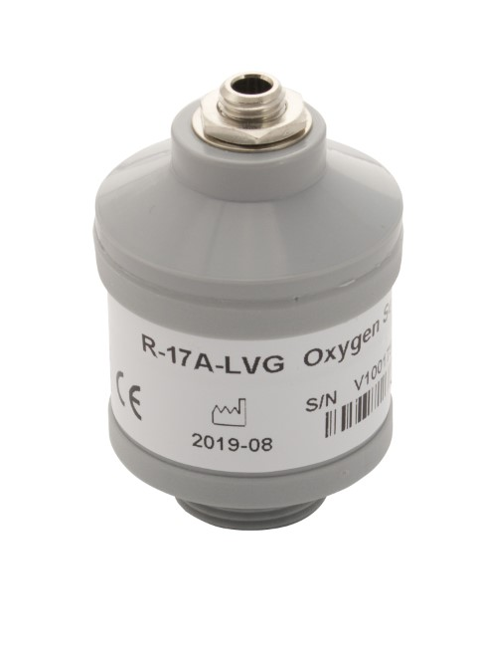
The A-LV designation denotes Automotive Low Voltage, this is the Teledyne version.

The A-LVG designation denotes Automotive Low Voltage Grey, this is the Viamed version with a grey coloured sensor body.

Shelf life

In order to prolong the shelf life of automotive oxygen sensors, they are sealed into gas barrier bags shortly after manufacture.

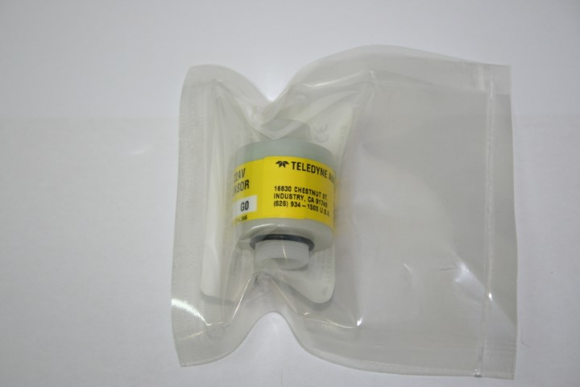

These bags restrict the transit of oxygen molecules from the outside to the inside of the bag, whilst the sensor consumes the available oxygen inside it.

Once the oxygen is consumed, the sensor output drops significantly and the sensor effectively ‘goes to sleep’.

The reaction does not stop entirely as some oxygen molecules still find their way through the gas barrier, but the effect is such that after 12 months inside the bag, a sensor will still retain approximately 90% of its original lifespan.

Viamed recommends that oxygen sensors be stored in unopened bags until required and are put into service before the warranty period expires.
Sensor packaging and boxes

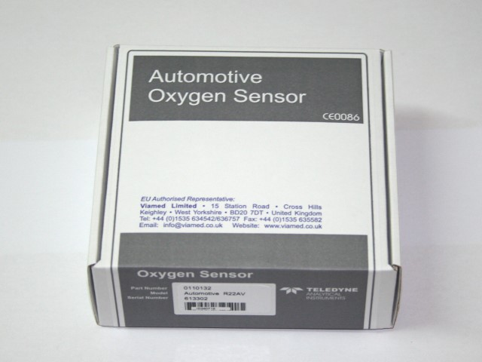
Sensors are packaged individually into sensor boxes, unless specified by the customer that they would prefer them bulk packed.

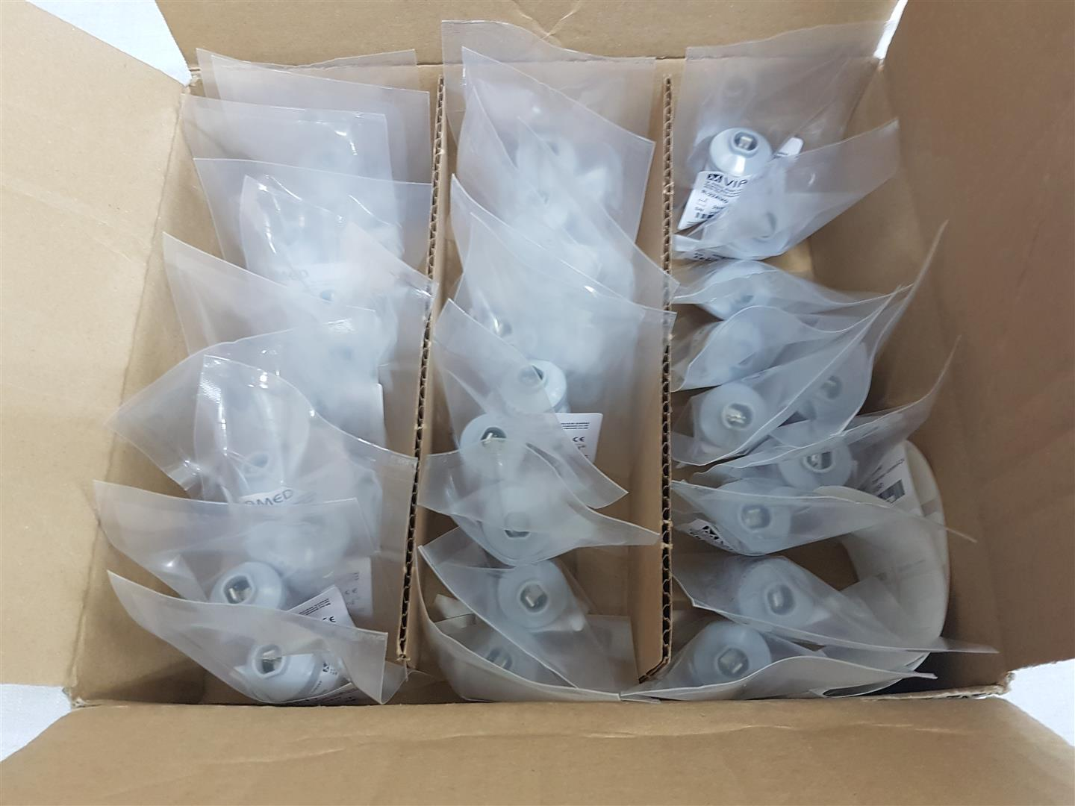
Advantage of individual boxes:

- Offers protection in storage or when carried by service engineers
- Less likely to result in bag punctures
- Allows onward posting without re-packaging when sold individually

Advantage of bulk packed boxes:

- Less waste packaging
- More compact storage and shipping

Check the customer memos to see whether a preference has been specified.

For customers that order in bulk, i.e. 100+ units at a time, ask if they would like them bulk packed and note their response on the memo.
Own brand labelling

For customers that order in high volumes and who request it, we have by special arrangement manufactured sensors using their own part numbers and labelling.

The main example of this is Prosol, for whom we manufacture Viamed R-17AVG and R-22AVG branded as Prosol GOC5230 and GOC5223 respectively.
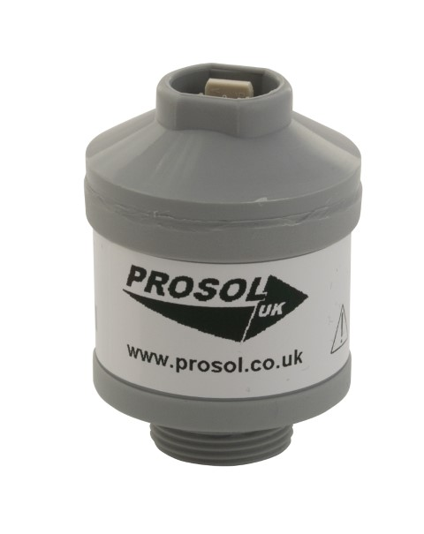
Viamed part number | Prosol part number | Base sensor model
0110364 | GOC5230 | R-17AVG
0110365 | GOC5223 | R-22AVG

There is currently a minimum requirement of 1,000 sensors per year, with 100+ per single order. Any own brand labelling enquiries should be referred to the Technical Support Manager, Export Manager or Commercial Director.

Lead-free sensors

Automotive oxygen sensors are not yet required to be lead-free, although this will change as more legislation is introduced in the future.

Safety

Always wear gloves if handling suspected leaking sensors.

Even small amounts of electrolyte on skin can cause the skin to melt, typically first noticed as a soapy feeling. Wash hands immediately if contact is suspected and notify the person responsible for first aid.

Do not dismantle sensors! Lead and lead oxide in the anode are toxic and dangerous to the environment.

Full safety advice is available of the material safety datasheets in Intrastats.

Sensor disposal service

Viamed offers a free sensor disposal service for any manufacturer’s sensors, all the customer has to pay is the return carriage.

Warranty

The customer and distributor warranty may differ from sensor to sensor, check the stock page on Intrastats.

Maintenance/Service

Oxygen sensors do not contain user serviceable components.

Viamed can check sensors that are under warranty and replace if found to be faulty.

Latex

All sensors and packaging are latex-free.

Where to find additional information

- Viamed website
- Product leaflets – linked to stock pages
- Technical datasheets – linked to stock pages
- FAQs on the stock page
- Memos on the stock page

