VM3COP55.04 V1000 Production Procedure
Parts list:

Part number: | Description: | Quantity:
1430284 | V1000 Case with cut outs | 1
1430286 | V1000 Case seal kit | 1
1430287 | V1000 Battery compartment | 1
1430288 | V1000 Battery contacts 4 x AA | 1
1430295 | V1000 Keypad membrane | 1
1430296 | V1000 Label set | 1
1430297 | V1000 Intensity control potentiometer | 1
1430298 | Duplas (hard top) black mat | 1
1430300 | V1000 PCB Assembly | 1
1430301 | V1000 Transducer Mount | 1
1430303 | V1000 Transducer mounting screw | 4
1430304 | V1000 Transducer mounting washer | 4
1430305 | V1000 Transducer mounting nut/spacer | 8
1430306 | V1000 Transducer screw | 4
1430307 | V1000 Transducer washer | 4
1430308 | V1000 Transducer nut | 4
1430309 | V1000 Transducer interface cushion. | 1
1430310 | Connector - crimp socket | 4
1430311 | Connector – 3-pole (transducer) | 1
1430312 | Connector – 2-pole (power) | 1
1430320 | V1000 Transducer v2 | 1
1430325 | Label – Warranty void if broken | 1
 | Tamper Evident Seal

Tool list:
Soldering iron
Anti-static mat and wrist strap
Wire cutters
Pliers
Screw drivers
Spanners
Crimp tool

Upper case preparation:
- Clean any residue from the surface of the case. | 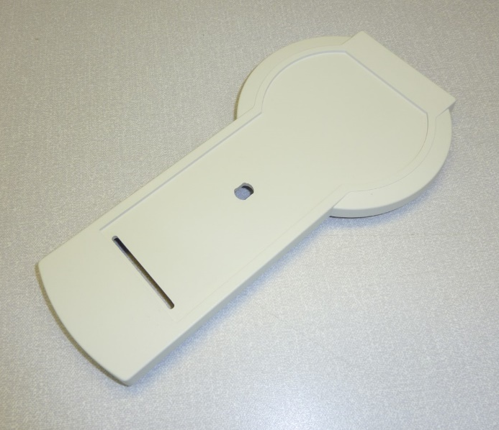
- Feed the keypad connector through the slotted hole near the bottom of the case. | 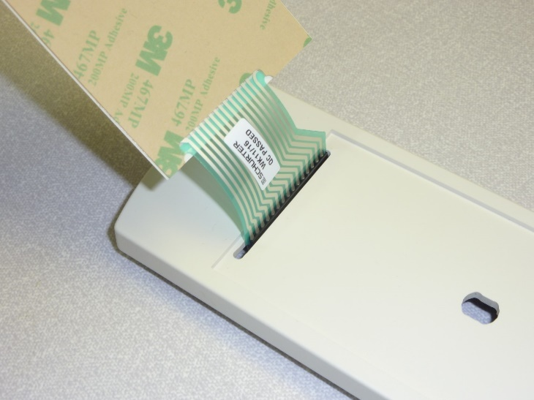
- Remove the protective backing from the keypad to expose the adhesive backing. | 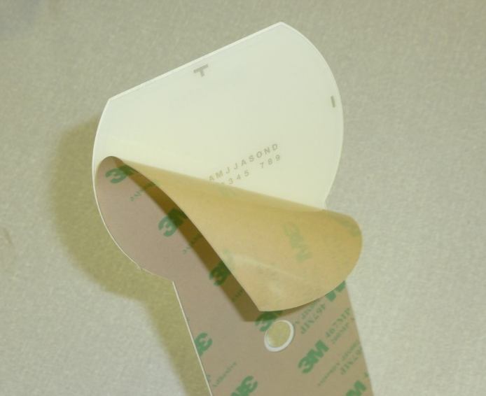
- Centrally locate the keypad membrane into the recess on the front of the case. Ensure that the bottom edge of the keypad is as close to the bottom edge of the recess as possible.  - When aligned correctly, press the keypad into place. | 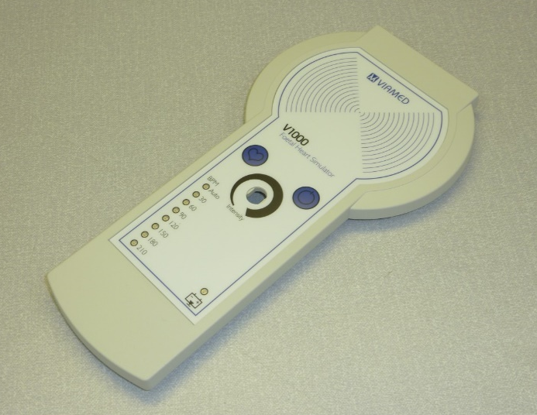
- Place the rubber seal over the thread of the control pot. | 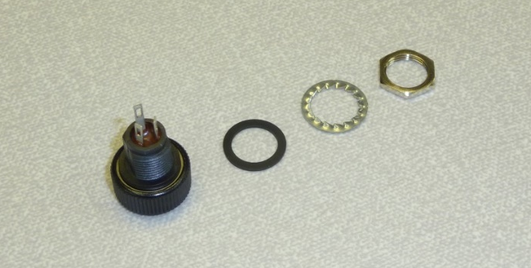
- Push the control pot through the central hole in the front of the case. Ensure the control pot is correctly orientated (Large tab to the top side of the case).  - Using the washer and nut, affix the control pot to the case. | 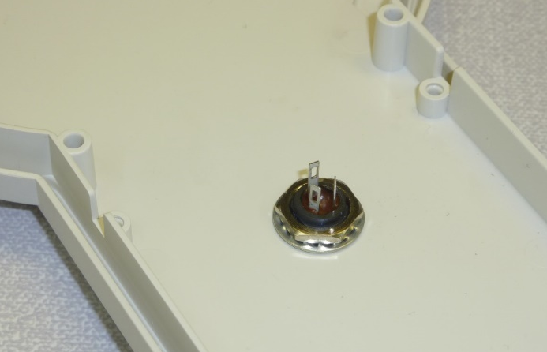
- Place the case seal into the channel around the perimeter of the case and push into place. | 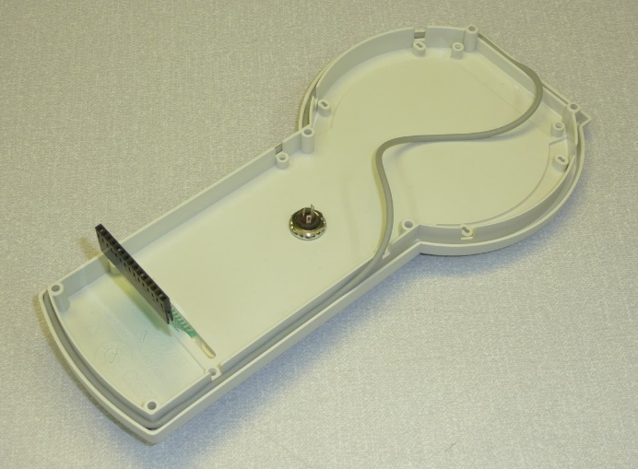
Lower case preparation:
- Remove the battery door from the lower case. | 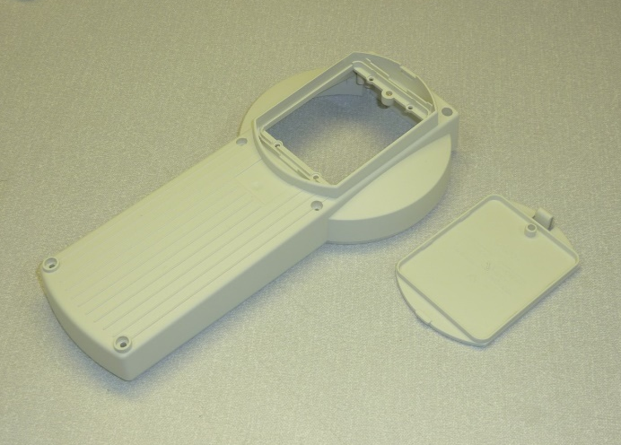
- The battery compartment is fitted from the inside of the case.  The polarity marks, in raised plastic on the battery compartment, should be on the left hand side of the inside of the case. | 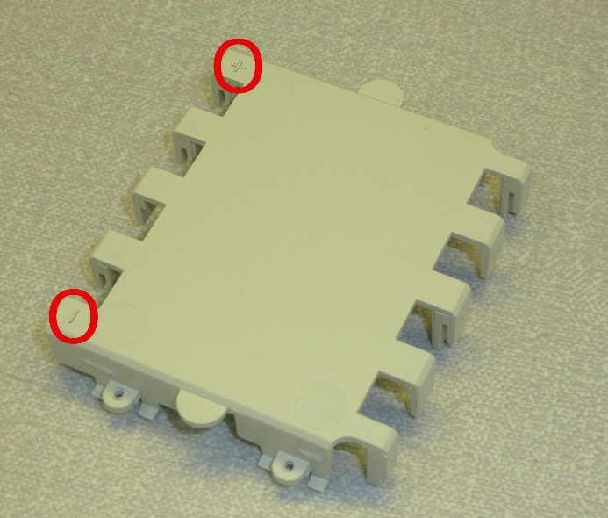
- Using the retaining hooks, located at each end of the battery compartment, insert the compartment into the lower case. | 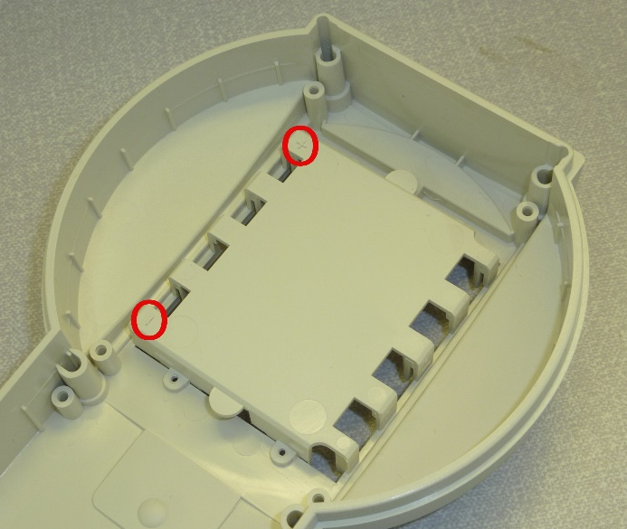
- Using the four retaining screws, affix the battery compartment in place. | 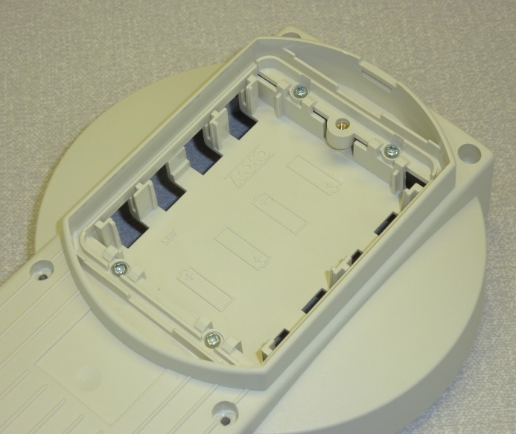
- Insert the battery contacts from the back of the case. | 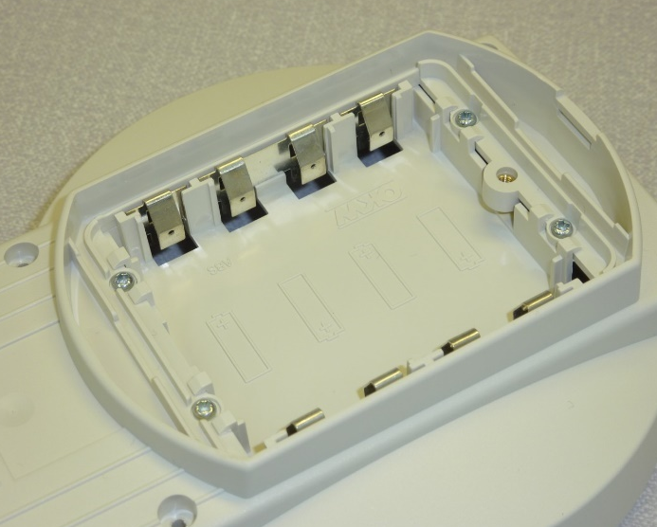
- Place the battery compartment seal into the channel around the perimeter of the battery compartment and push into place. | 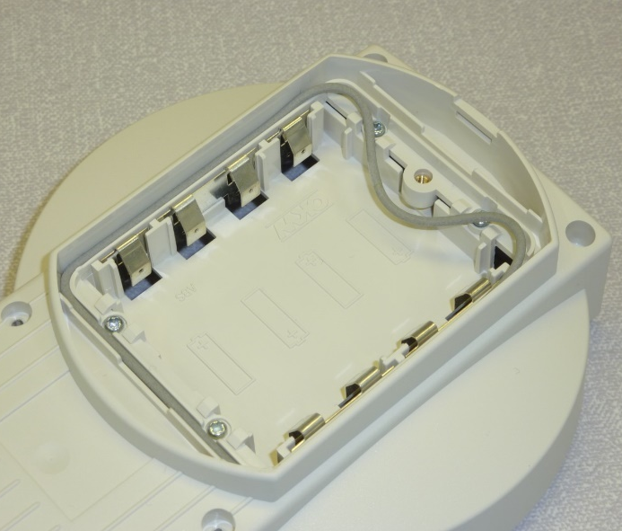
Transducer interface cushion preparation (PN: 1430309):
- Using a template, mark out and cut an interface cushion. | 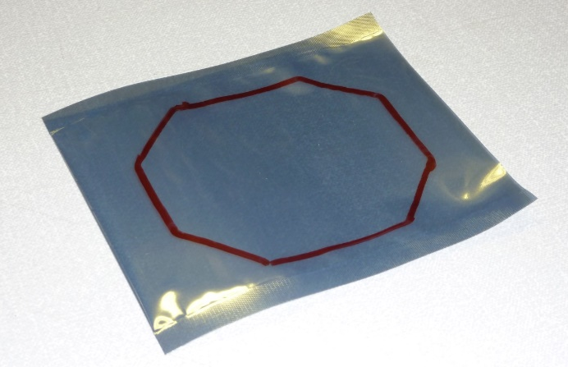
- Seal the edges of the transducer cushion, leaving a small gap for filling. | 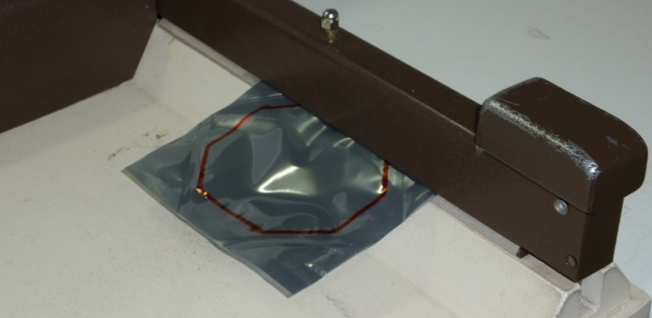
- Fill the transducer cushion with water, leaving as little air in the cushion as possible, and seal. | 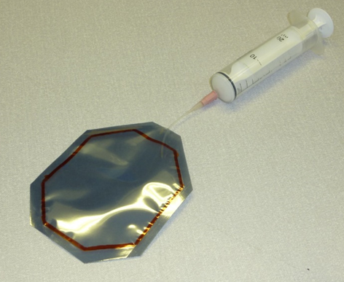
- Trim the excess material from the outline. | 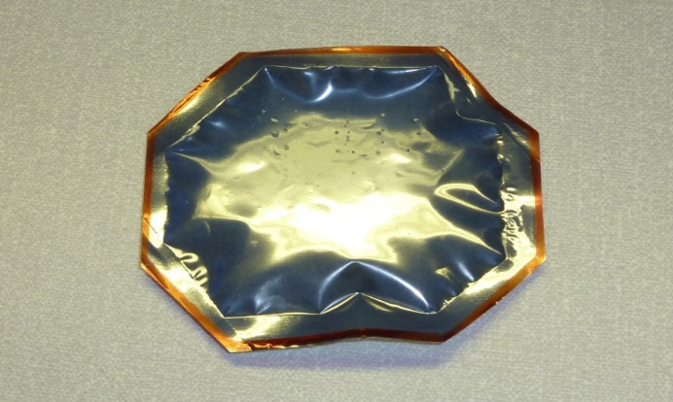
Transducer surround preparation:
- Using the template, mark out and cut a transducer surround from hard-backed foam. | 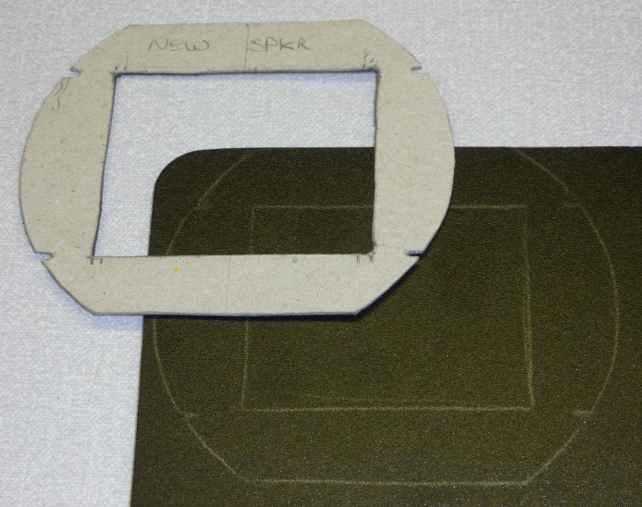
 | 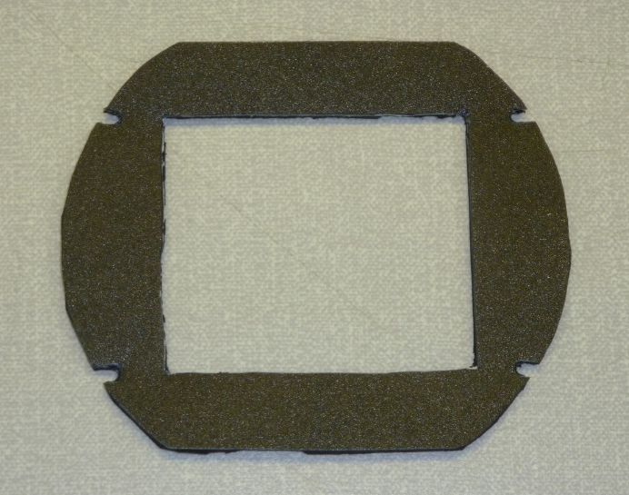
Assembly:
- Connect the keypad connector to the PCB. | 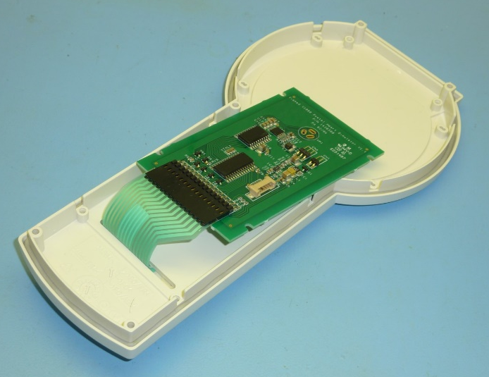
- Locate the PCB over the control pot, allowing the control pot tabs to pass through the three holes at the top of the PCB. | 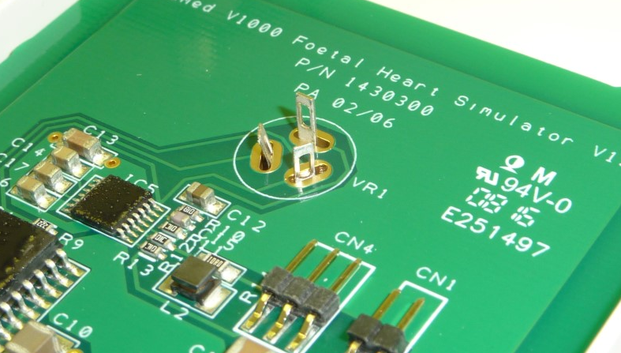
- Using the PCB retaining screws, affix the PCB into place. | 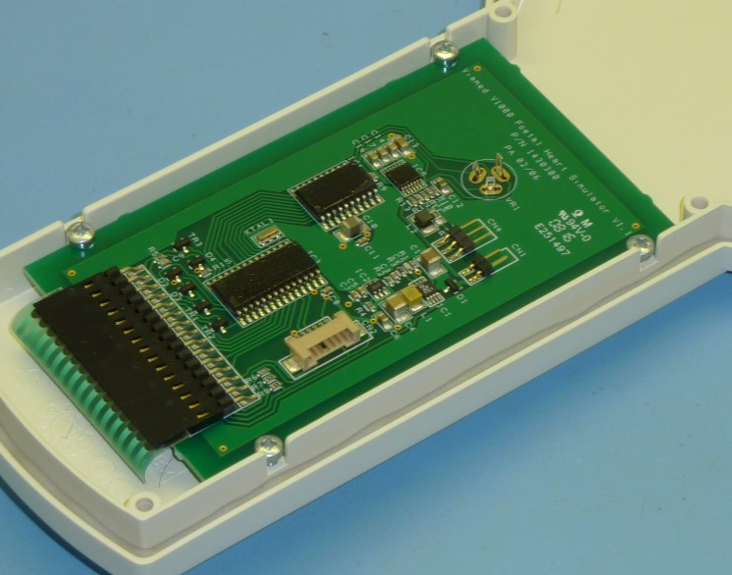
- Solder the three control pot tabs to the contacts on the PCB. | 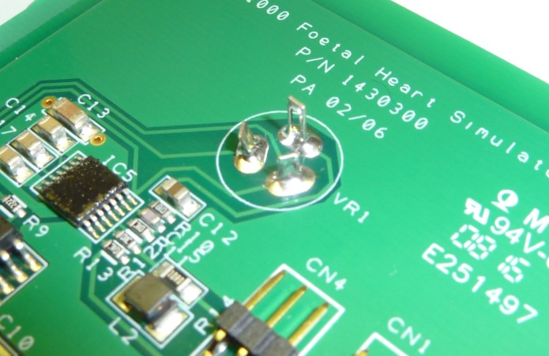
- Cut a length of ribbon cable to 75mm. Strip 2mm of plastic from each wire, and tin the wire.  - Strip 2mm of plastic from each wire. Affix a 3 pin M22 connector. | 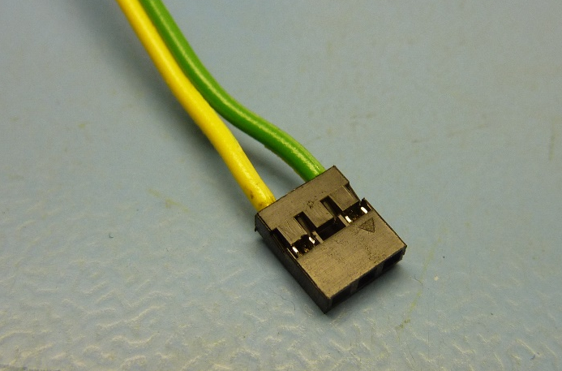
- Solder the cable to the transducer. | 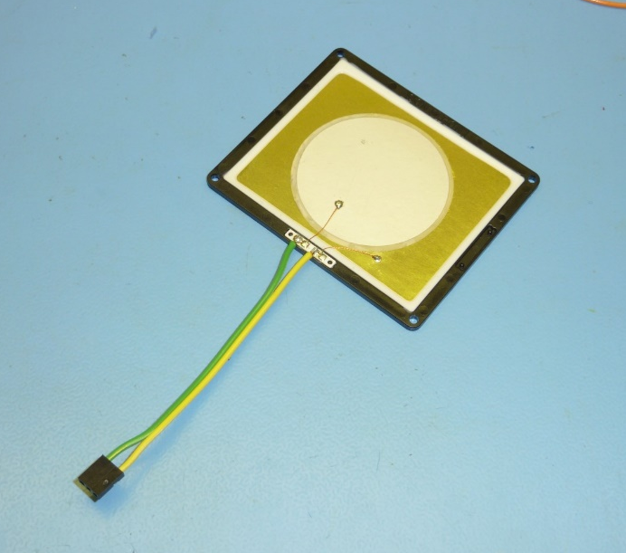
- Mount the transducer to the transducer mounting board. Space the transducer away from the board using a nut. | 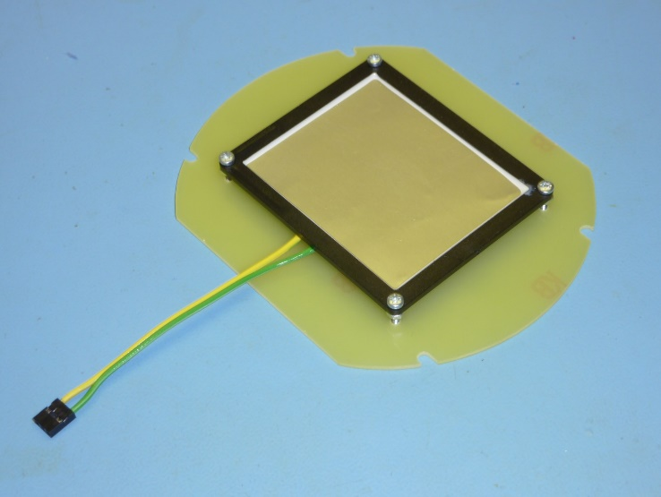
- Affix into place using a bolt, washer and nut | 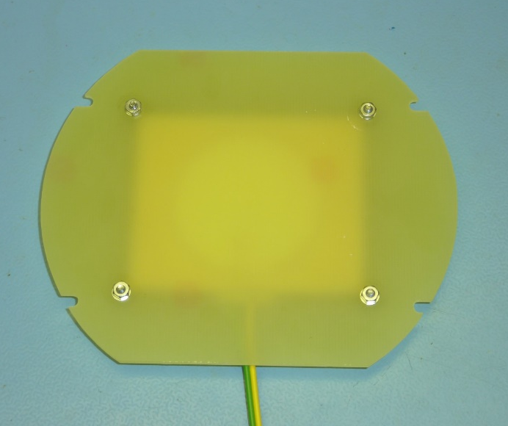
- Using a small amount of double sided tape, affix the transducer surround to the transducer mounting board. | 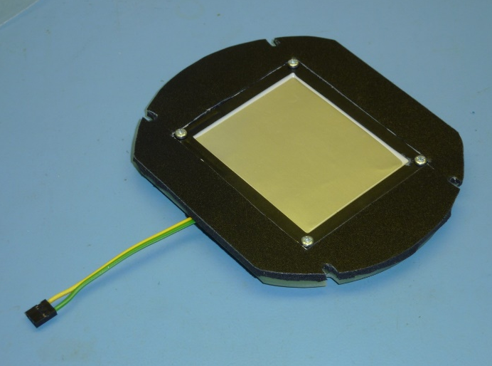
- Using double sided tape, affix the transducer interface cushion to the inside surface of the upper case. | 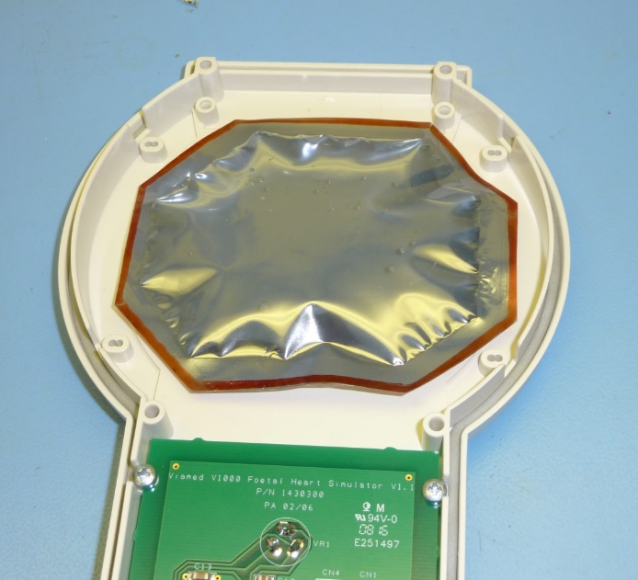
- Place the transducer assembly over the interface cushion, with spacing nut on the underside of the mounting board, and fix into place using the mounting screws. | 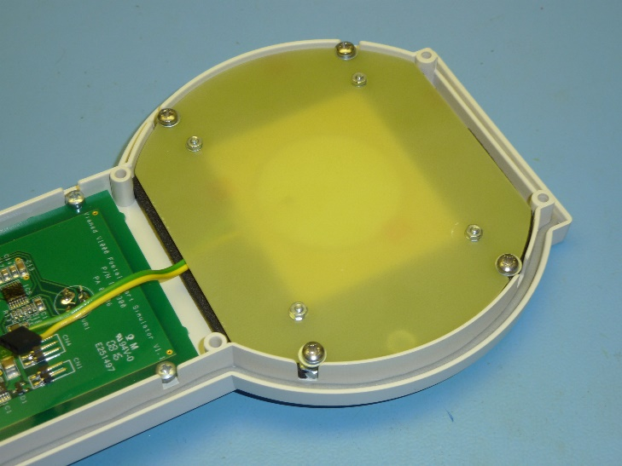
- Connect the transducer assembly to the PCB using the 3 pin connector. | 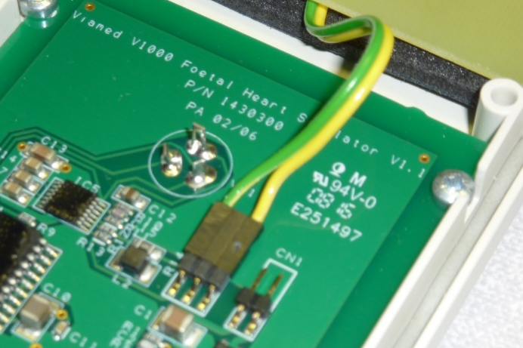
- Cut a length of ribbon cable to 150mm. Affix a 2 pin M22 connector. | 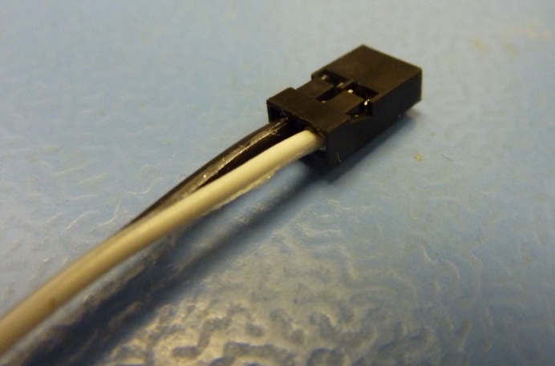
- Solder the ribbon cable to the battery contacts. | 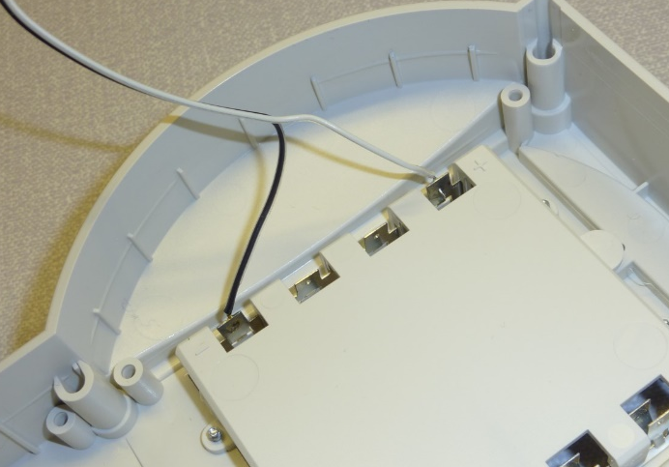
- Connect the 2 pin M22 connector to the 2 pin connector on the PCB. | 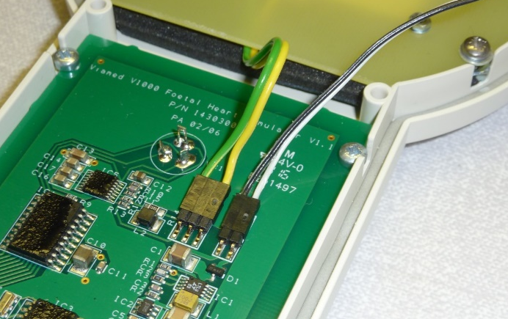
- At this point, test the unit. Insert 4xAA batteries and fix the case halves together.  - Test the unit functions as expected. Refer to the QA procedure for the method. | 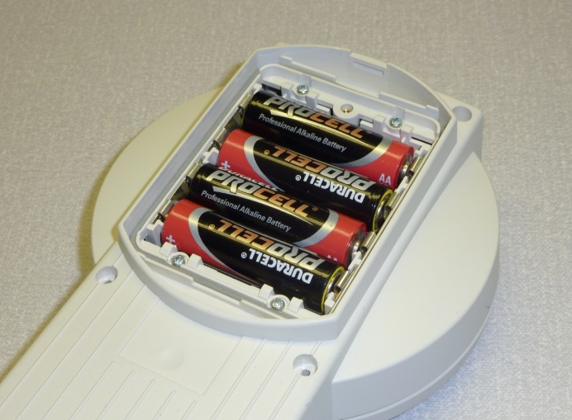
- When the unit is working as expected, use Tamper Evident Seal on the exposed nuts and screw heads. | 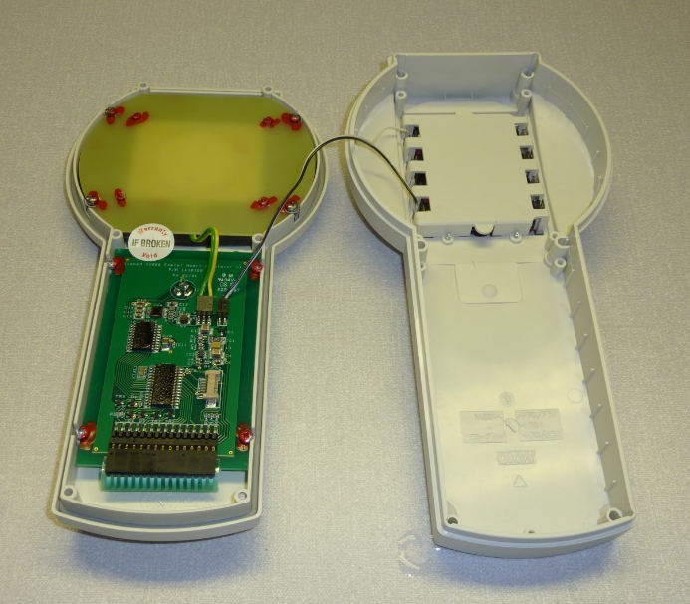
- Affix a serial number label to the back of the transducer assembly.  - Affix a ‘Warranty Void’ label between the transducer assembly and the main PCB. | 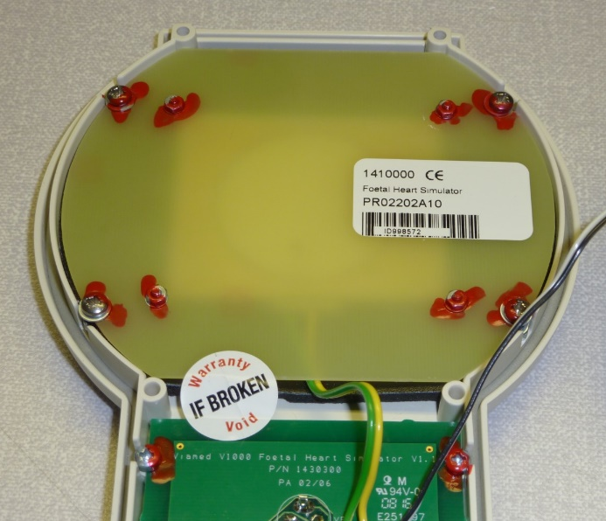
- Affix a serial number label to the inside of the battery compartment door. | 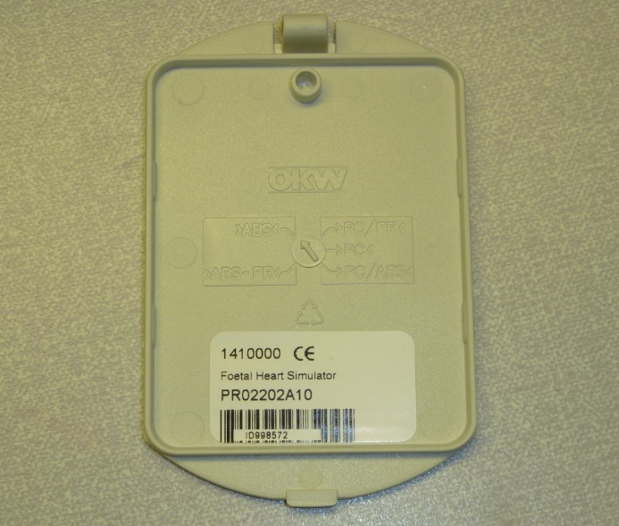
- Affix a trimmed serial number label to the inside of the battery compartment. | 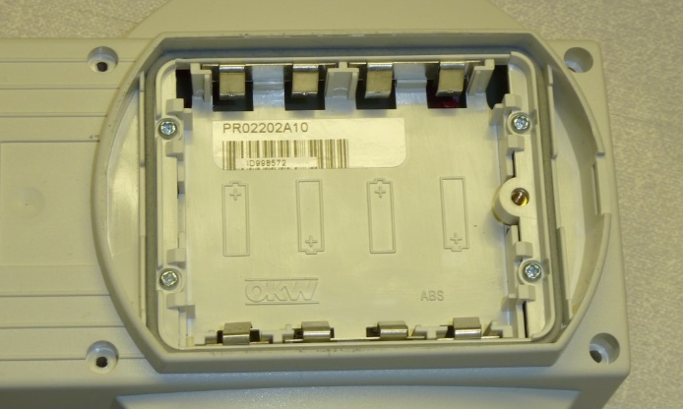
- Fully assemble the unit, using the case screws. | 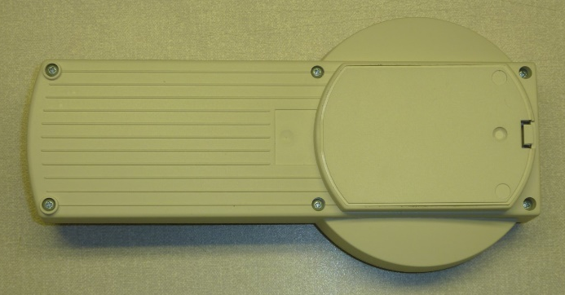
- Affix a ‘Calibration Void’ label to the top of the unit, between the case halves.  - Insert 4xAA batteries and test the unit. If the unit is working, then it may be submitted for QA. | 

