VM3COP61.11 Production Procedure for Microstim DB3 Tester (2510005)
Parts list
Qty | Description | Part No.
1 | Key fob case | 0131352
1 | PCB
1 | BNC socket
1 | LED
1 | LED surround
1 | Microstim lead | 2520000
1 | Strain relief | 0010618
1 | R1
1 | R2
1 | R3
1 | R4
1 | TH1
1 | D1
10mm | Heat shrink (6.0mm) | 0032321
1 | Cable clamp | 0030500

Tool list
Soldering iron
Wire cutters
Stanley knife
Snipe nose pliers
Phillips screw driver (size 0)
Low melt glue gun
Reaming tool
Cable clamp pliers

- Take the key-fob case and mark a pilot hole as shown. | 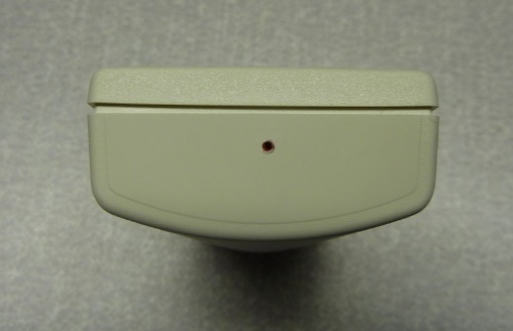
- Using a small handheld drill, drill through the case. | 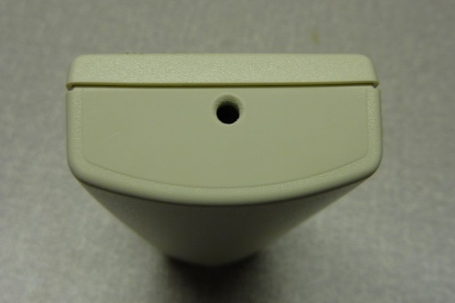
- Using a reaming tool, enlarge the hole to 10mm to fit the BNC connector. | 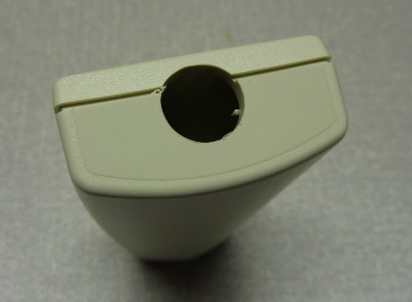
- Remove the keyring bar. | 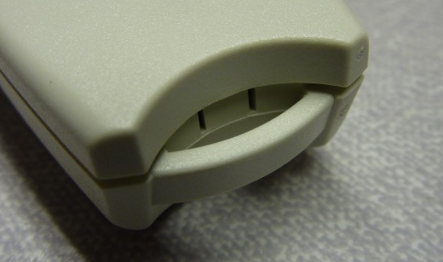
- File smooth any remnants of the keyring bar. | 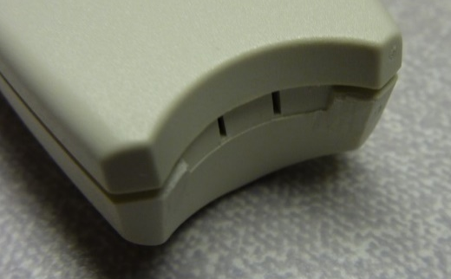
- Mark a pilot hole for the strain relief. | 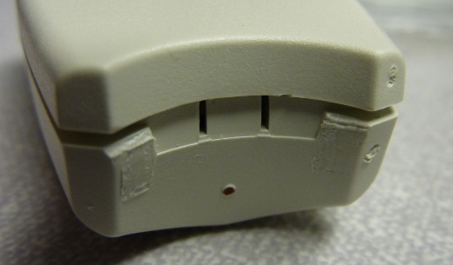
- Using a reaming tool, enlarge the hole to 6mm to fit the strain relief. | 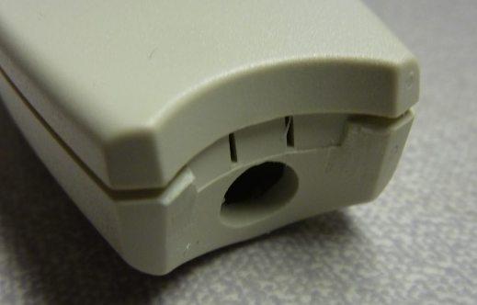
- Affix the top label to the case.  - In the centre of the label hole mark a pilot hole for the LED. | 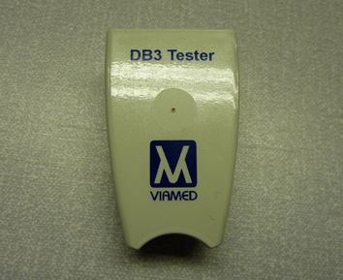
- Using a small handheld drill, drill through the case.  - Using a reaming tool, enlarge the hole to 8mm to fit the LED surround. | 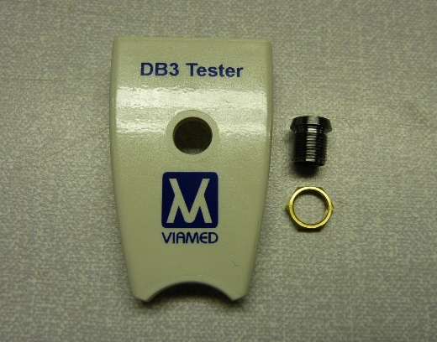
- Insert the LED surround and screw on the back nut. | 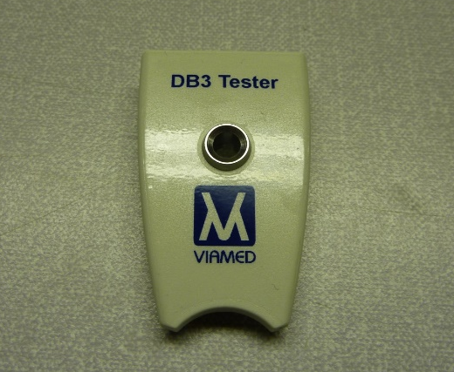
- Using an abrasive PCB cleaner, clean the PCB solder contacts. | 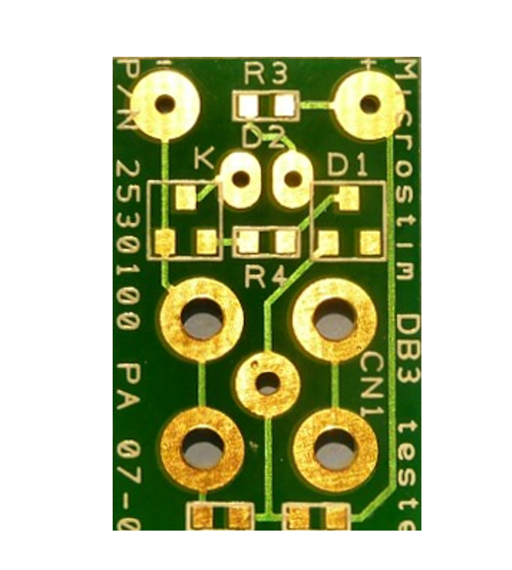
- Populate the PCB with components as shown. | 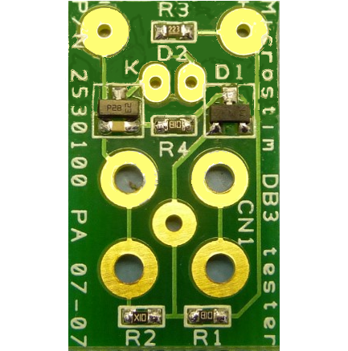
- Solder the BNC connector to the PCB. | 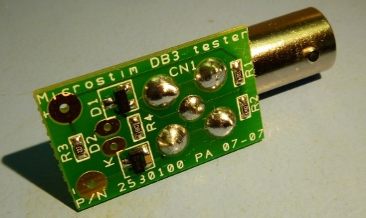
- Trim the press-studs from the cable.  - Trim the cable to 75cm. | 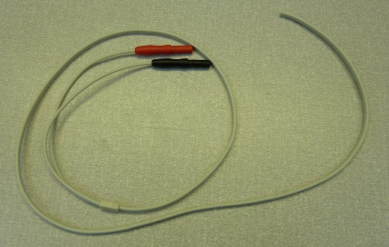
- Insert the strain relief into the hole at the back of the case.  - Attach the cable clamp 35mm from the end of the cable.  - Strip and tin 5mm on each of the wires. | 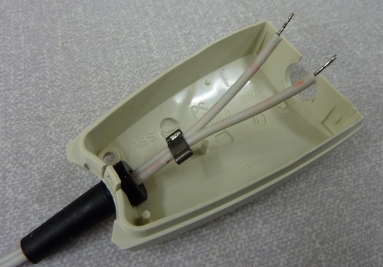
- Apply 10mm of 6mm heat shrink to the cable clamp. | 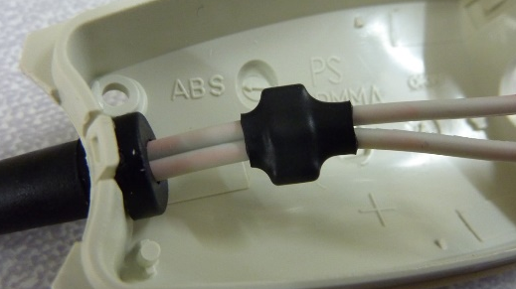
- Insert the LED as shown. | 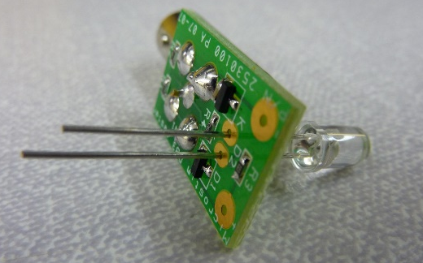
- Solder the LED in place. The LED should be 7mm above the PCB. | 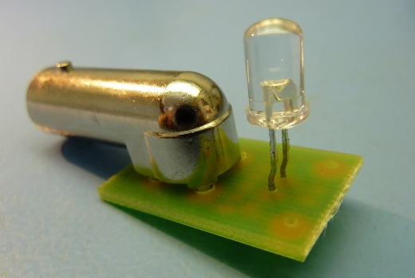
- Solder the lead to the PCB. The red lead to the positive contact and the black lead to the negative contact.  - Insert the PCB into the case. | 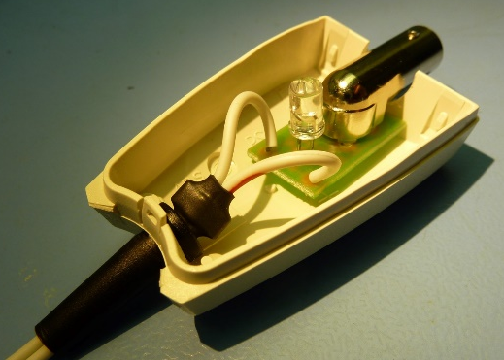
- Test the unit is working by attaching a Microstim DB3 and testing its functions. | 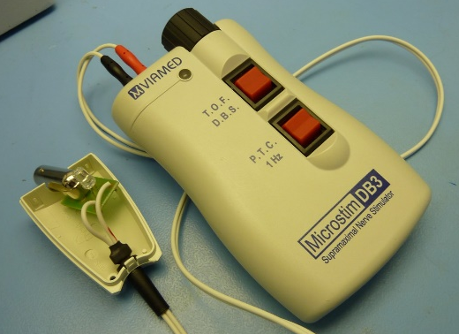
- Using low-melt glue, affix the PCB into the case. | 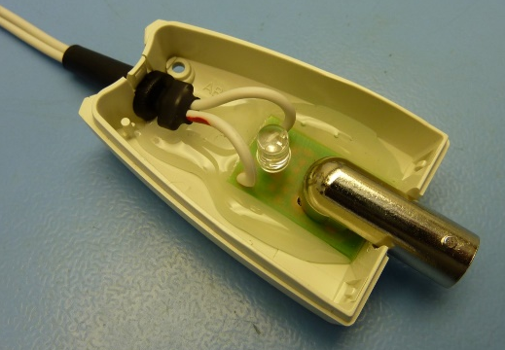
- Attach the case top and insert the retaining screw.  - Affix the serial number label to the underside of the case.  - The unit is now ready for QA. | 

