VM3COP61.10 Microstim DB3 QA Procedure
The QA procedure requires; 1 x PP3 battery, 1 x Microtim DB3 tester and an oscilloscope.
- Examine the Microstim to ensure there is no damage or marking to the unit or the labels. | 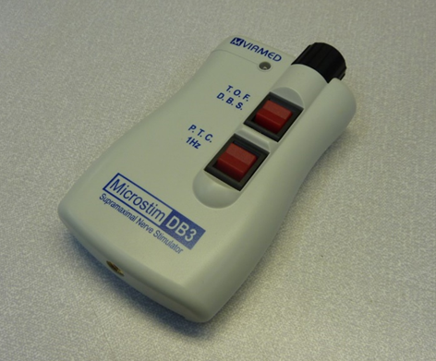
- Insert a test battery into the unit. | 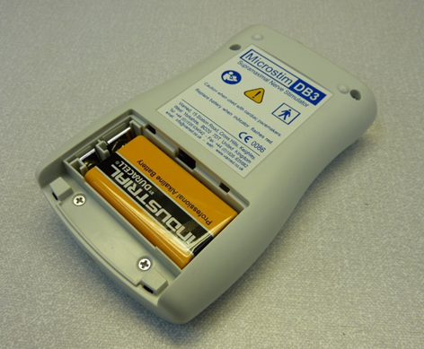
- Without the patient lead connected, press and hold the P.T.C. button. If the battery is of sufficient Voltage, then the L.E.D. on the front of the Microstim will light up in green. If the L.E.D. lights in amber or red, then replace the test battery and repeat this step. | 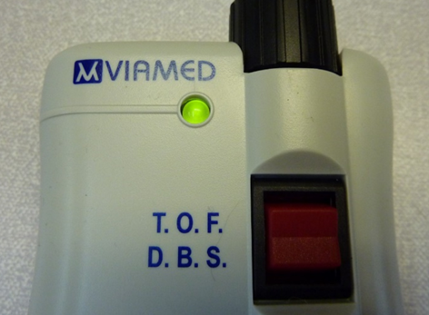
- Connect the Microstim to the Microstim tester. | 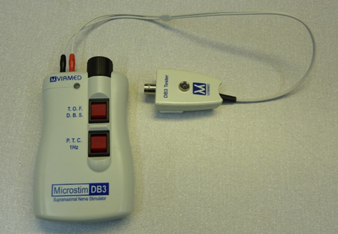
- Set the intensity control to maximum by rotating fully clockwise. | 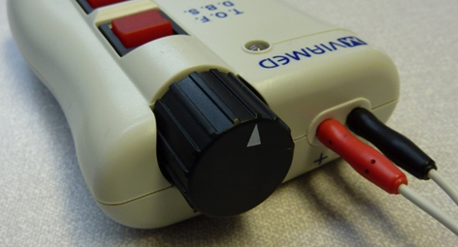
- Press and hold the each of the function buttons in turn.  The L.E.D. on the front of the Microstim tester should light and be accompanied by a high pitched tone from the Microstim.  If the unit fails to light the tester, or a tone is not heard, then reject the unit. | 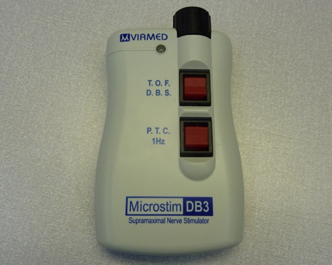
- Connect the Microstim tester to the oscilloscope. | 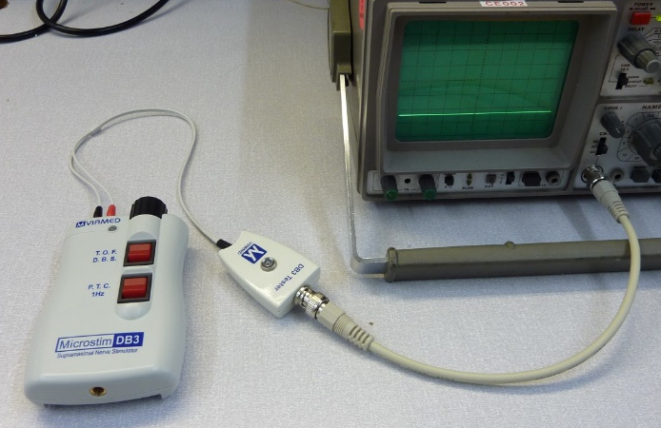
- Using a setting of 0.2V per division, test the maximum voltage output. This output should be ≥0.9V and ≤1V. The voltage output is most easily read when using the P.T.C. function. | 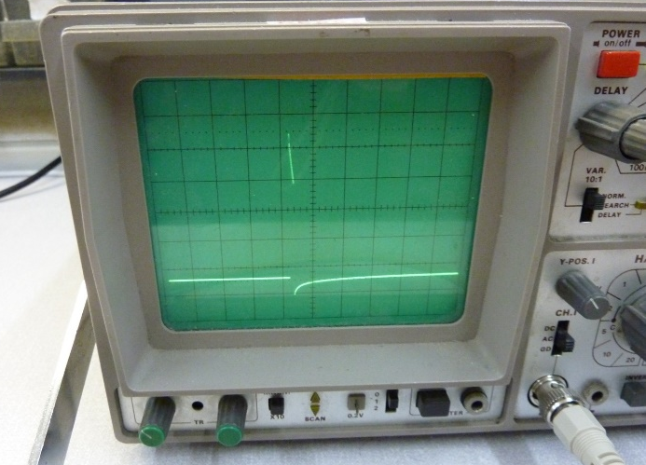
- If the Microstim has passed the QA tests, then record the result on the Intrastats system.
- Disconnect the Microstim from the tester, remove the test battery and replace the battery cover.

The Microstim is now ready to be packaged.

