TITLE: MaxO2ME Tech File Summary REVISION No. A

PREPARED BY: Darryl Zitting DATE: 1/27/15
Engineer

AMENDED BY: DATE:

REVISION A – DCO # 5630 – Initial Release

- Comprehensive Product Description

  - Detailed System Description
The MaxO2ME is a handheld oxygen analyzer/monitor capable of measuring the oxygen concentration from 0% to 100% in a sample gas. A MAX-550E oxygen sensor outputs a voltage which is used by the MaxO2ME to determine the concentration of oxygen based on a calibration at room air or 100% oxygen. The MaxO2ME contains alarms that can be controlled by the user to set a maximum or minimum allowable oxygen concentration.

- Oxygen sensor of approximately 1,500,000 O2 percent hours and / or 2 years.
- External sensor with 10 ft., extendable cable and diverter fitting for standard 15mm "T" adapter.
- Operation using 4 AA alkaline batteries (4 x 1.5 volts) for approximately 5,000 hours of performance with typical use.
- Oxygen-specific, galvanic sensor that achieves 90% of final value in approximately 15 seconds at room temperature.
- Self-diagnostic check of analog and microprocessor circuitry.
- Low battery indication.
- Calibration reminder timer that alerts the operator, using a calibration icon on the LCD display, to perform a unit calibration.
- Adjustable high-level and low-level alarming capability with flashing LED and audible indication of alarm conditions.
- Smart high-low alarm setting to help adjust alarm settings quickly.
- Back-light display with auto ambient light level.
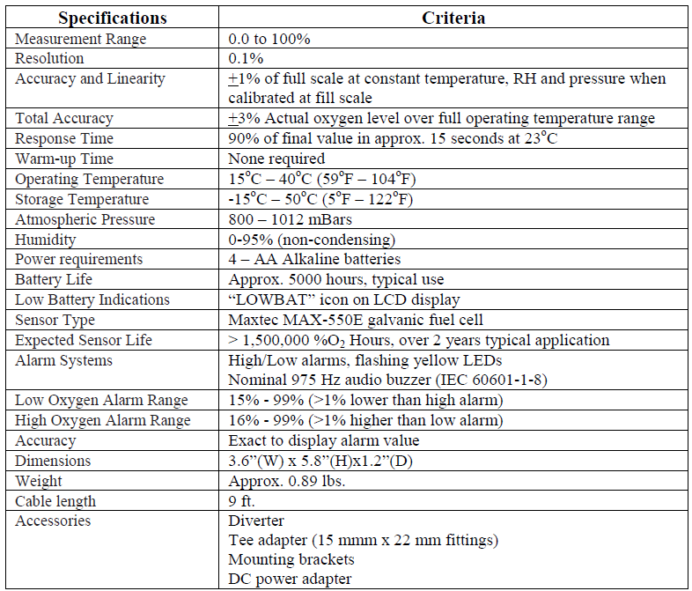
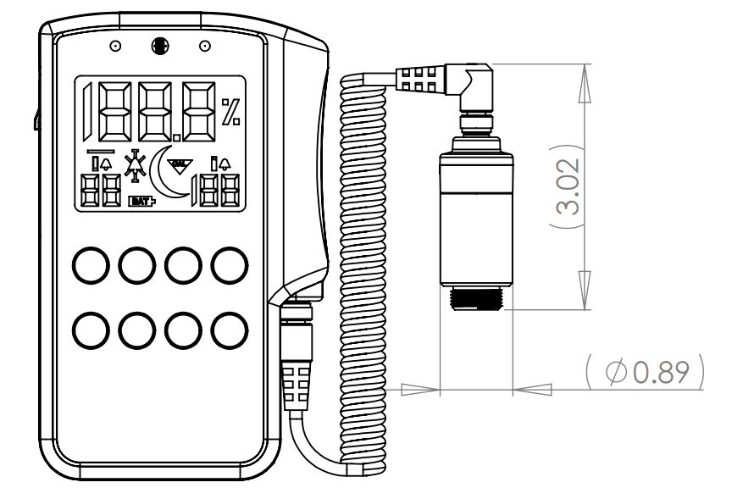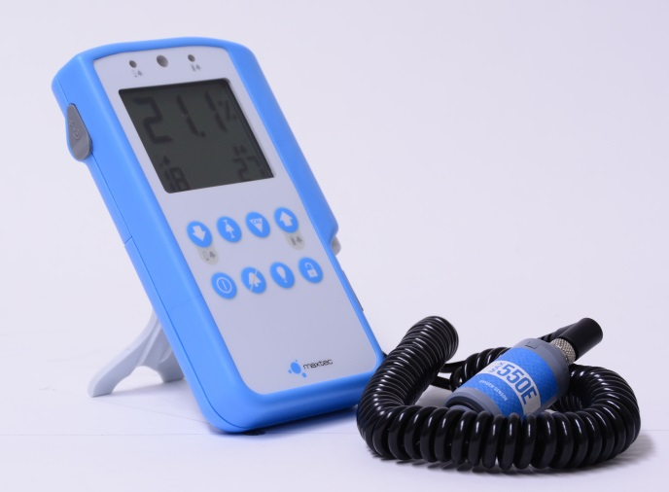
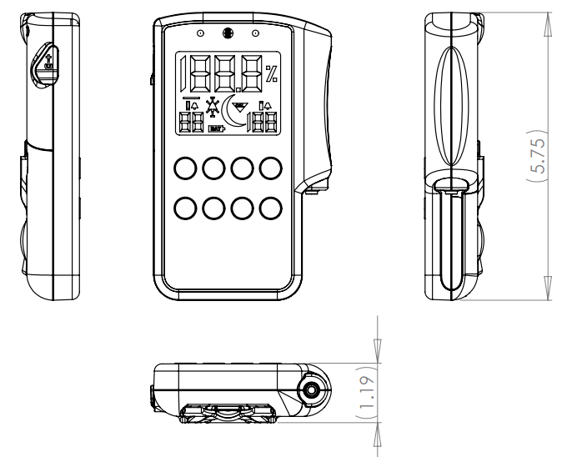
  - Packaging
The oxygen sensor has a label applied covering the sensor mouth to keep it clean and reduce the oxygen available to the sensor to improve shelf life. The sensor is then packaged in a simple cardboard/plastic blister pack. The monitor is packaged in roll-top Kraft corrugate box with a Korvu corrugate/stretch-film insert to suspend and protect the device. The accessories (sensor, cable, tee-adapter) are placed in the box in a separate compartment formed by the Korvu insert.
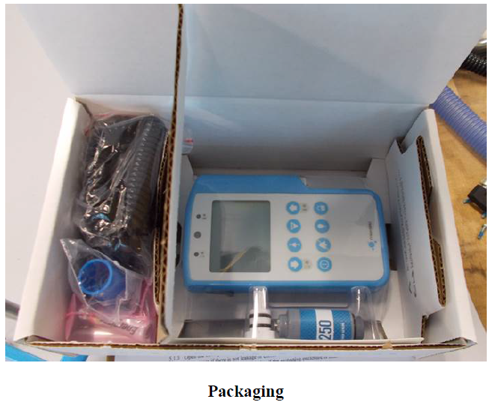
  - Sterilization
The MaxO2ME oxygen monitor does not require sterilization for its intended use or intended use environment. Maxtec does not claim the device to be sterile. Cleaning of the device is described in the User Manual/Instruction for Use.

  - Shelf Life
The MaxO2ME monitor does not have a shelf life. However, the replaceable galvanic oxygen sensor has a 2 year service life. Refer to Part B section 4 of this technical file for the shelf life validation test report.

  - Combination with Active Medical Devices
The MaxO2ME is an active medical device. It is powered by 4 AA batteries. The device power source is intended to operate the hardware required to measure and display the oxygen concentration of the gas being measured. Energy is not delivered to the patient by this device.

- Basic Scientific Concept

The oxygen sensor is an electrochemical cell of the self-powered, diffusion limited, metal-air battery type. These traditional ‘fuel cell’ oxygen sensors consist of a polymeric diffusion barrier (membrane), a sensing electrode (cathode) made of a noble metal such as gold, and a working electrode made of a less noble (more reactive) metal such as lead. The electrodes are immersed in an electrolyte contained in a robust outer housing made of a chemically resistant polymer. Oxygen diffusing into the sensor is catalytically reduced to produce water at the cathode. Concurrently the lead anode is oxidized by water in the electrolyte, to produce lead oxide to complete the reaction. Fuel cell oxygen sensors are current generators. The amount of current generated is proportional to the amount of oxygen consumed (Faraday's Law). A resistor network inside the sensor (including a thermistor) converts the current to a voltage and compensates for temperature effects on the electrochemical reaction. The monitor measures this voltage and converts it to percent (%) oxygen, based on calibration reference point measured at room air or 100% oxygen.

- Change Notification

This revision of the technical file is for the initial product release therefore no changes have been made to this device.

- Summary of Essential Test Results
Testing and verification to harmonized standards were performed by 3rd party nationally recognized test laboratories. Performance specification bench testing was carried out at Maxtec according to pre-determined test protocols. The following test reports were generated. Part B Section 4 of this technical file addresses verification testing. In addition, a study was carried out to validate the usability and suitability of the MaxO2ME for end users. Refer to the Usability Engineering File in Part B Section 2, item 2.2 of this technical file for further details.

Bench testing includes:
- ISO 80601-2-55 Performance of respiratory gas monitors
- 15040A ISTA2A Shipping Validation Test report
- 15042A Sensor performance test Report
- 15063A Gas leakage test Report
- 15064A Interfering gas effects test Report
- 15065A Temperature compensation test Report
- 15066A Drift of measurement accuracy test Report
- 15067A MaxO2ME Operating and Storage Environment Report
- 15069A Device Cleaning Report
- 15071A Measurement Accuracy test Report
- IEC 60601-1 - Electrical safety
- IEC 60601-1-2 – EMC
- IEC 60601-1-8 – Alarms

Please note that some test reports include the names of other products that were also tested at the same time. The only product that is the subject of this technical file is the MaxO2ME, any other product is not the subject of this technical file and should be ignored.

- Summary of Instructions for Use

  - Intended Use
The MaxO2ME oxygen monitor is intended for continuous monitoring of the concentration of oxygen being delivered to patients ranging from newborns to adults. It can be used in the pre-hospital, hospital and sub-acute settings. The MaxO2ME is not a life supporting device.

  - Indications
Any patient ranging from newborns to adults is indicated for use with the MaxO2ME.

  - Contraindications
There are no patient populations that are contraindicated for the maxO2ME. However, the MaxO2ME is contraindicated for MRI environments.

  - Warnings
- Before use, all individuals who will be using the MaxO2ME must become thoroughly familiar with the information contained in this Operation Manual. Strict adherence to the operating instructions is necessary for safe effective product performance. This product will perform only as designed if installed and operated in accordance with the manufacturer’s operating instructions.
- This product is not intended as a life-sustaining or life-supporting device.
- Medical Oxygen should meet the requirements of USP.
- The Alarm limits can be set to levels that would render them useless for a particular patient's clinical condition. Ensure that the delivered oxygen level and flow rate are set to values prescribed by the patient's physician. Also ensure that the high and low alarm limits are set to levels such that they will sound if the oxygen level is outside of safe limits. Be sure to review and, if necessary, re-set the alarm limits when the patient's clinical condition changes or when the patient's physician prescribes a change in oxygen therapy.
- To avoid explosion, DO NOT operate the oxygen monitor in the presence of flammable anesthetics or in an atmosphere of explosive gases. Operating the oxygen monitor in flammable or explosive atmospheres may result in fire or explosion.
- Never allow an excess length of cable near the patient’s head or neck, as such could result in strangulation. Secure excess cable to the bed rail or suitable object.
- Never use a MaxO2ME monitor with a cable that appears worn, cracked or has damaged insulation.
- The oxygen sensors contain a weak acidic solution encapsulated in a plastic housing. Under normal operating conditions the solution (electrolyte) is never exposed. In case of a leak or if damaged, DO NOT use the oxygen sensor.
- Use only genuine Maxtec accessories and replacement parts. Failure to do so may seriously impair the monitor’s performance. Repair or alteration of the MaxO2ME beyond the scope of the maintenance instructions or by anyone other than an authorized Maxtec service person could cause the product to fail to perform as designed. No modification of this equipment is allowed.
- Calibrate the MaxO2ME weekly when in operation and if environmental conditions change significantly. (I.e., Temperature, Humidity, Barometric Pressure. Refer to Calibration section of this manual).
- Use of the MaxO2ME near devices that generate electrical fields may cause erratic readings.
- If the MaxO2ME is ever exposed to liquids (from spills or immersion) or to any other physical abuse, turn the instrument OFF, remove batteries and allow todry completely, then power ON. This will allow the unit to go through its self-test and make sure everything is operating correctly.
- Never autoclave, immerse in liquid or expose the MaxO2ME (including sensor) to high temperatures (>50°C). Never expose the device to liquid, pressure, irradiation vacuum, steam, or chemicals.
- To protect the unit from potential leaky battery damage always remove batteries when the unit is going to be stored (not in use for 30 days or more) and replace dead batteries with recognized name brand AA Alkaline batteries. DO NOT use rechargeable batteries.
- This device does not contain automatic barometric pressure compensation.
- Not for use in an MRI environment.
- Battery replacement by inadequately trained personnel could result in a safety hazard.
- Electrical shock or damage to the equipment may occur if an inappropriate external power supply is used. Maxtec recommends using only the Maxtec approved external power supply, as listed in 9.0 Spare Parts and Accessories.

  - Adverse events
N/A

  - Operation Summary
Operation of the MaxO2ME consists in calibrating the oxygen sensor, setting the high/low oxygen alarms and placing the sensor in contact with the sample gas. If the previous calibration is valid, the MaxO2ME will begin to display oxygen concentration and monitor for alarm conditions immediately upon power-on. Refer to the Instructions for Use (Part B-6).

  - Use of Accessories
The only accessory which requires directions in the instructions for use is the T-adapter. The other accessories are self-explanatory and do not require instruction. The T-adapter accessory allows the user to adapt the sensor to standard 22mm tubing commonly used to deliver air/oxygen mixtures to the patient. Section 3.2 describes the use of the T adapter as follows:

“Place the external flow diverter in the sample gas stream. When using a standard T-adapter, make sure the sensor is mounted in the adapter with the flow diverter pointing downward. This will prevent moisture from potentially draining into the sensor membrane. NOTE: It is important that a tight fit exists between the diverter and the T-adapter.”

- Planned Changes
There are no changes currently planned for the MaxO2ME product.

- Summary of Manufacturing Process
The molded components and circuit board of the Max550 sensor are manufactured by a contract a molding supplier and a circuit board assembly supplier respectively. Manufacturing of the Max550 sensor, including anode, cathode and electrolyte preparation, is carried out at Maxtec. Testing of the Max550 sensor is performed on 100% of the sensor product by means of an automated test system. Prior to packaging, the final step in manufacturing of the Max550 sensor is to program the authentication chip in the sensor using a custom sensor programming tool. The manufacturing procedure, equipment, and testing is almost identical to the Max250 sensor that has been marketed for over 15 years, with additions to enable programming of the authentication chip.
The MaxO2ME monitor consists primarily of a circuit board assembly, membrane switch, cable assemblies and the molded components that form the enclosure. These components are each sourced through contract manufacturers according to Maxtec technical specification. Off-the-shelf fasteners are sourced from existing Maxtec suppliers. Assembly of the MaxO2ME monitor unit is performed at Maxtec. Prior to packaging, 100% of the monitor product is tested by means of specialized test tooling developed by Maxtec. Part B section 7 of this technical file provides greater detail for supplier interfaces and manufacturing procedures related to the MaxO2ME.

- Other Safety/Performance Information
There is no additional safety or performance related information necessary.

