Generating a New Service Visit ID.

Scope:
To generate a NEW service visit, do not use this procedure if the service visit is apart of a rolling yearly service visits.
Check the Service Visit logs page in intrastats to check before you start.

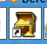
Intrastats Contact Management.
Search for the Opera account you want to create a new service visit.

Select the 'O' Account

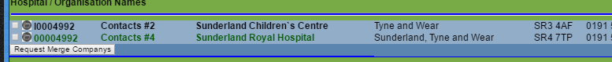
Select the Service Icon from the Icon bar

Click Add NEW Service ID

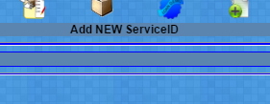
Enter the Basic Details

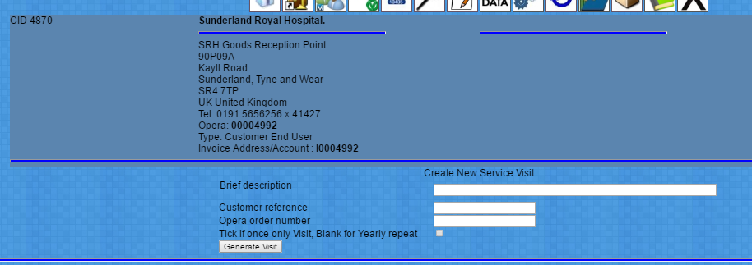
Brief Description of the visit,
Customer Reference number if applicable
and Opera order number if applicatable

If the visit should be chased on a yearly cycle, leave the box blank,
If the visit is a once only visit tick the box.

You will now be taken to the Add Items Screen.
The system has now generated a Service Visit ID which can be edited from the service visits menu.

Items to be serviced can now be added to the system.

