Complete Auto_calender Issues
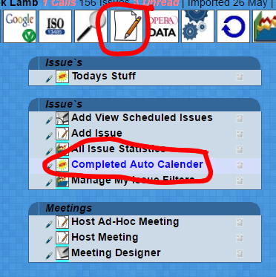
Meetings -> Completed Auto Calender Issues.

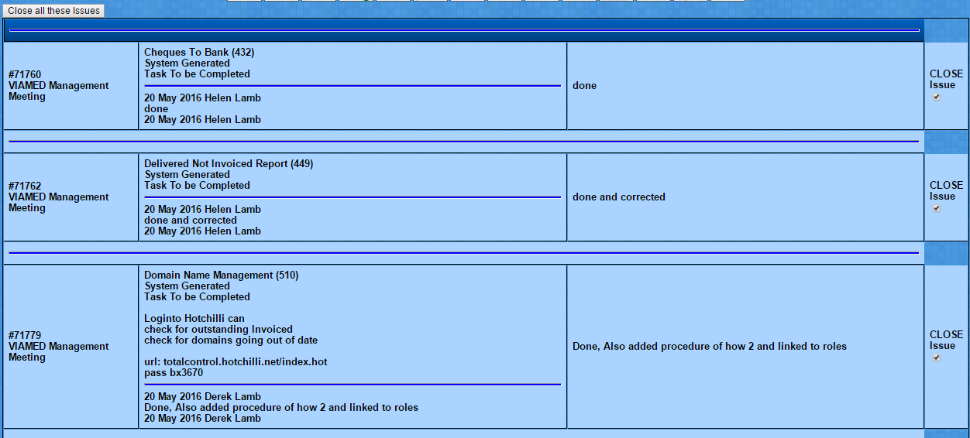
You will be presented with a list of completed Auto Issues
First column Issue number and Meeting attached to
Second column the whole Issue
Third column is the final notes in the completion notes.
In most cases this simply states 'Done'

The forth column is pre-ticked close button.

Scoll down the list and identifiy any problems which the user may have had while complting the task.
UN-tick any with outstanding issues.

Scoll back to the top of the list and Click

Go back into the list and you can now deal with any Issues remaining.
Either deal with the problem add to the issue notes in the normal way, or if its a longer term problem create a related issue and proceed.

Once all Issues are dealt with you can then go back in and close them all off.

