Amazon Web Services Invoice Pickup

Scope:

Amazon Web Services, is an online service, which basically simply provides a Linux PC out on the Web.

Viamed uses this, for Web development of Websites:
It hosts a working backup of many websites.
Viamed / vst / vandagraph etc..

Login:
derek@lamb.uk.net

Password:
See Derek.. - or Derek Password File, if unavailable, See Michael/Helen/Jenny Lamb to Access Derek Secure File.

Invoice Pick up
Sign into the service @ http://aws.amazon.com/

Select Billing from the top left Menu
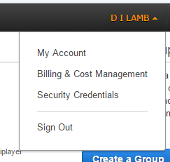
Select Bills
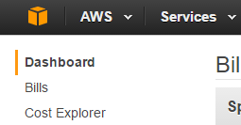
Change the Date to the previous month, and download the Invoice,
Send to Accounts.

