Maintain Update Of ISO Route Maps (804)
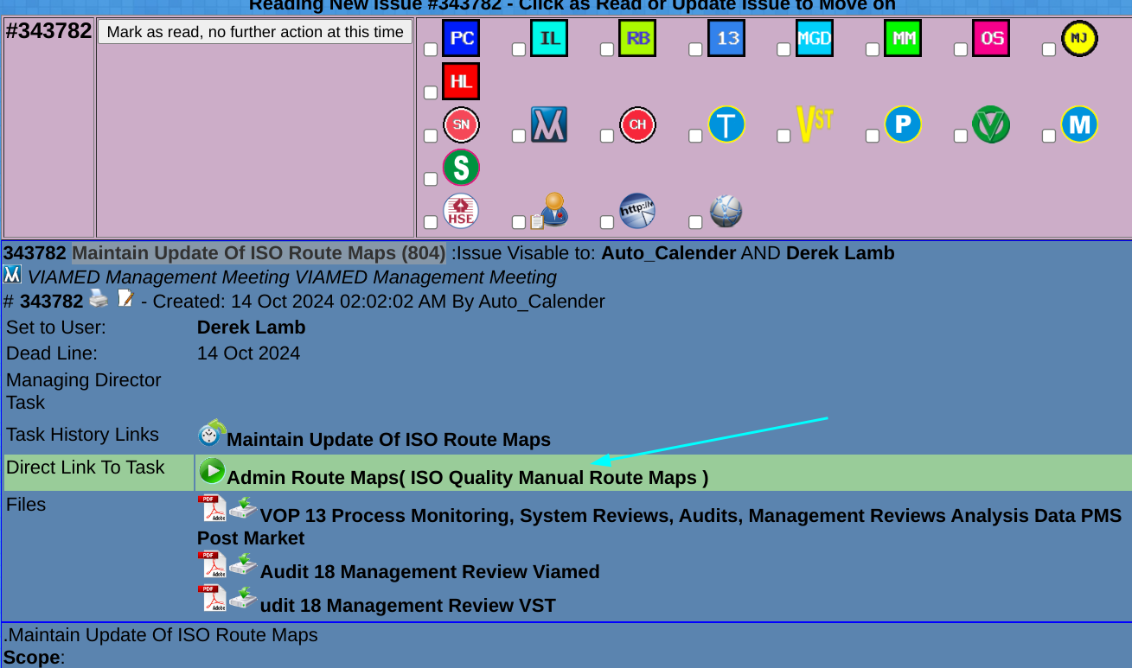

Start With Viamed:
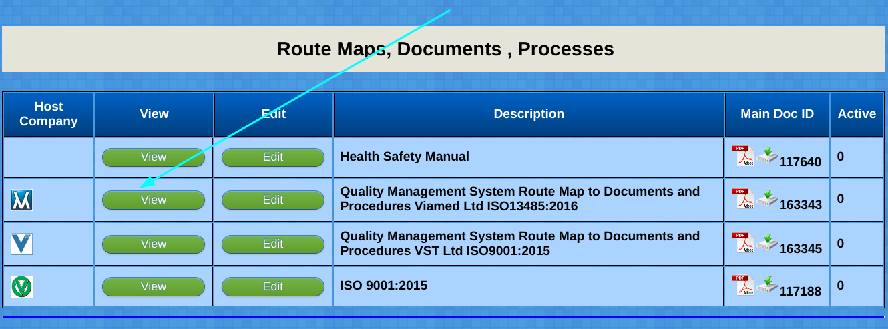
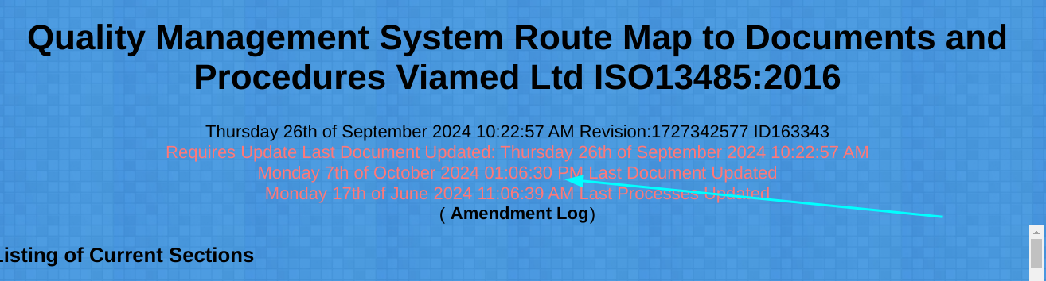
If you get Red Highlighted Test:

The route Map requires updating,
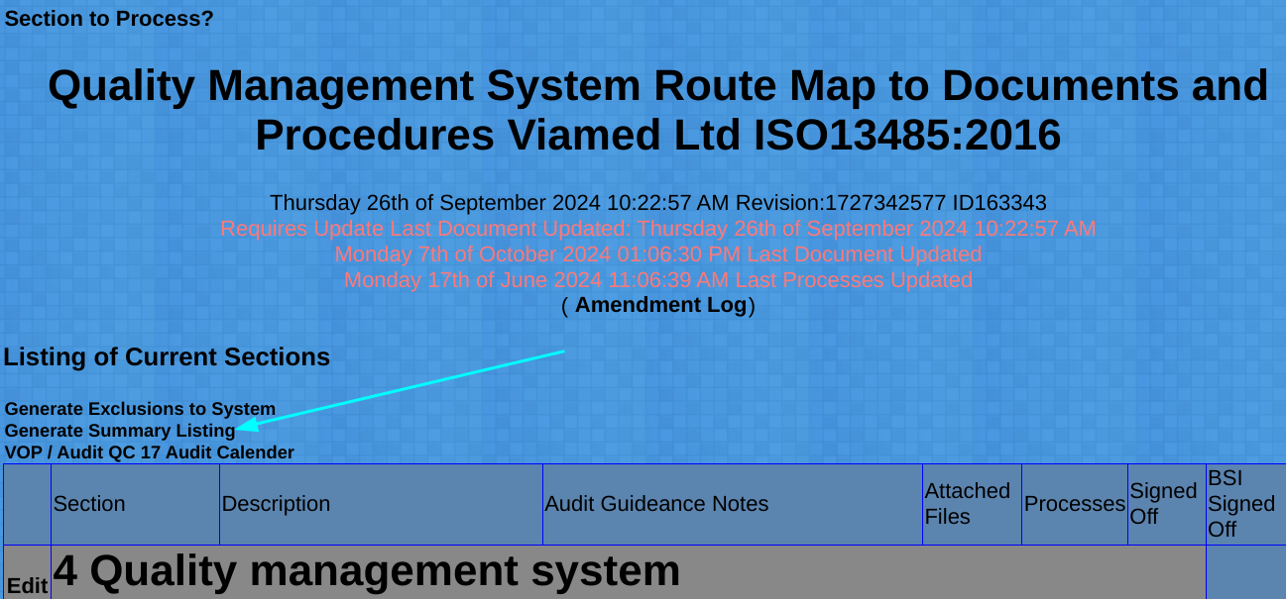

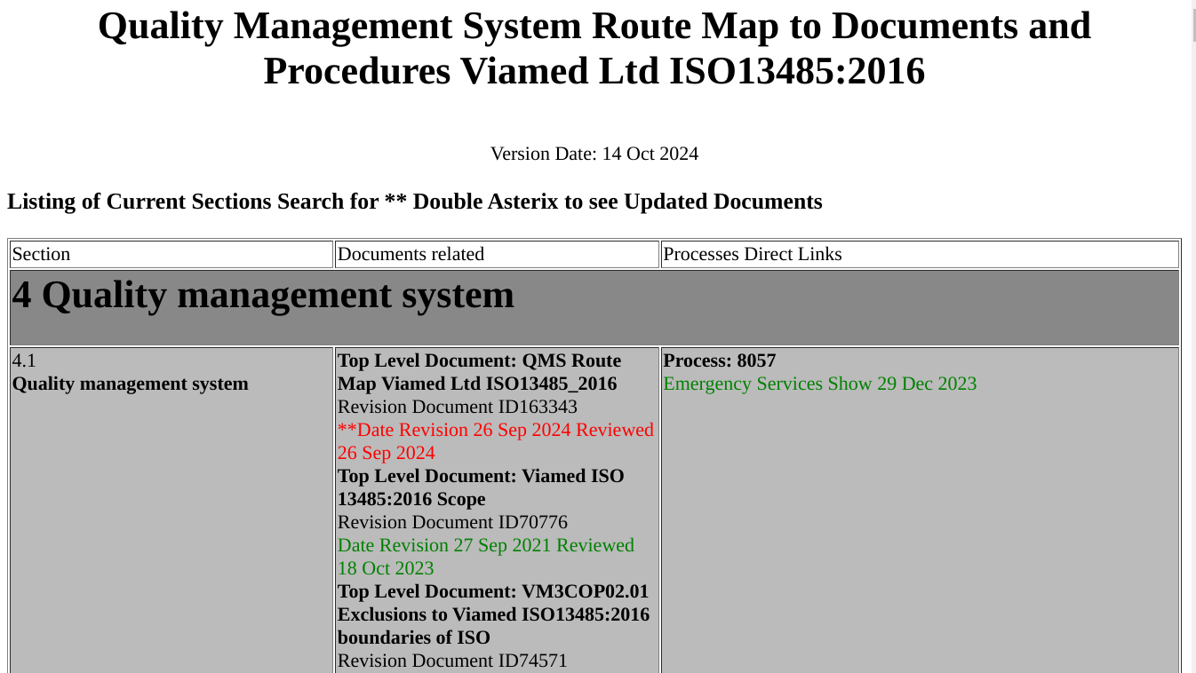

Right Click anywhere on the screen and Click Print then save as PDF
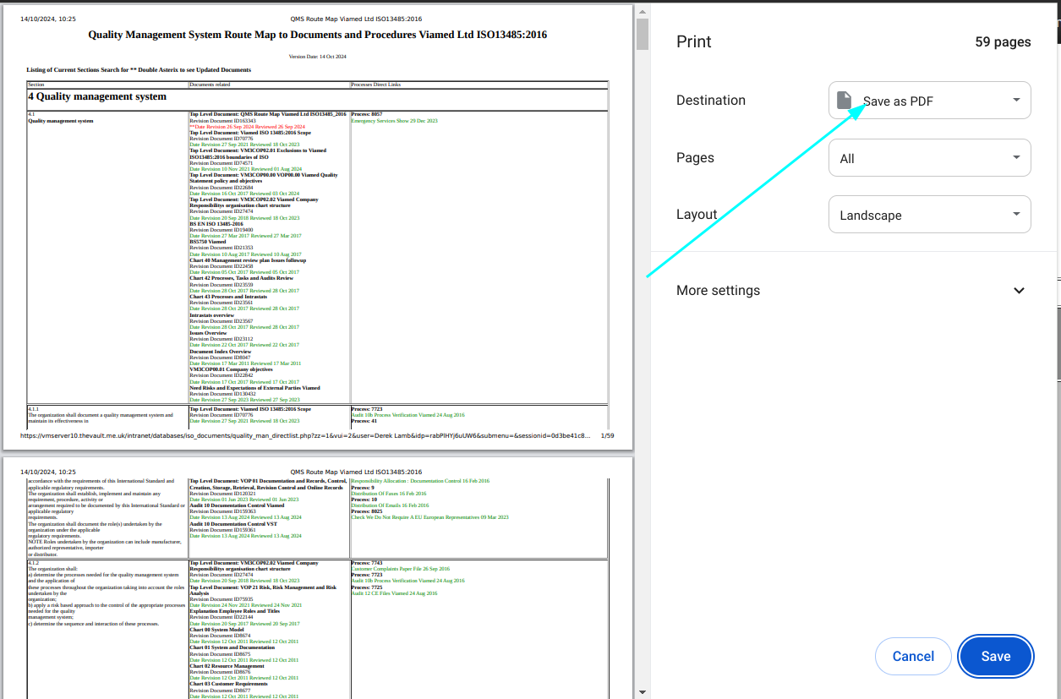

Click Back,
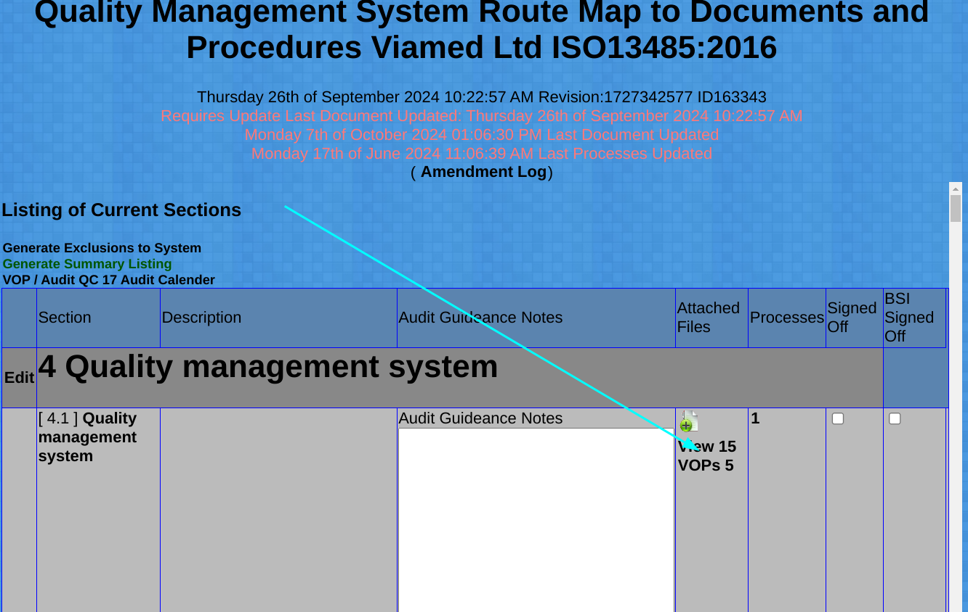
Click Primary Document
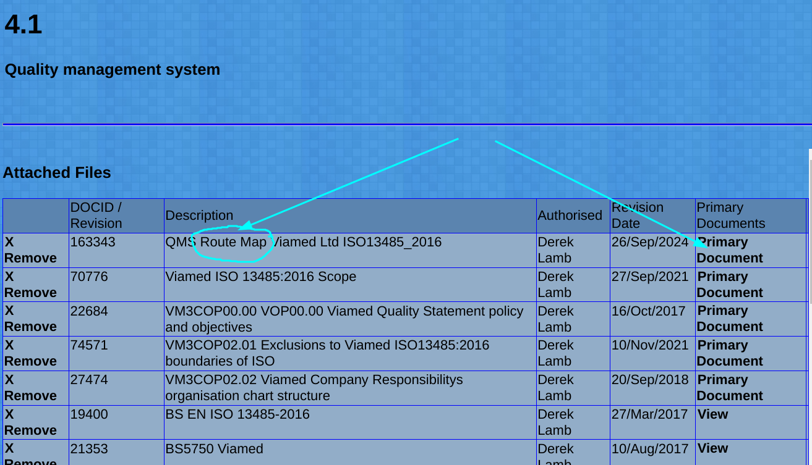
Admin Document
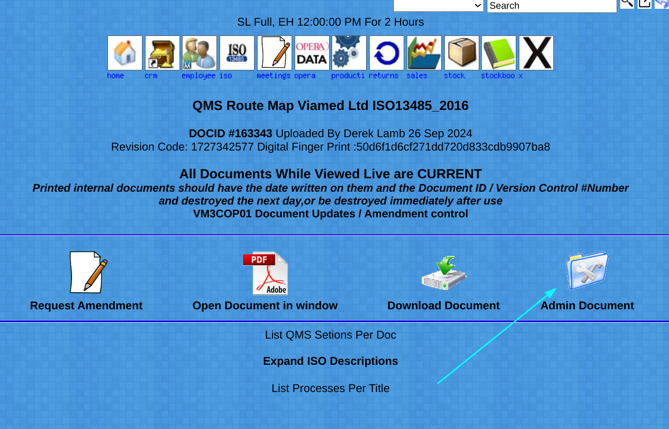

Admin Document again

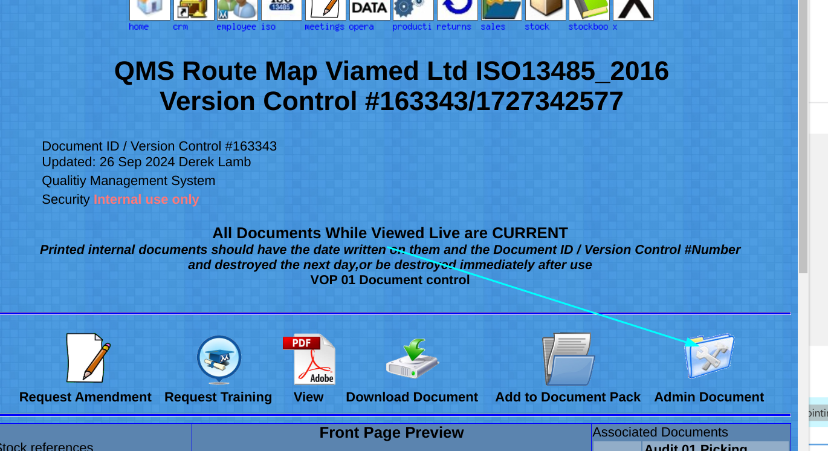

Upload New Revision of document

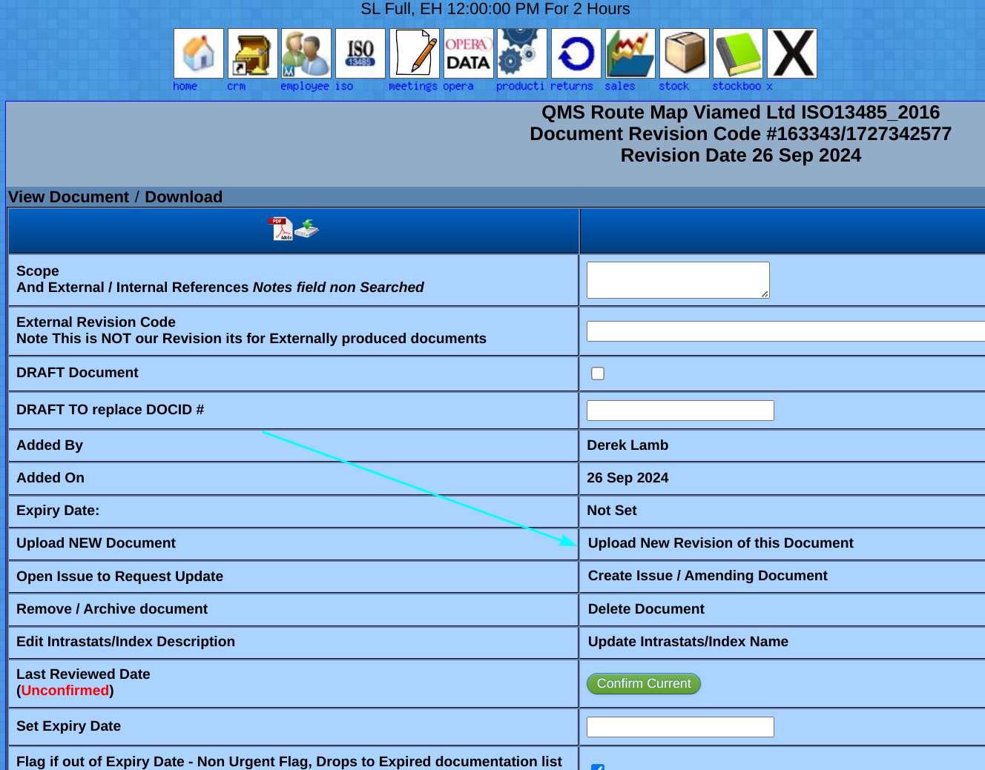
As this is an excluded file it does not require a risk assessment
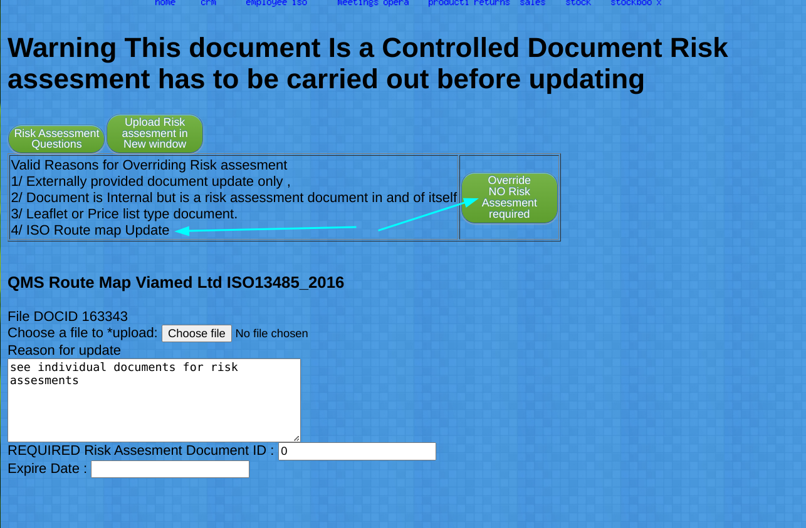
Click Choose File

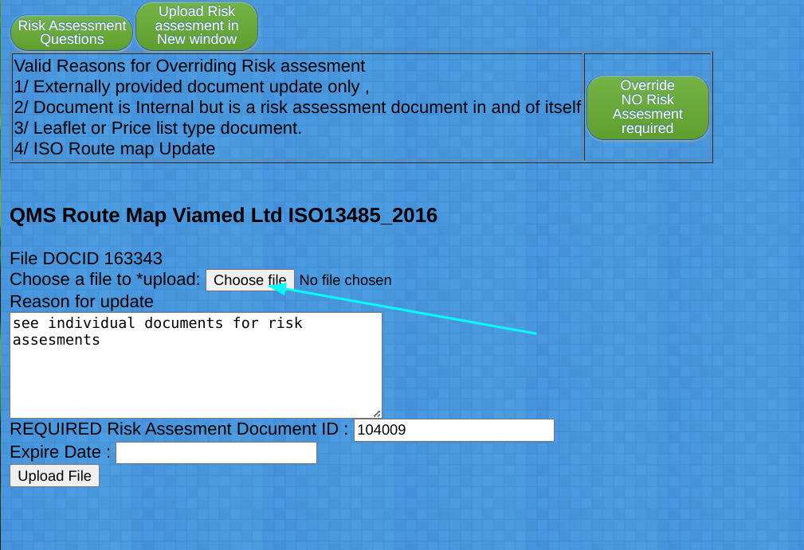

Then Upload:
If no upload button check there is a number in the Required Box

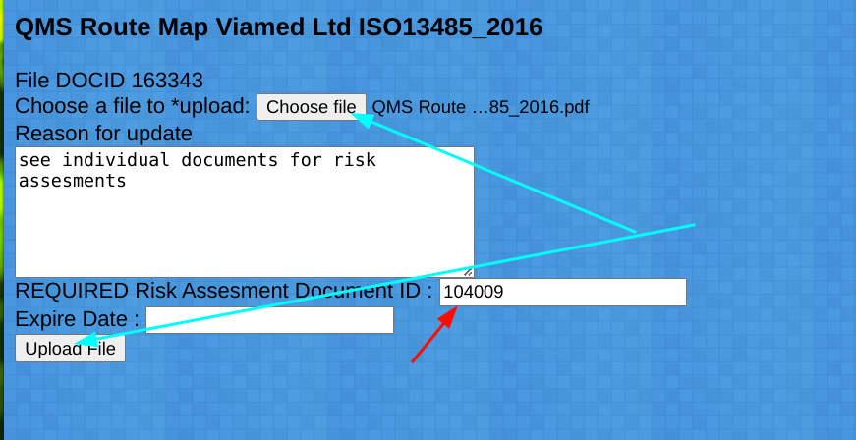
Repeat from the TOP but for VST ISO 9001, and or any other Companys with ISO 9001 / 13485 standards.

