TOF 3D Neuromuscular Transmission Monitor

What is the TOF 3D used for?

To measure the depth of neuromuscular blockade in patients under anaesthesia.

Neuromuscular blockade is when a neuromuscular blocking agent (a class of anaesthetic) is administered to a patient during anaesthesia to relax the muscles and prevent movement. This helps to maintain the optimum conditions for surgery.

This is necessary during intubation (inserting an endotrachael tube into the patients airway) to relax the airway and prevent patient movement.

Also suppresses the breathing response to allow the anaesthetic ventilator to take over breathing during anaesthesia.

Neuromuscular blockade must be reversed during the recovery phase, or the patient can be left with some residual paralysis. The TOF 3D allows the depth of blockade to be monitored during the recovery phase.

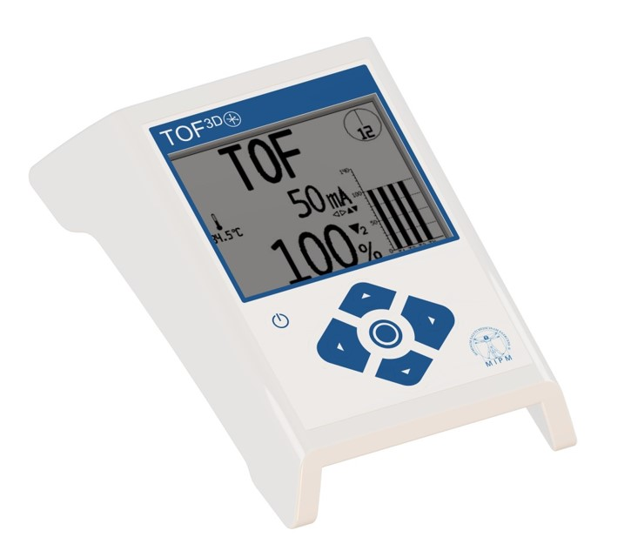
TOF 3D Neuromuscular Transmission Monitor

How does it work?

Applies an electronic stimulus and measures the twitch response generated by the muscles.

Most commonly placed on the hand to measure the twitch response on the digits of the hand.

Another method is to stimulate the facial nerve and measure the twitch response at the eyebrow.

We offer a reusable hand adapter (left), a disposable thumb adapter (middle) or a disposable eye adapter (right).

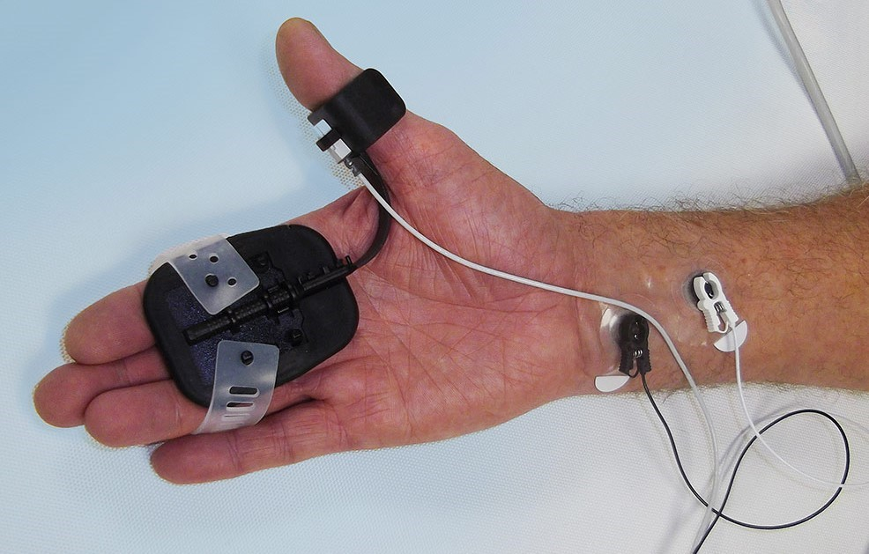
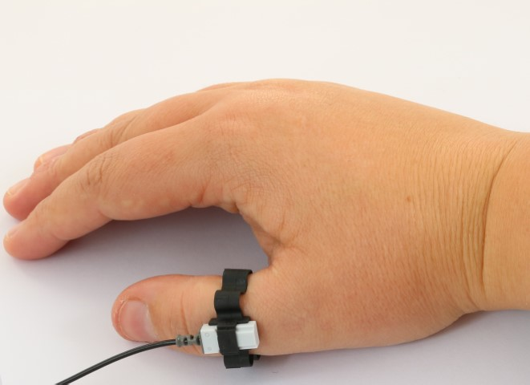
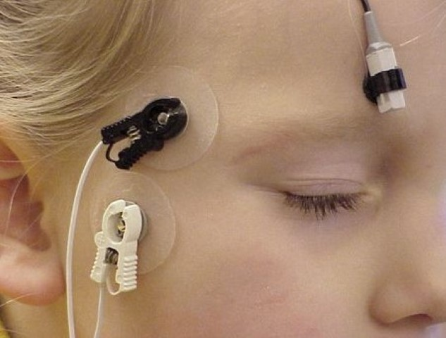

- 2520110 - TOF 3D Hand Adapter – reusable

- 2520111 - TOF 3D Thumb Adapters (box of 50) – single patient use

- 2520112 - TOF 3D Eye Adapters (pack of 50) – single patient use

Requires standard paediatric ECG electrodes, which Viamed does not supply but should be readily available to the end user.
Methods for measuring twitch responses

- Subjective - monitoring and assessment is carried out by the operator, which is open to interpretation.

The now discontinued Microstim DB3 was a subjective monitor, the anaesthetist would use visual and tactile methods, ie watching and feeling the twitch response.

- Quantitative - monitoring and assessment carried out by the monitor, which is measurable and repeatable.

The anaesthetic guidelines state that quantitative methods of measuring are necessary to ensure adequate recovery from block.

The TOF 3D is a quantitative monitor.

Types of quantitative monitoring

- Mechanomyography (MMG) – This is the gold standard. It has the disadvantage of being cumbersome and impractical for use in the operating theatre.

- Electromyography (EMG) - Measurement of electrical changes that occur in muscle during stimulation. More practical to use than MMG devices but is prone to electrical interference and movement.

- Acceleromyography(AMG) - Developed as a more convenient method of monitoring twitch responses. Uses an accelerometer attached to the thumb or other suitable measurement site.

The TOF 3D uses AMG.
TOF 3D Stimulation Modes

TOF (Train of Four)  4 short stimuli over a 2 second period.  Used to determine the degree of neuromuscular blockade. | 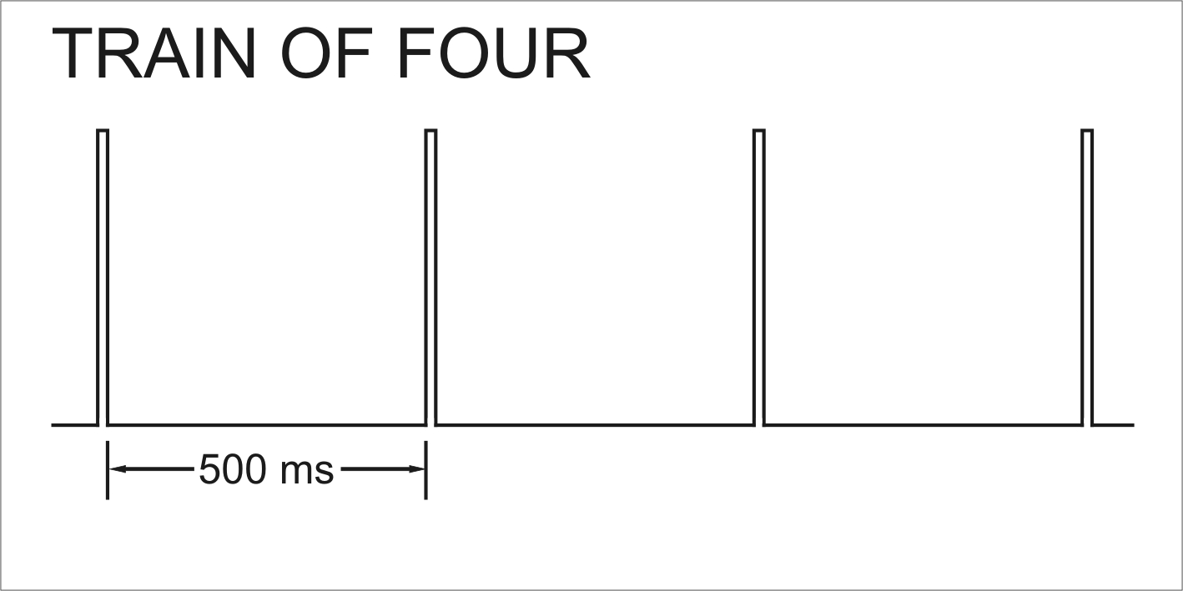
PTC (Post Tetanic Count) / TET (Tetanic)  50hz over 5 seconds (tetanic) followed by a 3s recovery period, then continuous short stimuli at 1s intervals.  Used for monitoring when profound neuromuscular blockade is required to minimise movement, eg during retinal surgery. | 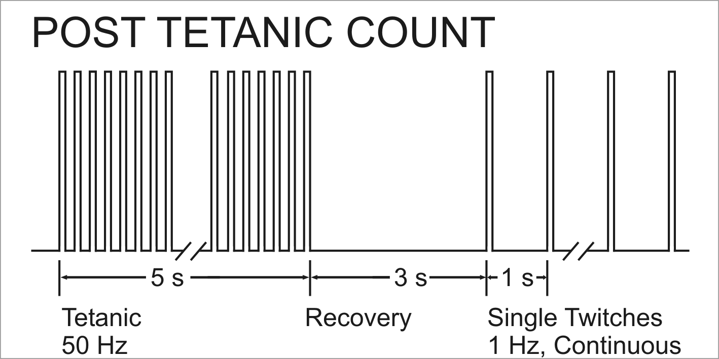
DBS (Double Burst Stimulation)  3 short stimuli 20ms apart, followed by 2 (or 3 if required) short stimuli with 750ms between the bursts.  Alternative method developed in the 1980s, considered more sensitive than TOF when performing subjective monitoring. | 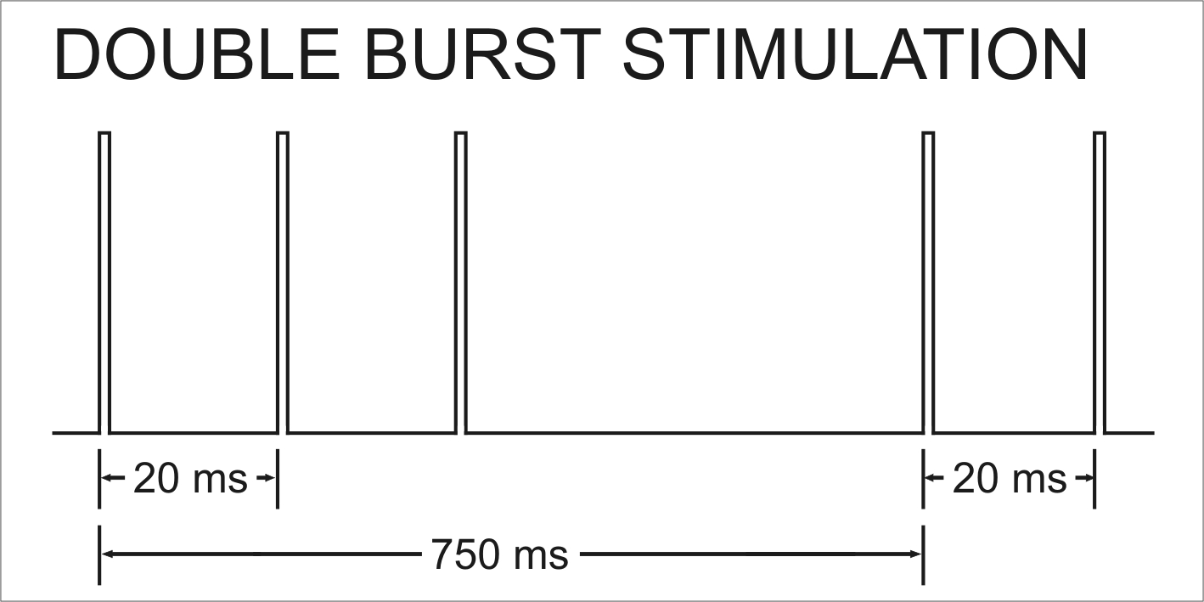
Single Twitch  Continuous short stimuli 1s apart (or 0.1s if required).  Can be used at the onset of neuromuscular block. | 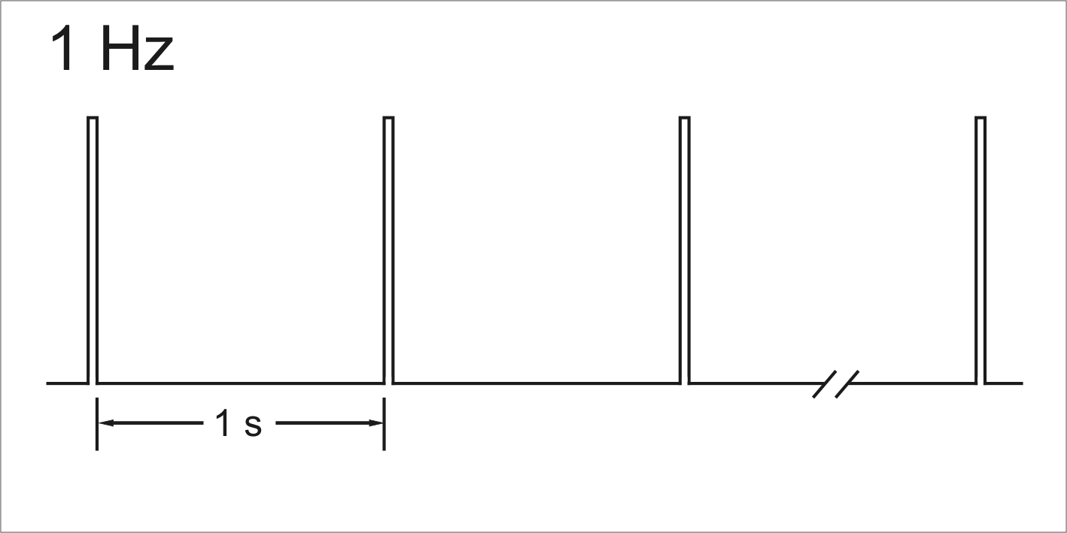
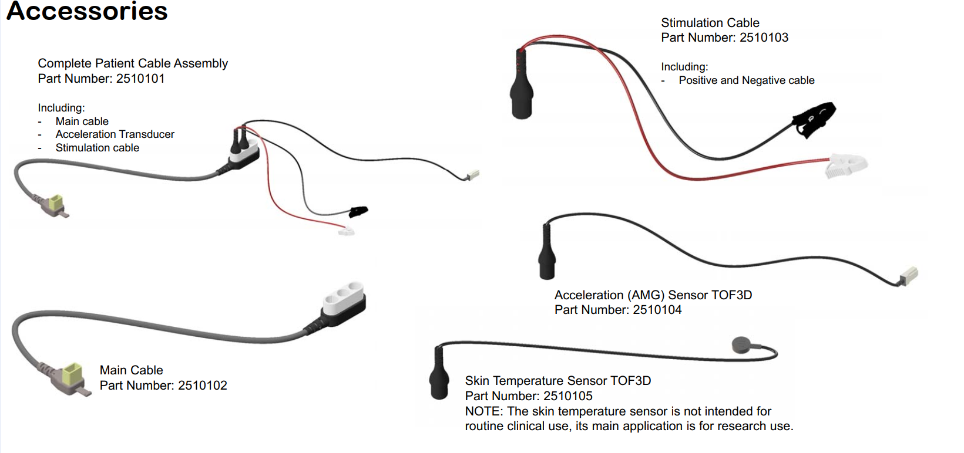

Adapters

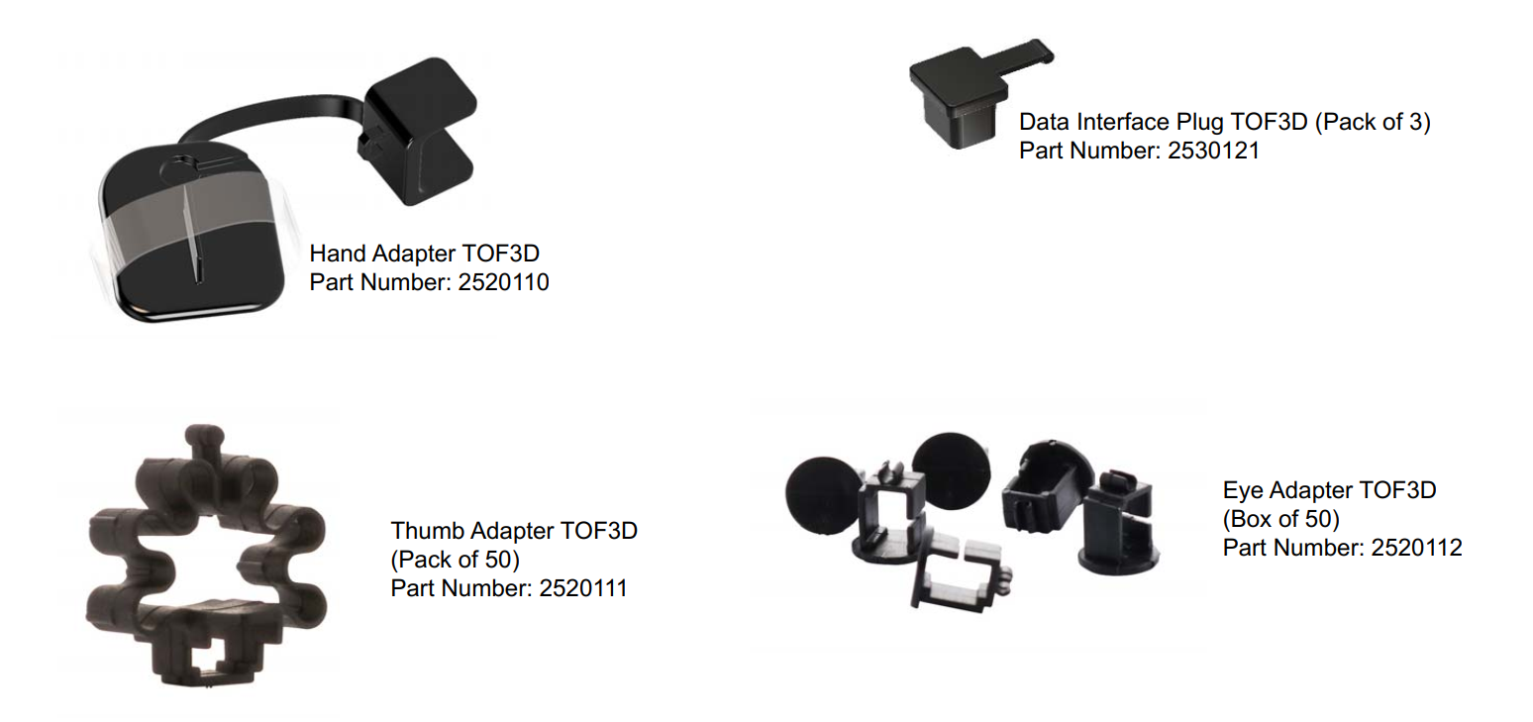

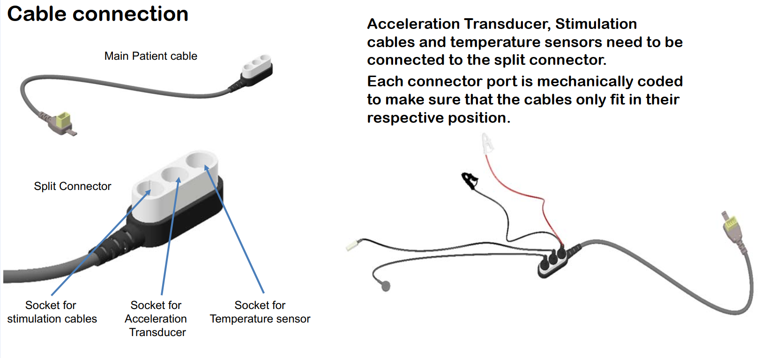

Mounting options

- 2520113 - TOF 3D Pole Mount (Variant A, Premium) – Can be used on vertical and horizontal poles, or with medirail.

- 2520114 - TOF 3D Pole Mount (Variant B, Standard) – Secured using tie wraps, which makes it difficult to relocate.

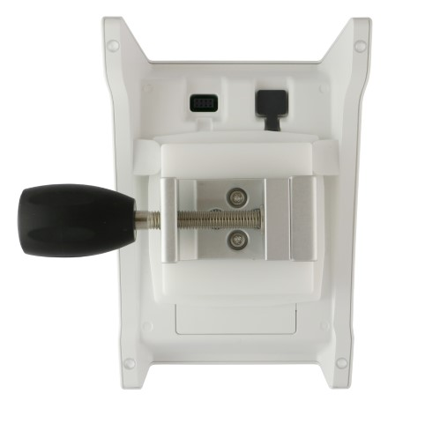 | 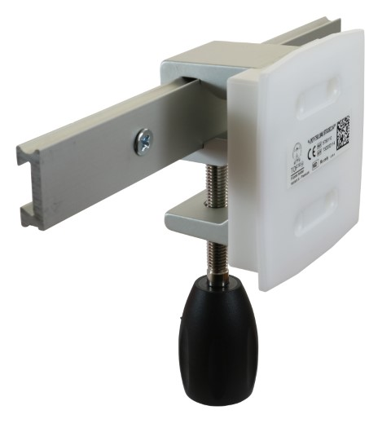 | 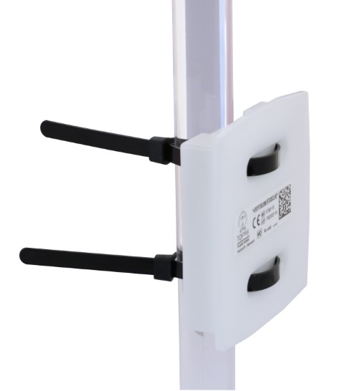
2520113 – Vertical pole configuration | 2520113 – Medirail configuration | 2520114 – Vertical pole configuration

Available as an optional accessory.

We recommend the premium variant A (p/n 2520113) as it is better constructed and more flexible.
Power requirements

Battery powered using 4x AA Alkaline batteries.

Cleaning

Sales to the NHS require devices to be cleaned and disinfected with specific brands of products, which are readily available through NHS Supplies. We have been advised that the following Clinell products have successfully passed testing by MIPM:

- Clinell Universal Wipes
- Clinell Sporicidal Wipes

A letter / statement to this effect is linked to the stock page under Technical Documents.

Warranty

The customer warranty is 24 months from the date of invoice.

Maintenance/Service

The TOF 3D does not contain user serviceable components.

Viamed offers an annual service under the following part number:

- 2580100 - Functional Check Service - TOF 3D

Latex

TOF 3D and accessories are all latex-free.

Handling and booking in

If you are required to handle returned TOF 3Ds in Goods In, please refer to VM3COP29.13 TOF 3D Goods In – Returns Procedure.

Where to find additional information

- Viamed website
- Product leaflets – linked to stock pages
- FAQs on the stock page
- Memos on the stock page
- Instructions for use

