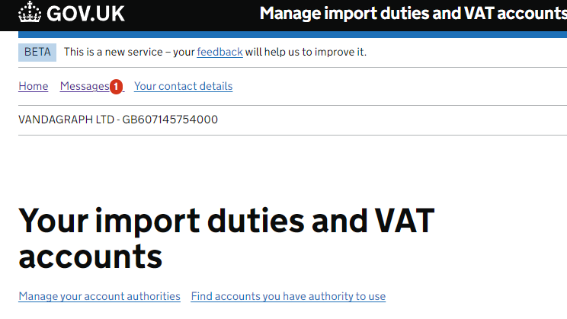
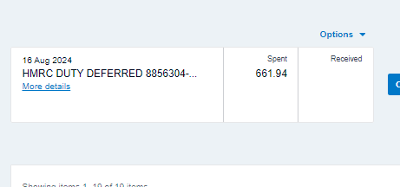
When being on HMRC looking for Deferred duty to certificates. If you have a charge on the bank from the HMRC you need to get the C79 from from the online site
https://www.gov.uk/guidance/get-your-import-vat-certificates

Each company has one Viamed, Vandagraph and VST. Once in go to Import VAT certifiacte (C79)
The certificate you want it the one dated the month before the date on the bank. If its not there you can request one from the bottom of the page - Is this page not working properly? (opens in new tab)

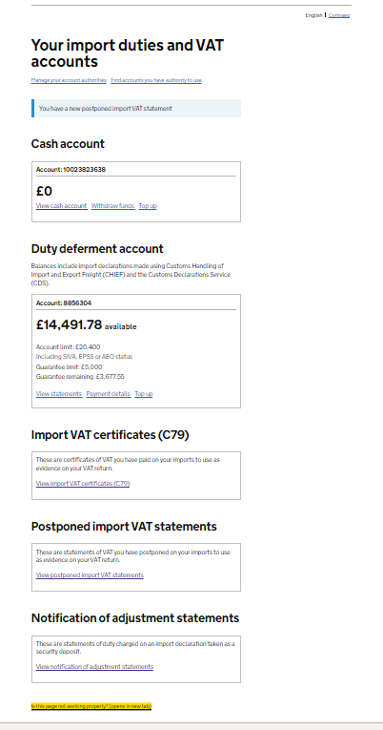
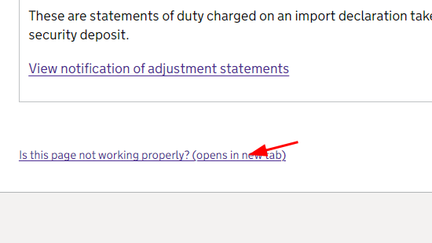
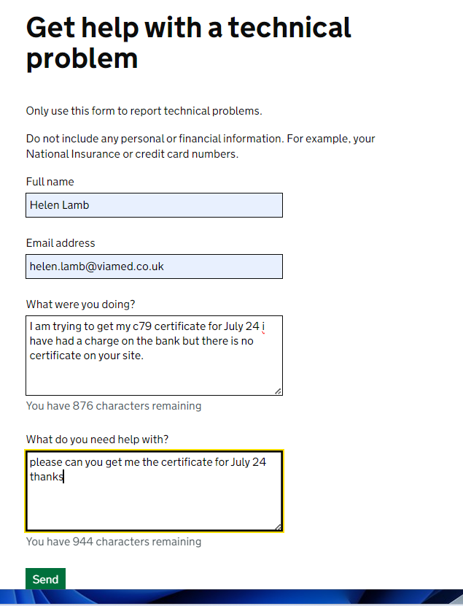
Fill in the submission page and send. They will come back to you by email in a few days.
I was told be them this is bast way to get these.

