- Update the production serial numbers.
- In the “Production” tab of Intrastats, click on the “Update production serial numbers” option.
- Scan the production sheet bar code or manually type the number found at the top the page.
- In the serial number box, replace the number with the serial number found on the Tom Thumb and press “Commit”. NB: This serial number will also be found on the Tom Thumb QA/Calibration sheet.

- QA and assign stock.
- Fill in the Intrastats QA form with the information from the QA/Calibration sheet.
- In the “Stock” tab of Intrastats, click on the “Stock book” option then click “Multi to one bar code”. In the text box, scan the bar code of the completed unit.
- Scan the items that are needed and press complete.

Part number | Description
3210011 | NeoPEEP neonatal ventilator circuit
3210071 | Single use silicone round facemask
0120140 | Adapter 15mm I.D. - 15mm I.D

- Print the labels.
- In the stock tab, click on the “Stock book” option and click on “Scan to queue”.
- Scan the relevant barcodes from the production sheet.
- Go back to the “Print queue” menu in Stock → Stock book and click on “Print queue”.
- Select the “Standard tracking label zebra” from the pull down menu for the small label and press go.
- On the label printing confirmation screen, press the print button.
- The label or labels should be previewed on the page. Press print.
- Select the ZM400 printer and press print.
- Go back to the “Print queue” menu in Stock → Stock book and click on “Print queue”.
- Select the “03100xx top box sticker” from the pull down menu for the large label and press go.
- On the label printing confirmation screen, press the print button.
- The label or labels should be previewed on the page. Press print.
- Select the 105SL printer and press print.

- Packing the Tom Thumb.
For a TT480 use the box with part number | 0350120
For a TT490 use the box with part number | 0350121

- Place the Tom Thumb in a labelled plastic bag
- Take the items to be included in the box.

Part number | Description
3210011 | NeoPEEP neonatal ventilator circuit
3210071 | Single use silicone round facemask
0120140 | Adapter 15mm I.D. - 15mm I.D
0390006* | TT480 Instruction Manual
0390007* | TT490 Instruction Manual
*Use the appropriate manual

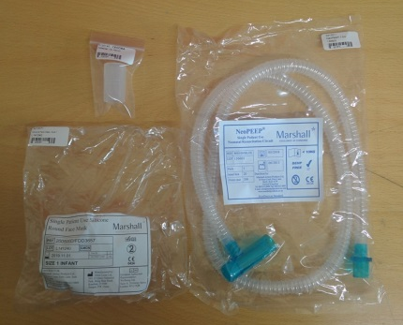 | 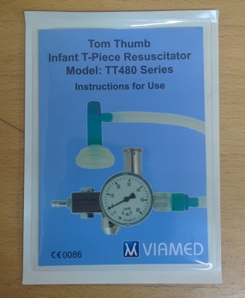 | 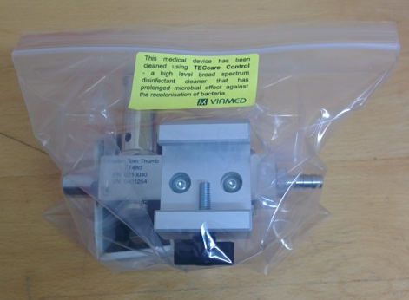

- Place a double layer of bubble wrap and few chippings into the box.  - Place the Tom Thumb on top of the chippings.  - Place the instruction booklet in the front of the box. | 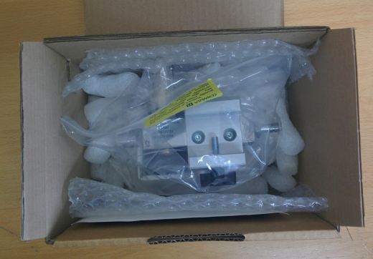
- Tape the 15mm adapter the NeoPEEP bag.  - Place mask, adapter and NeoPEEP on top of the Tom Thumb.  - Place a few more chippings into the box. | 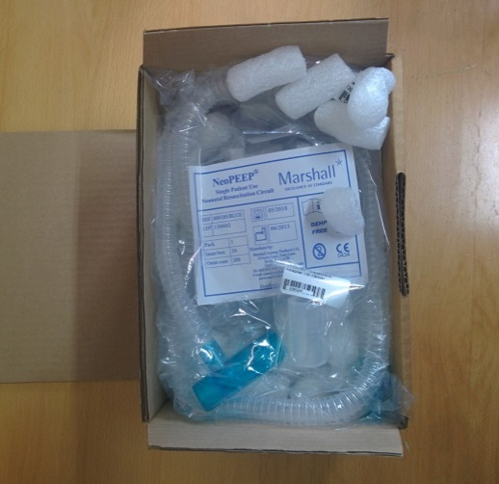
- Close the box. The contents should not move within the box.  - Affix the small label to the front of the box. Affix the large label to the top of the box. Affix the British made label to the lower right hand corner of the front of the box as shown in the picture. | 

