VM3COP20.16 Viamed eBay Orders

- Login to eBay – Username: medesales, Password: viamed17

- Go to My eBay, Selling, Sold.

- Print 3 copies of the order
  - 1 for delivery note
  - 2 for checking and filing
(1 to be filed in main office, other to be sent over to Cathy to be used as picking list).

- Produce order on account 00006666, do not amend invoice address. Priority should be determined in the same way as normal orders.
Order reference is the first 10 characters of the buyer’s username
i.e. “kerryharpe”. (If the buyers name is longer please include in the footer #kerryharper2k7.
Also in the footer please write: “eBay sale” then 12 digit listing number.

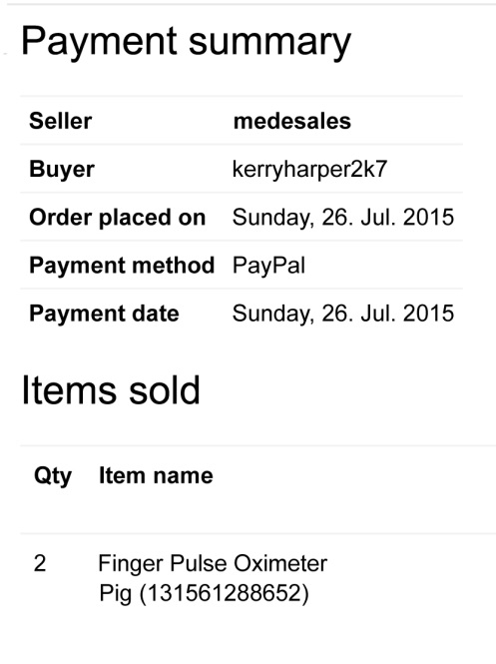
Buyer username
eBay Listing Number
Note: Pricing on eBay orders is plus carriage and includes VAT.
UK End user total price is the same but excludes VAT and includes postage.
When adding to Opera the end price should be equal to the total end value of the eBay order.
Example:
2810011 eBay price is £25.00 plus £5.00 postage = £30.00
2810011 UK End User £25.00+VAT = £30.00 including VAT
Postage
Royal Mail up to and including 10 oximeters (£5.00 inc VAT),
11+ UPS (£12.00 inc VAT).
- Order to be checked as normal, take round to goods out.

Goods out only

- Scan the order and deliver & invoice as usual.
Do not send the Viamed delivery note or invoice, just the eBay one provided.

- FILING: Please staple all paperwork, copy of order, delivery note and invoice together and file with normal orders in Goods Out.

- Add Medesales sender labels on the jiffy bag/box, do not use the Viamed franking address.

- Please make sure you update as dispatched on eBay using the above login details.

