OFFICE – checking the Active List
VM3COP20.20

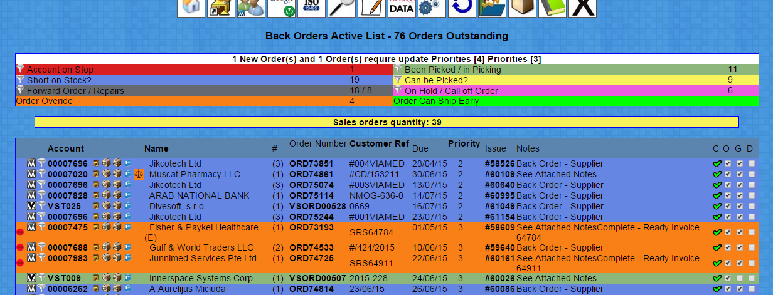

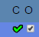
Each line of the Active list should be checked daily by both the office and goods out,
an item that has been check will have a tick in the appropriate column on the right,

Click the Account Number of the item to be checked,

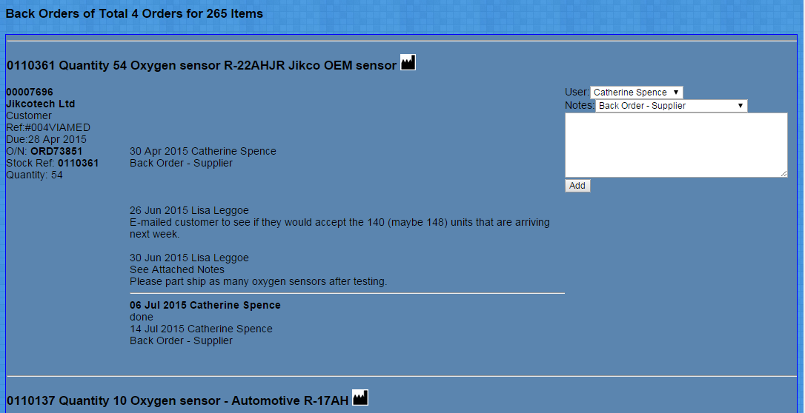
A page will open with all back orders relating to the customer,

Current status notes for each stock item should be vis-able,
the Manufacture Icon can be clicked to retrieve further information relating to the stock item,
Purchase order delivery dates and any other customer numbers will be displayed

You are checking the order is not stuck in limbo, the customer is aware of any delays, and we are aware of the order.

Once you are happy nothing needs doing with the customer order you can return the the active screen and tick the box as checked.

