


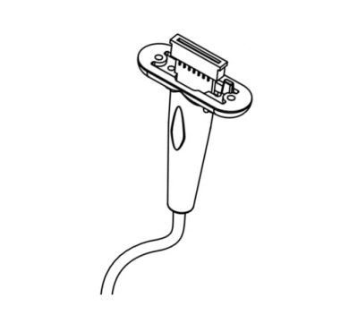

BIS Adapter Cables
User Manual

Intended Use & Indications for Use
The BIS Monitor Interface cable is connected with compatible monitor and BIS module, the BIS Patient Interface cable is connected with BIS module and patient sensor.
The BIS Adapter cables are designed to match the specifications of the original equipment manufacturers’.
The BIS Monitor Interface cable, the BIS Patient Interface cable,the BIS module,the patient sensor and host machine compose monitor system to monitor the patient electroencephalogram.
Storage & Handling
When not in use, cables should be loosely coiled and stored at room temperature. Don’t wrap cables around equipment cases to avoid damaging internal wires.

Operating Conditions
• Environment temperature: 0°C to +40°C
• Relative humidity: 15% to 85%
• Atmospheric pressure: 86 kpa ~ 106 kpa
Storage & Packaging
• Each cable is individually packaged.
• Cables must be stored in its original packaging and within the storage conditions to maximize the storage life.
• Storage conditions are as follows:
Ambient temperature: -10°C to +40°C
Relative humidity: 15% to 85%
Atmospheric pressure: 86 kpa ~ 106 kpa

Shelf Life
5 years.

Installation & Use
• Make sure the compatibility of the BIS adapter cable. See the attached compatible label
to ensure the device used with is compatible with the BIS adapter cable.
• Make sure the BIS adapter cable plug matches the connector on the device. Then fully plug
the BIS adapter cable into the device.
• Connect the BIS adapter cable with the compatible patient monitor, and check whether the operation can meet the requirements of compatible monitor manual.

Cleaning & Disinfecting
The cable must be cleaned and disinfected using a soft cloth moistened with soapy water or 70% isopropyl alcohol. Allow the cable to dry thoroughly before use. Do not use any abrasive agents or chemical product except 70% isopropyl alcohol.
Do not irradiate, autoclave, soak or immerse the cable in any kind of solution.

Warranty & Liability
Orantech offers 12 months warranty against defects in material or workmanship from the date
purchase. But does not include the damage or breakage due to the abusive use or negligent
care of the cables.
Orantech reserves the right to perform warranty service at its own facility. We guarantee that the products conform to the specifications of the safety and performance standards currently in force and applicable to it.
Warning
• Ensure the cable is physically intact with no broken or frayed wires or damaged
parts.Visually inspect the cable and discard if cracks or discoloration are found.
• All cables which are not connected correctly with patients or have faults may cause
reading error.

• High temperature, electromagnetic wave interference and high voltage sources can also
affect the equipment reading.
• The cables should be routed carefully to avoid suffocation to the patient.
• Follow the requirements of the equipment’s operating instructions installing and placing
cables correctly.
• Do not use with magnetic resonance equipment as it can cause burns on the patient.
• Cables metal parts must be kept dry otherwise it will cause equipment and reading failure.
• Please refer to the monitor’s instruction manual for proper use.

Caution
Federal (U.S.) Law restricts this device to sale by or on the order of a physician.

Waste Disposal
Please refer to your local laws and regulations for information on how to dispose of BIS Adapter Cables.

Title of Symbol

REP














Warning

Manufacturer

Refer to instruction
manual /booklet

Federal (U.S.) Law restricts this device to sale by or on the order of a physician

Non-sterile

Not made with natural rubber latex

Serial number

Batch code

Caution

Crossed out wheelie bin indicates separate treatment from general waste at end of life. Waste of Electrical
and Electronic Equipment Directive (WEEE)

Unique Device Identifier

Medical device

Protection against vertically falling water drops when
ENCLOSURE tilted up to 15° Community

CE Mark

Authorized Representative in
the European Community

Date of manufacture

Catalogue number












Support
To get the support, please contact the representative of manufacturer or local distributor.
The categories shown below are available for sale through the local distributors or e-commerce.

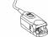 |  | 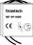 | 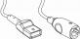
SpO2 | ECG | NIBP | IBP
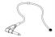 | 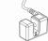 |  | 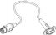
TEMP | EtCO2 | FETAL | EEG


Orantech Inc.

Zone#A, 4F, 1st Bld, 7th Industrial Zone, Yulv Community, GongMing, Guangming New District, Shenzhen, China 518106
www.orantech.com (+86) 755 2369 9939 info@orantech.com
Medten EU ApS
REF: M20-M215
Rev: A0
REP
Hejreskovvej 8, 3490 Kvistgård, Denmark

