Introduction to Blenders Training
Inspiration Healthcare (IHC) and Maxtec MicroMax
What are blenders?
An air oxygen blender is a medical device designed to precisely mix medical-grade air and oxygen to create a specific blend tailored to a patient's needs. These devices are commonly used in healthcare settings, such as hospitals, clinics, and home care environments, to deliver oxygen therapy to patients with respiratory conditions or those in need of supplemental oxygen. The blender ensures that the oxygen concentration delivered to the patient is accurate and consistent, helping healthcare professionals optimize patient care and improve outcomes.
Where are blenders used?
Medical air oxygen blenders are used in various clinical scenarios where patients require supplemental oxygen therapy or specific oxygen concentrations. Here are some instances where these devices might be used:
Respiratory Distress: Patients experiencing respiratory distress due to conditions such as asthma, chronic obstructive pulmonary disease (COPD), pneumonia, or acute respiratory failure may require supplemental oxygen to improve oxygenation and alleviate symptoms.
Post-Surgery: After certain surgical procedures, patients may require oxygen therapy to support their respiratory function during recovery.
Chronic Respiratory Conditions: Individuals with chronic respiratory conditions, such as cystic fibrosis or bronchiectasis, may require long-term oxygen therapy to maintain adequate oxygen levels in their blood.
Neonatal Care: Premature infants or newborns with respiratory issues may require oxygen therapy to support their developing lungs and oxygenate their blood. Introduced as a recommendation as part of the NICE guidelines – pure oxygen can cause blindness in Neonates.
This is primarily where we have sold our blenders for use.
Emergency Medicine: In emergency departments or during medical emergencies, such as cardiac arrest or trauma, patients may require immediate oxygen therapy to stabilize their condition.
Critical Care Units: Patients admitted to intensive care units (ICUs) due to severe illness or trauma may require precise oxygen therapy to maintain appropriate oxygen levels and support vital organ function.
Home Care: Patients with chronic respiratory conditions who require oxygen therapy on a long-term basis may use portable oxygen concentrators equipped with air oxygen blenders to receive therapy at home.
In all these instances, medical air oxygen blenders play a crucial role in delivering the appropriate oxygen concentration to patients, ensuring effective therapy and optimal outcomes.

Types of Blenders
There are 2 different types of blenders; high and low flow versions of medical air oxygen blenders differ in the rate at which the blended gas mixture is delivered to the patient.
Low Flow Blenders: Low flow blenders are designed to deliver relatively small volumes of the blended gas mixture to the patient's airway. These blenders are typically used when the patient's spontaneous breathing can adequately draw in the required amount of oxygen. They are commonly employed in scenarios where precise oxygen titration is necessary, such as in neonatal care or for patients with stable respiratory conditions. Low flow blenders typically deliver oxygen at flow rates ranging from 0 to 15 litres per minute.
High Flow Blenders: High flow blenders, on the other hand, are capable of delivering larger volumes of the blended gas mixture to the patient's airway, often exceeding the patient's spontaneous breathing capacity. These blenders are used when patients require higher concentrations of oxygen or when their respiratory effort is insufficient to maintain adequate oxygenation. High flow blenders are commonly utilized in critical care settings, including intensive care units (ICUs) and emergency departments, to deliver precise and high-flow oxygen therapy to patients with acute respiratory failure or severe hypoxemia. High flow blenders can deliver oxygen at flow rates exceeding 15 litres per minute, sometimes reaching up to 60 litres per minute or more.
While both low and high flow versions of medical air oxygen blenders serve the purpose of delivering precise oxygen concentrations to patients, they differ in their intended use based on the required flow rates and patient needs.
Connector Types
Medical air oxygen blenders utilize two connector types to ensure compatibility with different medical gas sources and delivery systems, these are NIST and DISS.
All outlets are DISS, this is the standard connection for flowmeters.
The NIST refers to the inlet of the blender, we use hoses with NIST fittings in the UK, in the US and some other countries they use DISS hoses.
NIST (Non-Interchangeable Screw Thread)
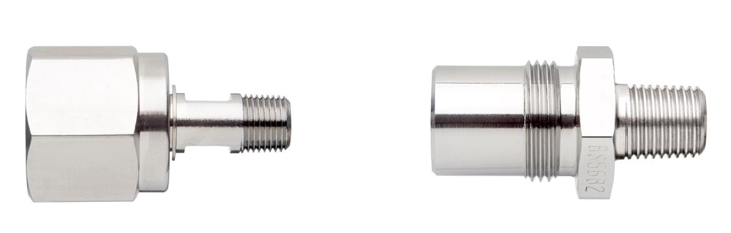

DISS (Diameter Index Safety System)
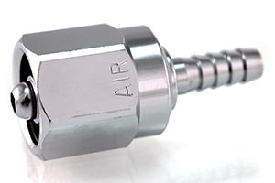
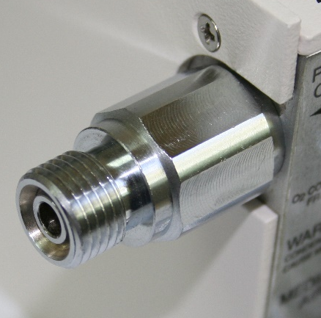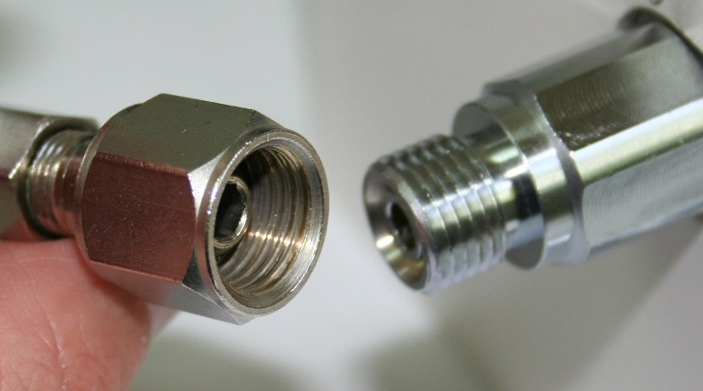
DISS connectors are another type of standardized fittings used in medical gas delivery systems.
Unlike NIST connectors, DISS connectors rely on a threaded interface rather than a pin-indexing system.
On Intrastats this information can be found in the descriptions or extended fields. Typically, this is shown against Maxtec MicroMax blenders.
Blender Items sold by Viamed
- Inspiration Healthcare (IHC) Blenders: High and Low Flow
- Maxtec MicroMax Low Flow Air/Oxygen Blender
- Maxtec BlenderBuddy2 – to be covered in next session
- Maxtec MaxBlend Lite – to be covered in next session
- Maxtec MaxBlend2 – to be covered in next session
- Maxtec MaxVenturi – to be covered in next session
- Maxtec DFB Flowmeter – to be covered in next session

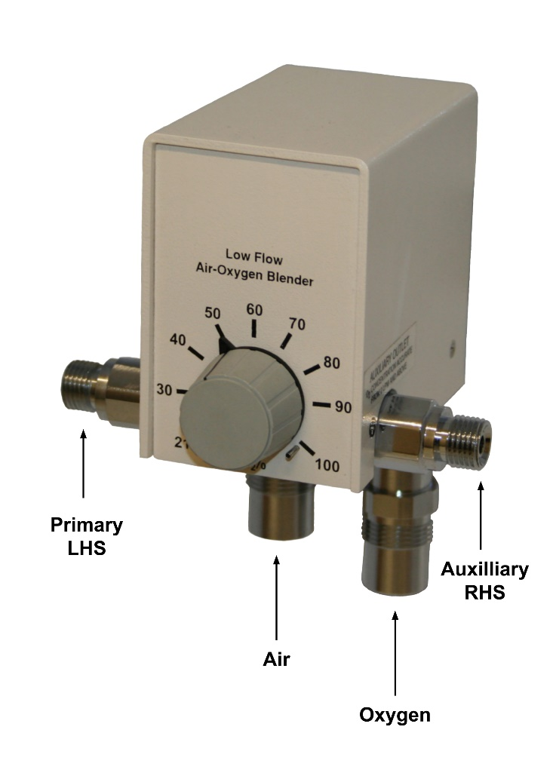
Inspiration Healthcare (IHC) Blenders: High and Low Flow (NIST)
Supplied by Inspiration Healthcare in the UK, these blenders are available in low and high flow.
Blenders can be used to supply mixed gas to infant resuscitators, such as the Tom Thumb infant resuscitation unit.
In order to offer maximum flexibility, blenders can be specified for either mounting on a pole or rail, with or without gas hoses, with a variety of flow meters.
Other blenders are available upon request, including MRI compatible models and various different flows and configurations – if you are unsure of which to offer, please contact the technical department.
Depending on the part number supplied, it may be supplied with flowmeter and hoses – see stock memos.
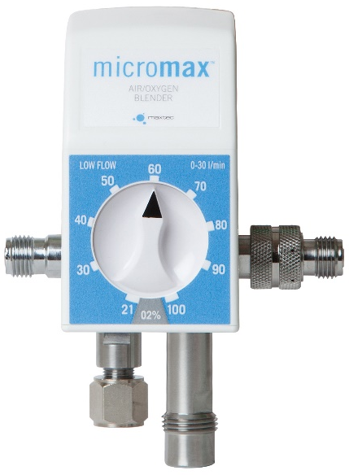
Maxtec MicroMax Series Low Flow Air/Oxygen Blender (DISS)
Supplied by Maxtec in the USA, the MicroMax features delivery of accurate FiO2 mixtures from two outlet ports and has an overall flow range of 15-120 LPM (High Flow) and 3-30 LPM (Low Flow). Currently we only have pricing for the Low Flow version (5610151) but alternatives as listed in Intrastats are currently available to purchase, this is under review.
Clinicians have the option to turn the bleed control to ON or OFF which provides a quieter operation for NICU and PICU settings.
When equipped with the Maxtec BlenderBuddy 2, the MicroMax provides users with a mixing package complete with a blender, 2 flow meters and an oxygen analyzer (sold separately).
Hoses
Hoses are available for all types of blenders which we supply.
Although the blender will either be a NIST or DISS connector, the other end can be a variety of connectors. Please check with the hospital to which connector is required to connect to the mains.
Some products are supplied with flow meters and hoses but can also be supplied separately.
Brands available: Inspiration Healthcare (IHC), MEC Medical or Maxtec.
Please check the stock memos against the blenders to see if these are already included.
Servicing
- Annual Blender Service
Includes annual service kit: 0332000
The price for this is £156.78 plus £12.00 return carriage (excluding VAT) – part number 0380020.
- Blender Overhaul Service
Includes overhaul service kit: 0332001
If we receive a purchase order for an overhaul service we need to order the overhaul service kit from Inspiration Healthcare.
Overhaul recommended every 4 years by Inspiration Healthcare for UK installed systems. In countries with poor medical gas supplies, outside of the UK, this is reduced to 2 years.
Note: overhaul kit includes the parts required for an annual service and overhaul, but does not include hoses which also need replacing every 4 years.
The price for this is £337.10 plus £12.00 return carriage (excluding VAT) – part number 0380019.
Pricing can be found on Intrastats, under the “£” symbol.
Certifications
Should you require to find information on what certifications a product has please see the stock screen, “i” icon and find the “Certificates” option. Click this and it will open the document index and all related certificates for that line.
Marketing Materials
Up to date copies of marketing materials such as leaflets, manuals and price lists (or in the £ screen) can be found on the stock pages under the “i” icon.

