Introduction to EEG Sensors

What is EEG?

EEG stands for electroencephalogram. It is a test that detects electrical activity in your brain using small, flat electrodes attached to your scalp. The electrodes detect tiny electrical charges that result from the activity of your brain cells.

In anaesthesia, EEG (electroencephalography) can be utilised for several purposes:

Monitoring Depth of Anaesthesia: EEG can help anaesthesiologists monitor the depth of anaesthesia during surgery. By analysing the patterns of brain activity, they can adjust the dosage of anaesthetic drugs to ensure the patient remains appropriately sedated or anesthetised throughout the procedure. This helps in preventing awareness during surgery while avoiding over-sedation.

Detecting Seizures: Some anaesthetic agents can lower the seizure threshold, especially in susceptible individuals. EEG monitoring allows for the early detection of seizure activity, enabling prompt intervention to prevent further complications.

Monitoring Brain Function: EEG can also provide insights into brain function during anaesthesia. It helps in assessing cerebral perfusion (blood flow that supplies oxygen and nutrients to the brain tissue) and identifying any abnormalities or changes in brain activity that may occur during surgery.

Assessing Depth of Sedation in Sedation Procedures: In procedures requiring sedation outside of the operating room/theatre, such as in endoscopy or imaging studies, EEG can help monitor the level of sedation to ensure patient safety and comfort.

Overall, EEG monitoring in anaesthesia contributes to safer and more effective management of patients undergoing surgical procedures or sedation, helping to minimize risks and optimise outcomes.

Departments Used

Taking the above into consideration we are targeting Theatres, ICU and HDU departments.

EEG Range from Viamed

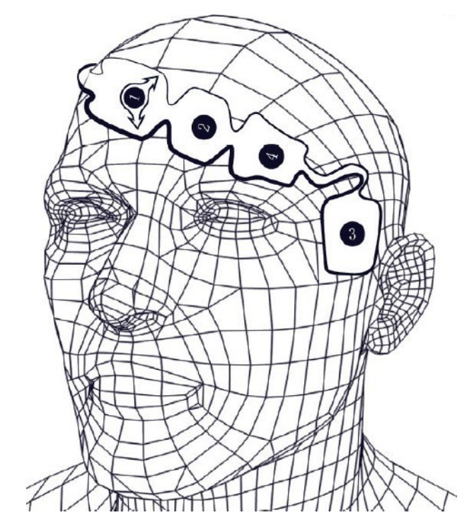
Viamed currently offers 2 types of EEG sensors:

- Disposable Single-Use EEG sensors for measurement of Bispectral Index
Disposable, single-use EEG sensors are specifically designed for anaesthesiologists and medical professionals to monitor and assess the depth of anaesthesia in patients using the Bispectral IndexTM (BIS) derived from the EEG signals. This provides real-time information about the patient’s consciousness and electrical brain activity during surgical procedures.

- Available in 3 types/sizes: Adult, Paediatric and Bilateral Adult
- Compatible with a large range of BISTM monitors and modules (see leaflet and cross reference for more information)
- Clinically tested, high-measurement accuracy
- Soft and bio-compatible material
- Latex-free

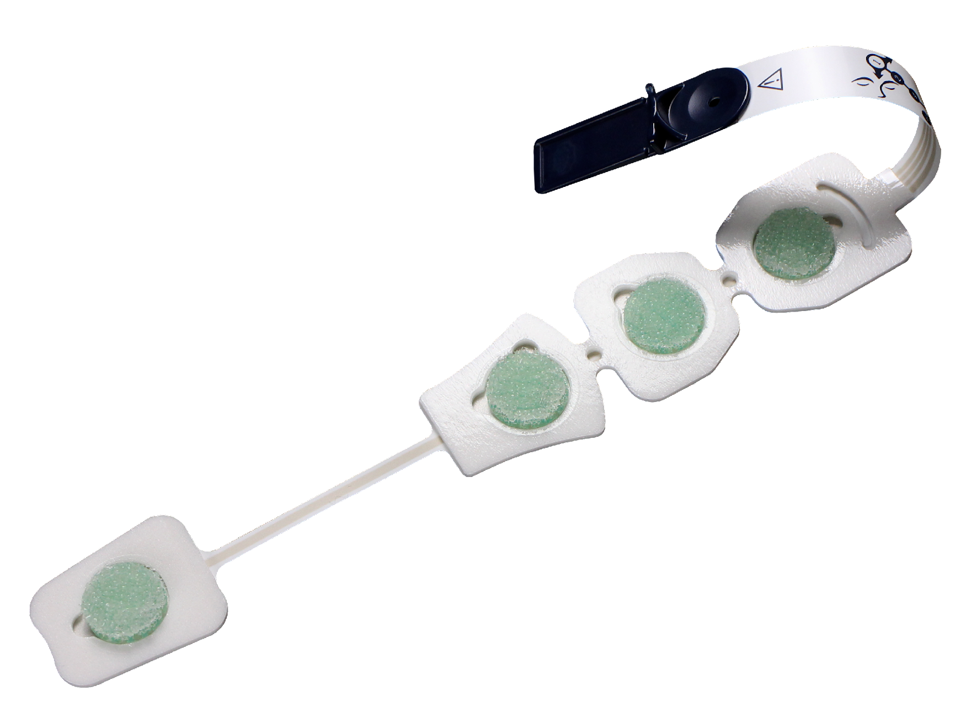 | 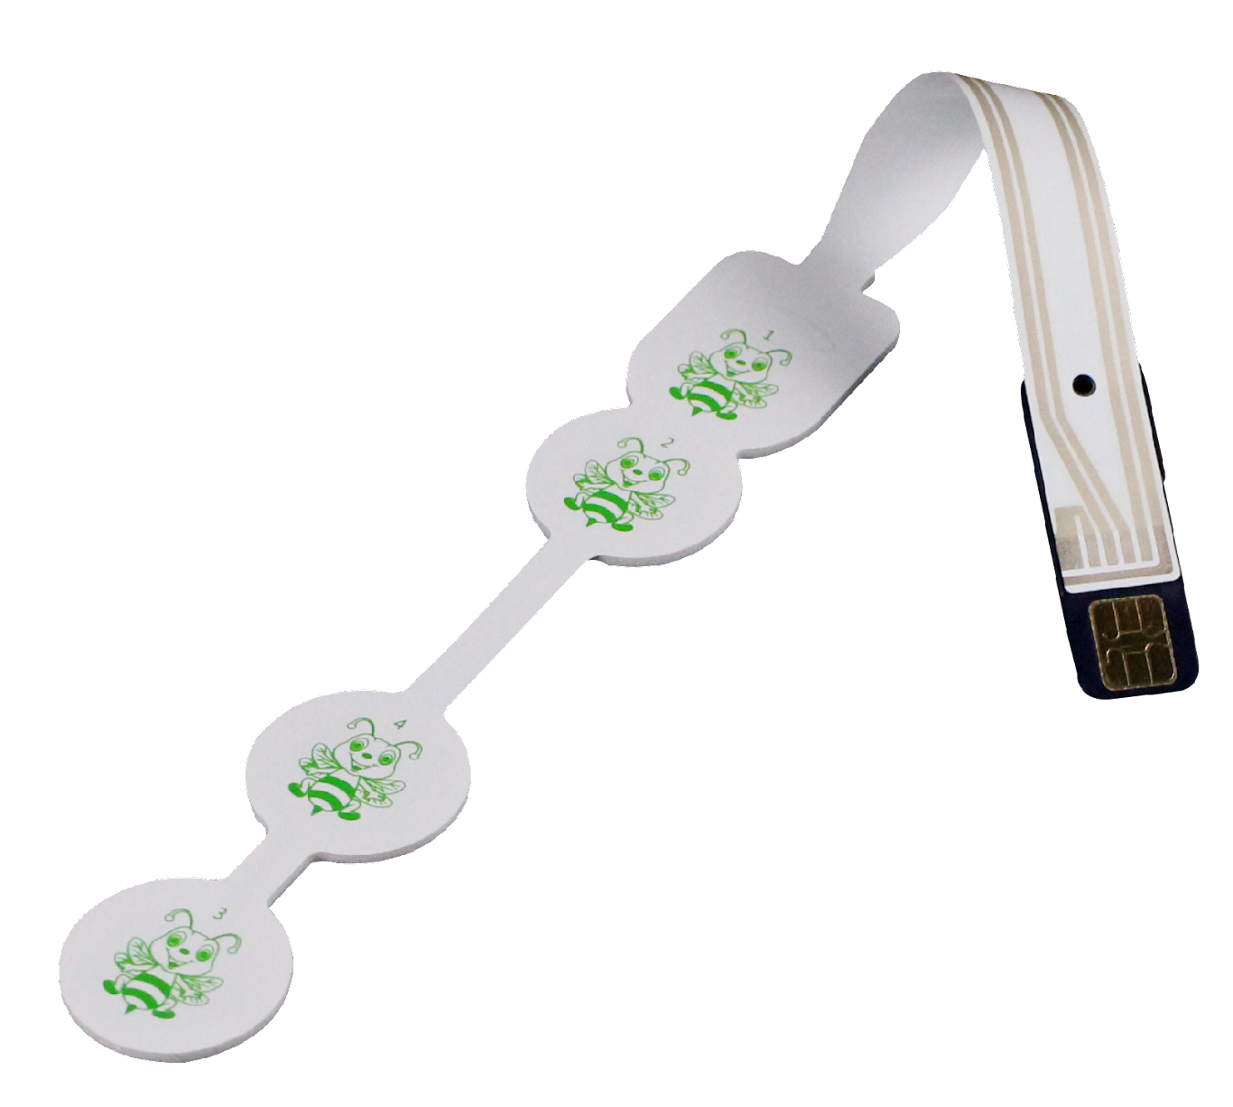 | 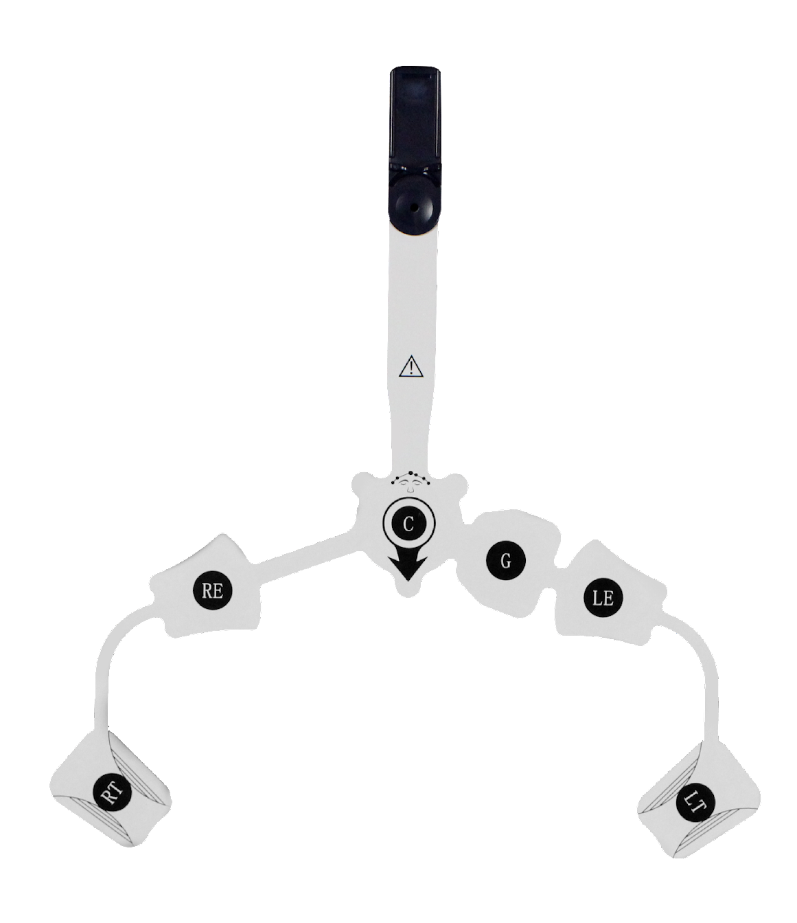
Part Number: 4610010  Adult  REF MK-01  Pack of 25  Comparable to Medtronic/Covidien  Item No.  186-0106 | Part Number: 4610011  Paediatric  REF MK-02  Pack of 25  Comparable to Medtronic/Covidien  Item No.  186-0200 | Part Number: 4610012  Bilateral Adult  REF MK-04  Pack of 25  Comparable to Medtronic/Covidien  Item No.  186-0212

Product Label
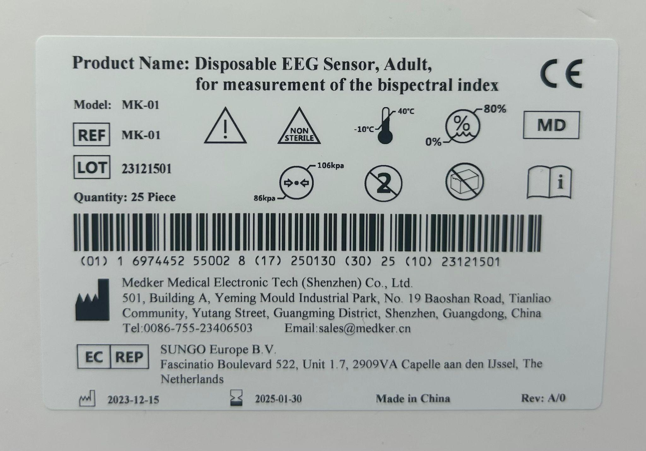
Product Packaging (Single)
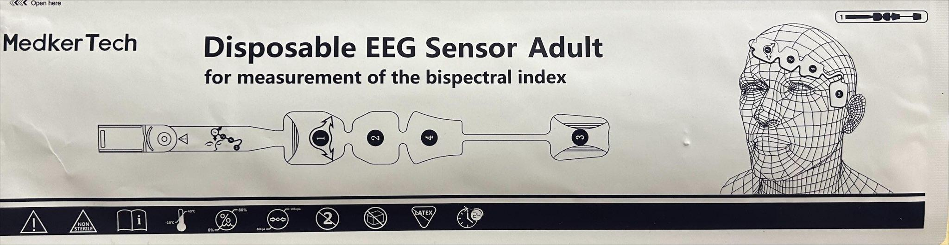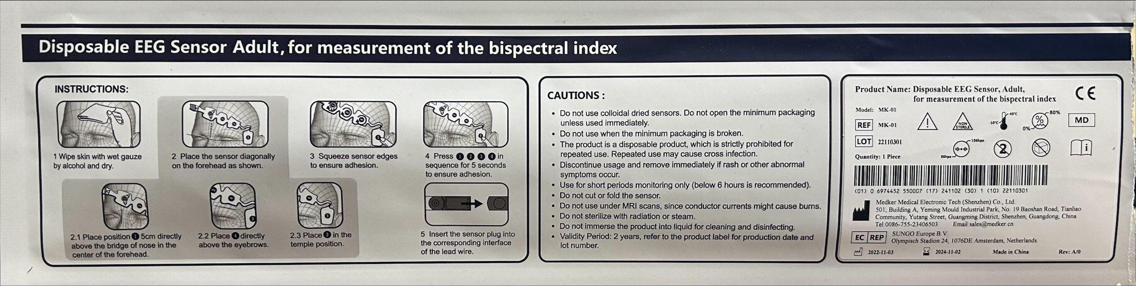
N.B. The box of 25 is provided in a plain white box with a single product label to show serials number etc.
- Disposable Single-Use Entropy EEG Sensors
Disposable, single-use EEG sensors are specifically designed for anaesthesiologists and medical professionals to monitor the state of the brain by data acquisition of electroencephalograph (EEG) and frontal electromyograph (FEMG) signals.

- Available for use with both adult and paediatric patients older than 2 years old.
- Clinically tested, high-measurement accuracy; “entropy is considered to be a more accurate and reliable indicator of hypnotic effects of anaesthetic and sedative drugs”
- Soft and bio-compatible material
- Latex-free
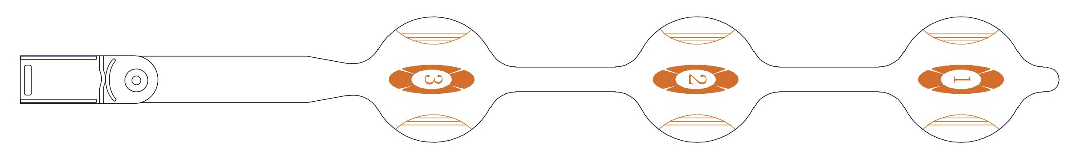
Part Number: 4610013
Adult and Paediatric over 2 years old
REF MK-03
Pack of 25
Comparable to GE Healthcare Item Nos.
M1174413 (sensor) and M1174414 (sensor and cable)
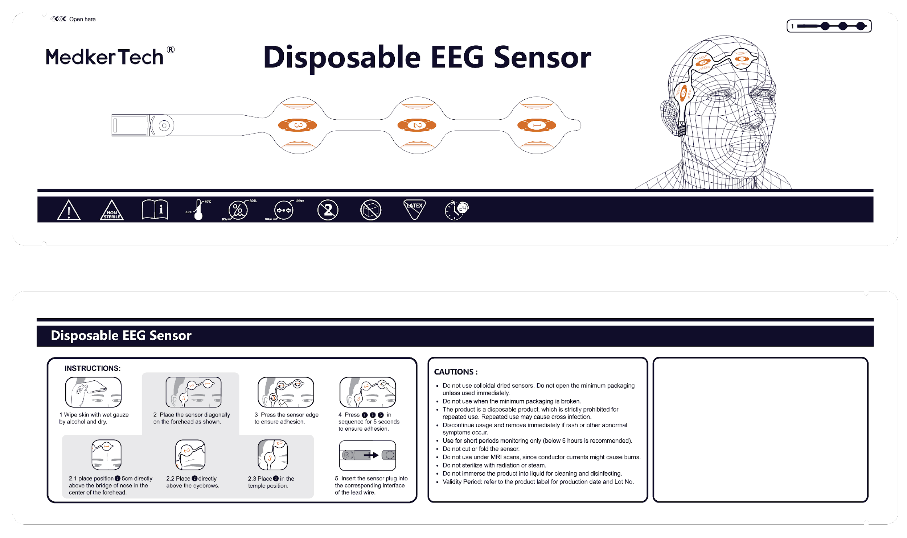
N.B. The box of 25 is provided in a plain white box with a single product label to show serials number etc.

Cross Reference
Cross reference can be found in Intrastats, drop down menu, cross references, select group
“EEG Cables”.
Pricing
Pricing can be found on Intrastats, under the “£” symbol. There are also downloadable PDFs against the “£” or in the “i” section.
Marketing Materials
Up to date copies of marketing materials such as leaflets, manuals and price lists (or in the £ screen) can be found on the stock pages under the “i” icon.
Certifications
Should you require to find information on what certifications a product has please see the stock screen, “i” icon and find the “Certificates” option. Click this and it will open the document index and all related certificates for that line.

https://www.ncbi.nlm.nih.gov/pmc/articles/PMC3282514/#:~:text=Compared%20to%20BIS%2C%20entropy%20is,complex%20and%20unpredictable%20%5B1%5D.

