Audit 24 the Service Logs,
Answer questions 1-4, Any non conformance generate an Issue.

INTRASTATS STOCK MENU
SERVICE VISITS
Service Visits

All Active and Single visit services should be shown.
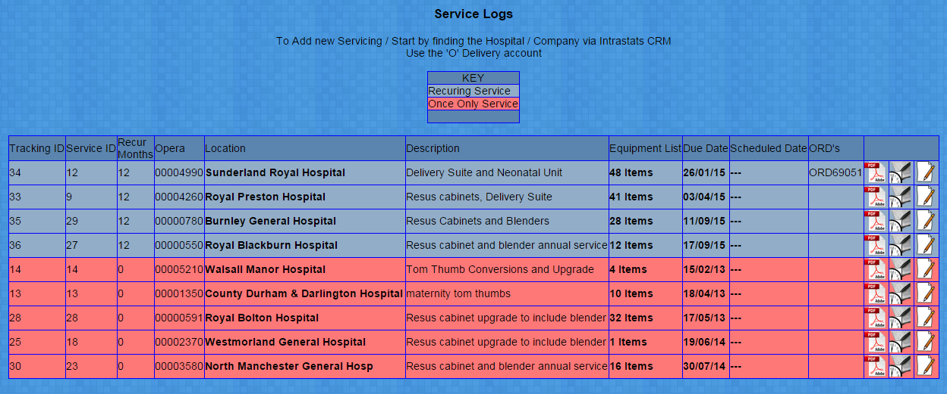
1. Are Any service Visits Over Due?,

Note Tracking ID 34 in the Example,

Has the Over due Visit got any Action notes:

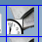
Click:

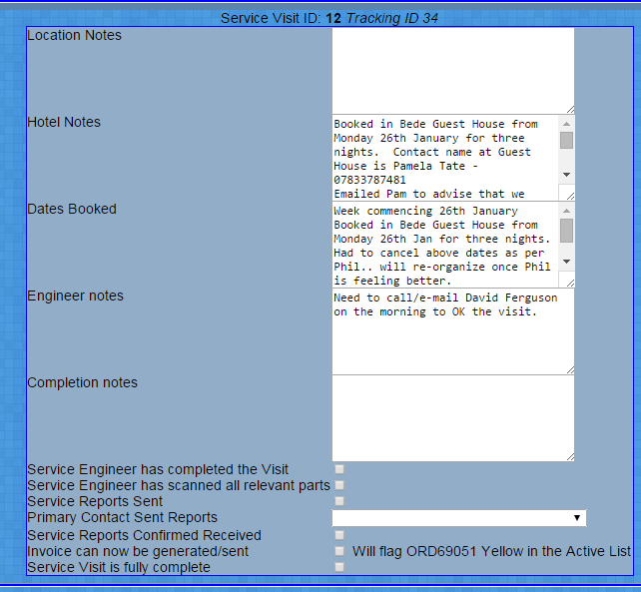

2. Have any over due Visit NOT got any action notes?

Drop out of the Service Visit Section,

Search Intrastats

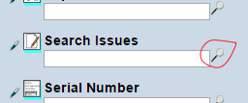

In the Subject Contains Words box type: Check The Service Visit Logs

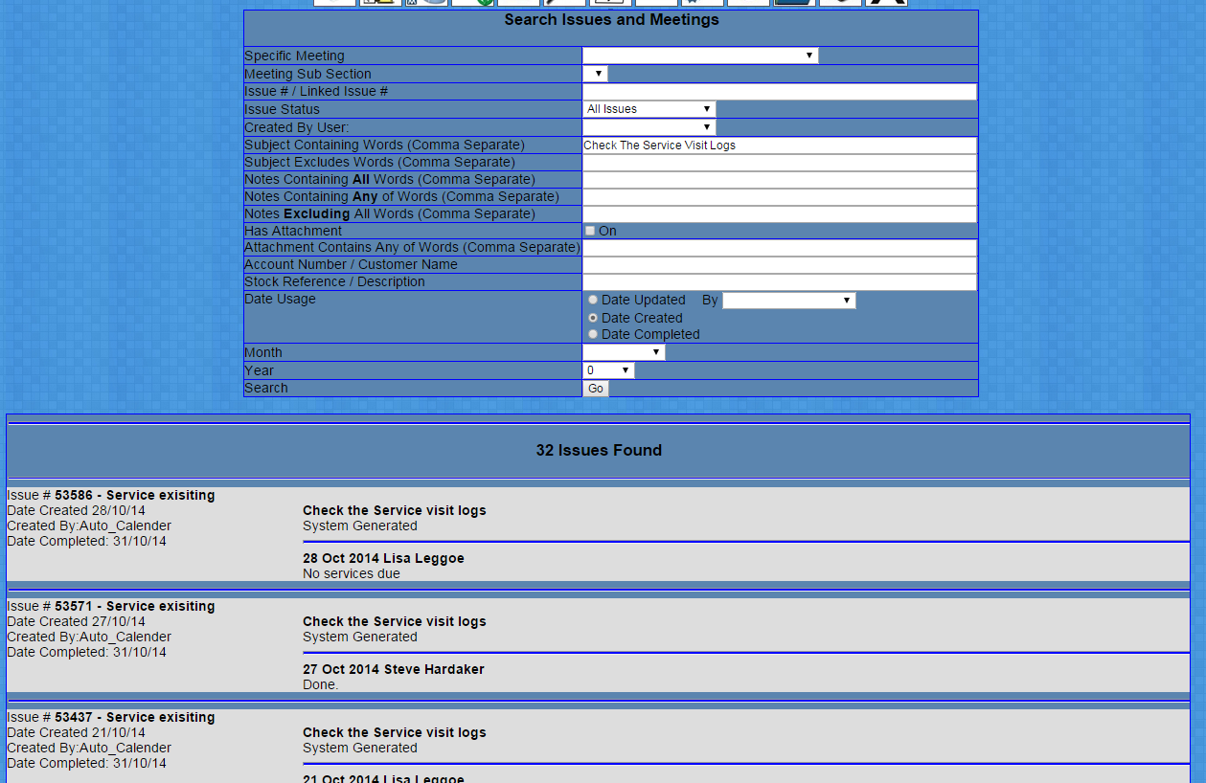
You should see a list of system generated tasks to 2 Different employees,
Scroll down the list,

3. Are more than 1 Issue outstanding per user?

4. Any problems found in the Issues system not being addressed?

