VM3COP20.071 UPS Updating UPS Rates in intrastats:


Stock Box Menu


UPS Rates

Monthly Update:

Each month the UPS surcharges change for Fuel rates:
Standard rate is Minimum charge we charge customers,
Fuel surcharge ground and Air International Fuel Surcharge are found at:

http://www.ups.com/content/gb/en/shipping/cost/zones/fuel_surcharge.html

Terminology changes:
current wording:

Standard Services
Through 1 February 2015: 7.50%
Effective 2 February 2015: 6.50%
All Express Services and Expedited Service
Through 1 February 2015: 11.50%
Effective 2 February 2015: 12.00%

Viamed Add : fixed at 10% to cover UPS surcharges

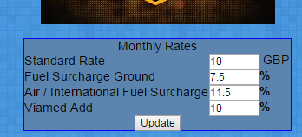

Enter details from the website and update,


Yearly Update:
Each year Viamed recieves a yearly updated XLS spreadsheet with raw figures.
Different type are in different tabs.

RAW UPS RATES:

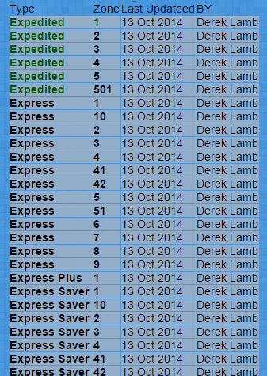

Bulk Import :
Click the Zone column to Zoom into the Type and Zone,
Only import Packages wieghts – do not include the Documents section,

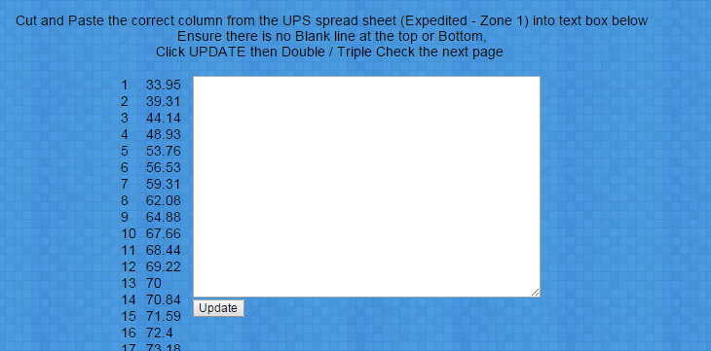

Remove any Spaces at the beginning and end of the text box

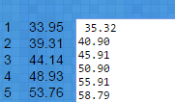
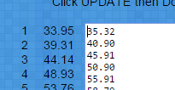

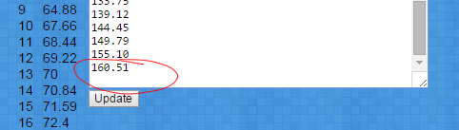

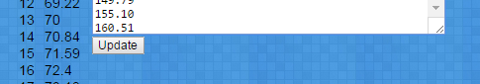

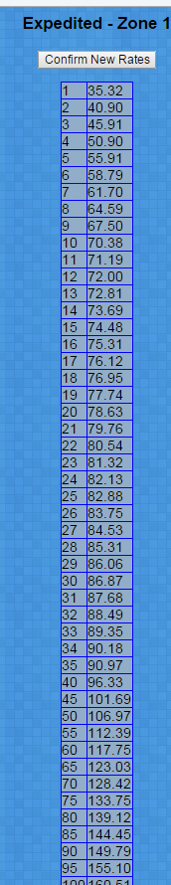

Click Update

Check the Shipping TYPE and ZONE are correct
to the data being imported,
Check the values are correct to the UPS spreadsheet

Assuming all is correct Click Confirm

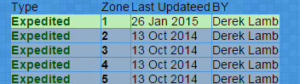

The list of Types to Zones will appear,
Lines in Green have been updated 'Recently'

