VM3COP20.071 UPS Updating UPS Rates in intrastats:


Stock Box Menu

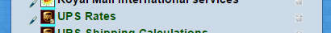
UPS Rates

Monthly Update:
http://www.ups.com/content/gb/en/shipping/cost/zones/fuel_surcharge.html

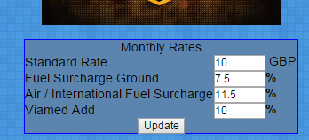

Enter details from the website and update,
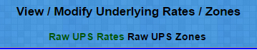

Yearly Update:
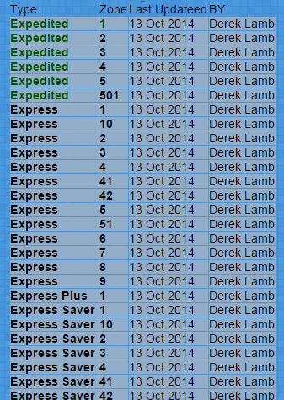
RAW UPS RATES:

Bulk Import :
Click the Zone column to Zoom into the Type and Zone
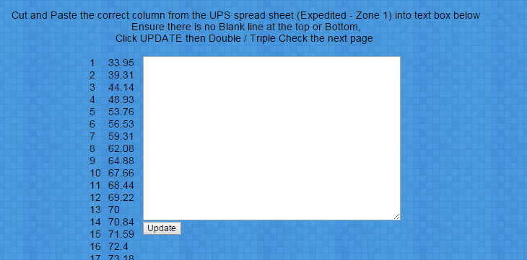

Remove any Spaces at the beginning and end of the text box

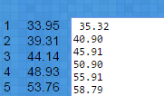
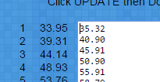

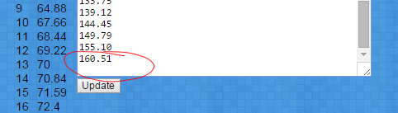

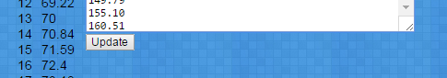

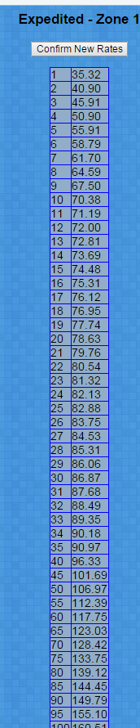

Click Update

Check the Shipping TYPE and ZONE are correct
to the data being imported,
Check the values are correct to the UPS spreadsheet

Assuming all is correct Click Confirm

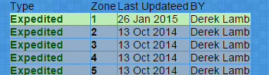

The list of Types to Zones will appear,
Lines in Green have been updated 'Recently'

