OBL Sensor Specification

Type: OOD103

Änderungsregister / Change log

Revision | Date | Author | Description
0 | 24.11.2020 | Maik Lingies | Start with Revisions Log
1 | 17.01.2024 | Maik Lingies | Add new Version Ref: 8010029

Measurement Range: | 0 % ... 100 % oxygen
Output in Ambient Air: | 9 to 13 mV
Electrical Interface: | 3 pin (Molex 22-11-1031)
Repeatability: | < 1% vol. O2 @ constant temperature and pressure
Linearity error: | 0.1 to 1.0 bar ppO2 < 3% relative
Linearity error: | 0.1 to 2.5 bar ppO2 < 5% relative (at ppO2 > 1.0 bar after 1 h equilibration time)
Response time: | < 5 sec. to 90% of final value
Zero Offset Voltage: | < 0.5% oxygen reading in 100% nitrogen @ 25°C after 36 seconds
Cross Interference: | < 0.5% vol. O2 response to: 5% CO2 balance N2
Influence of Humidity: | - 0.03% rel. per % RH at 25°C
Pressure Range: | 600 to 2500 mbar
Influence of Mechanical Shock: | < 1% relative after a fall from 1m
Operating Temperature: | 0°C to 50°C
Temperature Compensation: | Built-in NTC compensation
Effect of Temperature Compensation (steady state): | Between 0°C and +50°C: 5% relative error
Operating Humidity: | 0 - 99% RH non-condensing
Long Term Output Drift: | < 1% vol. oxygen per month
 | Typically < -15% relative over lifetime
Storage Temperature: | -20°C to +50°C
Recommended Storage: | +5°C to +15°C
Recommended Load: | ≥10 kOhms
Warm-Up Time: | < 30 minutes, after replacement of sensor
Nominal Sensor Lifetime: | 500,000% vol oxygen hours
Weight: | Approximately 28 grams
Warranty Period: | 15 months (including 3-month shelf life)
Part No.: | OOD103: 1001570 (REF 8010000 / VST2200)
 | OOD103: E1001570 (REF 8010006 / CR22D)
 | OOD103: E1001570 (REF 8010008 / NaNM01)
 | OOD103: E1001570 (REF 8010014 / K-22D)
 | OOD103: E1001570 (REF 8010015 / UDT-22)
 | OOD103: E1001570 (REF 8010018 / M3S)
 | OOD103: E1001570 (REF 8010019 / SG-22)
 | OOD103: E1001570 (REF 8010020 / 22D)
 | OOD103: E1001570 (REF 8010021 / DST-2200)
 | OOD103: E1001570 (REF 8010029 / mCCR)
All specifications are applicable at standard conditions: 1013 mbar, 25°C dry ambient air.

Mechanical draft:
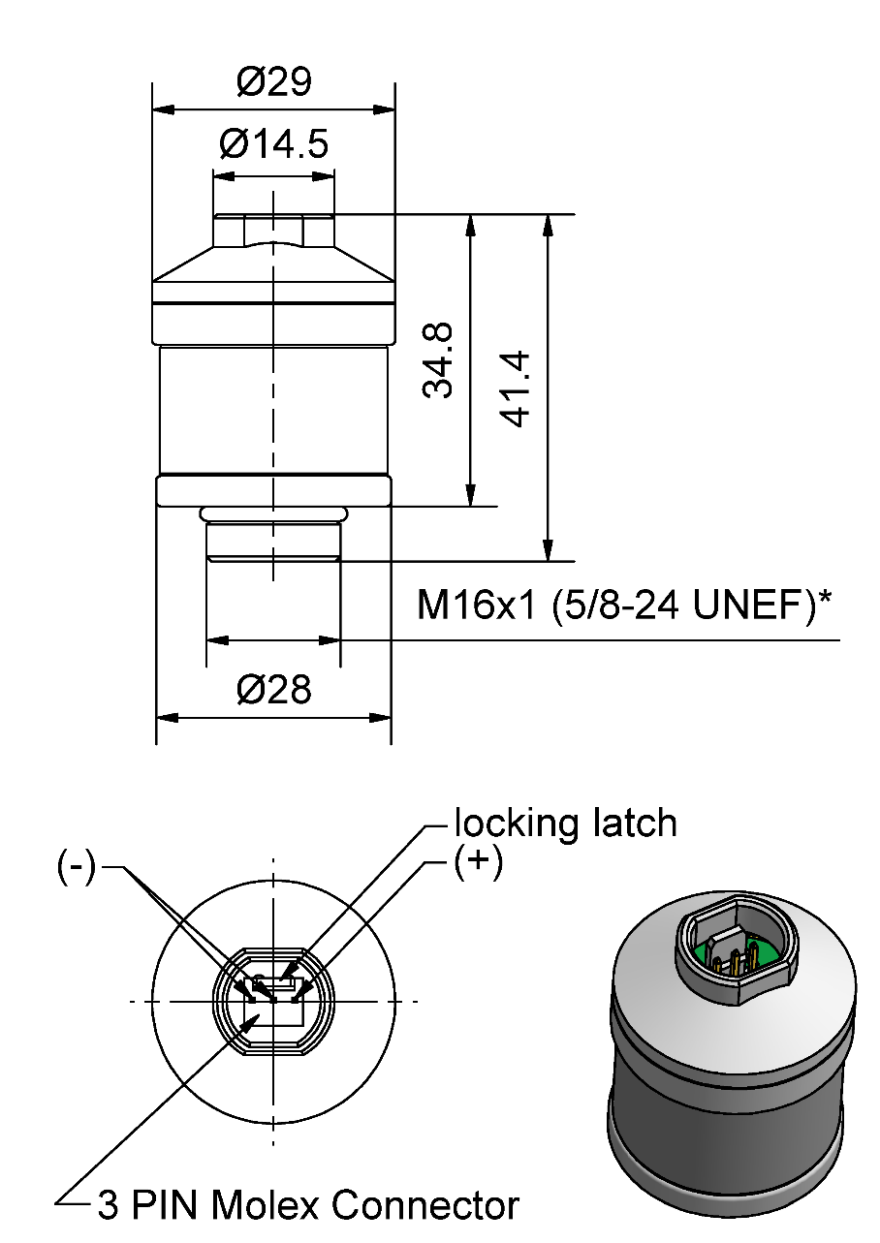

General tolerances ISO 2768-c
*Intermediate thread: Metric / Unified Extra Fine

Customized Design Specification:

- Integration of additional Zitex membrane in sensor gas diffusion way
- Conformal coating on the sensor PCB with PLASTIK 70
- 2 x 2mm holes drilled in the sensor PCB
- No information about EnviteC on PCB top / bottom sides, information for ordering process and traceability only.

PCB Layout:

Top | Bottom
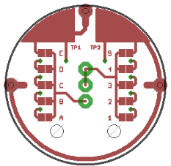 | 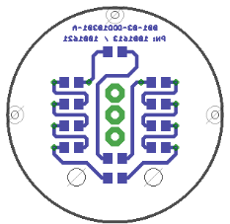

Product Labeling

OOD103: 1001570 (REF 8010000 / VST2200)
Label on Sensor (90x15) | Label on Blister- Card (63,5x46,6)
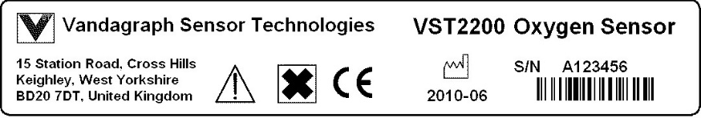 | 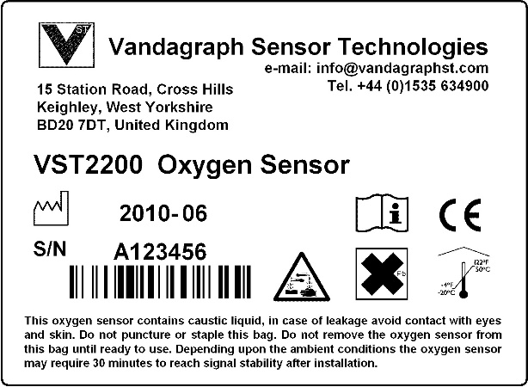
OOD103: E1001570 (REF 8010006 / CR22D)
Label on Sensor (90x15) | Label on Blister- Card (63,5x46,6)
 | 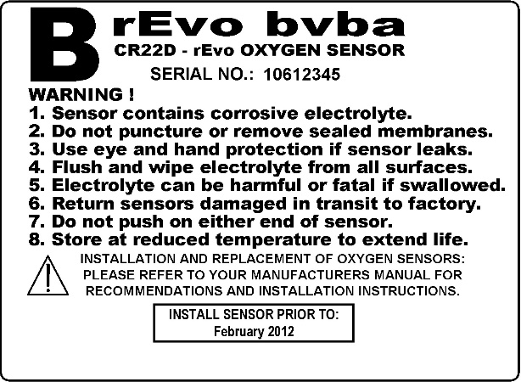
OOD103: E1001570 (REF 8010008 / NaNM01)
Label on Sensor (90x15) | Label on Blister- Card (63,5x46,6)
 | 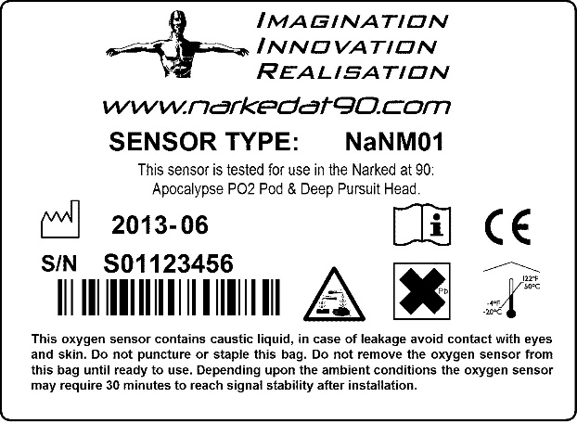
OOD103: E1001570 (REF 8010014 / K-22D)
Label on Sensor (90x15) | Label on Blister- Card (63,5x46,6)
 | 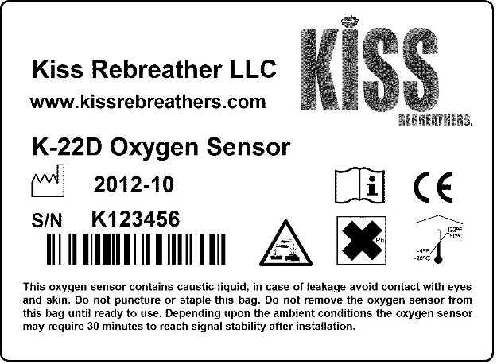
OOD103: E1001570 (REF 8010015 / UDT-22)
Label on Sensor (90x15) | Label on Blister- Card (63,5x46,6)
 | 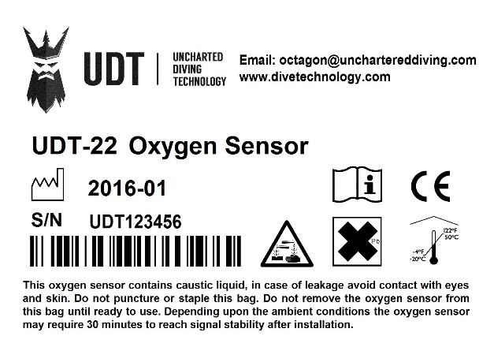
OOD103: E1001570 (REF 8010018 / M3S)
Label on Sensor (90x15) | Label on Blister- Card (63,5x46,6)
 | 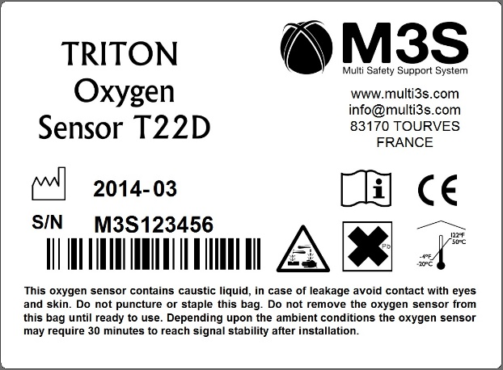
OOD103: E1001570 (REF 8010019 / SG-22)
Label on Sensor (90x15) | Label on Blister- Card (63,5x46,6)
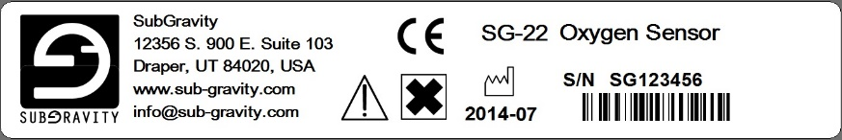 | 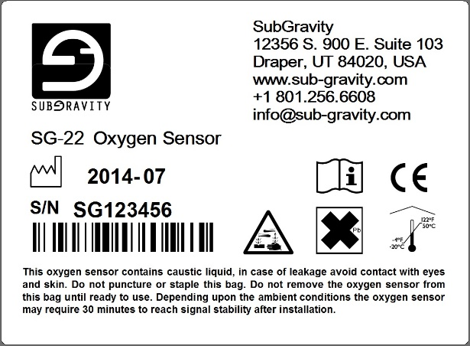
OOD103: E1001570 (REF 8010020 / 22D)
Label on Sensor (90x15) | Label on Blister- Card (63,5x46,6)
 | 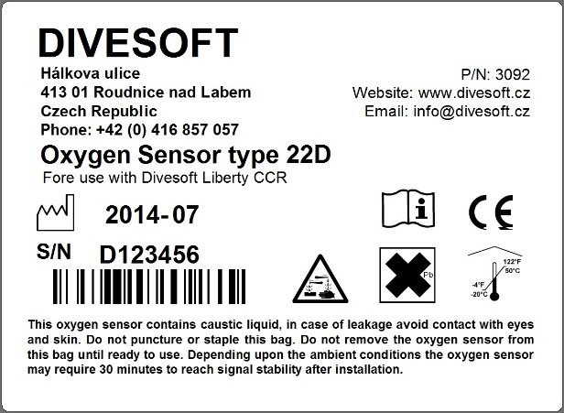
OOD103: E1001570 (REF 8010021 / DST-2200)
Label on Sensor (90x15) | Label on Blister- Card (63,5x46,6)
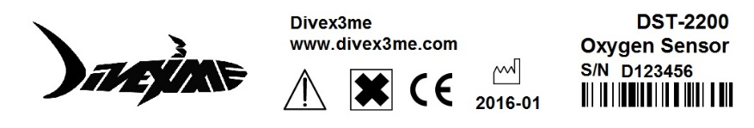 | 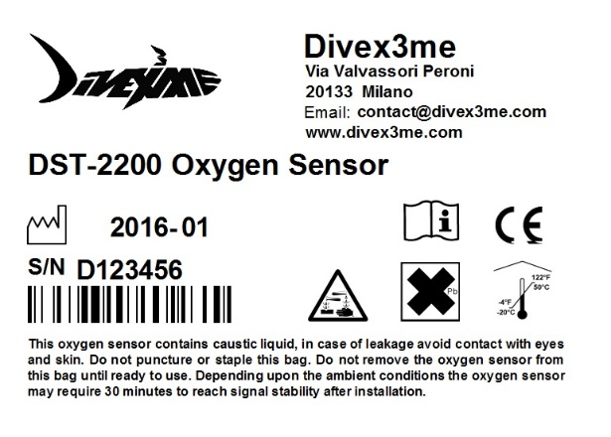
OOD103: E1001570 (REF 8010029 / mCCR)
Label on Sensor (90x15) | Label on Blister- Card (63,5x46,6)
 | 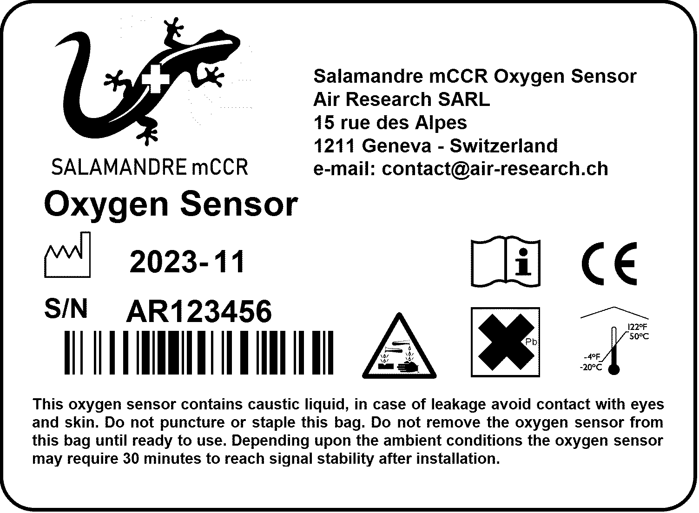

Customer Approval

Date:

Signature:

