VAT in Xero and processing non standard VAT amounts in to the Xero accounts system.

Most of the time Xero will work out the VAT correctly at 20% there is also an option have 5% for utility bills 0% for export customers and zero VAT items. There's also Exempt VAT for things like bank charges and the sale of books. This VAT is broken down into VAT on purchases and VAT on sales.

If the government ever changed the VAT rate you would go into Xero into the advanced settings where you can set that rates. Over the four different Xero companies logins we're using, sometimes these are called a different thing but VAT on purchases and VAT bills are the same.

Everything you do here will show up on the VAT return so it has to be right you have to include the paperwork so it can be checked at a later date and if you get it wrong on the VAT return you have to undo the transaction and redo it to make sure we are claiming back enough VAT. Sometimes the VAT amount can be in 10s of thousands of pounds so it's important to cover this.

In Xero when entering a none standard VAT amount to an invoice or bill we have to make a calculation in the unit price box. Mostly this will be regarding bills either HMRC deferred duty bills. (the reports are called C79 reports and you have to login to the Gov.uk site to access these. Must be downloaded every month and save. As they are only available for 6 month, there are in my secure files in VAT returns)
or some UPS/DHL/FEDEX invoices.

Add a Bill and copy the paperwork to the page so the VAT people and accountants can check it correct.
Put in the contact that the bill relates to. From in this example we are using UPS.

Put the reference number as the invoice number from the paperwork and the total amount at the top right hand corner. On line one put the item in as 2003:Carriage (Some of this will be slightly different depending on company Xero were using but mostly they are the same wording)

When you are putting UPS invoices into Xero as a bill you must check down the paperwork to make sure that there is not a second page with VAT detailed separately. In this case there were three and two pages. But this isn’t normal. In these cases the front page does not detail the VAT we can claim back. Normal UPS Invoices have the VAT broken down on the front page. These are specials and need to be entered as below.
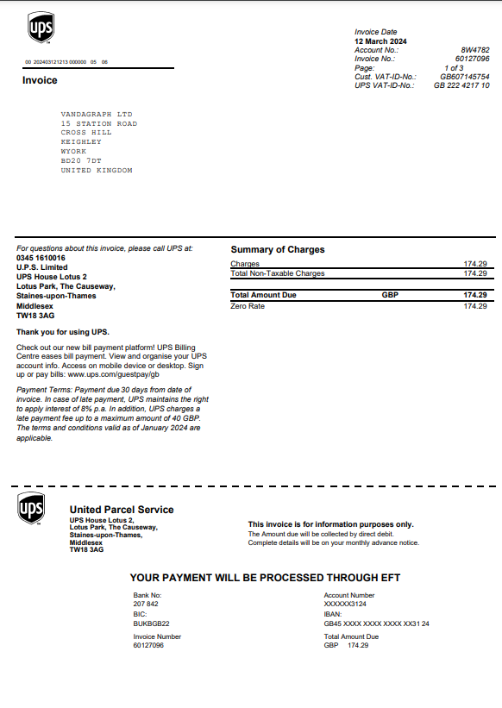
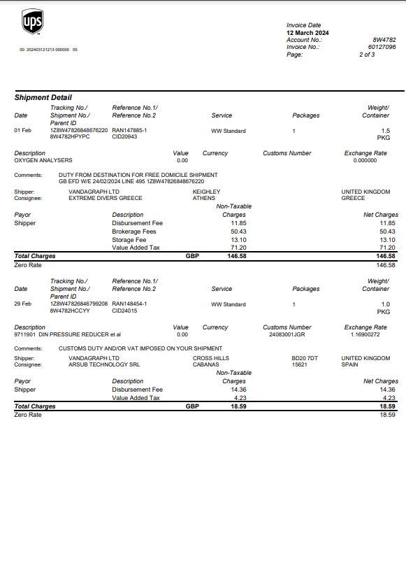

Line 1 Item 2003, Under description put as much information as possible including a breakdown of any fees disbursement fees, brokerage fees, storage fees and value added tax. I copy this from the description on the paperwork. In quantity put one. Unit price is where we do the calculation there are two options usually for the deferred duty line 1 would be 6 times the VAT amount with 20% VAT on purchases in the tax rate box. For UPS this can be the above or 5 times the VAT amount. (check the total at the bottom to see which you need to use).

Line 2 has the same information but in unit price it is -5 times the VAT amount and zero rated purchasing for VAT. This allows us to have the VAT amount at the bottom of the invoice be the correct VAT amount as per the paperwork you have.

Line 3 you put in any non vatable fees. This again is a Zero rated purchases line in the VAT column and at the bottom you should have a total that matches the total on the invoice and a total of at that matches what you have on your VAT certificate/ or invoice.

There is no getting round that this is complicated, but there is no easy way to put in a non-standard VAT amount into Xero.

There are a couple of calculations you can do to get the VAT amount correct to your paperwork they are always in line one. Times the vat amount by 5 or 6 and line 2 times the vat amount by minus 5.

If it doesn’t balance then its probably another figure that isn’t right. Re check it all before panicking and if in doubt ask the accountant for help.

So For example line one 6x60, line 2 is -5*60
or
5*60 and line 2 is -5*60.

It's only gonna make sense when you've had a go at it.

Line 1
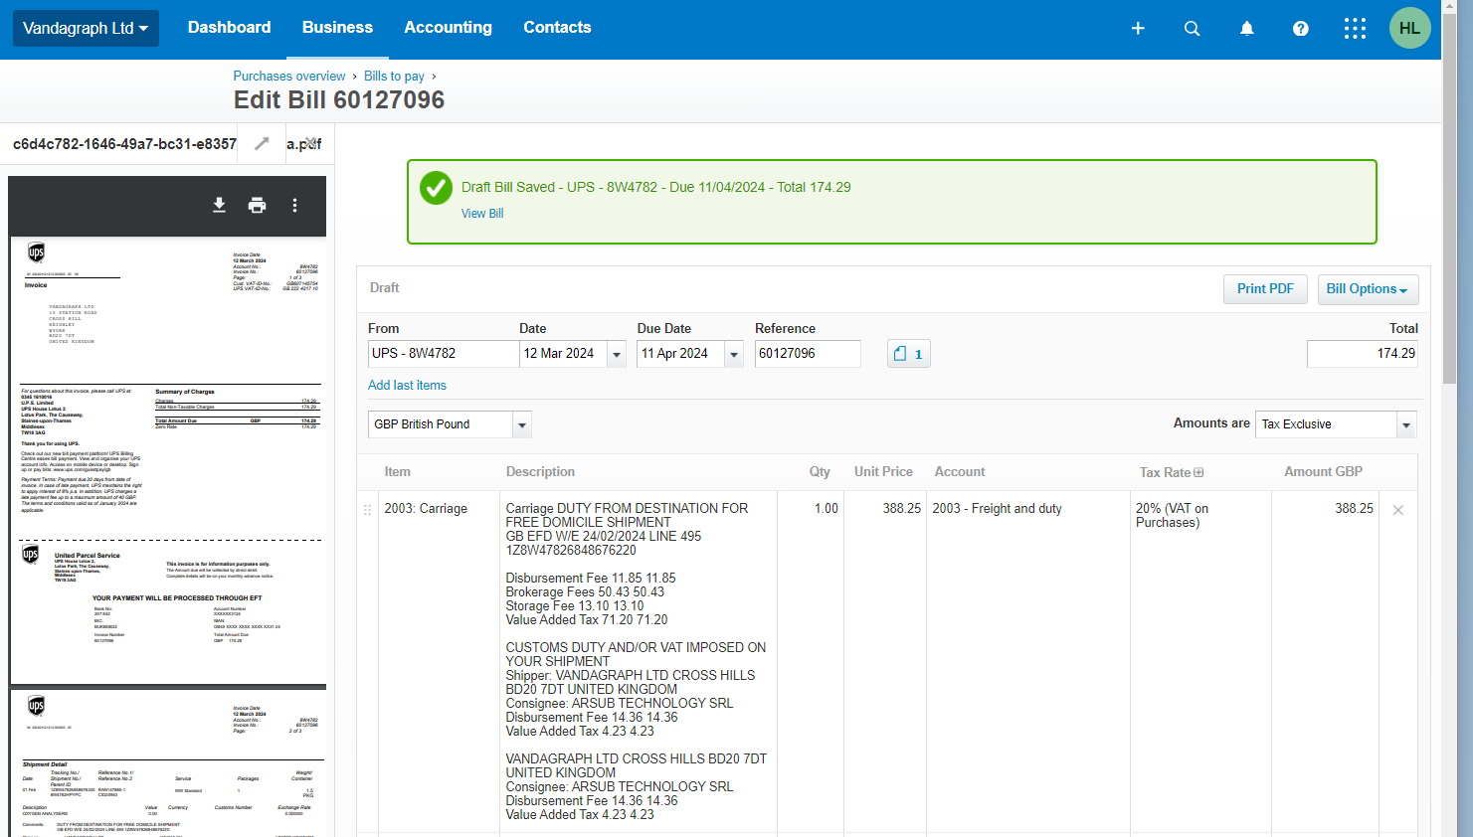

Line 2 and 3


